IEEE P802.15
Wireless Personal Area Networks

Project | IEEE P802.15 Working Group for Wireless Personal Area Networks (WPANs)
Title | Suggested Text for Many-to-Many Peering to Resolve Comment CID-37-43
Date Submitted | January 2017
Source | Huan-Bang Li (NICT)  Marco Hernandez (NICT)  Fumihide Kojima (NICT)
Re: | TG8 draft text for comment resolution for 802.15.8
Abstract | This is the work in progress text of the MAC component for IEEE 802.15.8 group for PAC.
Purpose | This document provides the details of draft text to IEEE 802.15.8
Notice | This document does not represent the agreed views of the IEEE 802.15 Working Group or IEEE 802.15.8 Task Group. It represents only the views of the participants listed in the “Source(s)” field above. It is offered as a basis for discussion and is not binding on the contributing individual(s) or organization(s). The material in this document is subject to change in form and content after further study. The contributor(s) reserve(s) the right to add, amend or withdraw material contained herein.
Release | The contributor acknowledges and accepts that this contribution becomes the property of IEEE and may be made publicly available by P802.15.
Patent Policy | The contributor is familiar with the IEEE-SA Patent Policy and Procedures:  <http://standards.ieee.org/guides/bylaws/sect6-7.html#6> and  <http://standards.ieee.org/guides/opman/sect6.html#6.3>.  Further information is located at <http://standards.ieee.org/board/pat/pat-material.html> and  <http://standards.ieee.org/board/pat>.

[This is draft text to resolve comment submitted to TG8]

      - Many-to-many peering procedure
Many-to-many peering occurs among an initiator PD (I-PD) and a number of responder PDs (R-PDs). The many-to-many peering procedure follows subclause 6.5.3.4, discovery procedure for many-to-many group, where the I-PD obtained a list of candidate R-PDs for forming many-to-many group. The result of many-to-many peering is that a number of selected PDs including the I-PD and all R-PDs get peered forming a PAC group. As illustrated in Figure xxx, many-to-many peering procedure shall contain the following steps.
- The I-PD’s higher layer triggers the many-to-many peering procedure by issuing the MLME-PEERING.request primitive to its MAC sublayer with the content of targeted R-PDs selected from the list of qualified R-PDs obtained at the many-to-many discovery.
- Upon reception of the MLME-PEERING.request primitive, the I-PD’s MAC sublayer multicasts the Peering Request command frame with the content of targeted R-PDs and the PeeringType parameter is set to MANY2MANY.
- Upon reception of Peering Request command frame, a R-PD’s MAC sublayer shall issue the MLME-PEERING.indication primitive to its next higher layer, indicating many-to-many peering request with the PeeringType parameter set to MANY2MANY.
- Each R-PD’s next higher layer receiving the MLME-PEERING.indication primitive decides either to accept or reject the request to peer within macPeeringResponseTimeout. The next higher layer of the R-PD shall issue a MLME-PEERING.response primitive to their MAC sublayers.
- Upon reception of the MLME-PEERING.response primitive, the R-PD’s MAC sublayer shall multicast the Peering Response command frame with the content of targeted R-PDs.
- The I-PD re-multicasts the Peering Request command frame if the I-PD does not receive the Peering Response command frame for the targeted R-PDs until reaching the macMaxFrameRetries.
- A soon as the I-PD broadcasts/multicasts Peering Request command frame, the I-PD shall wait for either: the arrival of Peering Response command frames from all targeted R-PDs or macPeeringResponseTimeout is reached.
- Upon reception of Peering Response command frames, the I-PD’s MAC sublayer shall issue the MLME-PEERING.confirm to its next higher layer.
- The I-PD’s next higher layer updates the content of targeted R-PDs in accordance with the results of the step h.
- The next higher layer of the I-PD may start many-to-many group operation using multicast with the updated R-PDs.

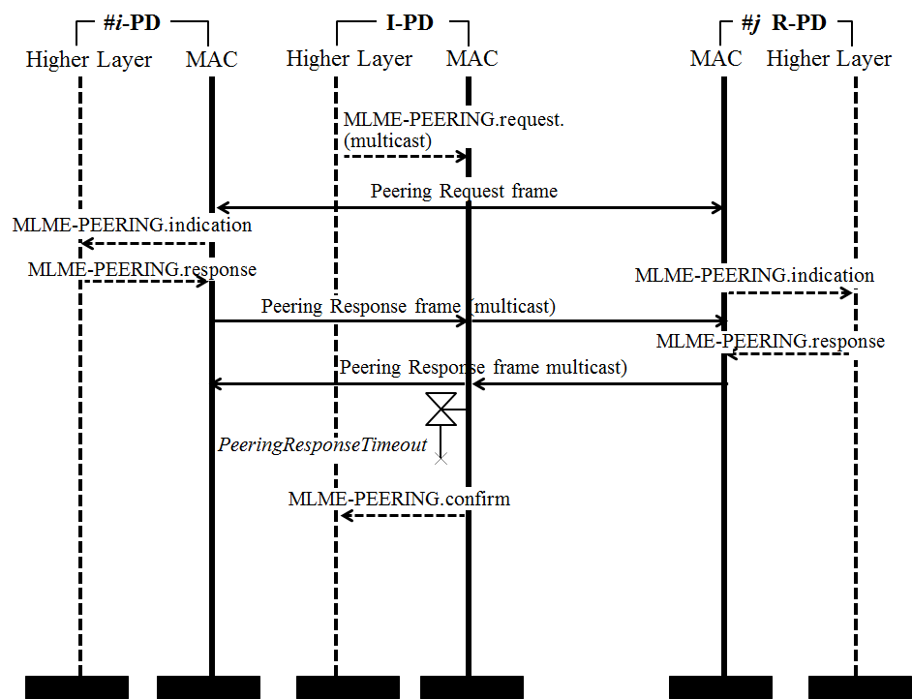
Figure xxx —Many-to-many peering procedure chart

