IEEE P802.15
Wireless Personal Area Networks

Project | IEEE P802.15 Working Group for Wireless Personal Area Networks (WPANs)
Title | Suggested Text for Many-to-Many Discovery to Resolve Comment CID-35
Date Submitted | September 2016
Source | Huan-Bang Li (NICT)  Marco Hernandez (NICT)  Fumihide Kojima (NICT)
Re: | TG8 draft text for comment resolution for 802.15.8
Abstract | This is the work in progress text of the MAC component for IEEE 802.15.8 group for PAC.
Purpose | This document provides the details of draft text to IEEE 802.15.8
Notice | This document does not represent the agreed views of the IEEE 802.15 Working Group or IEEE 802.15.8 Task Group. It represents only the views of the participants listed in the “Source(s)” field above. It is offered as a basis for discussion and is not binding on the contributing individual(s) or organization(s). The material in this document is subject to change in form and content after further study. The contributor(s) reserve(s) the right to add, amend or withdraw material contained herein.
Release | The contributor acknowledges and accepts that this contribution becomes the property of IEEE and may be made publicly available by P802.15.
Patent Policy | The contributor is familiar with the IEEE-SA Patent Policy and Procedures:  <http://standards.ieee.org/guides/bylaws/sect6-7.html#6> and  <http://standards.ieee.org/guides/opman/sect6.html#6.3>.  Further information is located at <http://standards.ieee.org/board/pat/pat-material.html> and  <http://standards.ieee.org/board/pat>.

[This is draft text to resolve comment submitted to TG8]

      - Discovery procedure for many-to-many group
Many-to-many discovery is defined for a group of mutual neighbour PDs. Mutual neighbour PDs means that any PD in the group shall be able to communicate with all other PDs of the group. Therefore, physical links must be available between any pair of PDs. Procedure for many-to-many discovery follows the steps as shown in Figure xx.
- The higher layer of an Initiator PD (I-PD) triggers the two-way discovery procedure by issuing the MLME-DISCOVERY.request with the parameter Discovery Type set to TWO-WAY-UNTARGETED.
- Upon reception of the MLME-DISCOVERY.request primitive, the I-PD’s MAC sublayer broadcasts the Discovery Request command frame.
- Each of the other PDs that captured the Discovery request sends an MLME-DISCOVERY.indication to its higher layer indicating two-way untargeted discovery request with the Discovery Type parameter.
- The next higher layer of each Responder PD (R-PD) shall issue a MLME-DISCOVERY.response primitive to its MAC sublayers, if the PD agreed to send the Discovery Response command frame to the I-PD.
- Upon reception of the MLME-DISCOVERY.response primitive, the R-PD’s MAC sublayer shall send the Discovery Response command frame to the I-PD during the CAP.
- Upon reception of the Discovery Response command frame, the I-PD shall send an Immediate Ack frame.
- If the Immediate Ack frame is not received, the R-PD shall notify the next higher layer by issuing the MLME-COMM-STATUS.indication primitive with the status parameter set to NO_ACK.
- A soon as the I-PD broadcasts the Discovery Request command frame, the I-PD shall monitor the CAP for possible Discovery Response command frames. The I–PD collects a list of first responded R-PDs and reports the first R-PDs’ list to the next high layer using DISCOVERY.confirm premitive.
- The I-PD’s issues the MLME-DISCOVERY.request with the parameter Discovery Type set to MANY2MANY and Destination Address parameter set to the MAC address of one of the first R-PDs in the list.
- Upon reception of the MLME-DISCOVERY.request primitive, the I-PD’s MAC sublayer sends the Discovery Request command frame with a request of content of received PDs.
- Upon reception of the Discovery Request command frame, the R-PD’s MAC sublayer shall send the Discovery Response command frame to the I-PD during the CAP with the content of its received PDs while it put the I-PD at the beginning of the list.
- Upon reception of the Discovery Response command frame, the I-PD shall send an Immediate Ack frame. If the Immediate Ack frame is not received, R-PDs shall notify the next higher layer by issuing the MLME-COMM-STATUS.indication primitive with the Status parameter set to NO_ACK.
- Upon reception of Discovery Response command frames, the I-PD’s MAC sublayer shall issue the MLME-Discovery.confirm primitive with the corresponding content of received R-PDs’ list of that particular R-PD.
- The steps from i to m are iterated until Discovery Request command frame have been sent to all R-PDs in the first R-PDs list.
- The next higher layer of the I-PD’s obtains a list of PDs qualified for the many-to-many group.

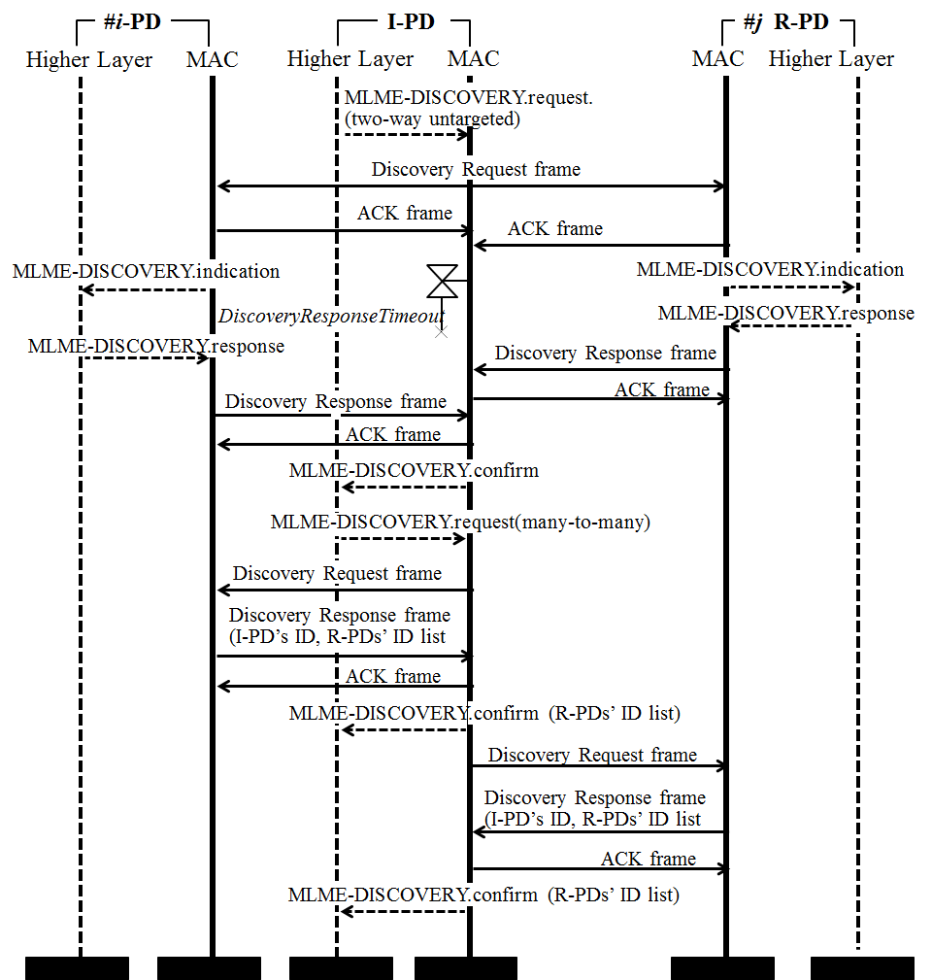
Figure 1—Discovery procedure sequence chart for forming many-to-many group

