IEEE P802.15
Wireless Personal Area Networks

Project | IEEE P802.15 Working Group for Wireless Personal Area Networks (WPANs)
Title | Text Input by Panasonic
Date Submitted | Mar. 2017
Source | [Hideki Aoyama]  [Panasonic]  [address] | Voice: [ ]  Fax: [ ]  E-mail: [aoyama.hideki@jp.panasonic.com]
Re: | [If this is a proposed revision, cite the original document.]  [If this is a response to a Call for Contributions, cite the name and date of the Call for Contributions to which this document responds, as well as the relevant item number in the Call for Contributions.]  [Note: Contributions that are not responsive to this section of the template, and contributions which do not address the topic under which they are submitted, may be refused or consigned to the “General Contributions” area.]
Abstract | [Description of document contents.]
Purpose | [Description of what the author wants P802.15 to do with the information in the document.]
Notice | This document has been prepared to assist the IEEE P802.15. It is offered as a basis for discussion and is not binding on the contributing individual(s) or organization(s). The material in this document is subject to change in form and content after further study. The contributor(s) reserve(s) the right to add, amend or withdraw material contained herein.
Release | The contributor acknowledges and accepts that this contribution becomes the property of IEEE and may be made publicly available by P802.15.

3.2 Acronyms and abbreviations
(Addition to the list)
MPM Mirror Pulse Modulation
PLCP Physical Layer Conversion Protocol

(Replacement for the whole 5.2.5)

5.2.5 MPM MAC frame format
MPM MAC frame format is composed of a MHR and a MSDU. The MHR field contains the sequence number subfield. The bit-length of the MPDU is set as macMpmMpduLength.

Bits:  0-5 | variable
Sequence Number | Frame Payload
MHR | MSDU
Figure 5.2.5 – MPM general MAC frame format

5.2.5.1 Sequence Number subfield
The Sequence Number subfield contains a frame sequence number. The bit-length of the Sequence Number subfield is set as macMpmSnLength. In the case that bit-length of the Sequence Number subfield is set as variable length, the first bit of the Sequence Number subfield is used as the Last Frame Flag, which is set as 1 for the last frame and 0 for the other frame. Figure 5.2.5.1 shows how to determine the bit-length of the Sequence Number subfield.

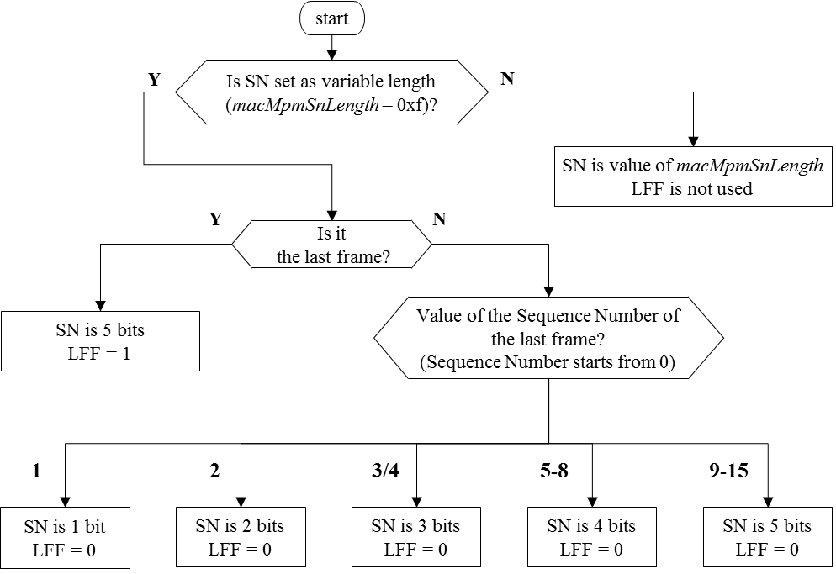
Figure 5.2.5.1 --- How to determine the bit-length of the Sequence Number subfield
SN: Bit-length of the Sequence Number subfield
LFF: the Last Frame Flag (the first bit of the Sequence Number subfield)

5.2.5.2 MSDU
The MSDU contains the frame payload.

6.4.2 MAC PIB attributes
(Addition to) Table 100 --- MAC PIB attribute
Attribute | Identifier | Type | Range | Description | Default
macMpmSnLength |  | Integer | 0x0-0xf | Indicates the bit-length of the Sequence Number subfield. Values from 0x0 to 0xe indicate the (fixed) bit-lengths. Value 0xf indicates that the bit-length is variable. | 0xf
macMpmMpduLength |  | Integer | 0x00-0xff | Indicates the bit-length of MPDU. | 12

(Replacement for the whole 8.5.2.5.4)

8.5.2.5.4 MPM dimming
MPM supports dimming by (a) analog dimming, (b) PWM dimming, (c) VPPM dimming (for only MPM PHY PPM mode), and/or (d) inserting dimming fields as shown in Figure 8.5.2.5.4.
The width of inserted pulse of PWM dimming shall be less than one third of the original pulse and less than 50 micro second.

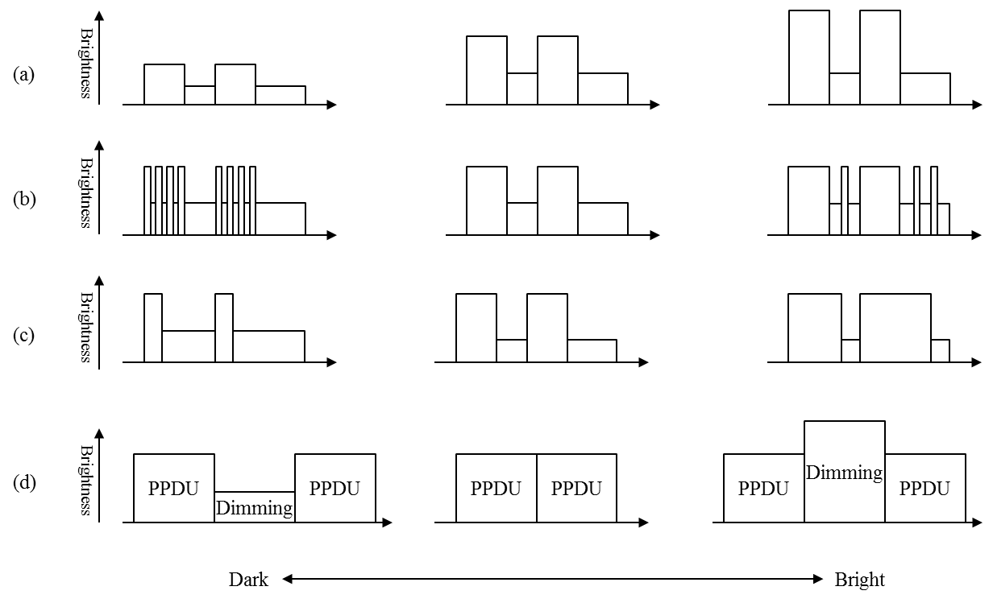
Figure 8.5.2.5.4 --- MPM dimming

(Replacement for the whole 8.6.7.4)

8.6.7.4 MPM PPDU format
MPM consists of the PSDU field only.

8.6.7.4.1 MPM PSDU field
The PSDU field contains MPDU that is converted by MPM PLCP.

9.5.2 PHY PIB attributes
(Addition to) Table 188 --- PHY PIB attributes
Attribute | Identifier | PLCP Center | Range | Description
phyMpmMode |  | Integer | 0-1 | Indicates the MPM PHY mode.  0: PWM mode  1: PPM mode
phyMpmPlcpHeaderMode |  | Integer | 0x0-0xf | Indicates the PLCP Header subfield mode and the PLCP Footer subfield. See 14.4.2 and 14.4.5.
phyMpmPlcpCenterMode |  | Integer | 0x0-0xf | Indicates the PLCP Center subfield mode. See 14.4.4.
phyMpmSymbolSize |  | Integer | 0x0-0xf | Indicates the number of symbols of the Payload subfield. 0x0 indicates variable. It is referred as N.
phyMpmOddSymbolBit |  | Integer | 0x0-0xf | Indicates the bit-length that is contained in each odd-numbered symbol of the Payload subfield. It is referred as M_{odd}.
phyMpmEvenSymbolBit |  | Integer | 0x0-0xf | Indicates the bit-length that is contained in each even-numbered symbol of the Payload subfield. It is referred as M_{even}.
phyMpmSymbolOffset |  | Integer | 0x00-0xff | Indicates the offset value of symbols of the Payload subfield. It is referred as W₁.
phyMpmSymbolUnit |  | Integer | 0x00-0xff | Indicates the unit value of symbols of the Payload subfield. It is referred as W₂.

(Replacement for the whole 14.4)

14.4 MPM
MPM PLCP converts MPDU to the PLCP Header subfield, the Front Payload subfield, the PLCP Center subfield, the Back Payload subfield, and the PLCP Footer subfield as shown in Figure 14.4. MPM PHY mode is set as phyMpmMode.

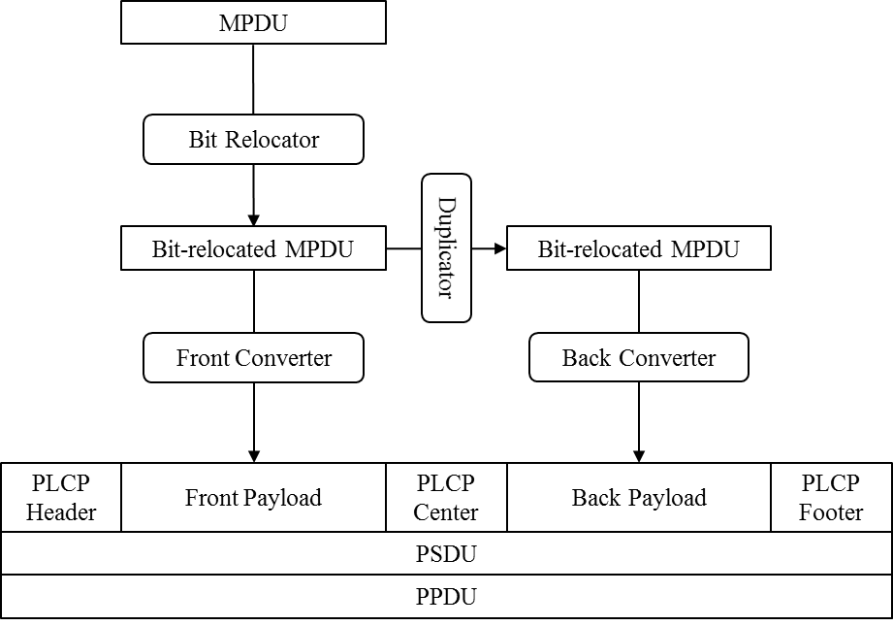
Figure 14.4 --- MPM PHY and PLCP

14.4.1 Bit Relocation
Let (x₀, x₁, x₂, …) be bits of MPDU, L_{SN} be the bit-length of the Sequential Number subfield, and N be the number of symbols of each Payload subfield. Relocated bits (y₀, y₁, y₂, …) are indicated as
$$y_{i}=\left\{\begin{matrix}x_{i+L_{SN}} & (i<N) \\ x_{i-N} & (N≤i<n+L_{SN}) \\ x_{i} & (N+L_{SN}≤i)\end{matrix}\right.$$

14.4.2 PLCP Header subfield
The PLCP Header subfield consists of four symbols for PWM mode and three symbols for PPM mode that are defined in Table 14.4.2.

Table 14.4.2 --- PLCP Header subfield modes
phyMpmPlcpHeaderMode | PLCP Header subfield symbols
 | PWM mode | PPM mode
0 | 0, 0, 0, 0 | 0, 0, 0
1 | 20, 10, 20, 20 | 90, 80, 80
2 | 30, 20, 30, 30 | 100, 90, 90
3 | 40, 30, 40, 40 | 110, 100, 100
4 | 50, 40, 50, 50 | 120, 110, 110
5 | 60, 50, 60, 60 | 130, 120, 120
6 | 70, 60, 70, 70 | 140, 130, 130
7 | 80, 70, 80, 80 | 150, 140, 140
8 | 90, 80, 90, 90 | 160, 150, 150
9 | 100, 90, 100, 100 | 170, 160, 160
10 | 110, 100, 110, 110 | 180, 170, 170
11 | 120, 110, 120, 120 | 190, 180, 180
12 | 130, 120, 130, 130 | 200, 190, 190

14.4.3 Front Payload subfield and Back Payload subfield
Each of the Front Payload subfield and the Back Payload subfield consist of N symbols. Let M_{odd} be a bit-length contained in an odd-numbered symbol, M_{even} be a bit-length contained in an even-numbered symbol, W₁ be a symbol value offset, and W₂ be a symbol value unit. N, M_{odd}, M_{even}, W₁, and W₂ are set in the PHY PIB in Table 188.

Relocated MPDU Payload Bits (y₀, y₁, y₂, …) are converted as follows. Let z_{i} be calculated as
$$z_{i}=\sum_{m=0}^{M^{-}-1}{y_{Nm+i}×2^{m}}+\sum_{m=M^{-}-1}^{M_{i}-1}{y_{k}×2^{m}}$$where
$$M^{-}=\min_{}\left(M_{odd},M_{even}\right)$$
$$M_{i}=\left\{\begin{matrix}M_{odd} (i∈odd number) \\ M_{even} \left(i∈even number\right)\end{matrix}\right.$$
$$k=\left(M^{-}-1\right)N+\left\lfloor \frac{\left(m-M^{-}\right)N+i}{2}\right\rfloor$$then the ith Symbol of the Front Payload subfield is calculated as
$$W_{1}+W_{2} ×\left(2^{m}-1-z_{i}\right)$$and the ith Symbol of the Back Payload subfield is calculated as
$$W_{1}+W_{2}×z_{i}$$

14.4.4 PLCP Center subfield
The PLCP Center subfield consists of four symbols for PWM mode and three symbols for PPM mode that are defined in Table 14.4.4.

Table 14.4.4 --- PLCP Center subfield modes
phyMpmPlcpCenterMode | PLCP Center subfield symbols
 | PWM mode | PPM mode
0 | 0, 0, 0, 0 | 0, 0, 0
1 | 20, 10, 10, 20 | 80, 90, 80
2 | 30, 20, 20, 30 | 90, 100, 90
3 | 40, 30, 30, 40 | 100, 110, 100
4 | 50, 40, 40, 50 | 110, 120, 110
5 | 60, 50, 50, 60 | 120, 130, 120
6 | 70, 60, 60, 70 | 130, 140, 130
7 | 80, 70, 70, 80 | 140, 150, 140
8 | 90, 80, 80, 90 | 150, 160, 150
9 | 100, 90, 90, 100 | 160, 170, 160
10 | 110, 100, 100, 110 | 170, 180, 170
11 | 120, 110, 110, 120 | 180, 190, 180
12 | 130, 120, 120, 130 | 190, 200, 190

14.4.5 PLCP Footer subfield
The PLCP Header subfield consists of four symbols for PWM mode and three symbols for PPM mode that are defined in Table 14.4.5.

Table 14.4.5 --- PLCP Footer subfield modes
phyMpmPlcpHeaderMode | PLCP Footer subfield symbols
 | PWM mode | PPM mode
0 | 0, 0, 0, 0 | 0, 0, 0
1 | 20, 20, 10, 20 | 80, 80, 90
2 | 30, 30, 20, 30 | 90, 90, 100
3 | 40, 40, 30, 40 | 100, 100, 110
4 | 50, 50, 40, 50 | 110, 110, 120
5 | 60, 60, 50, 60 | 120, 120, 130
6 | 70, 70, 60, 70 | 130, 130, 140
7 | 80, 80, 70, 80 | 140, 140, 150
8 | 90, 90, 80, 90 | 150, 150, 160
9 | 100, 100, 90, 100 | 160, 160, 170
10 | 110, 110, 100, 110 | 170, 170, 180
11 | 120, 120, 110, 120 | 180, 180, 190
12 | 130, 130, 120, 130 | 190, 190, 200

14.4.6 Waveform
Symbols shall be transmitted as two states of light intensity, the bright state and the dark state.
In MPM PHY PWM mode, symbol value corresponds to continuous time of a state in micro second. For example, the first symbol value corresponds continuous time of the first bright state and the second symbol value corresponds continuous time of the following dark state as shown in Figure 14.4.6A. The first state can be dark state as well.

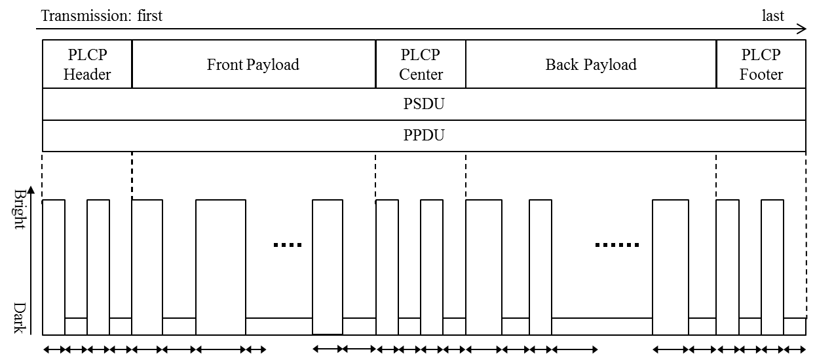
Figure 14.4.6A --- MPM PHY PWM mode waveform

In MPM PHY PPM mode, symbol value corresponds to duration time between the beginning of bright state and the beginning of the next bright state in micro second. The duration time of continuous bright state shall be shorter than 90% of the symbol value. Figure 14.4.6B shows an example waveform.

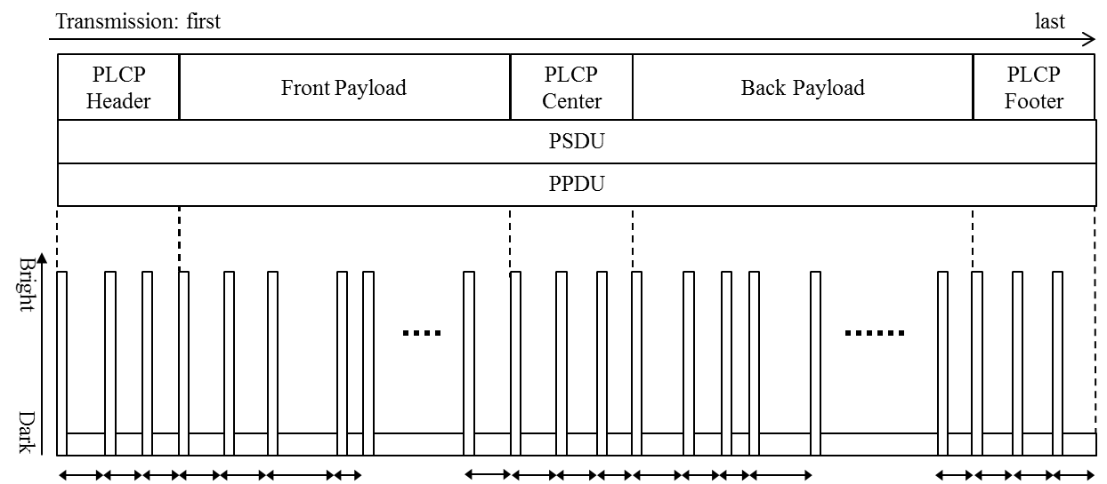
Figure 14.4.6B --- MPM PHY PPM mode waveform

For both modes, a transmitter can transmit only a part of the symbols, but all symbols of the PLCP Center subfield and at least N symbols from the Front Payload subfield and the Back Payload subfield must be transmitted.

