IEEE P802.15
Wireless Personal Area Networks

Project | IEEE P802.15 Working Group for Wireless Personal Area Networks (WPANs)
Title | OCC MACs configuration
Date Submitted | [January 2017]
Source | Trang Nguyen, Nam Tuan Le, and Yeong Min Jang (Kookmin University)
Re: | D1 comments and resolutions
Abstract | Summary on OCC MACs
Purpose | D1 comments and resolution
Notice | This document has been prepared to assist the IEEE P802.15. It is offered as a basis for discussion and is not binding on the contributing individual(s) or organization(s). The material in this document is subject to change in form and content after further study. The contributor(s) reserve(s) the right to add, amend or withdraw material contained herein.
Release | The contributor acknowledges and accepts that this contribution becomes the property of IEEE and may be made publicly available by P802.15.

Summary on OCC MACs
- MAC Supperframe
Unidirectional information broadcasting | Bidirectional data transfer  (OCC for both downlink and uplink)
PHY 4 modes | PHY 4
PHY 5 modes | x
PHY 6 modes | PHY 6

From our perspective, unidirectional information broadcasting modes shall not implement any MAC supper frame.
On the other hand, bidirectional data transfer modes shall optionally implement a simple channel access (e.g. unslotted ALOHA). Whenever TRX has data, it just transmits.

 | Information Broadcasting | Bidirectional data transfer
Channel access | No | Yes
Addressing | Source (optional) | Source or Destination
Security | No | Optional
Acknowledgement | No | Optional (prefer NO)
Superframe structure | No | Optional

- MAC frame formats
 |  | MHR | MSDU | MFR
 | IEEE 802.15.7-2011 | Frame control: 2 octets  Sequence No.: 1  Addressing fields:  Acknowledge field:  Polling field:  Security header: | Frame payload | FCS
PHY 4 | UFSOOK | x | - | CRC-3 (optional)
 | S2-PSK | x | - | x
 | S8-PSK | x | - | x
 | Twinkle VPPM | Addressing fields (source) | - | FCS
 | HS-PSK | Addressing fields | - | Optional
 | Offset-VPPM | x | - | FCS: 2
PHY 5 | RS-FSK | Frame control: 1  Sequence No.: 1  Addressing fields: 0/2 | - | FCS: 2
 | CM-FSK | Config. via MAC attributes | - | x
 | C-OOK | Config. via MAC attributes | - | x
 | Packet PWM/PPM | N/A | N/A | N/A
PHY 6 | Kookmin A-QL | Frame control: 1  Addressing fields: 1  -Source address (IB mode)  - Source/Dest. address (D2D mode) | - | Optional
 | Kookmin HA-QL | Config. via MAC attributes | - | x
 | VTASC | Frame control: 2  Sequence No.: 1  Addressing fields: 0/2/8 | - | FCS: 2
 | Invisible data embedded display

2.1 MHR Format
 |  | MHR (octets)
 |  | Frame control | Sequence number | Addressing fields | Ack. field | Polling field | Aux. Security Header
 | 15.7-2011 | 2 | 1 | multi subfields | 0/3/9 | 0/2/8 | 0/5/6/0/14
PHY 4 | UFSOOK
 | S2-PSK
 | S8-PSK
 | Twinkle VPPM |  |  | Source Address
 | HS-PSK | 1 |  | 1  (Source/Dest.)
 | Offset-VPPM
PHY 5 | RS-FSK | 1 | 1 | Source Add.:0/2  Dest. Add.:0/2
 | CM-FSK | Config. over MAC attributes
 | C-OOK | Config. over MAC attributes
 | Packet PWM/PPM | N/A
PHY 6 | Kookmin A-QL | 1 |  | 1  (Source/Dest.)
 | Kookmin HA-QL | Config. over MAC attributes
 | VTASC | 2 | 1 | 0/2/8
 | Invisible data embedded display

Comments
- If frame control field is disable, there is no need of MAC supper frame. Thus, low-rate OCC modes without MHR field on MAC shall be implemented on information broadcasting (IB mode).
- When MHR is disable, multiple MACs may be supported in the same network by re-configuring the MAC attributes.
- Frame control field is necessary at a situation that D2D is supported. A TRX generates a source address when it broadcasts data to multiple TRXs; and it generates a destination source address when it solely targets the communication to a specific one.

MACs Configuration
  - For low-rate modes, different OCC MACs are configurable via MAC attributes. The subfields of MHR field shall be configured via MAC attributes
  - For high-rate modes, MAC frame formats are presented.
Our comment:
Those MAC PIB attributes are designed for OCC modes only. I guess LiFi modes do not require those attributes. That’s why mandatory MAC attributes start with “macOcc…”.

I- MAC PIB Attributes

Attribute | Ident. | Type | Range | Description
macFrameVersion | - | 3 bit | 000- 111 | This attribute specifies the OCC MAC frame version.  000: IEEE Std 802.15.7-2011  001: IEEE Std 802.15.7-201x OCC  010-111: Reserved
macOccFrameType | - | 3 bit | 000- 111 | This attribute specifies the OCC MAC frame.  000: Unidirectional Information Broadcasting (IB) frame  001: Light-ID frame  010: Bidirectional data transfer (D2D mode)  011-111: Reserved
macOccSecurityEnable | - | Boolean | T/F | This is to configure security mode.  FALSE: Security disable (all the OCC broadcasting modes)  TRUE: Security enable
1- Light-ID MAC frame format (Indoor scenario)
macLightIdPrefix | - | byte | 0x00- 0xff | The Light-ID prefix field to indicate further information of the frame, such as company ID.
macLightIdFrameSubtype | - | 3 bit | b000  -b111 | This specifies the subtype of Light-ID MAC frame. Thus the subtype also gives the information of the frame length.  000: 3 subfields Light-ID  001: 4 subfields Light-ID  010: Mixed Light-ID subtypes (including the full and the shorten IDs)  011-111: Reserved
macLightIdFullIdCycle | - | Int. | 0-7 | This attribute is present solely macLightIdFrameSubtype = 010.  0: No shorten ID  1: (1 full ID || 22 shorten IDs)  3-7: Reserved
macLightIdSubfield1Length | - | Int. | 0-7 | This attribute specifies the length of subfield 1 of Light-ID payload.  0: 0 byte (for the shorten frame type)  1: 1 byte  2: 2 byte  3-7: Reserved
macLightIdSubfield2Length | - | Int. | 0-7 | Same as macLightIdSubfield1Length
macLightIdSubfield3Length | - | Int. | 0-7 | This attribute specifies the length of subfield 3 of Light-ID payload.  0: 1 byte  1: 2 byte  2-7: Reserved
macLightIdSubfield4Length | - | Int. | 0-7 | This attribute specifies the length of subfield 4 (optional subfield) of Light-ID payload.  0: 0 byte  1: 2 byte advertisement indicator  2-7: Reserved
2- Unidirectional IB mode MAC frame format

macIBSourceAddressEnable |  | Boolean | T/F | This is to enable the source addressing for OCC IB.  TRUE: Source Addressing is enable  FALSE: Source Addressing is disable
macIBSourceAddress |  | 1 byte |  | This specifies the address of the transmitting source if the IB Source Addressing is enable.  Otherwise, it sets to 0xff.
3- Bidirectional Data transfer MAC frame format (D2D)

macD2DSourceAddressModeEnable |  | Boolean | T/F | This is to enable the source addressing mode for OCC D2D.  TRUE: Source Addressing Mode  FALSE: Destination Addressing Mode
macD2DSourceDestAddress |  | 2 byte | 0x0000  – 0xffff | The Address field corresponds to the D2D Address Mode.  If Destination Addressing Mode is enable, this attributes specifies the address of the intended recipient of the frame.  Otherwise, this specifies the address of the transmitting source.
macD2DSecurityHeader |  | 2 byte | 0x0000  – 0xffff | The security header corresponds to the secured D2D mode.  This attribute is set to 0xffff if the security flag is disable.

II- MAC Format of Individual frames

2.1- Light-ID MAC frame format
The configuration of Light-ID MAC frame format is performed over MAC attributes:
macOccFrameVersion: 001
macOccFrameType: 001
macOccSecurityEnable: FALSE
MAC frame is light-ID frame when macOccFrameType = 001. The other MAC attributes for Light-ID frame (macLightIdPrefix, macLightIdFrameSubtype, macLightIdFullIdCycle, macLightIdSubfield1Length, macLightIdSubfield2Length, macLightIdSubfield3Length, and macLightIdSubfield4Length) shall configure the specification of the MAC frame used.
For the subtype of MAC frame formats of Light-ID that has macLightIdFrameSubtype =000 or macLightIdFrameSubtype =001, the format of MAC is only payload field as shown in Fig. 01. The subfields of the payload shall be formatted according to the selected frame subtype over the remaining attributes (macLightIdSubfield1Length, macLightIdSubfield2Length, macLightIdSubfield3Length, and macLightIdSubfield4Length).

Variable
Frame payload (3/4 subfields)
MSDU
Figure 01 – Light_ID frame format for selected subtype 000 and 001.
For the subtype of MAC frame formats of Light-ID that has macLightIdFrameSubtype =010, different MAC subframes, including a full ID frame (subtype 000 or 001) and multiple shorten ID frames, shall be transmitted as shown in Fig. 02. The shorten ID frame shall contain only the last subfield of the full ID frame payload.
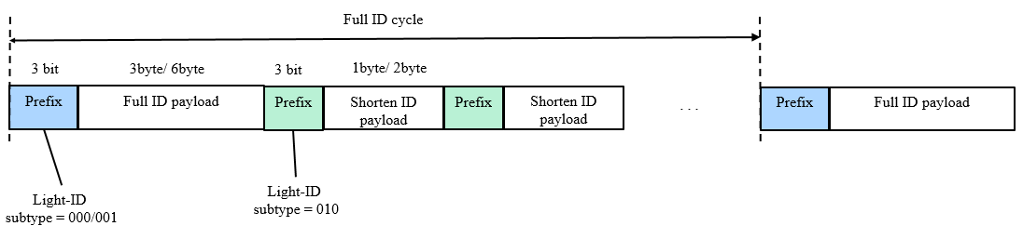
Figure 02 – Light_ID frame format for selected subtype 010 (with different MAC subframes).

Each subframe shall contain a prefix of 3 bits subtype that indicate the value of macLightIdFrameSubtype. The interframe interval between two full ID frames is configured over macLightIdFullIdCycle.

2.2- Unidirectional IB mode MAC frame format
All unidirectional IB modes shall configure MAC frame format over OCC MAC PIB attributes:
macOccFrameVersion: 001
macOccFrameType: 000
macOccSecurityEnable: FALSE

For low rate OCC modes (S2-PSK, S8-PSK, CM-FSK, C-OOK, HA-QL), two additional MAC attributes, macIBSourceAddressEnable and macIBSourceAddress, shall configure the addressing of the selected IB mode. Security is disable for all IB modes, therefore no MAC attribute for security is needed. Source address is optionally enable in case multiple sources are considered. If source address is enable, macIBSourceAddress shall configure the source addressing.

On the other hand, higher rate OCC modes (HS-PSK, and A-QL modulation) shall configure IB frame format over MHR subfields, not MAC PIB attributes. In this case, the MAC frame format shall be formatted as Fig. 03.
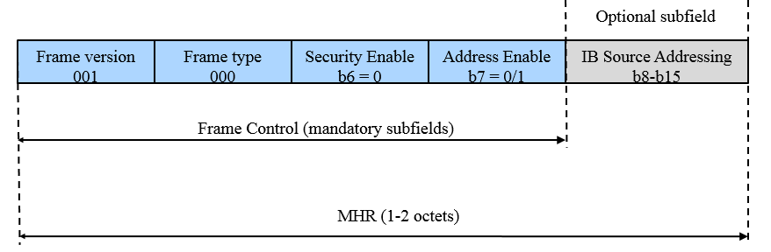
Figure 03 – Information broadcasting MAC frame format for high rate OCC mode (HS-PSK and A-QL)

2.3- Bidirectional Data transfer MAC frame format (D2D)
All bidirectional data transfer modes shall configure MAC frame format over OCC MAC PIB attributes:
macOccFrameVersion: 001
macOccFrameType: 010
macOccSecurityEnable: FALSE/TRUE
Once the D2D mode is selected, low rate OCC D2D modes (S2-PSK, S8-PSK, CM-FSK, C-OOK, HA-QL) shall configure the other characteristics of MAC frame format over three additional MAC attributes, macD2DSourceAddressModeEnable, macD2DSourceDestAddress, and macD2DSecurityHeader.
Compared to IB mode, Security is optionally enable over the MAC attribute macOccSecurityEnable, thus macD2DSecurityHeader is optionally presented.
On the other hand, higher rate OCC D2D modes (HS-PSK, and A-QL) shall configure D2D MAC frame format over MHR subfields, not MAC PIB attributes. In this case, the MAC frame format shall be formatted as Fig. 04.
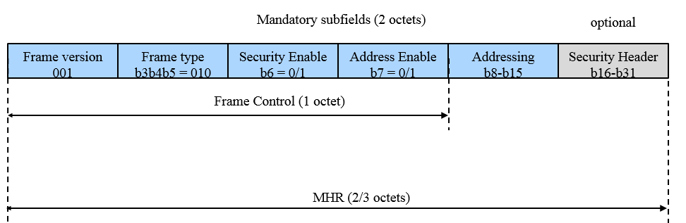
Figure 04 – Bidirectional data transfer MAC frame format for high rate OCC mode (HS-PSK, and A-QL)

