IEEE P802.15
Wireless Personal Area Networks
TG3d Coexistence Assurance Document
Date: 2017-01-19
Author(s):
Name | Affiliation | Address | Phone | Email
Thomas Kürner | TU Braunschweig | Inst. f. Nachrichtentechnik, Schleinitzstr. 22, 38092 Braunschweig | +49 531 391 2416 | t.kuerner@tu-bs.de
Sebastian Rey | TU Braunschweig | Inst. f. Nachrichtentechnik, Schleinitzstr. 22, 38092 Braunschweig | +49 531 391 2439 | rey@ifn.ing.tu-bs.de
Abstract
This serves as the Coexistence Assurance (CA) document for TG3d as required by the CSD.

Introduction

This document addresses the coexistence of IEEE P802.15.3d [1] as required by the CSD [2]. The relevent section is outlined below:

  - A WG proposing a wireless project shall demonstrate coexistence through the preparation of a Coexistence Assurance (CA) document unless it is not applicable.

IEEE P802.15.3d uses the frequency range between 252 to 325 GHz. This is the first IEEE 802 standard that is using this frequency range. Therefore no co-existence assurance to any other IEEE 802 standard is required at this time. In terms of other future IEEE 802 standards, which might be defined in the same frequency range, it is worth mentioning, that IEEE 802.15.3 provides listen-before-talk mechanisms during the Content Access Period, which is beneficial for coexistence.

However the frequency band 252 to 325 GHz is partly shared with other passive radio systems such as radio astronomy (RA) and earth exploration satellite services (EESS). Also current regulation does not provide a spectrum mask.

This document shorty describes the regulatory situation and measures foreseen in the draft standard to follow the regulatory constraints.

Regulatory Situation

In the Radio Regulations [3] fixed and mobile services have an allocation in the frequency band 252-275 GHz. In the frequency band beyond 275 GHz no dedicated allocation to any radio service is made. The use of this frequency band is regulated by footnote 5.565 of the radio regulations, which identifies the use of certain frequency bands where passive services must be protected from harmful interference. The footnote further enables the administrations to allow the use of these frequency bands for actives services such as fixed or mobile services as long as the active services are protected from harmful interference. Within IEEE 802.15 sharing studies have been performed [4,5,6,7], showing that it is feasible to achieve this requirement for the use cases targeted by IEEE P802.15.3d. In parallel more detailed specifications of the regulatory requirements will be subject to Agenda Item 1.15 at the upcoming World Radio Conference 2019 [13]. In the framework of this process IEEE and ITU-R have exchanged a couple of liaison statements [8,9,10,11,12].

Channelization

In order to reduce the probability of interference with passive services IEEE P802.15.3d specifies a default channel, which in a part of the spectrum where no protection of EESS is required. In order to reduce spourious emissions a spectrum mask has been defined, where the transmitted spectrum shall adhere to the transmit spectrum mask shown below from subclause 13.1.5 of [1]:

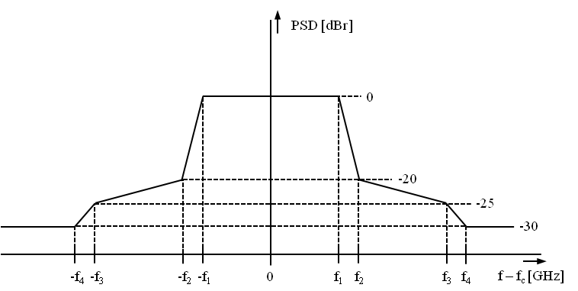
Figure 13-2— Generic transmit spectral mask

Table 13-2—Transmit spectrum mask parameters
Channel Bandwidth [GHz] | $$f_{1}[GHz]$$ | $$f_{2}[GHz]$$ | $$f_{3}[GHz]$$ | $$f_{4}[GHz]$$
2.160 | 0.94 | 1.10 | 1.60 | 2.20
4.320 | 2.02 | 2.18 | 2.68 | 3.28
8.640 | 4.18 | 4.34 | 4.84 | 5.44
12.960 | 6.34 | 6.50 | 7.00 | 7.60
17.280 | 8.50 | 8.66 | 9.16 | 9.76
25.920 | 12.82 | 12.98 | 13.48 | 14.08
51.840 | 25.78 | 25.94 | 26.44 | 27.04
69.120 | 34.42 | 34.58 | 35.08 | 35.68

References

[1] Draft P802.15.3d
[2] https://mentor.ieee.org/802.15/dcn/15/15-15-0683-01-003d-tg3d-csd-change.docx
[3] Radio Regulations 2016; http://www.itu.int/pub/R-REG-RR-2016
[4] https://mentor.ieee.org/802.15/dcn/10/15-10-0829-00-0thz-sharing-between-active-and-passive-services-at-thz-frequencies.ppt
[5] https://mentor.ieee.org/802.15/dcn/12/15-12-0101-00-0thz-will-thz-communication-interfere-with-passive-remote-sensing.pdf
[6] https://mentor.ieee.org/802.15/dcn/12/15-12-0324-00-0thz-interference-between-thz-communications-and-spaceborne-earth-exploration-services.pdf
[7] Priebe, S.; Britz, D. M.; Jacob, M.; Sarkozy, S.; Leong, K. M. K.; Logan, J. E.; Gorospe, B.; Kürner, T.: Interference Investigations of Active Communications and Passive Earth Exploration Services in the THz Frequency Range. IEEE Transactions on Terahertz Science and Technology, Vol. 2, No. 5, S. 525– 537, 2012.
[8] https://mentor.ieee.org/802.18/dcn/16/18-16-0008-04-0000-draft-liaison-statement-to-itu-r-wp1a-sm-2352-0-docx.docx
[9] https://mentor.ieee.org/802.18/dcn/16/18-16-0077-03-0000-draft-ls-to-wp5a-char-above-275ghz.docx
[10] https://mentor.ieee.org/802.18/dcn/16/18-16-0076-03-0000-draft-ls-to-wp5c-char-above-275ghz.docx
[11] https://mentor.ieee.org/802.18/dcn/17/18-17-0012-00-0000-preliminary-information-on-land-mobile-service-applications-associated-with-work-on-wrc-19-agenda-item-1-15.docx
[12] https://mentor.ieee.org/802.18/dcn/17/18-17-0016-00-0000-preliminary-information-on-fixed-service-applications-associated.docx
[13] http://www.itu.int/dms_pub/itu-r/oth/0c/0a/R0C0A00000C0016PDFE.pdf

