IEEE P802.15
Wireless Personal Area Networks

Project | IEEE P802.15 Working Group for Wireless Personal Area Networks (WPANs)
Title | SNUST - Invisible Data Embedding Related Draft D1 Comments Resolution on PHY PPDU Format and PIB Attributes
Date Submitted | November, 2016
Source | Jaesang Cha, Minwoo Lee [SNUST], Kim Daehyun, Lee DongWoo [Namuga Co., Ltd], Junghoon Lee [Dongseoul Univ.], Chunseop Kim [QUBER Co., Ltd], Kim Jin Tae, Shin Jae Kwon, Yang Seung Youn [Fivetek Co., Ltd], Juphil Cho [Kunsan Nat’ Univ.], Jungkyu Rho [Seokyeong Univ.], Gilsik Lee [Univ. of Texas], Sooyoung Chang [SYCA], Vinayagam Mariappan [SNUST] | Voice: [ ]  Fax: [ ]  E-mail: [chajs@seoultech.ac.kr]¹
Re: | Draft D1 Comment Resolution for Invisible Data Embedding
Abstract | Details of Resolutions regarding to the submitted Comments on D1 are suggested for Invisible Data Embedding PHY PPDU Format and PHY PIB Attributes. The Invisible Data Embedding is designed to operate on the application services like LED ID, Digital Signage with Advertisement Information.
Purpose | D1 Comments Resolutions and Editorial Revision.
Notice | This document has been prepared to assist the IEEE P802.15. It is offered as a basis for discussion and is not binding on the contributing individual(s) or organization(s). The material in this document is subject to change in form and content after further study. The contributor(s) reserve(s) the right to add, amend or withdraw material contained herein.
Release | The contributor acknowledges and accepts that this contribution becomes the property of IEEE and may be made publicly available by P802.15.

1. PPDU FORMART FOR INVISIBLE DATA EMBEDDING

PPDU Format

The PPDU frame structure is formatted as illustrated in Figure 4-1 for PHY VI – 2 Dimensional / Screen Source.
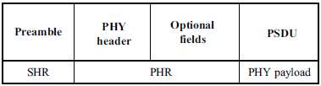
Figure 4-1 – Format of the PPDU
8.6.8.1.1 SHR Field
The SHR field is used by the transceiver to obtain optical clock synchronization with an incoming message is called Preamble. The standard defines one fast locking pattern (FLP) followed by choice of four topology dependent patterns (TDPs) for the purposes of distinguishing different PHY topologies is shown in Table 4-1.
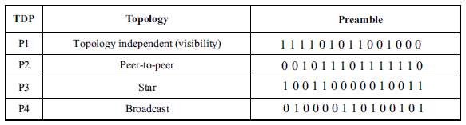
Table 4-1 – Preamble Pattern with Topologies
8.6.8.1.2 PHR Field
The PHY VI header is described as shown in Table 4-2 and shall be transmitted with data to identify the PHY Mode, Data rate, and PSDU length to identify the transmission specification.
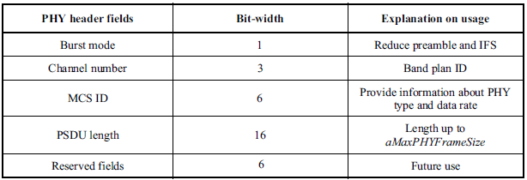
Table 4-2 – PHY Header
Burst Mode Field: The burst mode bit indicates that the next frame following the current frame is part of the burst mode. The Burst Mode bit shall be set TRUE if the burst mode is being used otherwise, the Burst Mode bit shall be set FALSE.
Channel Number Field: The channel number field for PHY shall be the band plan ID of the lowest wavelength. Refer to 9.3.1 for more detailed information.
MCS ID Field: The modulation and coding scheme (MCS) ID shall be indicated in the PHY header based on Table 83.
PSDU Field: The PSDU length field specifies the total number of octets contained in the PSDU.
8.6.8.1.3 PSDU Field
The PSDU field has a variable length and carries the data of the PHY VI frame. The FCS is appended if the PSDU has a non-zero byte payload. The structure of the PSDU field is as shown in Figure 4-2.
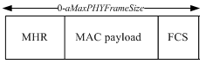
Figure 4-2 – PHY PSDU Field Structure

2. PHY PIP ATTRIBUTES FOR INVISIBLE DATA EMBEDDING

PHY PIB Attributes

The PHY PIB comprises the attributes required to manage the PHY sublayer of a device. The attributes contained in the IEEE802.15.7-2011 PHY PIB are presented in Table 125 - PHY PIB Attributes.
The additional PHY PIB attributes added on PHY for Invisible Data Embedding is presented in the Table 188 —PHY PIB attributes (continued).

PHY PIB Table 100 Additions
Attribute | Identifier | Type | Range | Description
phyINVApplicationSpecificMode | 0x10 | Unsigned | 0~255 | This attribute specifies the application specific PHY mode.  0 : Normal Data (Media Content, Information Content based on the Application used for)  1 : ID Data  2 : Authentication Data

Table 188 —PHY PIB attributes (continued)

