IEEE P802.15
Wireless Personal Area Networks

Project | IEEE P802.15 Working Group for Wireless Personal Area Networks (WPANs)
Title | SNUST - Offset-VPWM Related Draft D1 Comments Resolution on PHY PPDU Format and PIB Attributes
Date Submitted | November, 2016
Source | Jaesang Cha, Minwoo Lee, Soonho Jung [SNUST], Seungyoun Lee [Dongseoul Univ.], Ilkyoo Lee [Kongju National Univ.], Sangyule Choi[Induk Unv.], Sooyoung Chang [SYCA], Vinayagam Mariappan [SNUST] | Voice: [ ]  Fax: [ ]  E-mail: [chajs@seoultech.ac.kr]
Re: | Draft D1 Comment Resolution for Offset-VPWM
Abstract | Details of Resolutions regarding to the submitted Comments on D1 are suggested for Offset-VPWM PHY PPDU Format and PHY PIB Attributes. The Flash Light designed to support LBS, Authentication, IoT/IoL, etc.
Purpose | D1 Comments Resolutions and Editorial Revision.
Notice | This document has been prepared to assist the IEEE P802.15. It is offered as a basis for discussion and is not binding on the contributing individual(s) or organization(s). The material in this document is subject to change in form and content after further study. The contributor(s) reserve(s) the right to add, amend or withdraw material contained herein.
Release | The contributor acknowledges and accepts that this contribution becomes the property of IEEE and may be made publicly available by P802.15.

1. PPDU FORMART FOR Offset-VPWM

Offset-VPWM PPDU Format

The PPDU frame structure is formatted as illustrated in Figure 4-1 for PHY-IV ISC/ Low Rate PD.
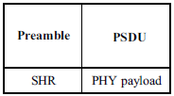
Figure 220 – PPDU Format

8.6.6.3.1 SHR Field
The preamble field is used by the transceiver to obtain optical clock synchronization with an incoming message. The standard defines one fast locking pattern (FLP). The MAC shall select the optical clock rate for communication during the clock rate selection process. The preamble shall be sent at a clock rate chosen by the TX and supported by the RX. The preamble is a time domain sequence and does not have any channel coding or line coding.
The preamble first starts with a FLP. The FLP is fixed as a pattern “11010010”. The fast locking pattern length shall not exceed the maximum. The timing information for preamble is shown in Figure 211.
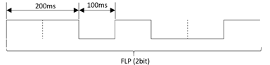
Figure 211 – Preamble Timing Diagram
In the Offset Variable Pulse Width Modulation for Smart Device Flash Light PHY uses OOK modulation for preamble transmission using flash light. The Preamble Bit Mapping shown in Figure 212.
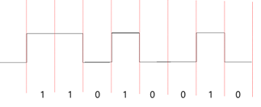
Figure 212 – Preamble Transmission – OFFSET VPWM BIT MAPPING
8.6.6.3.2 PSDU Field
The PSDU field has a variable length and carries the data of the PHY IV frame. The FCS is appended if the PSDU has a non-zero byte payload. The structure of the PSDU field is as shown in Figure 213.
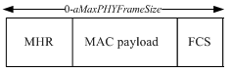
Figure 213 – PHY IV PSDU Field Structure

2. PHY PIP ATTRIBUTES FOR OFFSET-VPWM

PHY PIB Attributes

The PHY PIB comprises the attributes required to manage the PHY sublayer of a device. The attributes contained in the IEEE802.15.7-2011 PHY PIB are presented in Table 125 - PHY PIB Attributes.
The additional PHY IV PIB attributes added for Offset Variable Pulse Width Modulation for Smart Device Flash Light PHY is presented in the Table 188 —PHY PIB attributes (continued).

PHY PIB Table 100 Additions
Attribute | Identifier | Type | Range | Description
phySMFlashLIGHTApplicationSpecificMode | 0x10 | Unsigned | 0~255 | This attribute specifies the application specific PHY mode.  0 : Normal Data (Media Content, Information Content based on the Application used for)  1 : ID Data  2 : Authentication Data

Table 188 — PHY PIB attributes (continued)

