IEEE P802.15
Wireless Personal Area Networks

Project | IEEE P802.15 Working Group for Wireless Personal Area Networks (WPANs)
Title | Reworked blurred equations in UWB PHY text
Date Submitted | November 2016
Source | Billy Verso (DecaWave), | billy.verso (at) decawave.com
Re: | Improvement of UWB text readability 802.15.8 draft
Abstract | This document contains a reworking of the equations and other text that appear blurred in the first letter ballot circulation of the IEEE 802.15.8 draft standard.
Purpose | This document provides the details text for the IEEE 802.15.8 draft
Notice | This document does not represent the agreed views of the IEEE 802.15 Working Group or IEEE 802.15.8 Task Group. It represents only the views of the participants listed in the “Source(s)” field above. It is offered as a basis for discussion and is not binding on the contributing individual(s) or organization(s). The material in this document is subject to change in form and content after further study. The contributor(s) reserve(s) the right to add, amend or withdraw material contained herein.
Release | The contributor acknowledges and accepts that this contribution becomes the property of IEEE and may be made publicly available by P802.15.
Patent Policy | The contributor is familiar with the IEEE-SA Patent Policy and Procedures:  <http://standards.ieee.org/guides/bylaws/sect6-7.html#6> and  <http://standards.ieee.org/guides/opman/sect6.html#6.3>.  Further information is located at <http://standards.ieee.org/board/pat/pat-material.html> and  <http://standards.ieee.org/board/pat>.

- Overview
- Normative references
- Definitions
- General description
- MAC functional description
- MAC services
- General PHY requirements
- PHY services
- Low mobility PHY specification
- High mobility PHY specification
- UWB Physical (PHY) layer specification
  - General
The UWB PHY employs an impulse radio signaling scheme using band-limited pulses. The UWB PHY supports two alternative primary modulation modes of operation, a BPM-BPSK modulation mode and an OOK modulation mode, operating in channels between 3.1 GHz and 10.6 GHz.
The common elements of the UWB PHY are captured in this sub-clause, while the specifics of the BPM-BPSK and OOK modulation modes are in 11.2 and 11.3 respectively.
There are many parameter options within the UWB PHY, which for successful communications have to be the same at both ends of a link. The mechanisms for ensuring that are not defined within this PHY layer specification. These choices are typically preconfigured or mutually agreed.
Figure 1 shows the sequence of processing steps used to create and modulate a packet. The sequence of steps indicated here for the transmitter is used as a basis for explaining the creation of the UWB waveform. Note that the receiver portion of Figure 1 is informative and meant only as a guide to the essential steps that any compliant UWB receiver needs to implement in order to successfully decode the transmitted signal.
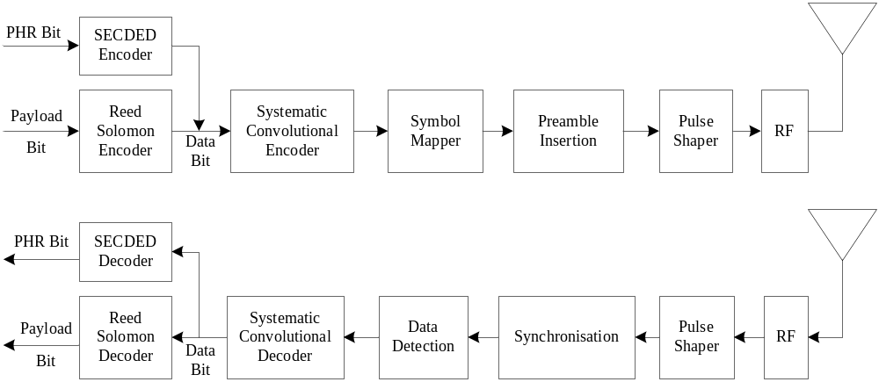
Figure 1 – UWB PHY signal flow

    - PPDU format
Figure 2 shows the format for the UWB frame, which is composed of three major components: the SHR preamble, the PHR, and the PSDU. For convenience, the PPDU packet structure is presented so that the leftmost field as written in this standard shall be transmitted or received first.
The SHR preamble is first, followed by the PHR, and finally the PSDU. The PSDU contains MAC sub-layer messages.

    - PPDU encoding process
The encoding process is composed of many steps as illustrated in Figure 2. The details of these steps are fully described in later sub-clauses, as noted in the following list, which is intended to facilitate an understanding of those details:
- Perform Reed-Solomon encoding on PSDU as described in 11.1.5.1.
- Produce the PHR with SECDED check bits as described in 11.1.3 and prepend to the PSDU.
- Perform convolutional coding as described in 11.1.5.2. Note that for the BPM-BPSK modulation mode in some instances at the 27 Mb/s data rate, the convolutional encoding of the data field is effectively bypassed and two data bits are encoded per BPM-BPSK symbol.
- Modulate and spread the PHR and PSDU according to the methods described for the BPM-BPSK modulation mode in 11.2.3.3 and 11.2.3.4, and for the OOK modulation mode in 11.3.3 and 11.3.4. Note that the PHR modulation rate may differ from that of the data field. The data field modulation rate is specified in the PHR. The PHR modulation rate options are defined in 11.1.3.
- Produce the SHR preamble field consisting of the SYNC field and the SFD field (marking the end of the SHR and the start of the packet data). The SYNC and SFD fields are described for the BPM-BPSK modulation mode in 11.2.2.1 and 11.2.2.2, respectively, and for the OOK modulation mode in 11.3.2.

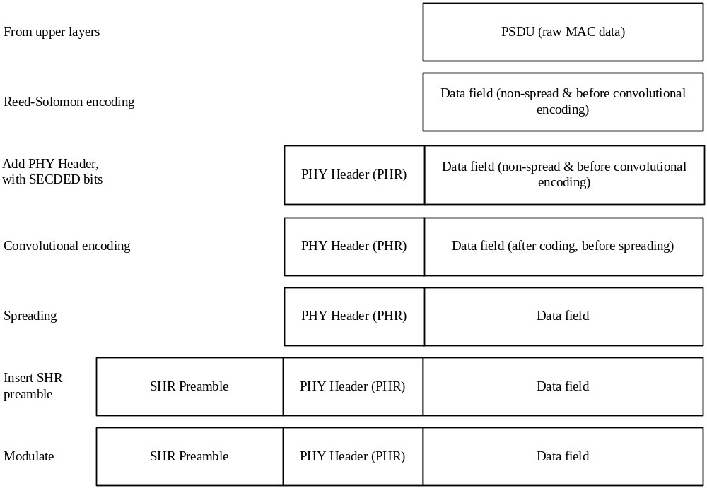
Figure 2 – UWB PHY PPDU encoding process

Table 1 and Table 2 show how the 19 header bits (H₀-H₁₈), N data bits (D₀-D_{N-1}), and two tail bits (T₀-T₁) are mapped onto the symbols. In these tables, the operation in the g₁ column is an XOR. The tables also show when the transition from the header to the data takes place. Note that the delay line of the convolutional code is initialized to zero. For this reason, the g₁ bit (position bit for BPM-BPSK modulation mode) within Symbol 0 shall always be zero.
Table 1 – mapping of header bits, data bits and tail bits onto symbols with Viterbi rate 0.5
Symbol # | Input data | g₀ | g₁
0 | H₀ | 0 | H₀ | 21 symbols  of PHR  at the appropriate  PHR modulation rate  for BPM-BPSK modulation mode  42 symbols  of PHR  at the appropriate  PHR modulation rate  for OOK modulation mode
1 | H₁ | H₀ | H₁
2 | H₂ | H₁ | H₀ H₂
3 | H₃ | H₂ | H₀ H₃
… | … | … | …
16 | H₁₆ | H₁₅ | H₁₄ H₁₆
17 | H₁₇ | H₁₆ | H₁₅ H₁₇
18 | H₁₈ | H₁₇ | H₁₆ H₁₈
19 | D₀ | H₁₈ | H₁₇ D₀
20 | D₁ | D₀ | H₁₈ D₁
21 | D₂ | D₁ | D₀ D₂ | N symbols  of data  at the data rate for BPM-BPSK modulation mode  2 × N symbols  of data  at the data rate  for OOK modulation mode
… | … | … | …
N + 17 | D_{N-2} | D_{N-3} | D_{N-4} D_{N-2}
N + 18 | D_{N-1} | D_{N-2} | D_{N-3} D_{N-1}
N + 19 | T₀ | D_{N-1} | D_{N-2} T₀
N + 20 | T₁ | T₀ | D_{N-1} T₁
Note for the BPM-BPSK modulation mode g₀ is the position bit and, g₁ is the polarity bit.

Table 2 –mapping of header bits, data bits and tail bits onto symbols with Viterbi rate 1
Symbol # | Input data | g₀ | g₁
0 | H₀ | 0 | H₀ | 21 symbols  of PHR  at the appropriate  PHR modulation rate  for the BPM-BPSK modulation mode
1 | H₁ | H₀ | H₁
2 | H₂ | H₁ | H₀ H₂
3 | H₃ | H₂ | H₀ H₃
… | … | … | …
16 | H₁₆ | H₁₅ | H₁₄ H₁₆
17 | H₁₇ | H₁₆ | H₁₅ H₁₇
18 | H₁₈ | H₁₇ | H₁₆ H₁₈
19 | T₀ | H₁₈ | H₁₇ T₀
20 | T₁ | D₀ | H₁₈ T₁
21 | D₀, D₁ | D₀ | D₁ | ^{N}/₂ symbols  of data  at the data rate  for the BPM-BPSK modulation mode
22 | D₂, D₃ | D₂ | D₃
… | … | … | …
^{N}/₂ + 19 | D_{N-6}, D_{N-5} | D_{N-6} | D_{N-5}
^{N}/₂ + 20 | D_{N-4}, D_{N-3} | D_{N-4} | D_{N-3}
^{N}/₂ + 21 | D_{N-2}, D_{N-1} | D_{N-2} | D_{N-1}
Note for the BPM-BPSK modulation mode g₀ is the position bit and, g₁ is the polarity bit.
    - PHY header (PHR)
The PHR shall be transmitted after the SHR preamble. The PHR consists of 19 bits and conveys information necessary for a successful decoding of the packet to the receiver. The PHR contains information about the data rate used to transmit the PSDU, the duration of the frame’s preamble, and the length of the frame payload. Additionally, six parity check bits are used to protect the PHR against channel errors.
The UWB PHY has two options for PHR, both 19 bits long, the one defined in 11.1.3.1 allows for PSDU of up to 127 octets (and supports reuse of the existing HRP UWB PHY standard defined in 802.15.4), while the PHR defined in 11.1.3.2 supports PSDU up to 1023 octets long.
For successful communications both ends of a link must use the same PHR options and modulation rate.
For the BPM-BPSK modulation mode the PHR shall be transmitted at the nominal rate of 110 kb/s (for the 110 kb/s data rate) and 850 kb/s for the higher data rates, and optionally at the data rate for 6.81 Mb/s and 27.24 Mb/s data rates. Table 3 gives the actual modulation rates of the PHR for the BPM-BPSK modulation, which are 15 % higher than the nominal rate because the PHR is not Reed-Solomon encoded.

Table 3 – BPM-BPSK modulation mode PHR modulation rates
Nominal PHR modulation rate | True PHR modulation rate
110 kb/s | 121.87 kb/s
850 kb/s | 975.00 kb/s
6.81 Mb/s | 7.80 Mb/s
27.24 Mb/s | 31.20 Mb/s

For the OOK modulation mode PHR shall be transmitted at the nominal rate of 55 kb/s, which is equivalent to the true modulation rate of 62.5 kb/s.
      - PHR for frames up to 127 octets
This PHR is shown in Figure 3.
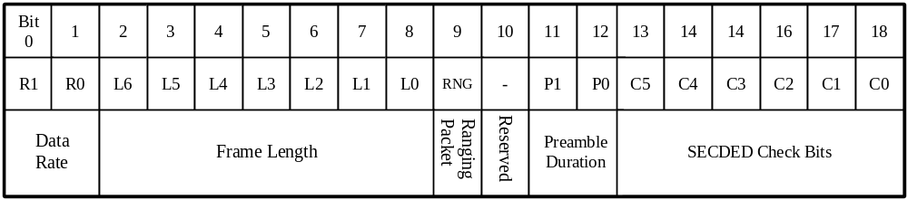
Figure 3 – UWB PHY bit assignment in PHR for frames up to 127 octets

The Data Rate field shall consist of two bits (R1, R0) that indicate the data rate of the PSDU, as per Table 4.
Table 4 – nominal data rates meaning
R1, R0 | Data rate for BPM-BPSK modulation mode | Data rate for OOK modulation mode
0, 0 | 110 kb/s (O) | 55 kb/s
0, 1 | 850 kb/s (M) | 109 kb/s
1, 0 | 6.81 Mb/s (O) | 218 kb/s
1, 1 | 27.24 Mb/s (O) | 437 kb/s

For the BPM-BPSK modulation mode the mandatory data rate shall be 850 kb/s, support for the other data rates listed in Table 4 is optional. For the OOK modulation mode the mandatory data rate shall be 55 kb/s, support for the other data rates listed in Table 4 is optional. Note: the nominal modulation mode data rates are calculated by multiplying the base modulation rate by 0.87 to allow for the overhead of the Reed-Solomon encoding.
The Frame Length field, L6–L0, shall be an unsigned 7-bit integer number that indicates the number of octets in the PSDU that the MAC sub-layer has request the PHY to transmit. Note that the high order bit of the length, L6, is transmitted first in time.
The Ranging bit, RNG, when set to 1 indicates that the frame is an RFRAME; otherwise RNG is set to 0.
The Preamble Duration field, P1–P0, represents the length of the SYNC portion of the SHR, as per Table 5.

Table 5 – Preamble Duration field values in PHR for frames up to 127 octets
P1, P0 | SYNC length (N_{sync}) for BPM-BPSK modulation mode | SYNC length (N_{sync}) for OOK modulation mode
0, 0 | Reserved | 8 symbols
0, 1 | 64 to 512 symbols | 32 to 64 symbols
1, 0 | 1024 to 2048 symbols | 128 to 256 symbols
1, 1 | 4096 symbols | 512 symbols

The Preamble Duration field may be used by a receiver set the value of the preamble duration for the ACK frame.
Valid preamble lengths for the BPM-BPSK modulation mode are 64, 128, 256, 512, 1024, 1536, 2048 and 4096 symbols. Valid preamble lengths for the OOK modulation mode are 8, 32, 64, 128, 256 and 512 symbols. Where the Preamble Duration field in the transmitted frame covers a range of preamble lengths, a receiver may count the number of preamble symbols received to additionally inform the choice of preamble length for any response frames.
The SECDED (single error correct, double error detect) field, C5–C0, is a set of six parity check bits that are used to protect the PHR from errors caused by noise and channel impairments. The SECDED bits are a simple Hamming block code that enables the correction of a single error and the detection of two errors at the receiver.
The SECDED bit values are computed as follows:
C0 = XOR (R0, R1, L0, L2, L4, L5, EXT, P1)
C1 = XOR (R1, L2, L3, L5, L6, RNG, EXT, P0)
C2 = XOR (R0, L0, L1, L5, L6, RNG, EXT)
C3 = XOR (L0, L1, L2, L3, L4, RNG, EXT)
C4 = XOR (P0, P1)
C5 = XOR (R1, R0, L6, L5, L4, L3, L2, L1, L0, RNG, EXT, P1, P0, C4, C3, C2, C1, C0)

      - PHR for frames up to 1023 octets
This PHR is shown in Figure 3.
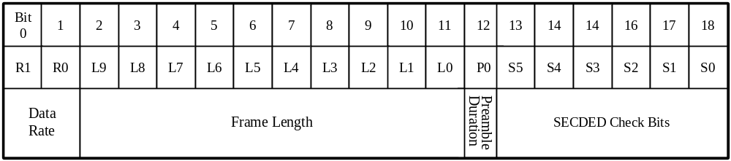
Figure 4 – UWB PHY bit assignment in PHR for frames up to 1023 octets

The Data Rate field shall have the same function and encoding as the PHR defined in 11.1.3.1 and Table 4.
The Frame Length field, L9–L0, shall be an unsigned 10-bit integer number that indicates the number of octets in the PSDU from the MAC sub-layer. Note that the high order bit of the length, L9, is transmitted first in time.
A single bit, P0, provides the Preamble Duration field, indicates the length of the SYNC portion of the SHR, as per Table 6.
Table 6 – Preamble Duration field values in PHR for frames up to 1023 octets
P0 | SYNC length (N_{sync}) for BPM-BPSK modulation mode | SYNC length (N_{sync}) for OOK modulation mode
0 | 64 to 1024 symbols | 8 to 64 symbols
1 | 1536 to 4096 symbols | 128 to 512 symbols

The Preamble Duration field may be used by a receiver set the value of the preamble duration for the ACK frame.
Valid preamble lengths for the BPM-BPSK modulation mode are 64, 128, 256, 512, 1024, 1536, 2048 and 4096 symbols. Valid preamble lengths for the OOK modulation mode are 8, 32, 64, 128, 256 and 512 symbols. Since the Preamble Duration field in the transmitted frame covers a range of preamble lengths, a receiver may count the number of preamble symbols received to additionally inform the choice of preamble length for any response frames.
The SECDED (single error correct, double error detect) field, S5–S0, is a set of six parity check bits that are used to protect the PHR from errors caused by noise and channel impairments. The SECDED calculation is the same as that defined in 11.1.3.1 except the resultant buts C5–C0 are inverted to get S5–S0 as follows:
S0= NOT (C0)
S1 = NOT (C1)
S2 = NOT (C2)
S3 = NOT (C3)
S4 = NOT (C4)
S5 = NOT (C5)
In the receiver the same checker and corrector block can be used for both PHR encodings, once the received SECDED bits S5–S0 are inverted.
    - Data field
The Data field is the last component of the PPDU and is encoded as shown in Figure 5.
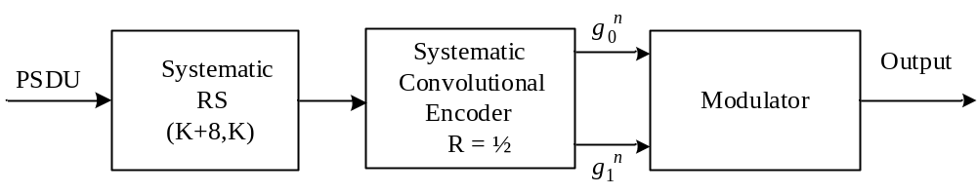
Figure 5 – data field encoding process
The data field shall be formed as follows:
Encode the PSDU using systematic Reed-Solomon block code, which adds 48 parity bits as described in 11.1.5.1.
Encode the output of the Reed-Solomon block code using a systematic convolutional encoder as described in 11.1.5.2, except in the cases where the Viterbi rate is 1.0 in which case the convolutional encoder is bypassed. For the BPM-BPSK modulation mode the Viterbi rates are given in Table 11.
Spread and modulate the encoded block. For the BPM-BPSK modulation this is described in 11.2.3.3 and 11.2.3.4, and for the OOK modulation mode in 11.3.3.
    - Forward error correction (FEC)
The FEC used by the UWB PHY is a concatenated code consisting of an outer Reed-Solomon systematic block code and an inner half-rate systematic convolutional code.
For all modes of OOK modulation the coding is always concatenation of outer Reed-Solomon and inner Viterbi code, however for the BPM-BPSK modulation mode the inner convolutional code is not necessarily enabled at all data rates, i.e. the rows of Table 11 that have a Viterbi rate of 1 indicate that the inner convolutional code is disabled for the PSDU part of the PHY frame.
The FEC encoding of a block of M PSDU bits, b₀, b₁, …, b_{M-1}, is shown in Figure 6. The Reed-Solomon encoder shall append 48 parity bits, p₀, p₁, …, p₄₇, to the original block. This results in a Reed-Solomon encoded block of length M + 48. Where the Viterbi rate is 0.5, a half-rate systematic convolutional encoder shall encode the Reed-Solomon encoded block into a systematic coded block of length 2M + 96 bits.
For BPM-BPSK modulation mode: The convolutional systematic bits 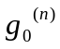 shall be used to encode the position of the burst whereas the convolutional parity bits 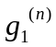 shall be used to encode the polarity of the pulses within a burst, except where the Viterbi rate is 1.0 where even outputs of the Reed-Solomon encoder (b₀, b₂,..., b_{M–2}, p₀, p₂,…, p₄₆) shall be used to encode the position of the burst, and odd outputs (b₁, b₃,..., b_{M–1}, p₁, p₃,…, p₄₇) shall be used to encode the polarity of the pulses. Note here that M is always an even number. A noncoherent receiver cannot see the convolutional parity bits (parity bits), and consequently a noncoherent receiver may use only a Reed-Solomon decoder to improve its performance. A coherent receiver may use either or both Reed-Solomon and convolutional decoding algorithms. Note here that since both the Reed-Solomon and the convolutional codes are both systematic, a receiver (either coherent or noncoherent) may be implemented without an FEC decoder. In this case, the information bits are simply recovered by demodulating the position of the burst. There will be additional parity check bits as a result of the Reed-Solomon encoding, but these may be simply ignored.
For OOK modulation mode the output modulation bits always represent concatenation of bits and as described in detail in 11.3.3.
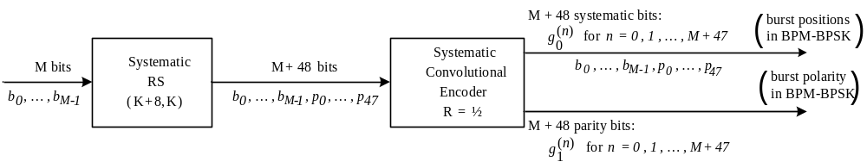
Figure 6 – FEC encoding process

      - Reed-Solomon encoding
The systematic Reed-Solomon code is over Galois field, GF(2⁶), which is built as an extension of GF(2). The systematic Reed-Solomon code shall use the generator polynomial
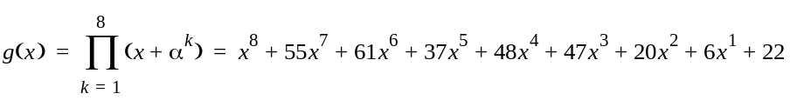
where α = 010000 is a root of the binary primitive polynomial 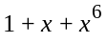 in GF(2⁶).
In Reed-Solomon encoding RS₆(K + 8, K), a block of I bits (with 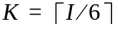) is encoded into a codeword of I + 48 bits. The Reed-Solomon encoding procedure is performed in the following five steps:
- Addition of dummy bits. The block of I information bits is expanded to 330 bits by adding 330 – I dummy (zero) bits to the beginning of the block. The expanded block is denoted as {d₀, d₁, ..., d₃₂₉} where d₀ is the first in time.
- Bit-to-symbol conversion. The 330 bits {d₀, d₁, ..., d₃₂₉} are converted into 55 Reed-Solomon symbols {D₀, D₁, ..., D₅₄} having the following polynomial representation:
Resulting 6-bit symbols are presented as , where d_{6k+5} is the MSB and d_{6k} is the LSB.
- Encoding. The information symbols {D₀, D₁, ..., D₅₄} are encoded by systematic RS₆(63,55) code with output symbols {U₀, U₁, ..., U₆₂} ordered as follows:
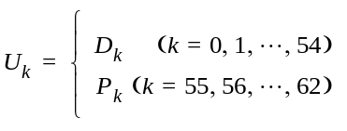
where P_{k} are parity check symbols added by RS₆(63,55) encoder.
The information polynomial associated with the information symbols {D₀, D₁, ..., D₅₄} is denoted as 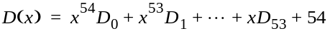. The parity check polynomial associated with the parity check symbols is denoted as 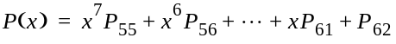. The parity check symbols are calculated as:
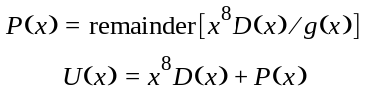
- Symbol-to-bit conversion. The output symbols {U₀, U₁, ..., U₆₂} are converted into binary form with LSB coming out first, resulting in a block of 378 bits {u₀, u₁, ..., u₃₇₇}.
- Removal of dummy bits. The 330 – I dummy bits added in the first step are removed. Only the last I + 48 bits are transmitted, i.e., {u_{330-I}, u_{331-I}, ..., u₃₇₇} with u_{330-I} being first in time.

      - Systematic convolutional encoding
The inner convolutional encoder shall use the rate R = ½ code with generator polynomials g₀ = [010]₂ and g₁ = [101]₂ as shown in Figure 7. Upon transmission of each PPDU, the encoder shall be initialized to the all zero state. Additionally, the encoder shall be returned to the all zero state by appending two zero bits to the PPDU. Note that since the generator polynomials are systematic, they are also noncatastrophic.
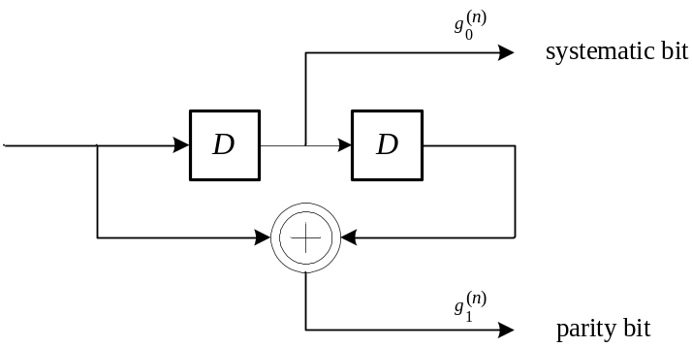
Figure 7 – systematic convolutional encoder
For BPM-BPSK modulation mode: The systematic bits shall be used to encode the position of the burst whereas the convolutional parity bits shall be used to encode the polarity of the pulses within a burst.
    - UWB PHY band allocation
The set of operating frequency bands are as defined in Table 7. The operating channel band shall be chosen to suit the regulations of the deployment region. In each channel band one or more mandatory frequencies are available. At least one of the available mandatory frequencies shall be occupied. The minimum 10 dB bandwidth shall be 500 MHz.
For interworking between units that occupy less than the full band width available within a channel, the receiving device needs to know the mandatory frequencies occupied by the transmitting device.

Table 7 – UWB PHY band allocation
Channel Index | Lower Band Edge (MHz) | Upper Band Edge (MHz) | Max Bandwidth (MHz) | Mandatory frequencies (MHz)
 |  |  |  | 3500 | 4000 | 4500 | 6500 | 7500 | 8000 | 8500 | 9000
1 | 4200 | 4800 | 600 |  |  | x
2 | 3100 | 4800 | 1700 | x | x | x
3 | 3400 | 4800 | 1400 | x | x | x
4 | 3100 | 5700 | 2600 | x | x | x
5 | 5925 | 7200 | 1275 |  |  |  | x
6 | 6000 | 9000 | 3000 |  |  |  | x | x | x | x
7 | 7250 | 10250 | 3000 |  |  |  |  | x | x | x | x
8 | 7200 | 10200 | 3000 |  |  |  |  | x | x | x | x
9 | 6000 | 10600 | 4600 |  |  |  | x | x | x | x | x

  - BPM-BPSK modulation mode
    - General
The BPM-BPSK modulation mode employs a combination of burst position modulation (BPM) and binary phase-shift keying (BPSK) is used to support both coherent and non-coherent receivers using a common signaling scheme. The combined BPM-BPSK is used to modulate the data symbols, with each symbol being composed of an active burst of UWB pulses. The various data rates are supported through the use of variable-length bursts, and the data modulation can be done at two mean PRF that are nominally 16 MHz or 64 MHz.
The SHR preamble for the BPM-BPSK modulation mode, employs a number of codes and spreading factors that result in various mean PRF between 3.85 MHz and 230.5 MHz which together give a total of 48 independent (non-interfering) communications channels that can be used in a single channel band or across the set of channel bands allowed in the deployed operating region.
    - SHR preamble
A SHR preamble shall be added prior to the PHR to aid receiver algorithms related to AGC setting, antenna diversity selection, timing acquisition, coarse and fine frequency recovery, packet and frame synchronization, channel estimation, and leading edge signal tracking for ranging.
Figure 8 shows the structure of the SHR preamble. The preamble can be subdivided into two distinct portions: SYNC (packet synchronization, channel estimation, and ranging sequence) and SFD (frame delimiter sequence). The duration of these portions are provided in 11.2.2.3, while 11.2.2.1 and 11.2.2.2 detail the different portions of the preamble.
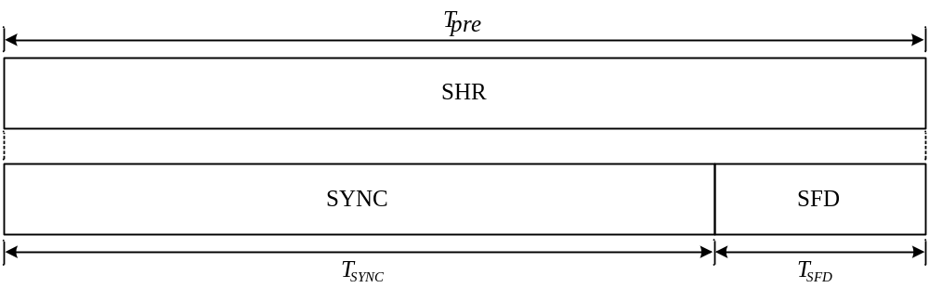
Figure 8 – SHR preamble structure
The length of the SYNC field is determined by the number of preamble symbol repetitions used, which is decided by the application layer. Valid SYNC lengths for the BPM-BPSK modulation mode are 64, 128, 256, 512, 1024, 1536, 2048 and 4096 preamble symbols.
      - SHR SYNC field
The SYNC field is specified by a preamble code and a spreading factor. The BPM-BPSK modulation supports 11 preamble code sequences of different lengths, each consisting of a sequence of code symbols drawn from a ternary alphabet {-1,0,1} and selected for use in the PHY because of their perfect periodic autocorrelation properties. The code sequences are defined in Table 8. The preamble code sequences are spread by the mechanism described below, by 1 or more specified spreading factors, to yield the final preamble symbol. Table 9 lists the spreading factors supported by each code index and the resultant symbol length. The combination of code index and spreading factor results in a total of 48 preambles of unique symbol period, which essentially provide 48 independent communications channels or networks that can share a single RF channel band (or the set of channel bands available in the operational area) with an extremely low level of mutual interference.

Table 8 – BPM-BPSK modulation SYNC field ternary codes
Code index | Code Length | Code sequence
1 | 7 | 00+0++-
2 | 13 | +0+0++00--++-
3 | 21 | --0-+00-++-0+0+-+++++
4 | 31 | ++00+00---+-0++-000+0+0-+0+0000  (This is the same as IEEE 802.15.4 HRP UWB PHY code #6)
5 | 57 | +0+0++-++--+-0++++---+++++-+++-0-+0---+---+-+0++-+--+00-+
6 | 63 | 0000+00000000+0000-00000-0+0000+000000-00-+00000-0+00-+0+++0000
7 | 73 | 00+0+++0++-+-+-0++++--++---+---0++-+0++++---++-+----+-0++-+---+0++-++-++-
8 | 91 | +0+0-+-+----0+-++-++------0+-+++-+++-+++++0+-+-+0-+-+++---+++++--+-++-++--00-++0--0++--+++-
9 | 127 | +00+000-0--00--+0+0+00-+-++0+0000++-000+00-00--0-+0+0--0-+++0++000+-0+00-0++-0+++00-+00+0+0-0++-+--+000000+00000-+0000-0-000--+  (This is the same as IEEE 802.15.4 HRP UWB PHY code #9)
10 | 133 | +00+---++++++++-0++0+0+++0-+---+0---++-+++-++----+-+-0-+++-+-0+-+---+-+----+-++-+--+++0+---+++++0++--++--+--0++--+-+---++++-++-+--++-
11 | 183 | -0--+++-+++--+-+--+-+++++0--++--++-+---0+0+++0+-0-----+-++--0++++-+----+++-+-+--++-++-+0-++++-+-++++-++-+++++++-+--++---+0+-----++--+++++++--++0+-+-+-+--00--+-+-++--++--+-0---++--0-++

Table 9 – BPM-BPSK modulation preamble sequences and symbol durations
Code  index (i) | C_{i} Code  Length | Preamble Sequence ID | Spreading  Factor (L),  or Delta Length δ_{L} | # chips per preamble symbol | Preamble symbol  duration, Tpsym  (ns) | Base Rate Msymbol/s | Mean PRF  (MHz)
1 | 7 | 1 | 57 | 399 | 799.3 | 1.25 | 5.00
1 | 7 | 2 | 58 | 406 | 813.3 | 1.23 | 4.92
1 | 7 | 3 | 59 | 413 | 827.3 | 1.21 | 4.83
1 | 7 | 4 | 61 | 427 | 855.4 | 1.17 | 4.68
1 | 7 | 5 | 64 | 448 | 897.4 | 1.11 | 4.46
1 | 7 | 6 | 67 | 469 | 939.5 | 1.06 | 4.26
1 | 7 | 7 | 68 | 476 | 953.5 | 1.05 | 4.19
1 | 7 | 8 | 70 | 490 | 981.6 | 1.02 | 4.08
1 | 7 | 9 | 71 | 497 | 995.6 | 1.00 | 4.02
1 | 7 | 10 | 74 | 518 | 1037.7 | 0.96 | 3.85
2 | 13 | 11 | 30 | 390 | 781.3 | 1.28 | 11.52
2 | 13 | 12 | 32 | 416 | 833.3 | 1.20 | 10.80
2 | 13 | 13 | 33 | 429 | 859.4 | 1.16 | 10.47
2 | 13 | 14 | 34 | 442 | 885.4 | 1.13 | 10.16
2 | 13 | 15 | 36 | 468 | 937.5 | 1.07 | 9.60
2 | 13 | 16 | 37 | 481 | 963.5 | 1.04 | 9.34
2 | 13 | 17 | 38 | 494 | 989.6 | 1.01 | 9.09
2 | 13 | 18 | 39 | 507 | 1015.6 | 0.98 | 8.86
2 | 13 | 19 | 40 | 520 | 1041.7 | 0.96 | 8.64
2 | 13 | 20 | 41 | 533 | 1067.7 | 0.94 | 8.43
3 | 21 | 21 | 20 | 420 | 841.3 | 1.19 | 19.02
3 | 21 | 22 | 22 | 462 | 925.5 | 1.08 | 17.29
3 | 21 | 23 | 23 | 483 | 967.5 | 1.03 | 16.54
3 | 21 | 24 | 25 | 525 | 1051.7 | 0.95 | 15.21
4 | 31 | 25 | 13 | 403 | 807.3 | 1.24 | 19.82
4 | 31 | 26 | 14 | 434 | 869.4 | 1.15 | 18.40
4 | 31 | 27 | 15 | 465 | 931.5 | 1.07 | 17.18
4 | 31 | 28 | 16 | 496 | 993.6s | 1.01 | 16.10
4 | 31 | 29 | 17 | 527 | 1055.7 | 0.95 | 15.16
4 | 31 | 30 | 18 | 558 | 1117.8 | 0.89 | 14.31
5 | 57 | 31 | 8 | 456 | 913.5 | 1.09 | 53.64
5 | 57 | 32 | 9 | 513 | 1027.6 | 0.97 | 47.68
5 | 57 | 33 | 10 | 570 | 1141.8 | 0.88 | 42.91
6 | 63 | 34 | 6 | 378 | 757.2 | 1.32 | 21.13
6 | 63 | 35 | 7 | 441 | 883.4 | 1.13 | 18.11
6 | 63 | 36 | 8 | 504 | 1009.6 | 0.99 | 15.85
6 | 63 | 37 | 9 | 567 | 1135.8 | 0.88 | 14.09
7 | 73 | 38 | 6 | 438 | 877.4 | 1.14 | 72.94
7 | 73 | 39 | 7 | 511 | 1023.6 | 0.98 | 62.52
7 | 73 | 40 | 8 | 584 | 1169.9 | 0.85 | 54.71
8 | 91 | 41 | 4 | 364 | 729.2 | 1.37 | 111.09
8 | 91 | 42 | 5 | 455 | 911.5 | 1.10 | 88.87
8 | 91 | 43 | 6 | 546 | 1093.8 | 0.91 | 74.06
9 | 127 | 44 | 3 | 381 | 763.2 | 1.31 | 83.86
9 | 127 | 45 | 4 | 508 | 1017.6 | 0.98 | 62.89
10 | 133 | 46 | 4 | 532 | 1065.7 | 0.94 | 113.54
11 | 183 | 47 | 2 | 366 | 733.2 | 1.36 | 230.50
11 | 183 | 48 | 3 | 549 | 1099.8 | 0.91 | 153.67
Note that to maintain the desired transmitter output power the pulse amplitude will need to be set depending on the average PRF resulting from the combination of the preamble code and the spreading factor being used.
When using the ternary code indexed by i, the SYNC field shall consist of N_{sync} repetitions of the symbol S_{i}, where S_{i} is the code C_{i} spread by the delta function δ_{L} of length L as shown in Table 9. The spreading operation, where code C_{i} is extended to the preamble symbol duration indicated in Table 9, is described mathematically by
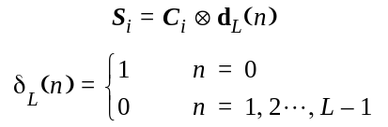

where the operator indicates a Kronecker product. After the Kronecker operation, a preamble symbol is formed as depicted in Figure 9, where L – 1 zeros have been inserted between each ternary element of C_{i}.
The spreading factor L, number of chips per symbol, preamble symbol duration T_{psym}, and base symbol rate for different channels are given in Table 9.
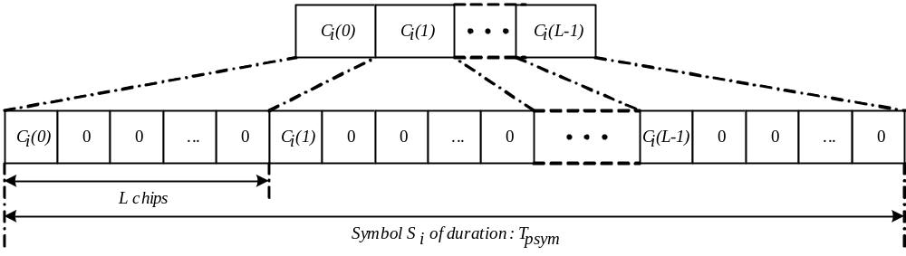
Figure 9 – BPM-BPSK construction of symbol S_{i} from code C_{i}
Note that in Table 9, preamble code ID 28 which has length 31 code and spreading factor L=16 is identical to the 16 MHz PRF preamble sequence code 6 of the IEEE 802.15.4 HRP UWB PHY, and, preamble code ID 45 which has length 127 code and spreading factor L=4 is identical to the 64 MHz PRF preamble sequence code 9 of the IEEE 802.15.4 HRP UWB PHY.
Support for the preamble code ID 28 shall be mandatory in the BPM-BPSK modulation mode, while support for the others is optional.
      - SHR SFD
The SFD marks the end of the SHR and the start of the PHR, which identifies the RMARKER for time-stamping, and the switch from the SHR modulation to the data modulation. The BPM-BPSK modulation mode shall support the SFD sequences identified in Table 10. In use the selected SFD shall be spread by the preamble symbol Si, where the leftmost bit shall be transmitted first in time. The SFD then essentially consists of a sequence of SYNC symbols sent as normal where a +1 appears in the defined sequence, or inverted where a -1 appears in the sequence, or a symbol time of no energy where a zero (0) appears in the defined sequence. The structure of the SHR preamble SYNC and SFD are shown in Figure 8.

Table 10 – BPM-BPSK modulation SFD sequences
Sequence  ID | SFD Sequence | SFD Length (symbols) | Usage
(a) | 0 +1 0 -1 +1 0 0 -1 | 8 | This is applicable to nominal data rates 850 kb/s, 6.81 Mb/s and 27 Mb/s, and is suitable for use in a network with non-coherent and/or coherent receivers. (This is the short SFD sequence defined in the IEEE 802.15.4 HRP UWB PHY)
(b) | -1 -1 -1 -1 +1 -1 0 0 | 8 | This is applicable to nominal data rates 850 kb/s, 6.81 Mb/s and 27 Mb/s, and is suitable for use in a network that consists only of coherent receivers. This is more robust than sequence (a).
(c) | -1 -1 -1 -1 +1 -1 +1 -1 -1 +1 +1 -1 -1 +1 0 0 | 16 | This is applicable to the 850 kb/s nominal data rate and a network that consists only of coherent receivers. This is more robust than sequence (b).
(d) | 0 +1 0 -1 +1 0 0 -1 0 +1 0 -1 +1 0 0 -1 -1 0 0 +1 0 -1 0 +1 0 +1 0 0 0 -1 0 -1 0 -1 0 0 +1 0 -1 -1 0 -1 +1 0 0 0 0 +1 +1 0 0 -1 -1 -1 +1 -1 +1 +1 0 0 0 0 +1 +1 | 64 | This is applicable to the 110 kb/s nominal data rate and is suitable for use in a network with non-coherent and/or coherent receivers. (This is the long SFD sequence defined in the IEEE 802.15.4 HRP UWB PHY)
(e) | -1 -1 -1 -1 -1 -1 -1 +1 -1 +1 -1 -1 -1 -1 -1 -1 +1 -1 -1 +1 -1 +1 -1 -1 +1 -1 -1 +1 -1 -1 +1 -1 -1 -1 +1 +1 -1 -1 -1 +1 +1 +1 -1 +1 -1 +1 -1 +1 -1 -1 -1 +1 -1 -1 +1 -1 -1 -1 -1 +1 +1 +1 0 0 | 64 | This is applicable to the 110 kb/s nominal data rate and is suitable for use in a network that consists only of coherent receivers. This is more robust than sequence (d).

      - Preamble timing parameters
Due to the variability in the preamble code length and PRF, there are many admissible values for the timing parameters of a preamble symbol. These values are summarized in Table 9. A preamble symbol is defined as the waveform consisting of one whole repetition of the modulated preamble symbol (of length given in Table 9). Details of the construction of the preamble symbol for various code lengths and PRFs are given in 11.2.2. For each, the preamble is constructed from a preamble code, C_{i}, by inserting a number of chip durations between code symbols. The number of chip durations to insert is denoted by δ_{L}, values for each code length and PRF are given in Table 9, and the chip insertion is detailed in 11.2.2.1.
The base symbol rate is defined as the rate at which the preamble symbols are sent. The base rates for each preamble option are given in Table 9.
The duration of the SYNC portion of the SHR, T_{SYNC}, is given by Tpsym × PSR, where Tpsym is the appropriate preamble symbol length from in Table 9 and PSR is one of the valid choices of preamble symbol repetitions: 64, 128, 256, 512, 1024, 1536, 2048 and 4096 preamble symbols.
The duration of the SFD portion of the SHR, T_{SFD}, is given by Tpsym × SL, where Tpsym is the appropriate preamble symbol length from in Table 9 and SL is the SFD sequence length from Table 10.
The total duration of the SHR preamble T_{pre} as shown in Figure 8, is the sum of T_{SYNC} and T_{SFD}.

    - PHR and PSDU - Symbol structure and modulation
With reference to the general UWB frame format of Figure 3, for the BPM-BPSK modulation mode, the modulation rate options for the PHR are defined in 11.1.3 and Table 3, while the modulation rate for the PSDU is defined by the data rate field within the PHR as listed in Table 4.
There are two choices for mean PRF for modulation of PHR and PSDU. These are nominally termed 16 MHz and 64 MHz PRF modes (but are actually more precisely 15.60 and 62.40 MHz). The data rate dependent timing parameters for these two PRF options are defined in Table 11.
      - Symbol structure for PHR and PSDU
In the BPM-BPSK modulation scheme, a symbol is capable of carrying two bits of information: one bit is used to determine the position of a burst of pulses while an additional bit is used to modulate the phase (polarity) of this same burst.
The structure and timing of a symbol is illustrated in Figure 10. Each symbol shall consist of an integer number of possible chip positions, N_{c}, each with duration T_{c}. The overall symbol duration denoted by Tdsym is given by Tdsym = N_{c} × T_{c}. Furthermore, each symbol is divided into two BPM intervals each with duration T_{BPM} =Tdsym /2, which enables binary position modulation.
A burst is formed by grouping N_{cpb} consecutive chips and has duration T_{burst} = N_{cpb}×T_{c}. The location of the burst in either the first half or second half of the symbol indicates one bit of information. Additionally, the phase of the burst (either –1 or +1) is used to indicate a second bit of information.
In each symbol interval, a single burst event shall be transmitted. The fact that burst duration is typically much shorter than the BPM duration, i.e., T_{burst} << T_{BPM}, provides for some multi-user access interference rejection in the form of time hopping. The total number of burst durations per symbol, N_{burst}, is given by N_{burst} = Tdsym /T_{burst}. In order to limit the amount of inter-symbol interference caused by multipath, only the first half of each T_{BPM} period shall contain a burst. Therefore, only the first N_{hop}= N_{burst}/4 possible burst positions are candidate hopping burst positions within each BPM interval. Each burst position can be varied on a symbol-to-symbol basis according to a time hopping code as described in 11.2.3.3 and 11.2.3.4.

      - PSDU timing parameters
The PSDU rate-dependent parameters and timing-related parameters are summarized in Table 11. The peak PRF shall be 499.2 MHz. This rate corresponds to the highest frequency at which a compliant transmitter shall emit pulses. The mean PRF is defined as the total number of pulses emitted during a symbol period divided by the length of the symbol duration.
The admissible data rates, data PRFs, and modulation timing parameters are listed in Table 11. Several data rates are supported. These are obtained by modifying the number of chips within a burst while the total number of possible burst positions remains constant. Therefore, the symbol duration, Tdsym, changes to obtain the stated symbol rate and bit rates.

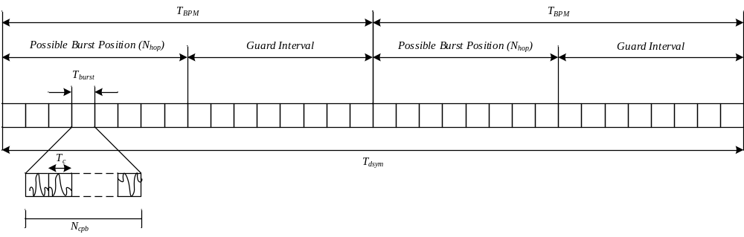
Figure 10 – BPM-BPSK symbol structure

Table 11 – rate-dependent and timing dependent parameters
Modulation & Coding |  |  | Data Symbol Structure |  |  |  |  |  | Data
Viterbi  Rate | RS  Rate | Overall  FEC Rate | #Burst  Positions per  Symbol Nburst | # Hop  Bursts  Nhop | # Chips  Per Burst  Ncpb | #Chips Per  Symbol | Burst  Duration  T burst (ns) | Symbol  Duration  Tdsym (ns) | Symbol  Rate  (MHz) | Bit Rate  Mb/s | Mean  PRF  (MHz)
0.5  0.5  0.5  1.0 | 0.87  0.87  0.87  0.87 | 0.44  0.44  0.44  0.87 | 32  32  32  32 | 8  8  8  8 | 128  16  2  1 | 4096  512  64  32 | 256.41  32.05  4.01  2.00 | 8205.13  1025.64  128.21  64.10 | 0.12  0.98  7.80  15.60 | 0.11  0.85  6.81  27.24 | 15.60  15.60  15.60  15.60
0.5  0.5  0.5  0.5 | 0.87  0.87  0.87  0.87 | 0.44  0.44  0.44  0.44 | 8  8  8  8 | 2  2  2  2 | 512  64  8  2 | 4096  512  64  16 | 1025.64  128.21  16.03  4.01 | 8205.13  1025.64  128.21  32.05 | 0.12  0.98  7.80  31.20 | 0.11  0.85  6.81  27.24 | 62.40  62.40  62.40  62.40

The peak PRF is 499.2 MHz. This is the highest frequency in megahertz at which a compliant transmitter shall emit pulses. The peak PRF is also used to derive the chip duration T_{c} by the formula T_{c} = ¹/_{peakPRF}. The value of T_{c} is approximately 2 ns. The channel bands are defined in Table 7. Note that the bandwidth is not necessarily the inverse of the chip duration T_{c}. Pulse shape and bandwidth are further defined in 11.2.4.1.
The Viterbi rate parameter determines the rate of the convolutional code applied to the PSDU data bits. A value of 1 indicates that no convolutional coding is applied while a value of 0.5 indicates that a rate 1/2 code as described in 11.1.5.2 is applied to the PSDU data bits.
The RS rate parameters indicates the (63, 55) Reed-Solomon code rate, which is approximately 0.87. The Reed-Solomon code is applied to all the PSDU data bits that are transmitted in the BPM-BPSK modulation mode. Reed-Solomon encoding is further described in 11.1.5.1.
The overall FEC rate is determine by the product of the Viterbi rate and the Reed-Solomon rate and has either a value of 0.44 or 0.87.
The burst-positions-per-symbol parameter is the total number of possible burst positions within the data symbol duration. N_{burst} has been chosen so that for each mean PRF a data symbol consists of a fixed number of burst durations.
The hop bursts parameter is the number of burst positions that may contain an active burst, that is, a burst containing BPM-BPSK modulation mode pulses. The value is computed as N_{hop} = N_{burst}/4.
The chips per burst parameter is the number of chip T_{c} durations within each burst period T_{burst}. Each burst consists of a multiple number of consecutive chips, as illustrated in Figure 10. Depending on the data rate to be used in the transmission of the PSDU, the number of chips in a burst varies, e.g., for low data rates, the burst consists of more chip periods than for high data rates. Particular, values of N_{cpb} have been selected so that the following is a valid data rate: (2 × Overall FEC rate)/(N_{cpb} × N_{burst} × T_{c}).
The burst duration is computed as T_{burst} = N_{cpb} × T_{c}.
The symbol duration is the duration of a modulated and coded PSDU symbol on the air and is computed as follows: T_{dsym} = N_{burst} × T_{burst}.
The symbol rate is the inverse of the PSDU symbol duration 1/T_{dsym}.
The bit rate is the user information rate considering FEC and is computed as follows:
Bit Rate = 2 × (Overall FEC Rate)/T_{dsym}
The mean PRF is the average PRF during the PSDU portion of a PHY frame and is computed as follows:
Mean PRF = N_{cpb}/T_{dsym}

      - Mathematical framework for BPM-BPSK modulation
The transmit waveform during the k^{th} symbol interval may be expressed as
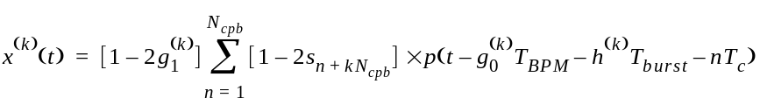
This equation describes the time hopping with polarity scrambling, which improves interference rejection capabilities of the BPM-BPSK modulation mode. The k^{th} symbol interval carries two information bits 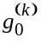 and 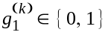. Bit 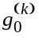 is encoded into the burst position whereas bit 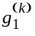 is encoded into the burst polarity. The sequence 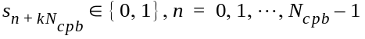 is the scrambling code used during the k^{th} symbol interval, 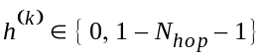 is the k^{th} burst hopping position, and p(t) is the transmitted pulse shape at the antenna input. The burst hopping sequence 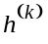 provides for multiuser interference rejection. The chip scrambling sequence 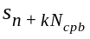 provides additional interference suppression among coherent receivers as well as spectral smoothing of the transmitted waveform. Note that equation defines the transmitted signal during the valid burst interval; at all other possible burst positions, no signal shall be transmitted. A reference modulator illustrating the BPM-BPSK modulation is shown in Figure 11.

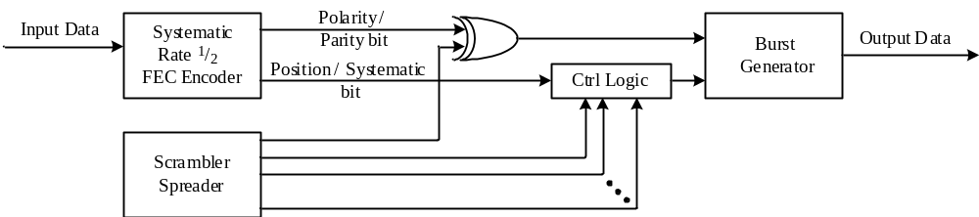

Figure 11 – BPM-BPSK reference symbol modulator

Note here that the FEC Encoder is not included if the modulation Viterbi rate is 1.0, as described in 11.1.4. In this case, the FEC encoder is replaced by a multiplexer which shall apply even bits to the position input and odd bits to the polarity input.

      - Spreading
The time-varying spreader sequence and the time-varying burst hopping sequence shall be generated from a common PRBS scrambler.
The polynomial for the scrambler generator shall be 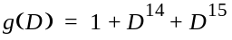
where D is a single chip delay, T_{c}, element. This polynomial forms not only a maximal length sequence, but also is a primitive polynomial. By the given generator polynomial, the corresponding scrambler output is generated as
where 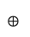 denotes modulo-2 addition.

A linear feedback shift register (LFSR) realization of the scrambler is shown in Figure 12. The LFSR shall be initialized upon the transmission of bit 0 of the PHR. Note that N_{cpb} may change depending on the data rate and PRF in use during the PSDU. The LFSR shall not be reset after transmission of the PHR.
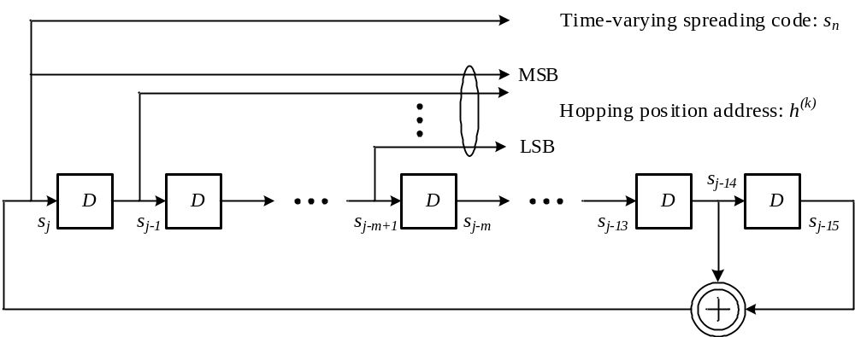
Figure 12 – BPM-BPSK LFSR implementation of the scrambler

The initial state of the LFSR shall be determined from the preamble code by first removing all the 0s in the ternary code and then replacing all the –1s with a zero. The first 15 bits of the resulting binary state shall be loaded into the LFSR. If the resulting binary state is less than 15 bits long then it shall be extended by concatenating it with itself until the requisite 15 bits are available. Table 12 shows an example of this procedure for the Table 8 preamble code index 4. Table 12 shows the initial state as well as the first 16 output bits from the scrambler.

Table 12 – Example LFSR initial state for preamble code index 4
Initial state  (s₋₁₅, s₋₁₄, …, s₋₁) | LFSR output: First 16 bits  s₀, s₁, …, s₁₅ (s₀ first in time)
111000101101101 | 0010011101101110

Note that even though each device within a network use the same initial LFSR setting, the communication is asynchronous so that the hopping and scrambling provides interference rejection.
The LFSR shall be clocked at the peak PRF of 499.2 MHz as specified in Table 11. During the k^{th} symbol interval, the LFSR shall be clocked N_{cpb} times, and the scrambler output shall be the k^{th} scrambling code 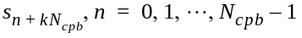. Furthermore, the k^{th} burst hopping position, shall be computed as follows:
where
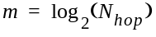

As shown in Table 11, the number of hopping burst N_{hop} is always a power of two, and consequently m is always an integer. Note that for N_{cpb} < m, the LFSR is clocked N_{cpb} times, not m times.
For the mandatory mode with mean data PRF of 15.60 MHz, the numbers of hopping bursts is 8, as indicated in Table 11, and consequently m takes on the values 3 and the corresponding hopping sequence is as follows:
h
k
(
)
s
k
N
c
p
b
2
s
1
k
N
c
p
b
+
4
s
2
k
N
c
p
b
+
+
+
=
    - BPM-BPSK modulation mode RF requirements
      - Transmitter baseband impulse response
The transmitted pulse shape p(t) of the BPM-BPSK modulation mode shall be constrained by the time domain mask defined in Figure 13. Note that this mask is for a pulse that has 500MHz 3dB bandwidth. For all other bandwidths, the pulse the times specified here should be divided by the ratio of the bandwidths.
-6
-4
-2
0
2
4
6
x 10 s
-9
0
0.2
0.4
0.6
0.8
1

-0.4
-0.2
(-2 ns, 0.1)
(-2 ns, 1.0)
(0 ns, -0.03)
(0 ns, -0.45)
Example Pulse (500MHz BW)
(-1.75 ns, 0.0)
(+1.75 ns, 0.0)
(+2.365 ns, -0.35)
(+2.98ns, 0.0)
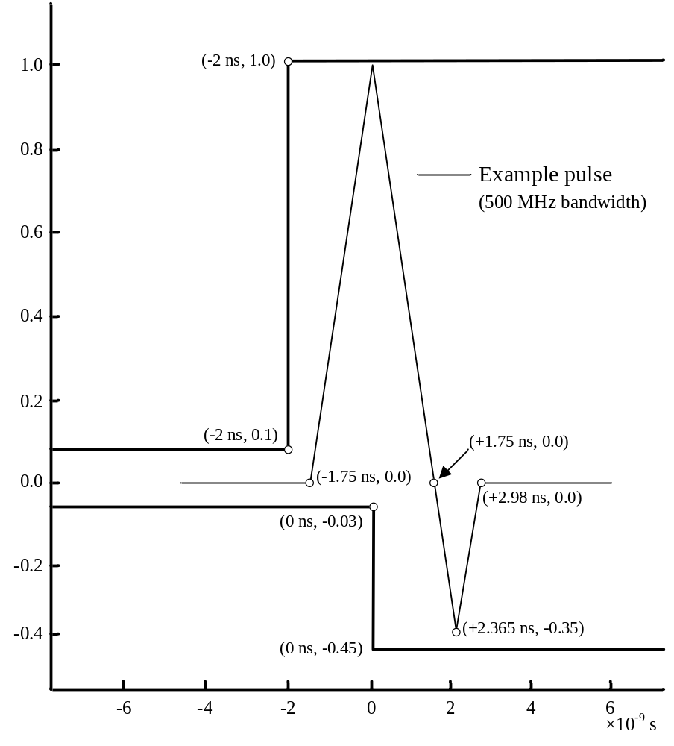
Figure 13 – BPM-BPSK time domain mask for compliant pulse
Note that it is not the intention of this standard to imply that pulse shaping shall occur at baseband, only that the measurements described here occur on the pulse envelope if shaping is done at passband.

      - Transmit PSD mask
The transmitted spectrum shall be less than –10 dBr (dB relative to the maximum spectral density of the signal) for 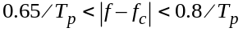 and –18 dBr for 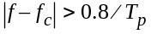. An example transmit spectrum mask is shown in Figure 14. The measurements shall be made using 1 MHz resolution bandwidth and a 1 kHz video bandwidth.
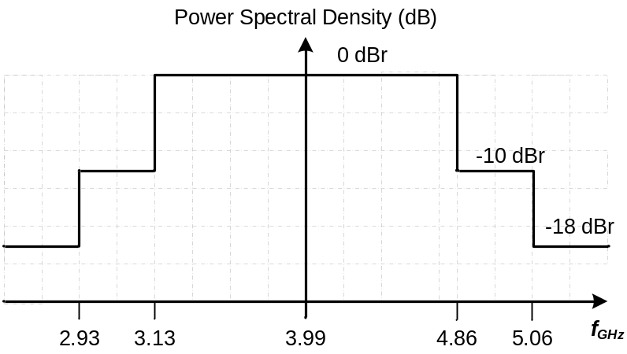
Figure 14 – BPM-BPSK example transmit spectrum mask for a band centered on 4 GHz

      - Chip rate clock and chip carrier alignment
A BPM-BPSK modulation mode transmitter shall be capable of chipping at the peak PRF given in Table 11 with an accuracy of ± 20 parts per million.
  - OOK modulation mode
    - General description
The OOK modulation mode is based on On-Off keying impulse radio signalling with a constant PRF of 1 MHz without hopping for all parts of PSDU. In contrast with the BPM-BPSK modulation mode described in 11.2, the transmitted UWB pulses are not constrained by a minimum cross-correlation with a specific pulse template and by a given spectral mask. Instead, these pulses are constrained in spectrum by the band plan specified in 11.1.6, which practically limits the transmitted signal spectrum by local regulations and neighboring ISM bands. These very wide channels allow transmission of UWB pulses with high energy. Furthermore, lack of the template pulse promotes usage of low-complexity impulse generators. High energy pulses along with relatively low data rates specified allow high communication range of this modulation mode.
    - Format of SHR
PHR bits P1-P0 determine SYNC length (N_{sync}) as specified in Table 5 and Table 6. Preamble shall consist of N_{sync} repetitions of the symbol - sequence V_{i} which i-th sequence in the set of Gold sequences of length L = 31 given in Table 13 with elements 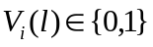 where . Since set of Gold sequences of length L = 3 has 33 sequences, there are 33 virtual channels available per physical channel. Gold sequences of length 31 have relatively short length with good circular autocorrelation properties. SFD shall represent logical inversion of sequence V_{i} used in the preamble.
Table 13: Employed set of Gold sequences of length 31.
Preamble Sequence ID  (i+1) | 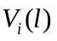  l=0 … l=30
1 | 1111100110100100001010111011000
2 | 1111100100110000101101010001110
3 | 0000000010010100100111101010110
4 | 0000101111000101010000011000101
5 | 0001110101100110111111111100011
6 | 0011000000100001100000110101111
7 | 0110101010101111011110100110111
8 | 1101111110110010100010000000111
9 | 1011010110001001011011001100110
10 | 0110000111111110101001010100100
11 | 1100100100010001001101100100001
12 | 1001100011001110000100000101010
13 | 0011101101110000010111000111100
14 | 0111110000001100110001000010001
15 | 1111001011110101111101001001011
16 | 1110111100000111100101011111110
17 | 1101010011100011010101110010100
18 | 1010001100101010110100101000000
19 | 0100110010111001110110011101000
20 | 1001001110011111110011110111001
21 | 0010110111010011111000100011010
22 | 0101000101001011101110001011101
23 | 1010100001111011000011011010011
24 | 0101101000011010011001111001110
25 | 1011111011011000101100111110101
26 | 0111011101011101000110110000010
27 | 1110010001010110010010101101101
28 | 1100001001000000111010010110010
29 | 1000111001101101101011100001100
30 | 0001011000110111001000001110000
31 | 0010011010000010001111010001001
32 | 0100011111101000000001101111011
33 | 1000010100111100011100010011111
Hence, the vector of SHR chips 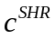 shall be calculated as
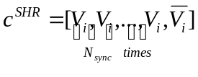.
    - Spreading and data rates
Bits R1-R0 shall decide data rate and number of chips per symbol (cs) in PSDU as specified in Table 4 and Table 14 respectively. PHR shall always be transmitted at the lowest data rate specified of 54.56 kbps and with 8 chips per symbols. The vector of coded PHR bits is denoted 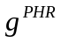, while the vector of coded PSDU bits is denoted 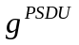. shall be calculated as 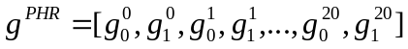, where 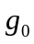 and 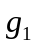 are defined in Table 1 and with superscript denotig Ssymbol #. Similarly, shall be calculated as , again where and are defined in Table 1 and with superscript denotng Ssymbol #. Spreading of to the vector of PHR chips denotedshall be done as
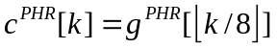,

for 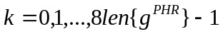, where 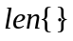 function returns vector length. Similarly, spreading of to the vector of PSDU chips 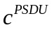 shall be done as
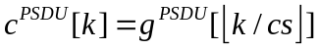,

for 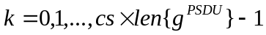. The vector of all PPDU chips (c) shall be calculated as concatenation of , 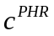 and :
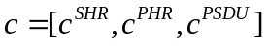.

Intervals of indexes of elements of vector are denoted as follows.
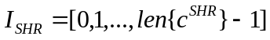,
,
].
Table 14: Number of chips per symbol with regard to bits R1-R0
R1-R0 | 00 | 01 | 10 | 11
Number of chips per symbol (cs) | 8 | 4 | 2 | 1

    - Symbol structure
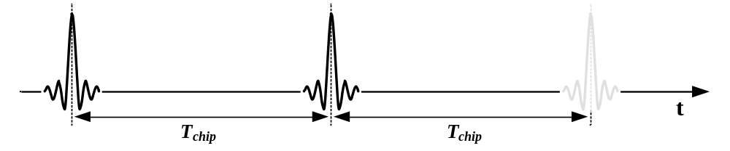
Figure 15: Symbol structure for OOK modulation mode
Symbol structure is illustrated in Figure 15. Note that in Figure 16 a constant chip duration of 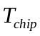 is used, zero chip which produces no emission is depicted as a dimmed pulse. The whole PPDU shall be transmitted using the constant chip interval of 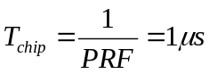 regardless of the data rate used. On-Off Keying (OOK) modulation shall be used for the whole PPDU. Transmitted signal for the k-th-th transmitted chip shall be expressed as
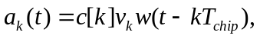

for 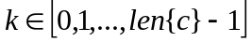. Here, transmitted pulse waveform is denoted 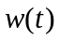. 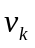 is used for flattening the spectrum of the transmitted signal and shall be calculated as follows:

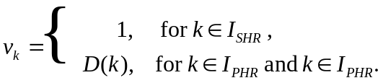

Here, 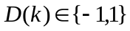 shall be arbitrary pseudo-random or random sequence chosen by the implementer. Purpose of 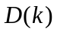 is to flatten the spectrum of the transmitted signal and totally avoid or at least reduce discrete frequency components.

    - Compliant pulses
The transmitted pulse shall be considered compliant with the OOK modulation mode if it satisfies the band allocation specified in 11.1.6 and has duration not greater than 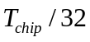.
  - Timestamps and time units
The UWB PHY supports precision ranging and localization through the capability of time stamping, using a ranging counter, the precise instant that the RMARKER is received (or transmitted) at the device antenna.

    - Time units
For the BPM-BPSK modulation mode, the time units used for ranging timestamps is defined by the least significant bit (LSB) of the time values which represents ¹/₁₂₈ of a chip time at the mandatory chipping rate of 499.2 MHz. Note: The LSB of the ranging counter represents a time interval so small that an actual physical counter would have to run at a nominal 64 GHz to produce values with this resolution. An actual physical realization is not expected. Instead it is assumed that computational techniques will be used to generate sufficient of the less significant bits to yield the desired operational precision.
For the OOK modulation mode, the time units used for ranging timestamps is defined by the least significant bit (LSB) of the time values which represents ¹/₆₄ of T_{chip} /₁₀₀₀ = 1 ns.
    - Antenna delays
The time of arrival and time of sending events relate to the RMARKER being at the antenna.
The receive timestamp will naturally occur in the digital domain of the receiver some period of time after the RMARKER arrives at the antenna. To calculate when the RMARKER was at the antenna, and generate an accurate time of arrival, all the system delays between the antenna and the internal digital receive timestamp need to be accounted for. This receive antenna delay then needs to be subtracted from the internal digital receive timestamp to give the time of arrival value.
Similarly in the transmitter all the system delays between the internal digital transmit timestamp and the antenna need to be accounted. This transmit antenna delay then needs to be added to the internal digital transmit timestamp to give the time of sending value, when the transmit RMARKER is at the antenna.
The mechanisms for determining these antenna delays are beyond the scope of this standard.

- Transmit power control
- Relative positioning and localization
- Security

