IEEE P802.15
Wireless Personal Area Networks

Project | IEEE P802.15 Working Group for Wireless Personal Area Networks (WPANs)
Title | Kookmin individual MAC frame formats
Date Submitted | [November 2016]
Source | Trang Nguyen, Nam Tuan Le, and Yeong Min Jang (Kookmin University)
Re:
Abstract | Kookmin individual MAC frame formats are presented.  The MAC frame formats have been presented in doc.: IEEE 802.15-16- 0011 -01-007a in January 2016. This document adds the explanation to the proposed MAC frames.
Purpose | D1 Comments Resolutions and Editorial Revision.
Notice | This document has been prepared to assist the IEEE P802.15. It is offered as a basis for discussion and is not binding on the contributing individual(s) or organization(s). The material in this document is subject to change in form and content after further study. The contributor(s) reserve(s) the right to add, amend or withdraw material contained herein.
Release | The contributor acknowledges and accepts that this contribution becomes the property of IEEE and may be made publicly available by P802.15.

# MAC support

Kookmin MAC supports 3 modes based on applications/usages as follows
- Light-ID broadcast mode
- Information Broadcast (IB) mode
- Bidirectional Device-to-Device (D2D) mode

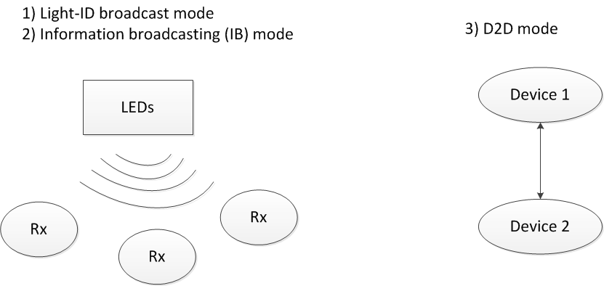
Figure x1 – MAC types support

Figure x2 provides an example usage of frame structure configuration for multiple topologies such as D2D, light-ID broadcast, and IB mode. Because no superframe structure is applied, all slots are data. For data transfer and information broadcast, data slots are continuously sent. For Light-ID broadcasting mode, shorten frames are sent in between two full frames.

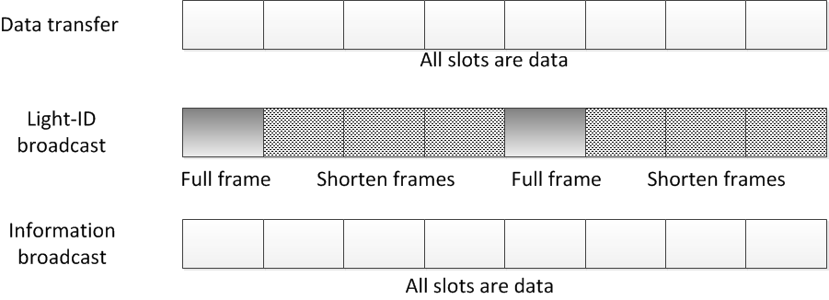
Figure x2 – MAC Overview

    - Kookmin General MAC frame format
The MAC frame format is composed of a MHR, a MSDU, and a MFR. The fields of the MHR appear in a fixed order; however, the addressing sub-fields and security sub-fields may not be included in all frames. The general MAC frame shall be formatted as illustrated in Figure x3.

0/6/10/16 | 0/TBD | 0/TBD | 0/TBD | variable | 0/TBD
Frame control | Sequence number | Addressing fields | Security Field | PSDU | FCS
MHR |  |  |  | MSDU | MFR

Figure x3 – General MAC frame formats
6.4.1.1 Frame control field
The frame control field is in variable length and contains information defining the frame type, addressing fields, and other control flags or optional field. The frame control field shall be formatted as illustrated in Figure x4.
Bits: 0/2 | 0/3 | 0/1 | 0/1 | 0/3/13
Frame version | Frame type | Security enabled | Destination/Source Addressing mode Enable | Optional fields
Figure x4 – Frame control field
6.4.1.1.1 Frame Version subfield
The Frame Version subfield specifies the version number corresponding to the frame. This subfield shall be set to 0b00 to indicate a frame compatible with IEEE Std 802.15.7.
The subfield is not present in low data rate modes including S2-PSK, S8-PSK, and low overhead M-FSK modes. The proposed values and usages of the Frame Version subfield is in figure x5.

Frame Version subfield value | Proposed usage
00 | IEEE Std 802.15.7-2011
01 | IEEE Std 802.15.7-201x High-rate PD Communication
10 | IEEE Std 802.15.7-201x OCC and Low-rate PD Communication
Figure x5 – Frame Version subfield
6.4.1.1.2 Frame type subfield
The subfield is for OCC data transfer modes (HS-PSK and 8-color code). The subfield is not present in the other OCC modes.
The Frame Type subfield shall be set to one of the non-reserved values listed in Table x6. The table compatible with the previous table of Frame type subfield IEEE Std 802.15.7-2011.

Table x6. Frame type subfield
Description | Frame type subfield (b2b1b0)
Data | 001
MAC command | 011
Light-ID | 100
Reserved | 101-111
Only data and MAC command frame types are utilized for OCC.
New frame type, light-ID frame type, that defines the data broadcasting to support OCC localization via identification of light sources is newly added with the frame type subfield 0b100.

6.4.1.1.3 Security Enabled subfield
All the broadcasting modes (light-ID broadcast and IB) do not have the Security Enabled subfield.
The Security Enabled subfield is enabled for protected D2D mode. The Security Enabled subfield is 1 bit in length, and it shall be set to one if the frame is protected by the MAC sublayer and shall be set to zero otherwise.

6.4.1.1.4 Destination/Source Addressing Mode Enabled subfield
All the broadcasting modes (light-ID broadcast and IB) do not have the Destination/Sourcce Addressing Mode Enable subfield. For D2D mode, both Destination Addressing Mode Enable subfield and Source Addressing Mode Enable subfield have one bit.

Table x7. Addressing Mode Enable subfield
Destination/Source Addressing Mode Enable subfield (b0) | Description
0 | Destination Addressing Mode
1 | Source Addressing Mode

6.4.1.1.5 Frame control Optional subfields
Subfields are specified only for the light-ID frames. There are two optional subfields used for the light-ID frame as follows. All the optional subfields are disabled in the Frame control field of other MAC frames not light-ID frame.
Table x8 - Frame control Optional subfields
Bits: 0/3 | 0/10
light-ID sub-type | Company ID

6.4.1.2 Sequence Number field
The Sequence Number field is TBD bits in length and specifies the sequence identifier for the frame.
For an OCC light-ID frame, the Sequence Number field shall specify a BSN.
For D2D mode, acknowledgment frame shall not be used, therefore, the Sequence Number field that specifies a DSN to match an acknowledgment frame to the data or MAC command frame shall not be used in OCC.

6.4.1.3 Destination Address field
The Destination Address field, when present, is TBD in length, and specifies the address of the intended recipient of the frame.
This field shall be included in the MAC frame only if the Destination Addressing Mode subfield of the frame control field is enabled.

6.4.1.4 Source Address field
The Source Address field, when present, is TBD in length, and specifies the address of the originator of the frame.
This field shall be included in the MAC frame only if the Source Addressing Mode subfield of the frame control field is enabled

Formats of individual frames

6.4.2.1 Kookmin light-ID broadcasting frame format
The light-ID broadcasting is designed to support localization application.
The light-ID broadcasting frame format is composed of a prefix and the Light-ID payload (content). The frame shall be formatted as illustrated in Figure y1.
prefix | Light-ID payload subfields
 | Zone-ID  subfield 1 | Zone-ID  Subfield 2 | Zone-ID  Subfield 3 | Advertisement  Subfield
bit: 6/16 | Bytes: 1-2 | Bytes: 1-2 | Bytes: 1-2 | Bytes: 1-2

Figure y1 – General light-ID frame format

6.4.2.1.2 Prefix
The Light-ID prefix shall be formatted as illustrated in Figure y2. Three bits frame type and three bits ligh-ID frame type subfields are mandatory. Optional subfield, if presented, shall contain 10 bits.
Light-ID frame type  subfield | Light-ID frame subtype  subfield | Optional subfield
b0b1b2 =000 | b3b4b5 | Bits: 0/10
Figure y2 – Light-ID prefix subfields

6.4.2.1.2.1 Light-ID Frame type
The frame type subfield shall be 0b100 to indicate that light-ID broadcasting is a type of data frame.

6.4.2.1.2.2 Light-ID frame subtype
Multiple types of light-ID utilizing OCC shall be supported. 3 bits shall be used to indicate the specific frame type as shown in table y1.
Table y1: Light-ID frame subtype
(3 bits) Light-ID frame subtype | Light-ID frame subtype description
000 | (3 subframes) Light-ID
001 | (4 subframes) Light-ID and advertisement data
010 | (1 subframe) Shorten Light-ID
011-111 | Reserved

For extending the number of Zone-ID fields, the reserved values of light-ID frame type (0b011 – 0b111) shall be used.

6.4.2.1.2.3 Optional subfield
The optional subfield is enabled only if the light-ID frame type subfield is 0b001. If enabled, the optional subfield shall consist of 10 bits to indicate the optional information such as company ID.

6.4.2.1.3 Zone-ID field
The number of Zone-ID fields depends in the light-ID frame type defined in table y1.
For OCC based indoor localization purpose, multiple payloads are sent each light-ID frame as illustrated in Figure y3. If the light-ID frame type field is 0b000, the light-ID payloads shall consist of 3 fields of the LED-identification. If the light-ID frame type field is 0b001, the light-ID payloads shall consist of 4 fields of the LED-identification. If the light-ID frame type field is 0b010, the light-ID payloads shall utilize only single field the LED-identification (shorten frame of light-ID).
Light-ID frame type: 0b001
0b000
.
0b010

Zone-ID subfield 1 | Zone-ID subfield 2 | Zone-ID subfield 3 | Advertisement subfield
bytes: 1/2 | bytes: 1/2 | bytes: 1/2 | bytes: 0/2
Figure y3 – LED-ID payload subfields

Zone-ID subfields, each shall consist of two smaller subfields, including ID sequence number (ID-SN) subfield and ID data subfield. The format of the Zone-ID is shown in Figure y4.
ID-Sequence number | ID data payload
bits: 3 | bits: 5/13
byte: 1/2
Figure y4 – Zone ID subfield

6.4.2.1.3.1 ID-sequence number (ID-SN)
ID-SN is to match an ID frame to the correct ID data subfield when multiple ID data subfields are utilized.
The four values of ID-SN (0b000 – 0b011) shall be used to specify the sequence number of three Zone-ID subfields and an advertisement subfield. The values (0b100 – 0b111) are reserved for later extension of the number of Zone-ID subfields for large-scale localization service employing OCC.
Table y2: ID-sequence number
ID-SN value | Description
000 | Zone-ID subfield 1 (Zone area)
001 | Zone-ID subfield 2 (floor)
010 | Zone-ID subfield 3 (LED identification)
011 | Advertisement subfield
100-111 | Reserved

6.4.2.1.3.2 ID Data payload
An ID payload is sent along with an ID-SN.
5 bits data payload shall be utilized for the light-ID frame subtype 0b000. Along with the ID-SN, one byte is sent each Zone-ID subfield.
15 bits data payload shall be utilized for the light-ID frame subtype 0b001. Along with the ID-SN, two byte is sent each Zone-ID subfield.
If the light-ID frame subtype is 0b001 (the shorten frame), only the last Zone-ID subfield shall be sent.
Further the length of LED identification data shall be defined via reserved values of light-ID frame subtype subfield and reserved values of ID-SN.

Light-ID inter-frame interval
To minimize overhead, the shorten forms of light-ID shall be sent in between two full light-ID frames as shown in Figure y5 . The interval between two full light-ID frame is TBD.

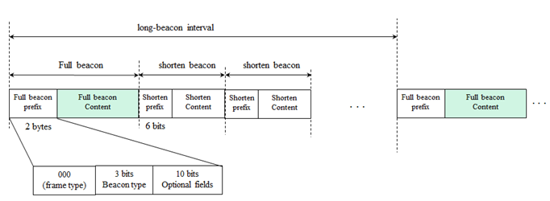
Figure y5 – light-ID interframe interval

6.4.2.2 Kookmin Data frame format

TBD

6.4.2.3 Kookmin Command frame format

TBD

