IEEE P802.15
Wireless Personal Area Networks

Project | IEEE P802.15 Working Group for Wireless Personal Area Networks (WPANs)
Title | Kookmin individual MAC frame formats
Date Submitted | [November 2016]
Source | Trang Nguyen, Nam Tuan Le, and Yeong Min Jang (Kookmin University)
Re:
Abstract | Kookmin individual MAC frame formats are presented.  The MAC frame formats have been presented in doc.: IEEE 802.15-16- 0011 -01-007a in January 2016. This document adds the explanation to the proposed MAC frames.
Purpose | D1 Comments Resolutions and Editorial Revision.
Notice | This document has been prepared to assist the IEEE P802.15. It is offered as a basis for discussion and is not binding on the contributing individual(s) or organization(s). The material in this document is subject to change in form and content after further study. The contributor(s) reserve(s) the right to add, amend or withdraw material contained herein.
Release | The contributor acknowledges and accepts that this contribution becomes the property of IEEE and may be made publicly available by P802.15.

# MAC support

Kookmin MAC supports 3 modes based on applications/usages as follows
- OCC beacon broadcast mode
- Information Broadcast (IB) mode
- Bidirectional Device-to-Device (D2D) mode

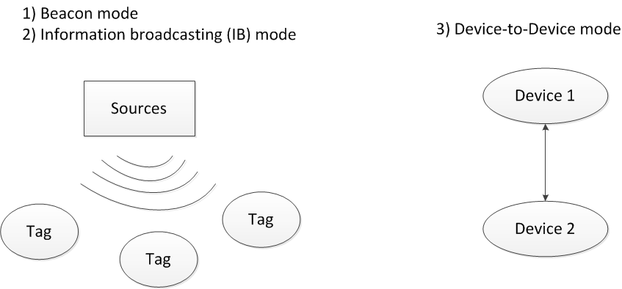
Figure x1 – MAC types support

Figure x2 provides an example usage of frame structure configuration for multiple topologies such as D2D, beacon, and IB modes. The beacons are to start the superframe in data/beacon broadcasting modes whereas all slots in D2D mode are for data transfer.

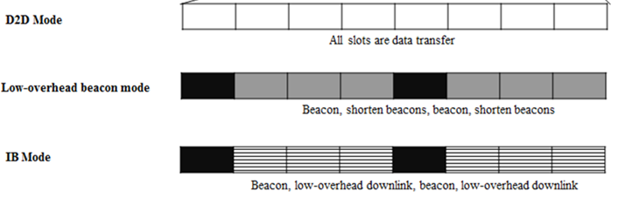
Figure x2 – MAC Overview

    - Kookmin General MAC frame format
The MAC frame format is composed of a MHR, a MSDU, and a MFR. The fields of the MHR appear in a fixed order; however, the addressing sub-fields and security sub-fields may not be included in all frames. The general MAC frame shall be formatted as illustrated in Figure x3.

6/10/16 | 0/TBD | 0/TBD | 0/TBD | variable | 0/TBD
Frame control | Sequence number | Addressing fields | Security Field | PSDU | FCS
MHR |  |  |  | MSDU | MFR

Figure x3 – General MAC frame formats
6.4.1.1 Frame control field
The frame control field is in variable length and contains information defining the frame type, addressing fields, and other control flags or optional field. The frame control field shall be formatted as illustrated in Figure x4.
Bits: 0/2 | 3 | 0/1 | 0/1 | 0/3/13
Frame version | Frame type | Security enabled | Destination/Source Addressing mode Enable | Optional fields
Figure x4 – Frame control field
6.4.1.1.1 Frame Version subfield
The Frame Version subfield specifies the version number corresponding to the frame. This subfield shall be set to 0b00 to indicate a frame compatible with IEEE Std 802.15.7.
The subfield is not present for low data rate modes including S2-PSK, S8-PSK, and low overhead M-FSK modes. The proposed values and usages of the Frame Version subfield is in figure x5.

Frame Version subfield value | Proposed usage
00 | IEEE Std 802.15.7-2011
01 | IEEE Std 802.15.7-201x High-rate PD Communication
10 | IEEE Std 802.15.7-201x OCC and Low-rate PD Communication
Figure x5 – Frame Version subfield
6.4.1.1.2 Frame type subfield
The Frame Type subfield shall be set to one of the non-reserved values listed in Table x6. The table is exactly matched to the previous table of Frame type subfield IEEE Std 802.15.7-2011.

Table x6. Frame type subfield
Description | Frame type subfield (b2b1b0)
Beacon | 000
Data | 001
MAC command | 011
Reserved
Especially, the Acknowledgement frame type is unused for our OCC modes.

6.4.1.1.3 Security Enabled subfield
All the broadcasting modes (beacon and IB) do not have the Security Enabled subfield.
The Security Enabled subfield is enabled for protected D2D mode. The Security Enabled subfield is 1 bit in length, and it shall be set to one if the frame is protected by the MAC sublayer and shall be set to zero otherwise.

6.4.1.1.4 Destination/Source Addressing Mode Enabled subfield
All the broadcasting modes (beacon and IB) do not have the Destination/Sourcce Addressing Mode Enable subfield. For D2D mode, both Destination Addressing Mode Enable subfield and Source Addressing Mode Enable subfield have one bit.

Table x7. Addressing Mode Enable subfield
Destination/Source Addressing Mode Enable subfield (b0) | Description
0 | Destination Addressing Mode
1 | Source Addressing Mode

6.4.1.1.5 Frame control Optional subfields
Subfields are specified only for the beacon frames. There are two optional subfields used for the beacon frame as follows. All the optional subfields are disabled in the Frame control field of other MAC frames not beacon.
Table x8 - Frame control Optional subfields
Bits: 0/3 | 0/10
Beacon specific type | Company ID

6.4.1.2 Sequence Number field
The Sequence Number field is TBD bits in length and specifies the sequence identifier for the frame.
For an OCC beacon frame, the Sequence Number field shall specify a BSN.
For D2D mode, acknowledgment frame shall not be used, therefore, the Sequence Number field that specifies a DSN to match an acknowledgment frame to the data or MAC command frame shall not be used in OCC.

6.4.1.3 Destination Address field
The Destination Address field, when present, is TBD in length, and specifies the address of the intended recipient of the frame.
This field shall be included in the MAC frame only if the Destination Addressing Mode subfield of the frame control field is enabled.

6.4.1.4 Source Address field
The Source Address field, when present, is TBD in length, and specifies the address of the originator of the frame.
This field shall be included in the MAC frame only if the Source Addressing Mode subfield of the frame control field is enabled

Formats of individual frames

6.4.2.1 Kookmin Beacon frame format
The beacon frame format is composed of a prefix and the beacon payload (content). The frame shall be formatted as illustrated in Figure y1.
Beacon prefix | Beacon payload subfields |  |  |  | FCS
 | Zone-ID  subfield 1 | Zone-ID  Subfield 2 | Zone-ID  Subfield 3 | Advertisement  Subfield
bit: 6/16 | Bytes: 1-2 | Bytes: 1-2 | Bytes: 1-2 | Bytes: 1-2 | TBD

Figure y1 – General beacon frame format

6.4.2.1.2 Beacon prefix
The beacon prefix shall be formatted as illustrated in Figure y2. Three bits frame type and three bits beacon type subfields are mandatory. Optional subfield, if presented, shall contain 10 bits.
Frame type subfield | Beacon type subfield | Optional subfield
b0b1b2 =000 | b3b4b5 | Bits: 0/10
Figure y2 – Beacon prefix subfields

6.4.2.1.2.1 Frame type
The frame type subfield shall be 0b000 to indicate that the frame is beacon frame.

6.4.2.1.2.2 Beacon type
Multiple types of beacon utilizing OCC shall be supported. 3 bits shall be used to indicate the specific beacon type as shown in table y1.
Table y1: Beacon type
(3 bits) Beacon type | Beacon description
000 | (3 subframes) LED-ID beacon
001 | (4 subframes) LED-ID beacon and advertisement data
010 | (1 subframe) Shorten beacon
011-111 | Reserved

For extending the number of Zone-ID fields, the reserved values of beacon type (0b011 – 0b111) shall be used.

6.4.2.1.2.3 Optional subfield
The optional subfield is enabled only if the beacon type subfield is 0b001. If enabled, the optional subfield shall consist of 10 bits to indicate the optional information of the beacon such as company ID.

6.4.2.1.3 Zone-ID field
The number of Zone-ID fields depends in the beacon type defined in table y1.
For OCC based indoor localization purpose, multiple payloads are sent each beacon as illustrated in Figure y3. If the beacon type field is 0b000, the beacon payloads shall consist of 3 fields of the LED-identification. If the beacon type field is 0b001, the beacon payloads shall consist of 4 fields of the LED-identification. If the beacon type field is 0b010, the beacon payloads shall utilize only single field the LED-identification (shorten beacon type).
Frame type: 0b001
0b000
.
0b010

Zone-ID subfield 1 | Zone-ID subfield 2 | Zone-ID subfield 3 | Advertisement subfield
bytes: 1/2 | bytes: 1/2 | bytes: 1/2 | bytes: 0/2
Figure y3 – LED identification fields

Zone-ID subfields, each shall consist of two smaller subfields, including ID sequence number (ID-SN) subfield and ID data subfield. The format of the Zone-ID is shown in Figure y4.
ID-Sequence number | ID data payload
bits: 3 | bits: 5/13
byte: 1/2
Figure y4 – Zone ID subfield

6.4.2.1.3.1 ID-sequence number (ID-SN)
ID-SN is to match an ID frame to the correct ID data subfield when multiple ID data subfields are utilized.
The four values of ID-SN (0b000 – 0b011) shall be used to specify the sequence number of three Zone-ID subfields and an advertisement subfield. The values (0b100 – 0b111) are reserved for later extension of the number of Zone-ID subfields for large-scale localization service employing OCC.
Table y2: ID-sequence number
ID-SN value | Description
000 | Zone-ID subfield 1 (Zone area)
001 | Zone-ID subfield 2 (floor)
010 | Zone-ID subfield 3 (LED identification)
011 | Advertisement subfield
100-111 | Reserved

6.4.2.1.3.2 ID Data payload
An ID payload is sent along with an ID-SN.
5 bits data payload shall be utilized for the beacon type 0b000. Along with the ID-SN, one byte is sent each Zone-ID subfield.
15 bits data payload shall be utilized for the beacon type 0b001. Along with the ID-SN, two byte is sent each Zone-ID subfield.
If the beacon type is 0b001 (the shorten beacon), only the last Zone-ID subfield shall be sent.
Further the length of LED identification data shall be defined via reserved values of beacon type subfield and reserved values of ID-SN.

Beacon interval
To minimize overhead, the shorten forms of beacon shall be sent in between two full beacons as shown in Figure y5 . The interval between two full beacon is TBD.

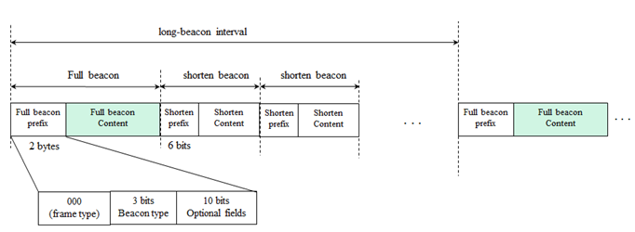
Figure y5 – beacon interval

6.4.2.2 Kookmin Data frame format

TBD

6.4.2.3 Kookmin Command frame format

TBD

