IEEE P802.15
Wireless Personal Area Networks

Project | IEEE P802.15 Working Group for Wireless Personal Area Networks (WPANs)
Title | Kookmin MAC functional description
Date Submitted | [November 2016]
Source | Trang Nguyen, Nam Tuan Le, and Yeong Min Jang (Kookmin University)
Re:
Abstract | Kookmin MAC description is introduced.  The MAC frame formats have been presented in doc.: IEEE 802.15-16- 0011 -01-007a in January 2016. This document adds the explanation to the proposed MAC frames.
Purpose | D1 Comments Resolutions and Editorial Revision.
Notice | This document has been prepared to assist the IEEE P802.15. It is offered as a basis for discussion and is not binding on the contributing individual(s) or organization(s). The material in this document is subject to change in form and content after further study. The contributor(s) reserve(s) the right to add, amend or withdraw material contained herein.
Release | The contributor acknowledges and accepts that this contribution becomes the property of IEEE and may be made publicly available by P802.15.

A. Kookmin MAC functional description

Kookmin MAC supports 3 modes based on applications/usages as follows
- Light-ID broadcast mode
- Information Broadcast (IB) mode
- Bidirectional Device-to-Device (D2D) mode

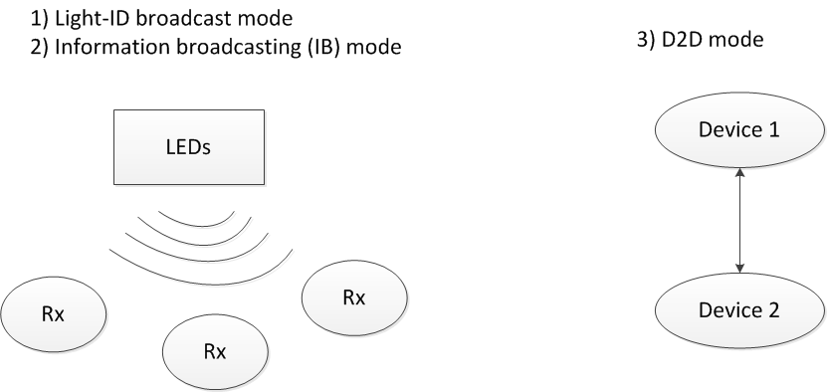
Figure x1 – MAC types support

Figure x2 provides an example usage of frame structure configuration for multiple topologies such as D2D, light-ID broadcast, and IB mode. Because no superframe structure is applied, all slots are data. For data transfer and information broadcast, data slots are continuously sent. For Light-ID broadcasting mode, shorten frames are sent in between two full frames.

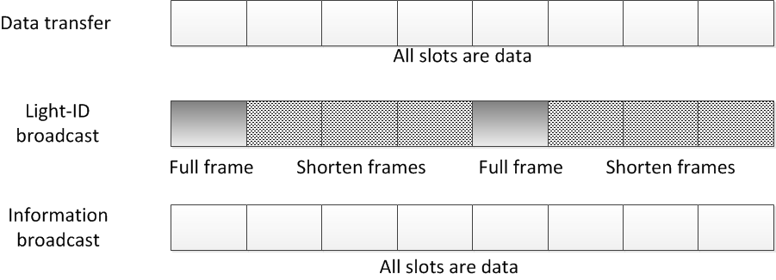
Figure x2 – MAC Overview

B. Kookmin General MAC frame format
TBD

