IEEE P802.15
Wireless Personal Area Networks

Project | Dependability Interest Group
Title | Meeting Minutes for November 2016
Date Submitted | November 11, 2016
Source | [Ryuji Kohno]  [Yokohama National University/ University of Oulu Research Institute Japan – CWC-Nippon(YNU/CWC-Nippon)] | Voice: +81-45-339-4115  +358 40 354 0034  E-mail: kohno@ynu.ac.jp  ryuji.kohno@oulu.fi
Re: | Meeting Minutes
Abstract
Purpose | Minutes of Dependability Interest Group sessions
Notice | This document has been prepared to assist the IEEE P802.15. It is offered as a basis for discussion and is not binding on the contributing individual(s) or organization(s). The material in this document is subject to change in form and content after further study. The contributor(s) reserve(s) the right to add, amend or withdraw material contained herein.
Release | The contributor acknowledges and accepts that this contribution becomes the property of IEEE and may be made publicly available by P802.15.

Monday, November 7, 2016, AM1, 8:00

  - Meeting called to order 8:00
By Chair Ryuji Kohno (YNU / CWC-Nippon)
Secretary Huang Ban Li (NICT, Japan)

  - Roll Call
Notepad for Attendance circulated.

  - Opening Report

Chair presented Opening report Doc #773

Chair showed IEEE Patent policy.

Chair issued Call for Potentially Essential Patents
No essential intellectual property in the scope of IG DEP was declared.

  - Approval of previous meeting minutes
Upon no comments on the previous meeting minutes in July, doc #556 meeting minutes were approved.

  - Review of CFI

Doc #14-449r6
Doc #15-217r6

  - Review of responses to CFI

Doc.#15-496

  - Presentation and Discussion on Expanded Use Cases and Related Areas for
Dependable Wireless Network
Doc.#16-777
- Mr. Demir Rakanovic (Neonseven) mentioned that medical healthcare service including remote care of elderly people should be involved in the focused use cases
- Use cases related with disaster prevention, rescue and recovering could be involved in option.
- This standard could be cooperated with any activities on ultra reliable networking in 5G standardization activities.
- Inter vehicle communication and ranging issues could be common with a newly extablished IG-Optical Wireless Communications(OWC),which would be proposed in WNG at mid plenary.later.
- Possibilities of collaboration with existing any industrial standard on Factory Automation(FA) has been recommended.
- One of uniqueness in this new standard is a use case of dependable wireless remote adaptive interactive feedback controlling and sensing, i.e. wireless adaptive servo control in real time..

  - Update Technical Requirement

Doc.#557r1

- Latency in normal and in critical operations could be corresponding to probabilistic and deterministic cases in 802.15.4e, respenctively
- Association and authentication delays are optional requirement.

  - Recess at 9:59

  - Attendees

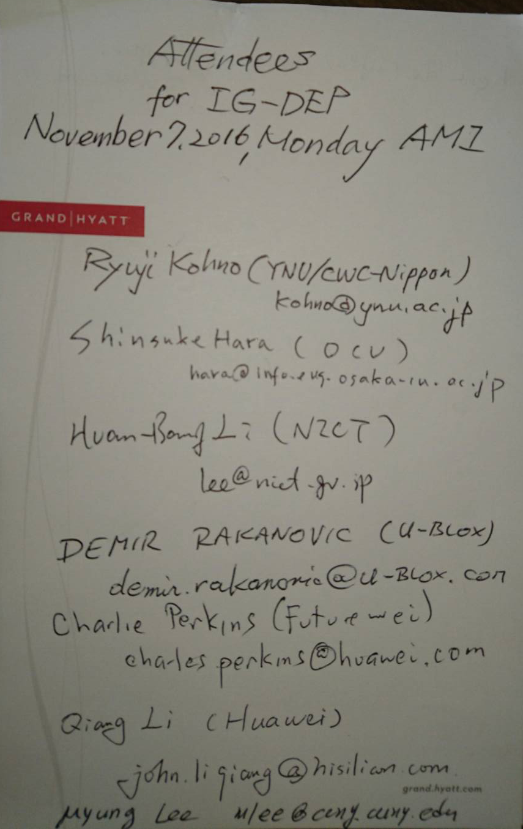

Monday 7 November, 2016, PM1, 13:30

  - Meeting called to order 13:33

  - Roll Call

  - Continue Updating Technical Requirement

Doc.#557r1

- Handover capability is according to density and velocity of cars.
- Interference models should be classified according to environment in use cases.
- Channel models should be also classified as well.

  - Reshcduling Tutorial

Doc.#558r2

- Since one keynote speaker out of two suddenly had cancelled to come due to his company’s urgent task, our planned tutorial evening on November 7th was cancelled and postponed to next March.
- Speakers can be increased up to four and time slot may be 7:30-9:00pm on March 13th, 2017.

  - Update of a draft PAR

Doc.#290r2

Completed a preliminary PAR for comments from WG15 experts.
Further PAR and CSD development is continued off-line and by telcos, if needed.

  - Adjourn 15:41

  - Attendees
