IEEE P802.15
Wireless Personal Area Networks

Project | IEEE P802.15 Working Group for Wireless Personal Area Networks (WPANs)
Title | Kookmin Suggested Merging RS-FSK modes with NTU
Date Submitted | [October 2016]
Source | Trang Nguyen, Hong Chang Hyun and Yeong Min Jang  (Kookmin University)
Re: | Combined Sorted D0 Comments (477r10)
Abstract | Suggested Resolution on how to merge Kookmin FSK modes with NTU RS-FSK modes. The content is TBD with NTU.
Purpose | D0 Comments Resolutions and Merging Proposal
Notice | This document has been prepared to assist the IEEE P802.15. It is offered as a basis for discussion and is not binding on the contributing individual(s) or organization(s). The material in this document is subject to change in form and content after further study. The contributor(s) reserve(s) the right to add, amend or withdraw material contained herein.
Release | The contributor acknowledges and accepts that this contribution becomes the property of IEEE and may be made publicly available by P802.15.

PHY Operating modes
Because both Kookmin’s M-FSK and NTU’s RS-FSK schemes are designed for rolling shutter camera Rx, so let us call RS-FSK as a common name for merged proposal.

Table xx. PHY B RS-FSK operating modes (Merged Kookmin’s M-FSK and NTU’s RS-FSK)
Modulation | RLL | Optical clock rate¹ | FEC | Bit Rate²
RS32-FSK§ | None | 10 Hz | Code rate = 4/5 | 40
RS64-FSK/2-PSK§ | None | 10 Hz | Code rate = 6/7 | 60
RS8-FSK* | None | 30 Hz | Parity code rate = 2/3 | 90 x 2/3=60
RS16-FSK* | None | 30 Hz | Parity code rate = 2/3 | 120 x2/3=90
§ Kookmin’s M-FSK modes * NTU’s RS-FSK modes

¹ Optical clock rate:
- The frequency at which the data is clocked out to the optical source. (IEEE 802.15.7-2011)
- Revised for RS-FSK modes as follows:
- Optical Clock Rate (for RS-FSK): The frequency at which the data symbol is clocked out to the optical source (i.e. how many frequency symbols per second are clocked out to the optical source).

² Bit rate calculation
- NTU data symbols are sent at 30Hz. To correct the error due to the frame rate drops off below 30fps, parity code at code rate 2/3 is applied.
- On the other hand, Kookmin data symbols are sent at 10Hz. Therefore, no parity code for the correction of frame rate drop is needed.

15.x Merged RS-FSK Proposal of Kookmin & NTU

15.x.1 Reference System Architecture
A reference implementation of RS-FSK is in Figure 01. The PHR and PSDU parts of the frame are subject to the clock-information-embedding block to support the camera Rx dealing with its frame rate variation problem. After embedding the clock information, FEC encoder is to protect data from error caused by the missing of data symbols when the Rx frame rate drops too low. The PHR part is encoded using parameters corresponding to the lowest data rate for the current negotiated clock rate. The PHY header shall be sent at 60bps using RS8-FSK modulation if the 30Hz optical clock rate is selected or at 40bps using RS32-FSK modulation if the 10Hz optical clock rate is selected. Neither support for 40bps at an optical clock of 10Hz nor support for 60bps at an optical clock of 30Hz is mandatory.
The RS-FSK Encoder along with dimmer will map a block of data into a specific frequency at the desired dimming level.

Figure 01– Reference Architecture for RS-FSK modes

15.x.2 Clock information Embedding
The clock information (also known as asynchronous bit(s), noted as Ab) shall be embedded into every block of data to deal with the asynchronous communication in which the camera Rx frame rate may irregularly vary within a wide range (see 15.x.2.1 for Asynchronous communication). Also, the embedding of clock bits may support a low-frame-rate camera Rx detects the presence of lost data symbol during sampling (see 15.x.2.2 for lost symbol detection).
The block of data consists of N bits data, and the count of data bits per block depends on how many frequencies are used for modulation (see 15.x.4 RS-FSK Encoder).

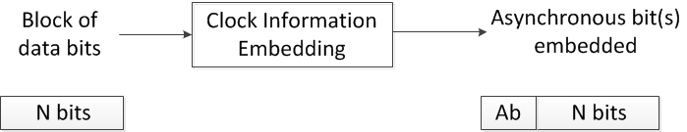
(Asynchronous bit is the clock information bit and denoted as Ab)
Figure 02– Clock information embedding into a block of data bits

15.x.2.1 Single asynchronous bit embedding for Asynchronous Communication
A single clock information bit (Ab) is embedded with N data bits to form a block of (N+1) bits that is subject to the RS-FSK encoder to map with a frequency. The number of frequencies for modulation shall be 2^{N+1} to carry all of (N+1) bits at a time. RS32-FSK operating mode utilizes 32 frequencies to map 5 bits (4 data bits along with one Ab) with a frequency symbol. Likewise, RS64-FSK operating mode utilizes 64 frequencies to map 5 data bits along with one Ab.
The embedding of a single bit shall reduce one data bit payload carried by a frequency symbol. Therefore, inserting the single clock information bit is equivalent to the use of half amount of frequencies for modulation. In other words, the bandwidth is divided in two sub-bands, the lower sub-band and higher sub-band are alternately used to modulate a block of data bits at a time.
Embedding one Ab bit into each frequency symbol helps a camera Rx dealing with asynchronous communications as presented in section X-01???

15.x.2.2 Multiple sub-bands division for lost symbol detection
The division of the bandwidth into multiple sub-bands (more than two sub-bands) and the respective use of those sub-bands to modulate a block of data bits shall support a low-frame-rate camera Rx in detecting the lost symbol during its sampling process.
In RS8-FSK and RS16-FSK operating modes, the division of the bandwidth into three sub-bands to respective use for modulating three adjacent blocks of bits shall support the detection of one lost symbol. In RS64-FSK operating mode, the division of bandwidth into four sub-bands to respective use for modulating is equivalent to the embedding of two Ab bits into every block of data bits, hence supporting the detection of the missing of two consecutive symbols.
The detection of lost symbols using Ab or sub-bands division is described in section X-02???

15.x.3 FEC Encoder
The parity code shall be used for RS8-PSK and RS16-FSK operating modes to recover the lost data symbols due to the frame rate drop problem. The selection of parity code rate depends on the probability of loss symbol. For the selected clock rate at 30Hz and the camera frame rate greater than 25fps, the lost symbol rate is assumed to be no more than 1/3; therefore the parity code rate of 2/3 is used.
For RS32-FSK and RS64-FSK operating modes, the optical clock is selected at the lower rate, 10Hz, therefore no parity code shall be used if the camera frame rate ensures every data symbol is captured at least once.

15.x.4 RS-FSK Encoder

15.x.4.1 RS8-FSK Encoder
The data mapping for RS8-FSK shall be defined as in Table 01.
Table 01 – Data mapping for RS8-FSK
Bit Pattern | Frequency Ratio
000 | $$f_{base}$$
001 | $$\frac{18}{17}f_{base}$$
010 | $$\frac{18}{16}f_{base}$$
011 | $$\frac{18}{15}f_{base}$$
100 | $$\frac{18}{14}f_{base}$$
101 | $$\frac{18}{13}f_{base}$$
110 | $$\frac{18}{12}f_{base}$$
111 | $$\frac{18}{11}f_{base}$$

Where the value of the base frequency$f_{base}=f_{1}$ shall be informed by the synchronization frame (see superframe structure, section TBD). The rest of the data frequencies, i.e., $\left\{f_{i} \right| i=2…8\}$, are determined by the ratio of them to $f_{base}$ as given in Error! Reference source not found..

15.x.4.2 RS16-FSK Encoder
The data mapping for RS16-FSK shall be defined as in Table 02.
Table 02 – Data mapping for RS16-FSK
Bit Pattern | Frequency Ratio | Bit Pattern | Frequency Ratio
0000 | $$f_{base}$$ | 1000 | $$\frac{36}{28}f_{base}$$
0001 | $$\frac{36}{35}f_{base}$$ | 1001 | $$\frac{36}{27}f_{base}$$
0010 | $$\frac{36}{34}f_{base}$$ | 1010 | $$\frac{36}{26}f_{base}$$
0011 | $$\frac{36}{33}f_{base}$$ | 1011 | $$\frac{36}{25}f_{base}$$
0100 | $$\frac{36}{32}f_{base}$$ | 1100 | $$\frac{36}{24}f_{base}$$
0101 | $$\frac{36}{31}f_{base}$$ | 1101 | $$\frac{36}{23}f_{base}$$
0110 | $$\frac{36}{30}f_{base}$$ | 1110 | $$\frac{36}{22}f_{base}$$
0111 | $$\frac{36}{29}f_{base}$$ | 1111 | $$\frac{36}{21}f_{base}$$

When transmitting frequency labels, PSDU encapsulated only one frequency$f_{base}=f_{1}$. The rest of the frequencies, i.e., $\left\{f_{i} \right| i=2…16\}$, are determined by the ratios of them to $f_{base}$ listed in Error! Reference source not found..

15.x.4.3 RS32-FSK Encoder
RS32-FSK utilizes one of 32 selected frequencies to map a block of five bits at a time including one Ab (bit b₀) and four data bits (bits b₁-b₄) into a frequency symbol. The data mapping for RS32-FSK shall be defined as in Table 03. Among five bits input, the first bit is always the Ab and the remaining four bits are actual data payload.
Table 03- RS32-FSK encoding table
Baud input  b₀ b₁ b₂ b₃ b₄ | Frequency symbol Output
f_{SF} | fo
00000 | f1
00001 | f2
. . . | . . .
11110 | f₃₁
11111 | f₃₂
f'_{SF} | f₃₃
where b₀ is an asynchronous bit Ab; b₁-b₄ are data bits.
The selection of 32 frequencies are determined as the relationship with the pair of preamble frequencies as follows:
- Two preamble frequencies: f’_{SF} = f_{SF} + 33.∆f
- Data frequency: f_{i} = f_{SF} + i.∆f (i=1; 2;…; 32)
where ∆f is the frequency separation value; f_{SF} and f’_{SF} are two preambles.

15.x.4.4 RS64-FSK Encoder
RS64-FSK utilizes one of 64 selected frequencies to map a block of six bits at a time including one Ab (bit b₀) and five data bits (bits b₁-b₅) into a frequency symbol. The data mapping for RS64-FSK shall be defined as in Table 04. Among six bits input, the first bit is always the Ab and the remaining five bits are actual data payload.
Table 04- RS64-FSK encoding table
Baud input  b₀ b₁ b₂ b₃ b₄ | Frequency symbol Output
f_{SF} | f₀
000000 | f₁
000001 | f₂
. . .
011110 | f₃₁
011111 | f₃₂
f'_{SF} | f₃₃
110000 | f₃₄
110001 | f₃₅
…
111110 | f₆₄
111111 | f₆₅
where b₀ is an asynchronous bit Ab; b₁-b₅ are data bits.

The RS64-FSK frequency band is a twice as the RS32-FSK frequency band. The first 34 frequencies of RS64-FSK (from f_{o} to f₃₃, including two preamble frequencies and 32 data frequencies) are the same as those of RS32-FSK mapping table. In addition, the remaining 32 data frequencies are calculated as follows.
- Two preamble frequencies: f’_{SF} = f_{SF} + 33.∆f
- The first 32 data frequencies: f_{i} = f_{SF} + i.∆f (i=1; 2;…; 32)
- The last 32 data frequencies: f_{i} = f’_{SF} + (i-33).∆f (i=34; 35; …;65)
where ∆f is the frequency separation value; f_{SF} and f’_{SF} are two preambles.

15.x.4.5 Hybrid RS64-FSK/2-PSK Encoder
The 64-FSK in hybrid RS64-FSK/2-PSK is achieved by allocating 64 frequencies on the selected band, the same as RS64-FSK. PSK modulation is additionally used to tackle the higher link capacity (i.e. spectrum efficiency). For rectangular wave in RS64-FSK, 2-PSK is utilized to gain one more bit per frequency symbol.
Also, support for asynchronous communication is mandatory. Hence to support asynchronous demodulation of 2-PSK signal, a pair of light sources is used instead of a single light source. Figure 03 shows a design of LED lighting in using pairs of LEDs for transmitting a hybrid signal of 2-PSK and RS64-FSK. For 2-PSK modulation, bit “0” is mapped by modulating the same phase signals to a pair of light sources, whereas bit “1” is mapped by modulating the inverse-phase signals to the pair of light sources.
Also, the hybrid modulation is advantageous in communication distance from 2-PSK without reducing the link capacity of RS64-FSK. At a far distance that the size of light source on the captured image is considerably small and the camera Rx cannot distinguish frequencies, it is still able to demodulate the 2-PSK information from the phase relationship between signals at a pair light sources.
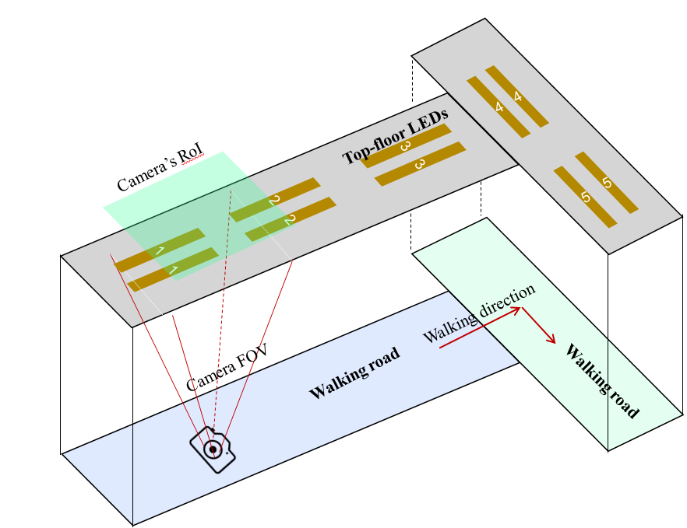
Figure 03– A lighting system using pairs of light sources for hybrid RS64-FSK and 2-PSK modulation

15.x.5 Dimmer
RS-FSK supports dimming by changing the duty cycle of the transmitted signal to achieve the desired dimming output. The duty cycle can be varied in steps of TBD.

Annex X

X.1 Asynchronous Communication using Asynchronous bit
This annex describes the asynchronous communication in which Ab is sent along with data bits every frequency symbol to support time-variant frame rate camera decoder.

X.1.1 Frequency allocation and data mapping
X.1.1.1 Bandwidth
A bit of clock information (Ab) is inserted to the beginning data bits to form a block of bits that is subject to map into a frequency symbol. Figure X1 illustrates an example of encoding procedure to map data into frequency symbol.
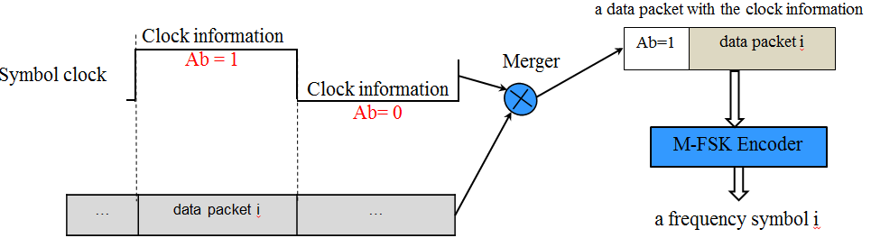
Figure X1– Data and clock information merging in frequency domain

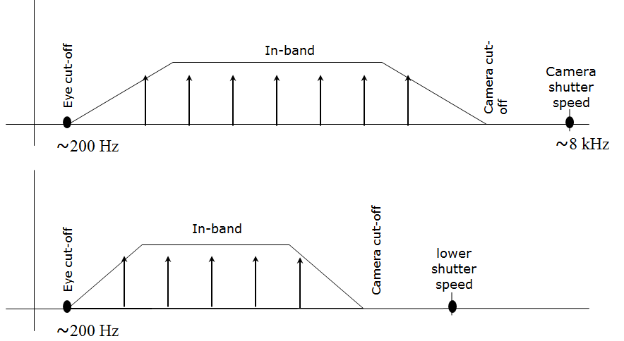
Figure X2– Frequency band used for M-FSK Encoder
Typically, a rolling shutter camera, such as Smartphone camera has a fixed shutter speed at 8 kHz. The cut-off frequency of the camera is the upper limit value for the frequency band. The frequency band is also lower limited by the eye cut-off frequency to ensure being invisible to human eye. Therefore, the selection of bandwidth for frequency modulation is recommended in within [200Hz; 6 kHz].
The frequency separation, however, has limited by the sampling rate of the image sensor. The sampling rate here is the pixel read-out rate of the image sensor, therefore depending on the selected resolution as well. The frequency separation is chosen to be wide enough for the commercial cameras, such as Smartphone cameras being able to distinguish the transmitting in-band frequencies. Figure X2 illustrates the selected frequency band and frequency separation.

X.1.1.2 Frequency separation selection
The sampling rate (of image sensor, the frequency at which a row of pixels is sampled) must be at least twice the rate of the highest frequency on the signal, according to Nyquist's theorem. This relationship is described by the equation:
$f_{max}=f_{Nyquist}= \frac{f_{s}}{2}$ (1)
where
f_{max} is the maximum resolvable frequency
f_{Nyquist} is the Nyquist frequency
f_{s} is the sampling rate of image sensor (i.e. pixel row sampling)
The frequency resolution ($∆$f) is dictated by the acquisition time:
$∆f=\frac{1}{T}= \frac{f_{s}}{N_{row}}$ (2)
where
T is the acquisition time (of a rolling image)
N_{row} is the number of samples (pixel rows) acquired throughout the diameter of light source along with the rolling direction of image sensor.
f_{s} is the sampling rate (the rolling frequency of pixel row).

The condition for a camera Rx being able to differentiate a frequency is that the size of light source on the captured image is large enough.
$N_{row}\left(d\right)≥ \frac{f_{s}}{∆f}$ (3)
where
N_{row}(d) is the actual number of samples (pixel rows) acquired from the captured image of light source at distance d.
fs is the sampling rate (the rolling frequency of pixel row).
$∆$f is the frequency separation of M-FSK.

The actual number of samples (pixel rows) acquired from the captured image of light source at distance d is calculated as.
$N_{row}\left(d\right)= w \frac{L/(2tan\left(\frac{FOV}{2}\right)}{d }$ (4)
where w is the image width (in case the rolling axis is along with the width of the image sensor)
L is the normalized length (diameter) of the light source along with the width of the image sensor
d is the distance between light source Tx and camera Rx
FOV is the field of view of camera.

The requirement of light source size on the captured image leads to the upper-limited communication distance as follows
$$d ≤ \frac{\left(∆f\right) w}{f_{s}} (L/(2tan\left(\frac{FOV}{2}\right))$$
The maximum distance of transmission is proportional to the frequency resolution and the size (diameter) of light source.

Example:
For a system with typical webcam is used, the sampling rate of image sensor is fs = 15.323 kHz, and the lowest resolution of camera has N_{row} = 480. The minimum frequency separation is computed as:
$(∆f)_{min}=f_{s}/N_{row} =31 Hz$.
For RS64-FSK or RS32-FSK, with 100Hz frequency resolution is utilized, the maximum distance is
$$d_{max}= \frac{\left(100 Hz\right) ×480}{15.323 kHz} (1.2 meter/(2×tan\left({30}^{0}\right))=3.26 meter$$
For RS16-FSK or RS8-FSK, with 400Hz frequency resolution is utilized, the maximum distance is
$$d_{max}= \frac{\left(400 Hz\right) ×480}{15.323 kHz} (1.2 meter/(2×tan\left({30}^{0}\right))=13.02 meter$$
The distance is achieved at much further if the frequency separation is high. The trade-off between distance and data rate should be considered for the design of system. The proposed four operating modes satisfy the distance requirement for intended indoor scenario.

For a system with Smartphone Nexus 5x is used, the sampling rate of image sensor is fs = 34.53 kHz, and the selected resolution of camera has N_{row} = 960. The minimum frequency separation is computed as:
$(∆f)_{min}=f_{s}/N_{row} =36 Hz$.
For RS64-FSK or RS32-FSK, with 100Hz frequency resolution is utilized, the maximum distance is
$$d_{max}= \frac{\left(100 Hz\right) ×960}{34.53 kHz} (1.2 meter/(2×tan\left({30}^{0}\right))=2.89 meter$$
For RS16-FSK or RS8-FSK, with 400Hz frequency resolution is utilized, the maximum distance is
$$d_{max}= \frac{\left(400 Hz\right) ×960}{34.53 kHz} (1.2 meter/(2×tan\left({30}^{0}\right))=11.56 meter$$
From the calculation, the RS-FSK performance does not have much dependence on the type of smartphone image sensors. In other words, RS-FSK has stability.

X.1.2 Time-Variant Frame Rate Camera Rx Decoder
An asynchronous bit Ab is sent along with data bits every frequency symbol. Assume the camera Rx has time-variant frame rate but still ensure every symbol is captured at least once. The remaining problem of asynchronous communication is that Rx should implement down-sampling correctly.

Tx | Data symbol #i  b₀ b₁ b₂ b₃ b₄ |  |  | Data symbol #(i+1)  b₀ b₁ b₂ b₃ b₄
 | Clock information: b₀ = Ab=0 |  |  | Clock information: b₀ = Ab=1
Rx Sampling | #1 | #2 | #3 | #4 |  | #5
De-mapping | 0 b₁ b₂ b₃ b₄ | 0 b₁ b₂ b₃ b₄ | 0 b₁ b₂ b₃ b₄ | 1 b₁ b₂ b₃ b₄ |  | 1 b₁ b₂ b₃ b₄
Down-sampling | 0 b₁ b₂ b₃ b₄ |  |  | 1 b₁ b₂ b₃ b₄
Figure X3– Asynchronous Decoding with a Time-Variant Frame Rate Camera Rx
Figure X3 gives an example of asynchronous decoding with a time-variant frame rate camera Rx. After de-mapping all the captured images to bits, Rx check the first bit (Ab) to perform down-sampling correctly.
The down-sampling is incorrect if the camera frame rate drops too low resulting to the missing of data symbol during the sampling process. Under the presence of lost data symbol entirely due to the low frame rate, multiple asynchronous bits shall be sent along with data bits every frequency symbol to support the detection of lost data symbols as addressed in section X.2.

X.2 Lost Symbol(s) detection using Multiple Asynchronous bits
A pair of two asynchronous bits can generate four different states, 00, 01, 10, and 11. The states of Ab is respectively sent along with data bits as shown in Figure X4.
The detection of lost symbols is obtained following two steps. At first, the extraction of two Ab bits from the pair of bits which are de-mapped every captured image. After that, the comparison of the pair of Ab from two adjacent symbols (de-mapped from two adjacent images) will determine the lost symbol(s) in between two interested symbols.
Figure X4 indicates the successful detection of two lost symbols in between two samplings using a pair of Ab bits.
Tx | Data symbol 1  b₀ b₁ b₂ b₃ b₄ b₅ | Data symbol 2  b₀ b₁ b₂ b₃ b₄ b₅ | Data symbol 3  b₀ b₁ b₂ b₃ b₄ b₅ | Data symbol 4  b₀ b₁ b₂ b₃ b₄ b₅ | Data symbol 5  b₀ b₁ b₂ b₃ b₄ b₅
 | Ab= b₀b₁=00 | Ab= b₀b₁=01 | Ab= b₀b₁=10 | Ab= b₀b₁=11 | Ab= b₀b₁=00
Rx Sampling | #1 |  |  | #2
De-mapping | 0 0 b₂ b₃ b₄ b₅ |  |  | 1 1 b₂ b₃ b₄ b₅
Lost symbols detection |  | Detected: lost (Ab=01) symbol | Detected: lost (Ab=10) symbol

Figure X4- Demodulation with missed symbols detection using two Ab bits
In Figure X4, if Rx makes the first sampling at the data symbol 1 and the second sampling at data symbol 5, the asynchronous bits from two samplings are both equal “0 0”; therefore Rx cannot detect any lost symbol. This means that the detection is successful if the camera frame rate is no less than 1/3 of the symbol rate.

