IEEE P802.15
Wireless Personal Area Networks

Project | IEEE P802.15 Working Group for Wireless Personal Area Networks (WPANs)
Title | Draft D0 Related Sequential Scalable 2D Code Comments Resolutions on Super Frame Structure and PHY Dimming
Date Submitted | September, 2016
Source | Jaesang Cha, Vinayagam Mariappan, [SNUST], Junghoon Lee [Dongseoul Univ.], Ilkyoo Lee [Kongju National Univ.], Kongju National Univ. [Ntriever Co., Ltd], Jungkyu Rho [Jungkyu Rho], Sooyoung Chang [SYCA], Kim Jin Tae [Fivetek Co., Ltd] | Voice: [ ]  Fax: [ ]  E-mail: [chajs@seoultech.ac.kr]
Re: | Draft D0 Comment Resolution for Sequential Scalable 2D Code
Abstract | Details of Resolutions regarding to the submitted Comments on D0 are suggested for Sequential Scalable 2D Code Super Frame Structure and PHY Dimming. The proposed method is designed to operate on the application services like LED ID using Color/QR Code, etc, LBS, Emergency EXIT Signage, LED-IT and Digital Signage with Advertisement Information etc.
Purpose | Draft D0 Comments Resolutions and Editorial Revision.
Notice | This document has been prepared to assist the IEEE P802.15. It is offered as a basis for discussion and is not binding on the contributing individual(s) or organization(s). The material in this document is subject to change in form and content after further study. The contributor(s) reserve(s) the right to add, amend or withdraw material contained herein.
Release | The contributor acknowledges and accepts that this contribution becomes the property of IEEE and may be made publicly available by P802.15.

PHY DIMMING FORMART FOR SEQUENTIAL SCALABLE 2D CODE

Sequential Scalable 2D Code Dimming

The Display to camera communication dimming control is depending on the mode of embedding data (Visible or Invisible) on display system, rate at which data is repeatedly coding on video frame, and rate at which data refresh on display.
The Display Light Pattern based Transmitter with Sequential Scalable 2D Code for OCC uses the visibly embedding the data on Video display frame. The function description of proposed PHY model is given in Figure 3-1.
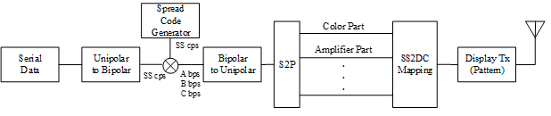
Figure 3-1 – Display Transmitter Functional Block Diagram
The Smart Device Camera Capture Visual Frame from Screen is shown Figure 3-2.
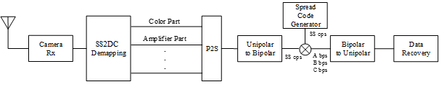
Figure 3-2 – Receiver Functional Block Diagram
The ROI of Screen Visual Area is extracted from the captured visual frame and then apply the Sequential Scalable 2D Code detector based on mapping scheme applied on the transmitter. The data recovered by applying SS on the data decoded.
The PHY VI for Display Light Pattern based Transmitter with Sequential Scalable 2D Code designed with built-in Scalable bitrate Controller by controlling the Video display refresh rate or by frames in which data to be encoded repeatedly.

SUPERFRAME STRUCTURE FOR SEQUENTIAL SCALABLE 2D CODE

Sequential Scalable 2D Code Superframe Structure

The Display Light Pattern Based Transmitter with Sequential Scalable 2D Code uses the unslotted ALOHA; that is, when the Display Light Pattern Based Transmitter with Sequential Scalable 2D Code uses has a packet to send, it just sends it. This support with beacon and without beacon support and the transmitter does not do a listen before talk channel activity check.
The super frame structure for PHY without beacon is shown in Figure 6-1.
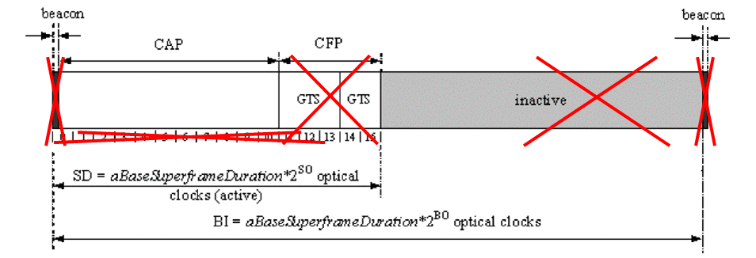
Figure 6-1 – PHY Superframe Structure without Beacon

The super frame structure for PHY with beacon is shown in Figure 6-2.
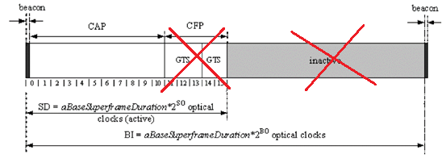
Figure 6-2 – PHY Superframe Structure with Beacon

