IEEE P802.15
Wireless Personal Area Networks

Project | IEEE P802.15 Working Group for Wireless Personal Area Networks (WPANs)
Title | Draft D0 Related Invisible Data Embedding Comments Resolutions on Super Frame Structure and PHY Dimming
Date Submitted | September, 2016
Source | Jaesang Cha, Vinayagam Mariappan, Minwoo Lee [SNUST], Kim Daehyun, Lee DongWoo [Namuga Co., Ltd], Junghoon Lee [Dongseoul Univ.], Chunseop Kim [QUBER Co., Ltd], Kim Jin Tae, Shin Jae Kwon, Yang Seung Youn [Fivetek Co., Ltd], Juphil Cho [Kunsan Nat’ Univ.], Jungkyu Rho [Seokyeong Univ.], Sooyoung Chang [SYCA] | Voice: [ ]  Fax: [ ]  E-mail: [chajs@seoultech.ac.kr]¹
Re: | Draft D0 Comment Resolution for Invisible Data Embedding
Abstract | Details of Resolutions regarding to the submitted Comments on D0 are suggested for Invisible Data Embedding Super Frame Structure and PHY Dimming. The Invisible Data Embedding is designed to operate on the application services like LED ID, Digital Signage with Advertisement Information.
Purpose | Draft D0 Comments Resolutions and Editorial Revision.
Notice | This document has been prepared to assist the IEEE P802.15. It is offered as a basis for discussion and is not binding on the contributing individual(s) or organization(s). The material in this document is subject to change in form and content after further study. The contributor(s) reserve(s) the right to add, amend or withdraw material contained herein.
Release | The contributor acknowledges and accepts that this contribution becomes the property of IEEE and may be made publicly available by P802.15.

PHY DIMMING FORMART FOR INVISIBLE DATA EMBEDDING

Invisible Data Embedding Dimming

The Display to camera communication dimming control is depending on the mode of embedding data (Visible or Invisible) on display system, rate at which data is repeatedly coding on video frame, and rate at which data refresh on display.
The Invisible Data Embedded Display TX Schemes for OCC uses the Alpha Blending or Watermarking to embed the data on Video display frame. The function description of proposed PHY model is given in Figure 3-1. First the payload is coded with SS Code and modulated by M-FSK/M-PSK/2D Code modulation schemes. The modulated data frame the Grid Framing to blend/watermarked with original video frame to display on the screen visual region. The GRID framing size can be in order of 4x4, 8x8, 16x16, 32x32, 64x64 etc. The Grid frame size selection decision left up to the system designer.
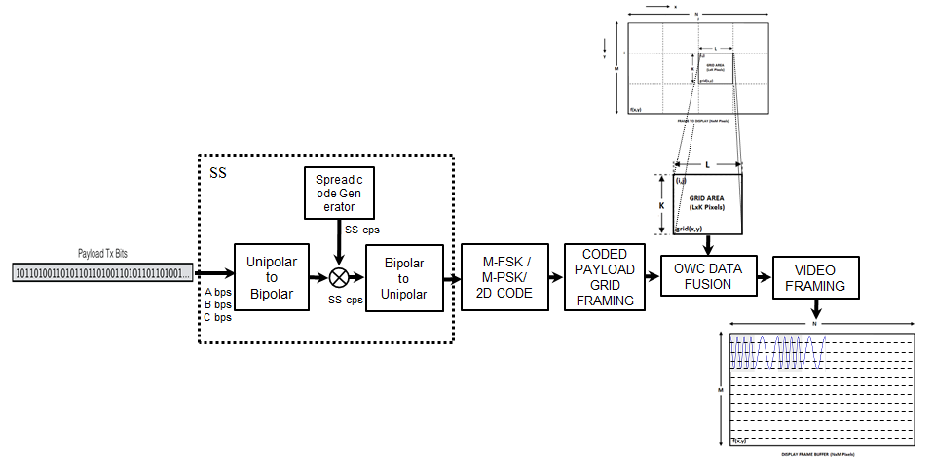
Figure 3-1 – Display Transmitter Functional Block Diagram
The Smart Device Camera Capture Visual Frame from Screen is shown Figure 3-2.
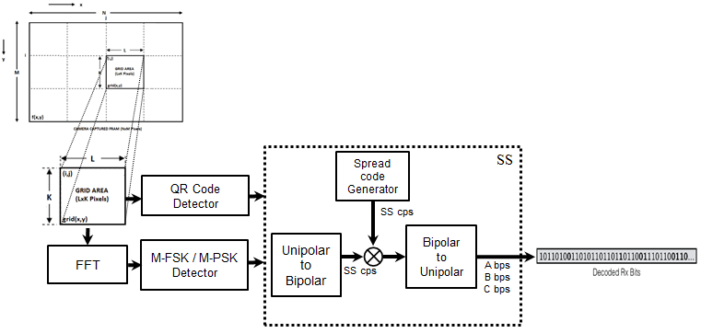
Figure 3-2 – Receiver Functional Block Diagram
To decode the data stream, the ROI of display visual area is extracted from the captured visual frame using image processing methods and then invisibly embedded data extracted using blending or watermark extraction procedure. The blending or watermark based data extraction procedure is applied based on modulation scheme used to invisibly embedding the data on the transmitter system (Supported Modulation scheme is described in 2.1 Modulation Schemes). The data embedded on display is SS Coded data so SS decoding is applied to recover original data from the visual sequence.
In addition, the invisible data embedded display TX schemes designed with built-in scalable bitrate controller by controlling visual refresh rate of the display or by frames in which data to be encoded on visual sequence.

SUPERFRAME STRUCTURE FOR INVISIBLE DATA EMBEDDING

6.2.1.8 Invisible Data Embedding Superframe Structure

The Invisible Data Embedded Display TX Schemes use unslotted ALOHA; that is, when the Invisible Data Embedded Display transmitter has a packet to send, it just sends it. This support with beacon and without beacon support and the transmitter does not do a listen before talk channel activity check.
The super frame structure for PHY without beacon is shown in Figure 6-1.
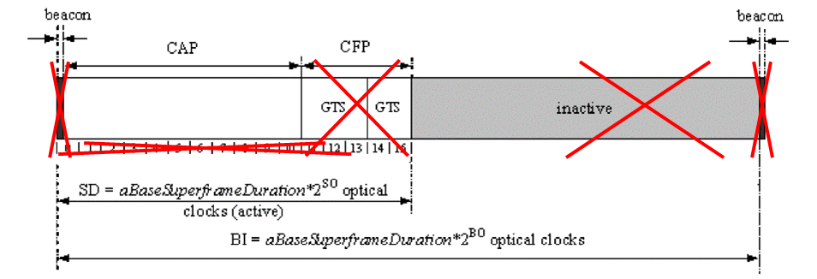
Figure 6-2 – PHY Superframe Structure without Beacon

The super frame structure for PHY with beacon is shown in Figure 6-2.
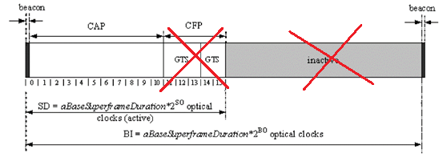
Figure 6-2 – PHY Superframe Structure with Beacon

