IEEE P802.15
Wireless Personal Area Networks

Project | IEEE P802.15 Working Group for Wireless Personal Area Networks (WPANs)
Title | Draft D0 Related Invisible Data Embedding Comments Resolutions on PHY PPDU Format and PIB Attributes
Date Submitted | September, 2016
Source | Jaesang Cha, Vinayagam Mariappan, Minwoo Lee [SNUST], Kim Daehyun, Lee DongWoo [Namuga Co., Ltd], Junghoon Lee [Dongseoul Univ.], Chunseop Kim [QUBER Co., Ltd], Kim Jin Tae, Shin Jae Kwon, Yang Seung Youn [Fivetek Co., Ltd], Juphil Cho [Kunsan Nat’ Univ.], Jungkyu Rho [Seokyeong Univ.], Gilsik Lee [Univ. of Texas], Sooyoung Chang [SYCA] | Voice: [ ]  Fax: [ ]  E-mail: [chajs@seoultech.ac.kr]¹
Re: | Draft D0 Comment Resolution for Invisible Data Embedding
Abstract | Details of Resolutions regarding to the submitted Comments on D0 are suggested for Invisible Data Embedding PHY PPDU Format and PHY PIB Attributes. The Invisible Data Embedding is designed to operate on the application services like LED ID, Digital Signage with Advertisement Information.
Purpose | D0 Comments Resolutions and Editorial Revision.
Notice | This document has been prepared to assist the IEEE P802.15. It is offered as a basis for discussion and is not binding on the contributing individual(s) or organization(s). The material in this document is subject to change in form and content after further study. The contributor(s) reserve(s) the right to add, amend or withdraw material contained herein.
Release | The contributor acknowledges and accepts that this contribution becomes the property of IEEE and may be made publicly available by P802.15.

PPDU FORMART FOR INVISIBLE DATA EMBEDDING

PPDU Format

The PPDU frame structure is formatted as illustrated in Figure 4-1 for PHY VI – 2 Dimensional / Screen Source.
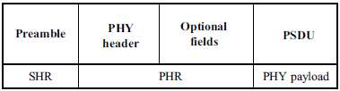
Figure 4-1 – Format of the PPDU
9.6.8.4.1 SHR Field
The SHR field is used by the transceiver to obtain optical clock synchronization with an incoming message is called Preamble. The standard defines one fast locking pattern (FLP) followed by choice of four topology dependent patterns (TDPs) for the purposes of distinguishing different PHY topologies is shown in Table 4-1.
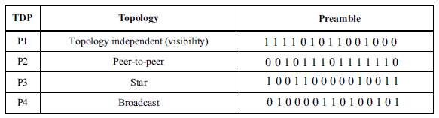
Table 4-1 – Preamble Pattern with Topologies
9.6.8.4.2 PHR Field
The PHY VI header is described as shown in Table 4-2 and shall be transmitted with data to identify the PHY Mode, Data rate, and PSDU length to identify the transmission specification.
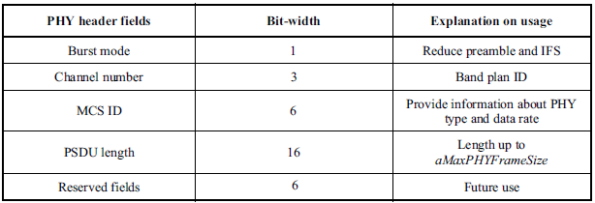
Table 4-2 – PHY Header
Burst Mode Field: The burst mode bit indicates that the next frame following the current frame is part of the burst mode. The Burst Mode bit shall be set TRUE if the burst mode is being used otherwise, the Burst Mode bit shall be set FALSE.
Channel Number Field: The channel number field for PHY shall be the band plan ID of the lowest wavelength. Refer to 9.3.1 for more detailed information.
MCS ID Field: The modulation and coding scheme (MCS) ID shall be indicated in the PHY header based on Table 83.
PSDU Field: The PSDU length field specifies the total number of octets contained in the PSDU.
9.6.8.4.3 PSDU Field
The PSDU field has a variable length and carries the data of the PHY VI frame. The FCS is appended if the PSDU has a non-zero byte payload. The structure of the PSDU field is as shown in Figure 4-2.
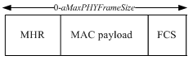
Figure 4-2 – PHY PSDU Field Structure

PHY PIP ATTRIBUTES FOR INVISIBLE DATA EMBEDDING

PHY PIB Attributes

The PHY PIB comprises the attributes required to manage the PHY sublayer of a device. The attributes contained in the IEEE802.15.7-2011 PHY PIB are presented in Table 125 - PHY PIB Attributes.
The additional PHY PIB attributes added on PHY for Invisible Data Embedding is presented in the Table 125—PHY PIB attributes (continued).

PHY PIB Table 100 Additions
Attribute | Identifier | Type | Range | Description
phyINVApplicationSpecificMode | 0x10 | Unsigned | 0~255 | This attribute specifies the application specific PHY mode.  0 : Normal Data (Media Content, Information Content based on the Application used for)  1 : ID Data  2 : Authentication Data

Table 125—PHY PIB attributes (continued)

Superframe Structure

The Invisible Data Embedded Display TX Schemes use unslotted ALOHA; that is, when the Invisible Data Embedded Display transmitter has a packet to send, it just sends it. This support with beacon and without beacon support and the transmitter does not do a listen before talk channel activity check.
The super frame structure for PHY without beacon is shown in Figure 6-1.
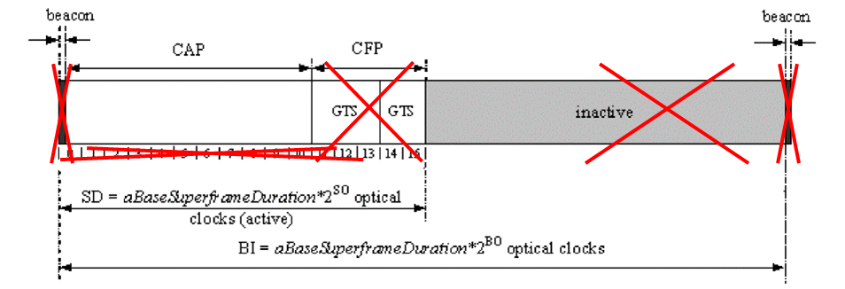
Figure 6-2 – PHY Superframe Structure without Beacon

The super frame structure for PHY with beacon is shown in Figure 6-2.
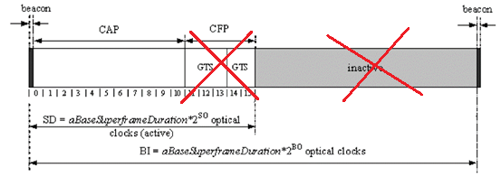
Figure 6-2 – PHY Superframe Structure with Beacon

MAC Frame Formats

The MAC frame structure is formatted as illustrated in Figure 7-1 for 2 Dimensional codes.
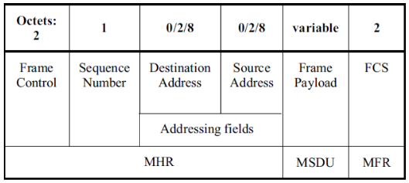
Figure 7-1 – MAC Frame Format
Frame Control Field:
The frame control field is formatted as illustrated in Figure 7-2 for 2 Dimensional codes.
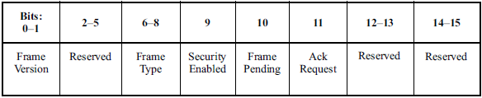
Figure 7-2 –Frame Control Field Format
Frame Version Subfield: Specifies the version number corresponding to the frame. This subfield shall be set to 0b01 to indicate a frame compatible with IEEE Standard 802.15.7r1 and all other subfield values shall be reserved for future use.
Frame Type Subfield: Specifies the Frame Type used in MAC Frame. This field shall be set to one of the non-reserved values listed in Table 7-1.
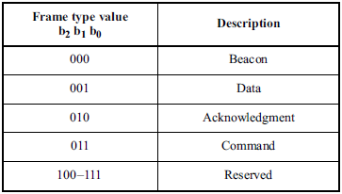
Table 7- 1 – Frame Type Subfield
Security Enabled Subfield: Species the Security on Data Frame is enable or not on transmission. This field is 1 bit in length, and it shall be set to one if the frame is protected by the MAC sublayer and shall be set to zero otherwise. The Auxiliary Security Header field of the MHR shall be present only if the Security Enabled subfield is set to one.
Frame Pending Subfield: Species the Pending on Data Frame is available or not on transmission. This field is 1 bit in length and shall be set to one if the device sending the frame has more data for the recipient. This subfield shall be set to zero otherwise.
Acknowledgment Request Subfield: Specifies whether an acknowledgment is required from the recipient device on receipt of a data or MAC command frame. This field is 1 bit in length and this subfield is set to one, the recipient device shall send an acknowledgment frame. If this subfield is set to zero, the recipient device shall not send an acknowledgment frame.
Sequence Number Field:
The Sequence Number field is 1 octet in length and specifies the sequence identifier for the frame.
For a beacon frame, the Sequence Number field shall specify a BSN. For a data, acknowledgment, or MAC command frame, the Sequence Number field shall specify a DSN that is used to match an acknowledgment frame to the data or MAC command frame.
Destination Address Field:
The Destination Address field, when present, is either 2 octets or 8 octets in length, according to the value specified in the Destination Addressing Mode subfield of the frame control field, and specifies the address of the intended recipient of the frame.
A 16-bit value of 0xffff in this field shall represent the broadcast short address, which shall be accepted as a valid 16-bit short address by all devices currently listening to the channel.
This field shall be included in the MAC frame only if the Destination Addressing Mode subfield of the frame control field is nonzero.
Source Address Field:
The Source Address field, when present, is either 2 octets or 8 octets in length, according to the value specified in the Source Addressing Mode subfield of the frame control field, , and specifies the address of the originator of the frame.
This field shall be included in the MAC frame only if the Source Addressing Mode subfield of the frame control field is 10 or 11.
Frame Payload Field:
The Frame Payload field has a variable length and contains information specific to individual frame types. If the Security Enabled subfield is set to one in the frame control field, the frame payload is protected as defined by the security suite selected for that frame.
FCS Field:
The FCS field is 2 octets in length and the FCS is calculated over the MHR and MSDU parts of the frame. The FCS shall be only generated for payloads greater than zero bytes.
The FCS is an optional filed in MAC frame format and the field information generated based on payload and FCS option used in the MAC frame from RS (64, 32) / RS (160,128) / None.

MAC PIB Attributes
The MAC PIB comprises the attributes required to manage the MAC sublayer of a device. The attributes contained in the IEEE802.15.7-2011 MAC PIB are presented in Table 60 - MAC PIB Attributes. The additional MAC PIB attributes added for 2 Dimensional codes are presented the Table 8-1.
MAC PIB Attributes Table 60 Additions
Attribute | Identifier | Type | Range | Description | Default
macTxMode | 0x91 | Unsigned | 0-255 | This attribute indicates the MAC transmission mode is visible or Invisible.  0 : Visible VTASC Mode  1 : Visible Sequential Scalable 2D Code  2 : Invisible Mode – Blending Method  3 : Invisible Mode – Watermarking Method | 0
macTxCamerEnable | 0x92 | Unsigned | 0-255 | This attribute indicates the Transmitter is Enabled with Camera or not for Interactive Receiver distance specific data transfer control.  0 : Camera not connected  1 : Camera connected | 0
macRxDistance | 0x93 | Unsigned | 0-255 | This attribute notify the Receiver distance from Transmitter | 0
macTxDataType | 0x94 | Unsigned | 0-255 | This attribute indicates the type of data to be transmitted.  0 : Normal Data (Media Content, Information Content based on the Application used for)  1 : ID Data  2 : Authentication Data | 0
maxDataLength | 0x95 | Integer | 0-65535 | This attribute specify the length of the data to be transmitted | 0

Table 8-1 - MAC PIB Attributes Additions

