IEEE P802.15
Wireless Personal Area Networks

Project | IEEE P802.15 Working Group for Wireless Personal Area Networks (WPANs)
Title | Draft D0 Related Invisible Data Embedding Comments Resolutions on MAC Frame Format and MAC PIB Attributes
Date Submitted | September, 2016
Source | Jaesang Cha, Vinayagam Mariappan, Minwoo Lee [SNUST], Kim Daehyun, Lee DongWoo [Namuga Co., Ltd] , Seoungyoun Lee [Dongseoul Univ.], Chunseop Kim [QUBER Co., Ltd], Jinyoung Kim [Kwangwoon Univ.], Byongmoon Yang [Sunil Eleccomm Co. Ltd], Jeong Gon Kim[ Korea Poly' Univ.], Juphil Cho [Kunsan Nat’ Univ.] , Kim Jin Tae, Shin Jae Kwon, Yang Seung Youn [Fivetek Co., Ltd], Gilsik Lee [Univ. of Texas], Sooyoung Chang [SYCA] | Voice: [ ]  Fax: [ ]  E-mail: [chajs@seoultech.ac.kr]
Re: | Draft D0 Comment Resolution for Invisible Data Embedding
Abstract | Details of Resolutions regarding to the submitted Comments on D0 are suggested for Invisible Data Embedding MAC Frame Format and MAC PIB Attributes. The Invisible data embedding method is designed to operate on the application services like LED ID, Digital Signage with Advertisement Information etc.
Purpose | D0 Comments Resolutions and Editorial Revision.
Notice | This document has been prepared to assist the IEEE P802.15. It is offered as a basis for discussion and is not binding on the contributing individual(s) or organization(s). The material in this document is subject to change in form and content after further study. The contributor(s) reserve(s) the right to add, amend or withdraw material contained herein.
Release | The contributor acknowledges and accepts that this contribution becomes the property of IEEE and may be made publicly available by P802.15.

MAC FRAME FORMARTS FOR INVISIBLE DATA EMBEDDING

Invisible Data Embedding MAC Frame Formats

The MAC frame structure is formatted as illustrated in Figure 7-1 for 2 Dimensional codes.
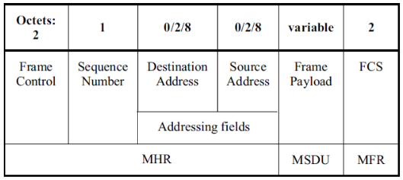
Figure 7-1 – MAC Frame Format
6.4.8.1 Frame Control Field
The frame control field is formatted as illustrated in Figure 7-2 for 2 Dimensional codes.
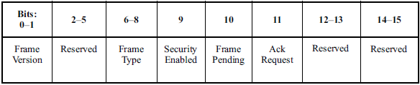
Figure 7-2 –Frame Control Field Format
        - Frame Version Subfield
Specifies the version number corresponding to the frame. This subfield shall be set to 0b01 to indicate a frame compatible with IEEE Standard 802.15.7r1 and all other subfield values shall be reserved for future use.
        - Frame Type Subfield
Specifies the Frame Type used in MAC Frame. This field shall be set to one of the non-reserved values listed in Table 7-1.
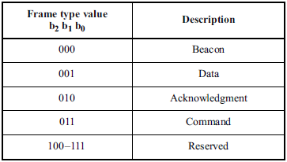
Table 7- 1 – Frame Type Subfield
        - Security Enabled Subfield
Species the Security on Data Frame is enable or not on transmission. This field is 1 bit in length, and it shall be set to one if the frame is protected by the MAC sublayer and shall be set to zero otherwise. The Auxiliary Security Header field of the MHR shall be present only if the Security Enabled subfield is set to one.
        - Frame Pending Subfield
Species the Pending on Data Frame is available or not on transmission. This field is 1 bit in length and shall be set to one if the device sending the frame has more data for the recipient. This subfield shall be set to zero otherwise.
        - Acknowledgment Request Subfield
Specifies whether an acknowledgment is required from the recipient device on receipt of a data or MAC command frame. This field is 1 bit in length and this subfield is set to one, the recipient device shall send an acknowledgment frame. If this subfield is set to zero, the recipient device shall not send an acknowledgment frame.
6.4.8.2 Sequence Number Field
The Sequence Number field is 1 octet in length and specifies the sequence identifier for the frame.
For a beacon frame, the Sequence Number field shall specify a BSN. For a data, acknowledgment, or MAC command frame, the Sequence Number field shall specify a DSN that is used to match an acknowledgment frame to the data or MAC command frame.
6.4.8.3 Destination Address Field
The Destination Address field, when present, is either 2 octets or 8 octets in length, according to the value specified in the Destination Addressing Mode subfield of the frame control field, and specifies the address of the intended recipient of the frame.
A 16-bit value of 0xffff in this field shall represent the broadcast short address, which shall be accepted as a valid 16-bit short address by all devices currently listening to the channel.
This field shall be included in the MAC frame only if the Destination Addressing Mode subfield of the frame control field is nonzero.
6.4.8.4 Source Address Field
The Source Address field, when present, is either 2 octets or 8 octets in length, according to the value specified in the Source Addressing Mode subfield of the frame control field, , and specifies the address of the originator of the frame.
This field shall be included in the MAC frame only if the Source Addressing Mode subfield of the frame control field is 10 or 11.
6.4.8.5 Frame Payload Field
The Frame Payload field has a variable length and contains information specific to individual frame types. If the Security Enabled subfield is set to one in the frame control field, the frame payload is protected as defined by the security suite selected for that frame.
6.4.8.6 FCS Field
The FCS field is 2 octets in length and the FCS is calculated over the MHR and MSDU parts of the frame. The FCS shall be only generated for payloads greater than zero bytes.
The FCS is an optional filed in MAC frame format and the field information generated based on payload and FCS option used in the MAC frame from RS (64, 32) / RS (160,128) / None.

MAC PIP ATTRIBUTES FOR INVISIBLE DATA EMBEDDING

MAC PIB Attributes

The MAC PIB comprises the attributes required to manage the MAC sublayer of a device. The attributes contained in the IEEE802.15.7-2011 MAC PIB are presented in Table 62 - MAC PIB Attributes. The additional MAC PIB attributes added for 2 Dimensional codes are presented the Table 62—MAC PIB attributes (continued).
MAC PIB Attributes Table 60 Additions
Attribute | Identifier | Type | Range | Description | Default
macTxMode | 0x91 | Unsigned | 0-255 | This attribute indicates the MAC transmission mode is visible or Invisible.  0 : Visible VTASC Mode  1 : Visible Sequential Scalable 2D Code  2 : Invisible Mode – Blending Method  3 : Invisible Mode – Watermarking Method | 0
macTxCamerEnable | 0x92 | Unsigned | 0-255 | This attribute indicates the Transmitter is Enabled with Camera or not for Interactive Receiver distance specific data transfer control.  0 : Camera not connected  1 : Camera connected | 0
macRxDistance | 0x93 | Unsigned | 0-255 | This attribute notify the Receiver distance from Transmitter | 0
macTxDataType | 0x94 | Unsigned | 0-255 | This attribute indicates the type of data to be transmitted.  0 : Normal Data (Media Content, Information Content based on the Application used for)  1 : ID Data  2 : Authentication Data | 0
maxDataLength | 0x95 | Integer | 0-65535 | This attribute specify the length of the data to be transmitted | 0

Table 62—MAC PIB attributes (continued)

