IEEE P802.15
Wireless Personal Area Networks

Project | IEEE P802.15 Working Group for Wireless Personal Area Networks (WPANs)
Title | Draft D0 Related Offset-VPWM Comments Resolutions on Super Frame Structure and PHY Dimming
Date Submitted | September, 2016
Source | Jaesang Cha, Minwoo Lee,  Vinayagam Mariappan, Soonho Jung  [SNUST], Seungyoun Lee [Dongseoul Univ.], Ilkyoo Lee [Kongju National Univ.], Sangyule Choi[Induk Unv.], Jungkyu Rho [Seokyeong Univ] , Sooyoung Chang [SYCA] | Voice: [ ]  Fax: [ ]  E-mail: [chajs@seoultech.ac.kr]
Re: | Draft D0 Comment Resolution for Offset-VPWM
Abstract | Details of Resolutions regarding to the submitted Comments on D0 are suggested for Offset-VPWM Super Frame Structure and PHY Dimming. The Flash Light designed to support LBS, Authentication, IoT/IoL, etc.
Purpose | Draft D0 Comments Resolutions and Editorial Revision.
Notice | This document has been prepared to assist the IEEE P802.15. It is offered as a basis for discussion and is not binding on the contributing individual(s) or organization(s). The material in this document is subject to change in form and content after further study. The contributor(s) reserve(s) the right to add, amend or withdraw material contained herein.
Release | The contributor acknowledges and accepts that this contribution becomes the property of IEEE and may be made publicly available by P802.15.

PHY DIMMING FORMART FOR OFFSET-VPWM

Offset-VPWM Dimming

In the Offset Variable Pulse Width Modulation for Smart Device Flash Light PHY IV uses the Smartphone Camera LED Flash light sources, no need concerning dimming. The Camera LED Flash light is no using for illumination and blinking speed is very low, then can't control dim.
- Symbol Length : P, P+V, P+2V, P+3V
The Figure 3-1 shows the 2bit symbol map dimming control for Offset Variable Pulse Width Modulation for Smart Device Flash Light.
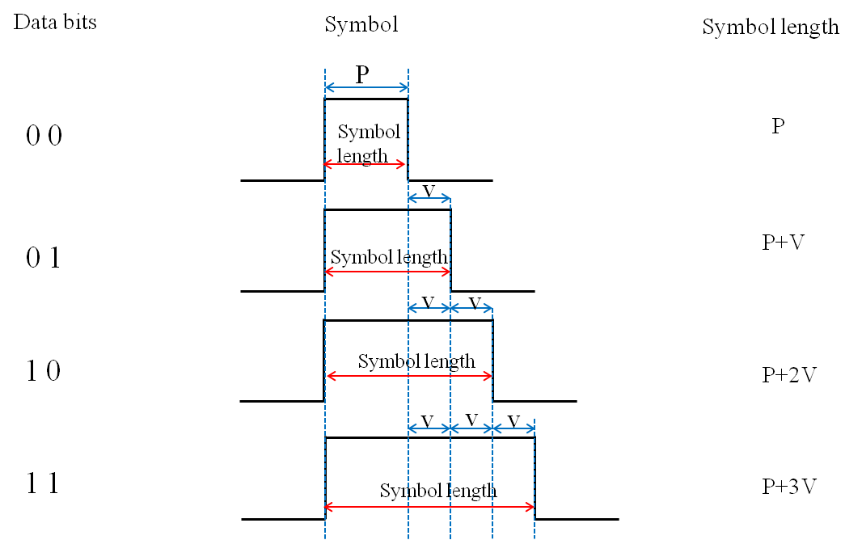
Figure 3-1 – 2 Bit Symbol Map Dimming Control

In accordance with the provisions of the symbol, depending on the data bit transmission because the High Pulse interval being determined brightness is adjustable (P >> V, V>time error (jitter)).

SUPERFRAME STRUCTURE FOR OFFSET-VPWM

Offset-VPWM Superframe Structure

The Offset Variable Pulse Width Modulation for Smart Device Flash Light PHY uses the unslotted ALOHA; that is, when the Smart Device flash light transmitter has a packet to send, it just transmit the data. This support with beacon and without beacon support and the transmitter does not do a listen before talk channel activity check.
The super frame structure for Offset Variable Pulse Width Modulation without beacon is shown in Figure 6-1.
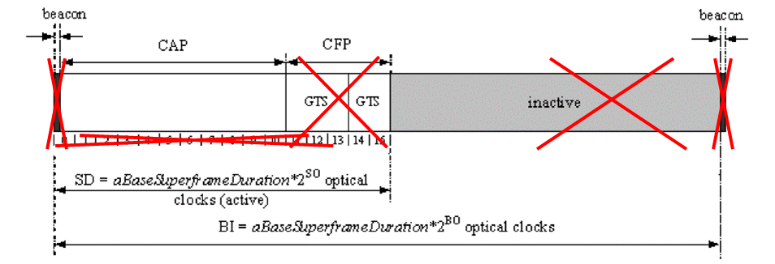
Figure 6-1 –Superframe Structure without Beacon

