IEEE P802.15
Wireless Personal Area Networks

Project | IEEE P802.15 Working Group for Wireless Personal Area Networks (WPANs)
Title | Draft D0 Related Offset-VPWM Comments Resolutions on PHY Layer Operating Modes and Specifications
Date Submitted | September, 2016
Source | Jaesang Cha, Minwoo Lee,  Vinayagam Mariappan, Soonho Jung  [SNUST], Jinyoung Kim [Kwangwoon Univ.], Junghoon Lee [Dongseoul Univ.], Ilkyoo Lee [Kongju Nat’ Univ.],Hojin Shin [Induk Univ.], Sooyoung Chang [SYCA] | Voice: [ ]  Fax: [ ]  E-mail: [chajs@seoultech.ac.kr]
Re: | Draft D0 Comment Resolution for Offset-VPWM
Abstract | Details of Resolutions regarding to the submitted Comments on D0 are suggested for Offset-VPWM PHY Layer Operating Modes and PHY Specifications. The Flash Light designed to support LBS, Authentication, IoT/IoL, etc.
Purpose | D0 Comments Resolutions and Editorial Revision.
Notice | This document has been prepared to assist the IEEE P802.15. It is offered as a basis for discussion and is not binding on the contributing individual(s) or organization(s). The material in this document is subject to change in form and content after further study. The contributor(s) reserve(s) the right to add, amend or withdraw material contained herein.
Release | The contributor acknowledges and accepts that this contribution becomes the property of IEEE and may be made publicly available by P802.15.

PHY LAYER OPERATING MODES FOR OFFSET-VPWM

Operating Modes

The Offset Variable Pulse Width Modulation for Smart Device Flash Light uses the PHY IV – Singular Point Source /Surface Light Source.
The PHY IV Operating Modes system specifications are given in Table 79. The additional PHY Operating Modes by Offset Variable Pulse Width Modulation for Smart Device Flash Light is presented the Table 79 – PHY IV Operating Modes (continued).

PHY Operating Modes
Modulation | RLL Code | Optical Clock Rate | FEC |  | Data Rate
 |  |  | Outer Code (RS) | Inner Code (CC)
OffsetVPWM | None | 25Hz | None | None | 18 bps

Table 79 – PHY IV Operating Modes (continued)

PHY SPECIFICATIONS FOR OFFSET-VPWM

Offset-VPWM

The PHY IV with supported data rates and operating conditions is shown in Table 79 – PHY IV Operating Modes (continued) for Offset Variable Pulse Width Modulation for Smart Device Flash Light data transmission.
The proposed Offset-VPWM (Variable Pulse Width Modulation) designed with following characteristics,
- Modulation methods includes line coding
- Defining the sum (P + nV) of the unit to be added to the minimum pulse (P) which is a reference pulse width (V) as a Symbol ( P>>V, V>time error(jitter) )
- Can specify a 2bit data symbol, 4bit data symbol according to number of added pulse
- Data is expressed with offset pulse width, 2bits data(for example) were mapped into 4 Offset-VPWM symbols
The data symbol map for two bits symbol with pulse width and respective symbol blinking waveform are shown in Table 2-1 and Figure 2-1 respectively.
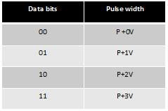
Table 2-1 – Two Bits Symbol Mapping Truth Table
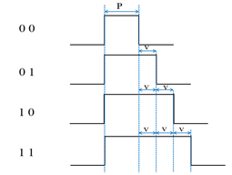
Figure 2-1 – Two Bit Symbol Data Diagram
In offset-VPWM, the data is expressed with offset pulse width, 4bits data (for example) were mapped into 16 Offset-VPWM symbols. The 4 bits symbol mapping truth table is shown in Table 2-2.
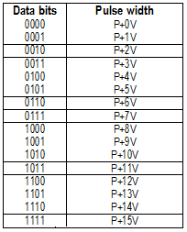
Table 2-2 – Four Bits Symbol Mapping Truth Table
The symbol arrays mapping is described in waveform pattern as shown in Figure 2-2.
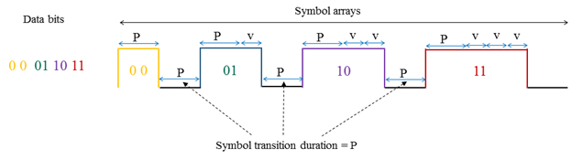
Figure 2-2 – Symbol Array Mapping Timing Diagram

Note: [Receiver Detection Method]
Receiver can synchronize rising edge and check pulse width length using Rolling-shutter method. The receiver detection process in the wave formatted approach is show in Figure 2-3.
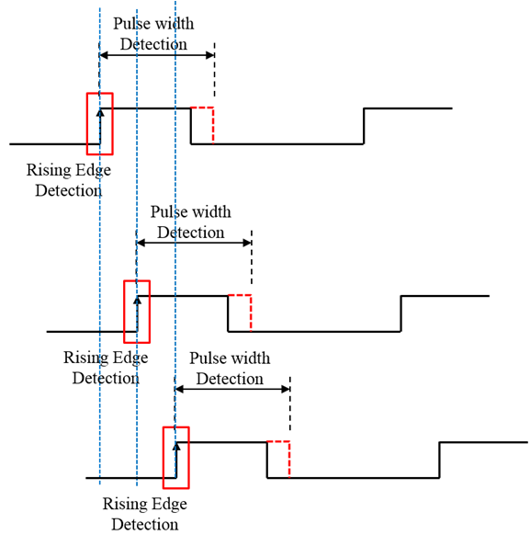
Figure 2-3 – Receiver Detection Process

