IEEE P802.15
Wireless Personal Area Networks

Project | IEEE P802.15 Working Group for Wireless Personal Area Networks (WPANs)
Title | Draft D2 Comment Resolution based PHY Modes TX Profile and RX Profile Specification Revision
Date Submitted | June 2017
Source | Jaesang Cha (SNUST), Soo Young Chang (CSUS), Vinayagam Mariappan (SNUST) | Voice: [ ]  Fax: [ ]  E-mail: [chajs@seoultech.ac.kr]
Re: | Draft D2 Comment Resolution supportive PHY Modes TX Profile and RX Profile Revision based on Modulation Schemes
Abstract | Details of Resolutions regarding to the submitted Comments on D2 are suggested for PHY Modes TX Profile and RX Profile based on Modulation Schemes. The PHY Modes TX Profile and RX Profile Revision based on Modulation Schemes is provides the specification to design of LED ID / OCC based application services like IoT/IoL, LED ID, Digital Signage with Advertisement Information, LBS, Emergency EXIT Signage, etc.
Purpose | D1 Comments Resolutions and Editorial Revision.
Notice | This document has been prepared to assist the IEEE P802.15. It is offered as a basis for discussion and is not binding on the contributing individual(s) or organization(s). The material in this document is subject to change in form and content after further study. The contributor(s) reserve(s) the right to add, amend or withdraw material contained herein.
Release | The contributor acknowledges and accepts that this contribution becomes the property of IEEE and may be made publicly available by P802.15.

Annex I (Informative)

PHY Modes TX and RX Profile

The PHY Mode TX profile defines the PHY mode specific modulation schemes based on the transmitter source classification and the RX profile defines the types of receivers supported based on the modes and modulation schemes.

I.1 PHY Modes TX Profiles:

The transmitter sources are classified into four different groups based on modulation schemes proposed on this standard. These source classifications are:
- Discrete / Single Source
- 2-Dimentsional / Multi-Source
- Surface Source
- Display / Screen Source

Each of these sources can be described as following.

Discrete / Single Source: in this type of devices, light rays are emanated in all directions, originating from a single point in space. This light source can be designed with a single LED or multiple LEDs but light ray emanation is considered as a single point space. This type of light source includes directional lights, point lights and spotlights.

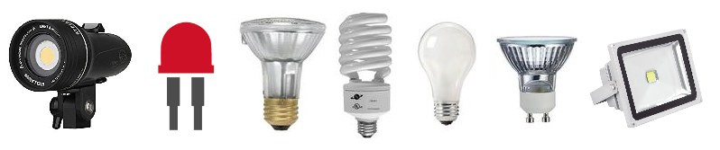
Figure - X1: Discrete / Single Source

2-Dimentsional / Multi-Source: In this type of devices, light rays are emanated in all directions, originating from multiple points and the light rays are parallel to each other in space. This light can be designed with multiple source points with each source point emanation considered as separate single source emanation.
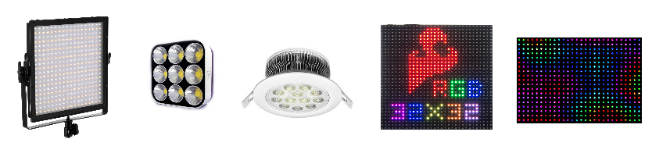

Figure -X2: 2-Dimentsional / Multi Source

Surface Source: The surface light source is a type of device in which a primary light source is disposed at the side of a light guide plate and one surface of the light guide plate serves as a luminous surface.

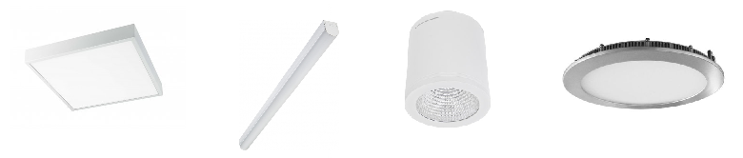

Figure - X3: Surface Source

Display / Screen Source: This type of devices utilizes visual scene output surface adopting image projection technologies that show text and often graphic images. This type includes video display terminals (VDTs), liquid crystal displays (LCDs), light-emitting diodes, gas plasmas, tablet screens, surface screens, smart phone screens, smart watch screens, and other image projection technologies.

Figure - X4: Display / Screen Source
Table X1 shows that each PHY Mode mainly supports what sorts of TX.

Table X1 – ISC/L-PD PHY Modes TX Profile

 |  | Discrete (or single) source | 2-Dimensional / Multi-Source | Surface source | Display / Screen Source
PHY I |  | x |  | x
PHY II |  | x |  | x
PHY III |  | x |  | x
PHY IV | UFSOOK | x |  | x
 | Twinkle VPPM | x |  | x
 | S2-PSK | x
 | S8-PSK | x
 | HS-PSK | x
 | Offset-VPWM | x | x | x
PHY V | NS-FSK |  |  | x
 | C-OOK |  |  | x
 | CM-FSK |  |  | x
 | Packet PWM/PPM |  |  | x
PHY VI | A-QL |  |  |  | x
 | HA-QL |  |  |  | x
 | VTASC | x | x | x | x
 | SS2DC | x | x |  | x
 | IDE-MPFSK-BLEND |  | x |  | x
 | IDE-2DBIN-WM |  | x |  | x

I.2 PHY Modes RX Profile:

The PHY Modes RX Profile gives types of decoders used for particular PHY modes. This standard includes two types of RX decoders, which are photodiode and image sensor. The photodiodes are categorized into monochrome and color photodiodes. In addition, the image sensors are categorized into global shutter, rolling shutter, and high-speed/ROI type cameras.

Table X2 shows what sorts of Rx each PHY mode mainly supports.

Table X2 – ISC/L-PD PHY Modes RX Profile

 |  | Photodiode |  | Image sensor |  |  | Other characteristics
 |  | Monochrome | Color | Global shutter | Rolling shutter | High-speed / ROI
PHY I |  | x | x
PHY II |  | x | x
PHY III |  |  | x
PHY IV | UFSOOK | x | x | x
 | Twinkle VPPM | x | x |  | x
 | S2-PSK |  |  |  | x
 | S8-PSK |  |  |  | x
 | HS-PSK |  |  |  | x
 | Offset-VPWM | x | x | x | x | x
PHY V | NS-FSK | x | x |  | x | x
 | C-OOK | x | x |  | x | x
 | CM-FSK |  |  |  | x
 | Packet PWM/PPM | x | x |  | x | x
PHY VI | A-QL |  |  |  | x | x
 | HA-QL |  |  |  | x | x
 | VTASC | x | x | x |  | x
 | SS2DC | x | x | x |  | x
 | IDE-MPFSK-BLEND | x | x | x |  | x
 | IDE-2DBIN-WM | x | x | x |  | x

