# Comment 12



## Proposed resolution

During San Diego meeting, the LIFI sub-committee has agreed that there should be four topologies (peer-to-peer, star, broadcast and coordinated) and two network functionalities (relay, hybrid RF & OWC). It is proposed to modify the text into:

*The IEEE 802.15.7r1 visible-light communication personal area network (VPAN) standard maps the intended applications to four topologies: peer-to-peer, star, broadcast and coordinated, as shown in* *Figure* *1.*



*Moreover, two advanced technologies are supported, relaying and heterogeneous networking of OWC and RF, as shown in Fig. 1a.*

Additional Fig. 1a: Advanced technologies



# Comment 13



## Proposed resolution

During San Diego meeting, the LIFI sub-committee has agreed that there should be four topologies (peer-to-peer, star, broadcast, coordinated) and two network functionalities (relay, hybrid RF & OWC). It is proposed to modify the text into:

*In the star topology, the communication is established between devices and a single central controller, called the coordinator. In the peer-to-peer topology, one of the two devices in an association takes on the role of the coordinator. In the coordinated topology, multiple devices communicate with multiple coordinators, supervised by a global controller. The global controller has a fixed network link to each coordinator. Note that the functionality of the coordinator is not part of this standard.*

*In addition, two advanced network functionalities may be enabled: relaying and heterogeneous RF&OWC. With the relaying functionality, an intermediate relay node is introduced between the coordinator and the device. With the heterogeneous RF&OWC functionality, data transmission over the optical wireless link can be combined with a parallel radio-based wireless link.*



Fig. 1a: Advanced network functionalities.

# Comment 16



## Proposed resolution

Same as comment 12.

# Comment 17

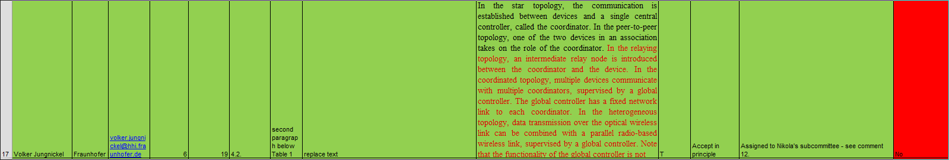

## Proposed resolution

Same as comment 13.

# Comment 18

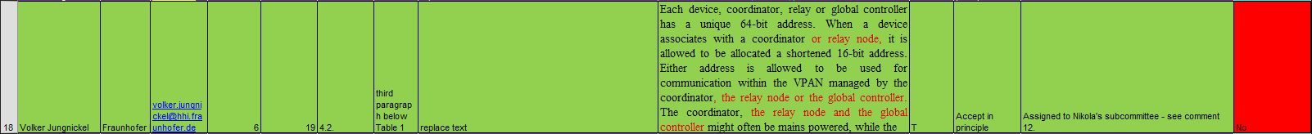

## Proposed resolution

Adopt HHI’s modification in general. Yet, HHI’s modification may has one flaw, i.e., how the address is defined for global controller is out-of-scope and should not be specified. It is proposed to modify the text into:

*Each device, coordinator or relay node has a unique 64-bit address. When a device associates with a coordinator or relay node it is allowed to be allocated a shortened 16-bit address. Either address is allowed to be used for communication within the VPAN managed by the coordinator, the relay node or the global controller. The coordinator, the relay node and the global controller might often be mains powered, while the devices will often be battery powered.*

# Comment 19



## Proposed resolution

Replace the existing figure 1 with the new figure below. HHI suggests to use in principle the version provided in comment 13 because the global controller has another functionality and should thus have another color compared to the coordinators Regarding the formatting, 1x4 or 2x2 figures, both is fine.



# Comment 20



## Proposed solution

Adopt the text from HHI in comment 29. New subsection 4.2.x is added after 4.2.3 as below:

*4.2.x Relay functionality*

*With the relay functionality, an intermediate relay is used to assist a transmission via a direct optical wireless link. With the relay functionality, each relay supports different duplexing and relay modes. For full duplex (FD), the relay receives and transmits data simultaneously, while in half duplex (HD), the relay receives the data in one time slot and retransmits it in another time slot. The relay supports two modes; amplify-and-forward (AF), and decode-and-forward (DF).*

* *In AF mode, the RD receives the data from the coordinator, which are then retransmitted after amplification.*
* *In DF mode, the received data is decoded by the relay and then retransmitted to the destination device.*

*In case the device is disconnected from the coordinator, a relay search request is conducted, including the relay capabilities. The coordinator broadcasts a relay search request frame. Each relay replies back on the control channel with its own capabilities including duplexing and relaying modes. The coordinator selects the relay that provides the best connectivity. The coordinator initiates a relay link setup procedure between the coordinator, the selected relay and the device. A connection remains active until the direct link between the coordinator and the device is reinitiated and the coordinator requires a termination of the link between the coordinator and the relay.*

# Comment 21



## Proposed solution

Adopt the text from HHI in comment 30 in general. New subsection 4.2.y is added after 4.2.3 as below:

*4.2.y Coordinated topology*

*The basic structure of a coordinated topology is illustrated in Figure 1. In the coordinated topology, multiple coordinators are connected to each other and to a global controller through backhaul network. The backhaul is out of the scope of this specification. Multiple VPANs are coordinated by the global controller. The global controller may be in charge of various kinds of coordination among the multiple VPANs, e.g. handover, interference management, VPAN status monitoring, etc.*

# Comment 22



## Proposed solution

An updated figure is used, see comment 19.

# Comment 23

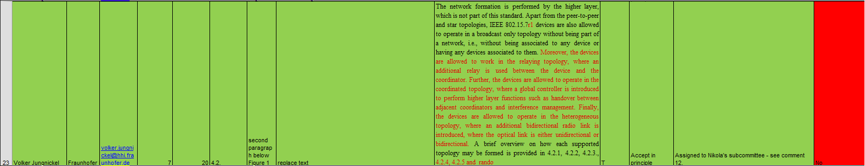

## Proposed solution

Adopt HHI’s text in general, revise according to our agreement on “four topology and two network functionalities”, as below.

*The network formation is performed by the higher layer, which is not part of this standard. Apart from the peer-to-peer and star topologies, IEEE 802.15.7r1 devices are also allowed to operate in a broadcast-only topology without being part of a network, i.e., without being associated to any device or having any devices associated to them. Moreover, the devices are allowed to operate in the coordinated topology, where a global controller is introduced to perform higher layer functions such as handover between adjacent coordinators and interference management.*

*In addition, IEEE 802.15.7r1 devices are allowed to operate with relay network functionality, where an additional relay is used between the device and the coordinator. Finally, the devices are allowed to operate with heterogeneous RF&OWC network functionality, where an additional bidirectional radio link is introduced, where the optical link is either unidirectional or bidirectional.*

*A brief overview on how each supported topology may be formed is provided in* *4.2.1,**4.2.2,*  *4.2.3, 4.2.4, 4.2.5 and 4.2.6.*

# Comment 24



## Proposed solution

Modify the text as below:

*In case illumination function is required, visibility support is also provided in the absence of communication or in the idle or receive modes of operation. The purpose of this mode is to maintain illumination and mitigate flicker.*

# Comment 25



## Proposed solution

* + - 1. Section 4.3 (Huawei version of network topologies) is removed. And the sentence that the comment against is also removed.
      2. Section 4.3.1 (Heterogeneous network of VLC and RF) is moved to 4.2.6 as a new subsection as below

*4.2.6 Heterogeneous RF & OWC functionality*

*The IEEE 802.15.7r1 specification supports heterogeneous RF&OWC functionality. The functionality may be used in conjunction with different network topologies as demonstrated in Figure 2. The RF AP may be co-located with a coordinator or a global controller. Each coordinator provides optical wireless links to the devices while the RF AP provides a parallel RF link.*



***Figure 2—Hybrid RF&OWC funcationality***

*As shown in Table xx, three types of devices according to the capabilities in supporting OWC and RF are considered for IEEE 802.15.7r1. Type 1 devices support OWC only operations. Type 2 devices support OWC downlink operations as well as RF bidirectional operations. Type 3 devices support OWC bidirectional operations as well as RF bidirectional operations.*

*Type 2 and type 3 devices can operate via OWC and RF simultaneously. In the downlink, aggregated transmission through both OWC link and RF link may be used, besides switching between OWC link and RF link. For type 2 devices, uplink traffic as well as control information may be transmitted through the RF link or relayed via the global controller to the coordinator. Specification of these networking functionalities is out of scope in 802.15.7r1.*

***Table xx—Device classification according to supported RF capabilities***

|  |  |  |  |  |  |
| --- | --- | --- | --- | --- | --- |
|  | ***Device Type*** | ***RF Down*** | ***RF Uplink*** | ***OWC*** | ***OWC Uplink*** |
|  | ***Link*** | ***Downlink*** |
|  |  |  |  |
|  |  |  |  |  |  |
|  | *Type 1* |  |  | *x* | *x* |
|  |  |  |  |  |  |
|  | *Type 2* | *x* | *x* | *x* |  |
|  |  |  |  |  |  |
|  | *Type 3* | *x* | *x* | *x* | *x* |
|  |  |  |  |  |  |

# Comment 26



## Proposed solution

Section 4.3 is removed, see comment 25. For the length of the device address, the 15.7-2011 approach is going to be kept, i.e. 64 bit long address and 16 bit short address. See section 4.2 of D0.

# Comment 27



## Proposed solution

Same as comment 26.

# Comment 28



## Proposed solution

Same as comment 26.

# Comment 29

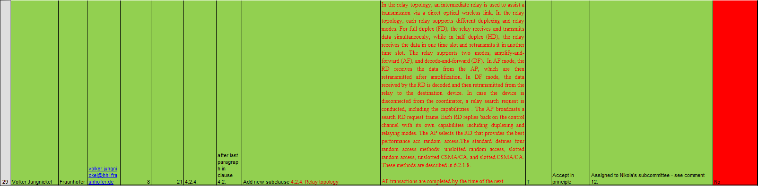

## Proposed solution

Same as comment 20.

# Comment 30

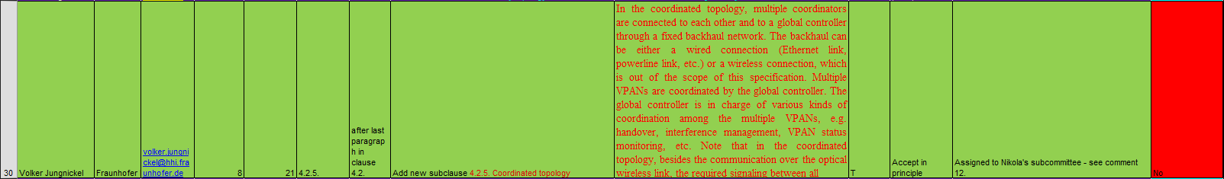

## Proposed solution

Same as comment 21.

# Comment 31

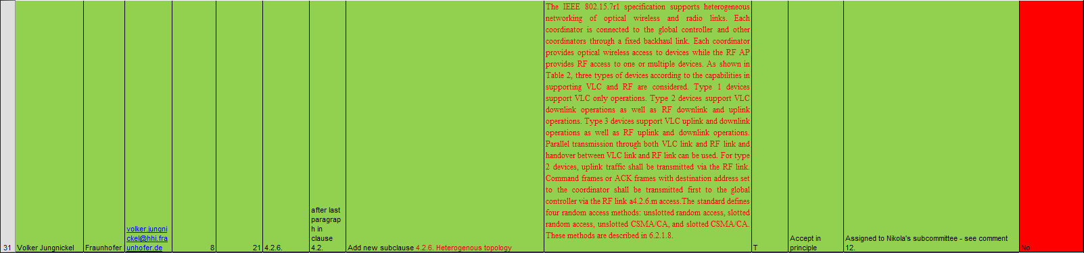

## Proposed solution

HHI’s text is adopted in general. A new subsection *4.2.6 Heterogeneous RF & OWC functionality* is inserted, see comment 25.

# Comment 32



## Proposed solution

As hybrid RF&OWC is a network functionality, it can be used in conjunction with different network topologies. It is envisioned that, for different topologies, the RF AP may located at different nodes. For example, as shown in the figure below, RF AP may co-located with a coordinator in star topology while co-located with a global controller in coordinated topology.



For coordinated network, it may be beneficial to have RF-AP to be co-located with global controller rather than coordinator. Because firstly, the cost should be lower, there is only one RF AP for multiple VPANs rather than one for each VPAN. Secondly, the coverage of RF and OWC is significantly different. Have one RF AP should be enough to cover the coverage of multiple OWC coordinators.

It is proposed that:

1. Move section 4.3.1 to 4.2.6 (See comment 25)
2. The uplink command frames and ACK frames processing is described only for coordinated topology. And change all “shall” to “may”, as shown below.

*For coordinated topology, command frames or ACK frames with destination address set to the coordinator may be first transmitted to the global controller through RF link and then forwarded to the coordinator through the backhaul link.*

# Comment 45



## Proposed solution

As discussed during San Diego meeting, polling is a contention-free access method, and may be used within CFP.

Since 15.7-2011 already has a complete contention-free access mechanism, i.e., GTS, introduction of polling will results in two mechanisms for CFP.

* Right now, Huawei is not convinced why there is a need to keep two contention-free access methods. More analysis or evaluations maybe needed in the future.

HHI is in favor of allowing both, GTS and polling.It is proposed to adopt the following text:

*Any device wishing to communicate during the contention access period (CAP) between two beacons competes with other devices via random access. The standard defines four random access methods: unslotted random access, slotted random access unslotted CSMA/CA, and slotted CSMA/CA. These methods are described in* *6.2.1.8.* *Any device wishing to communicate during the contention free period (CFP) between two beacons use resources assigned by the coordinator. The standard defines two contention-free access methods: [GTS and polling]. These methods are described in x.x.x.x.*

# Comment 46



## Proposed solution

Hidden node problem: Because of the limitation of FOV, Device 1 cannot hear the signal from Device2. Therefore Device1 may not be able to sense the signal transmitted by Device2 when Device2 is making a random access. It results in collision. Current CSMA/CA procedure in 802.15.7 does not provide any hidden node avoidance mechanisms.

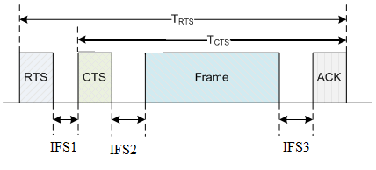

Polling and GTS may be able to solve the problem. But both are supposed to be used only in CFP.

Since RTS/CTS is the most widely used scheme to solve the hidden node problem, it is proposed to adopt RTS/CTS in 15.7r1.

It is proposed to adopt the following modification

1. *A beacon frame, used by a coordinator to transmit beacons.*
2. *A data frame, used for all transfers of data.*
3. *An acknowledgment frame, used for confirming successful frame reception. Note that a data frame and an ACK frame for the reverse link direction can be combined to avoid the additional interframe spacing and reduce latency.*
4. *A MAC command frame, used for handling all MAC peer entity control transfer.*
5. *A control frame, used for RTS/CTS procedure*
6. *A CVD frame, used to maintain the proper light intensity between data frames, support dimming and for visually providing information such as communication status and channel quality to the user.*

# Comment 47



## Proposed solution

It is proposed to adopt RTS/CTS in 15.7r1, the reason is addressed in comment 46.

It is proposed to adopt the following modification:

*The IEEE 802.15.7r1 VPAN uses four types of channel access mechanism, depending on the network configuration. Non-beacon-enabled VPANs use an unslotted random channel access mechanism, with or without CSMA/CA, as described in* *6.2.1.8.* *Each time a device wishes to transmit data frames or MAC commands, it waits for a random back off period. Following the random back off, the device transmits its frame of data. If the optional carrier sense mechanism is active and the channel is found to be busy following the random back off, the device waits for another random period before trying to access the channel again. Acknowledgment frames are sent without using a random access mechanism (i.e., scheduled).*

*Beacon-enabled VPANs use a slotted random channel access mechanism, with or without CSMA/CA, where the back off slots are aligned with the start of the beacon transmission. Each time a device wishes to transmit data frames during the CAP, it locates the boundary of the next back off slot and then waits for a random number of back off slots. If the optional collision avoidance mechanism is active, and the channel is busy, following this random back off the device waits for another random number of back off slots before trying to access the channel again. If the channel is idle or the optional carrier sense mechanism is not active, the device begins transmitting on the next available back off slot boundary. Acknowledgment and beacon frames are sent without using a random access mechanism (i.e., scheduled).*

*RTS/CTS mechanism is used in addition, if configured.*

# Comment 53



## Proposed solution

The approach 1 and approach 2 here is used to solve the **bandwidth ambiguity issue** in CAP.

Since there is going to be multiple bandwidths to be supported in 15.7r1, 10 MHz / 25 MHz / 50 MHz / 100 MHz / 200 MHz / 500 MHz / 1 GHz according to table 152 of 15.7D0, devices in the same VPAN may transmit in different bandwidth. For the CAP, 15.7-2011 uses CSMA/CA for contention-based channel access (without RTS / CTS). The coordinator has no idea which device will transmit next in the CAP. So the coordinator does not know which bandwidth to use for the reception. One example is shown in the figure below. As both device 1 and device 2 may transmit in CAP, coordinator does not know which bandwidth is assumed for reception.



There could be several solutions for this:

* Option 1: Coordinator can use blind decoding: coordinator will try to use all possible bandwidth for demodulation and one of them will fit the transmission. But the complexity is high.
* Option 2: Always use minimal bandwidth in CAP: require all devices to use minimal bandwidth in CAP, then coordinator will have no problem for reception no matter which device is transmitting. However, it means severe reduction in efficiency. For example, for a device of 50MHz capability, transmitting in 10MHz means 80% data rate reduction.
* Option 3: Divide CAP into multiple bandwidth regions, and one region for one specific bandwidth transmission. The coordinator can first inform the devices about the division of the regions in the beacon, so that each device knows which region to use for contention based on the bandwidths it supports. Then in each region, the coordinator will use the specific bandwidth for reception. So there is no bandwidth ambiguity issue.
* Option 4: Use RTS/CTS: devices firstly transmit RTS frame (which is always in minimal bandwidth), after the reception of RTS frame the coordinator knows which device is transmitting. Coordinator then assign the bandwidth used for future transmission in CTS. So the device wins the contention can use the bandwidth negotiated during RTS/CTS. This approach also solve the bandwidth ambiguity issue. In addition, it solves the hidden node problem at the same time.

Based on the above analysis, it is proposed to adopt the last two approaches to solve the bandwidth ambiguity problem.

It is proposed to adopt the following text:

***6.2.1.x Multiple modulation bandwidths supporting***

*The coordinator and the devices in the VPAN may support different modulation bandwidths and the coordinator has no prior knowledge of which device will win during the contention in the CAP. To support multiple modulation bandwidths, the coordinator can divide the CAP into multiple regions according to the modulation bandwidths that the associated devices use. The procedure is described in this section. Alternatively, the coordinator may keep the CAP undivided. In this case, the RTS/CTS mechanism for undivided CAP shall be used as described in clause x.x.x.x.*

*The coordinator records the supported modulation bandwidth of each associated device in its VPAN during association (see clause xxx ). It may divide the CAP into multiple regions, each dedicated to a specific modulation bandwidth, according to the records. For each region, only the frames that are modulated using the specific bandwidth are allowed. The coordinator shall indicate the division of the CAP in the beacon frame, indicating a modulation bandwidth for each region respectively in the CAP descriptor subfield (see clause xxx).*

*A device shall transmit and receive in a particular region using the modulation bandwidth as indicated in the beacon frame. When a device attempts to transmit a frame, it shall locate the region that it is allowed to transmit according to the modulation bandwidths it can support.*

*At least one region for the transmission using the minimum modulation bandwidth shall be preserved, which can be used for the association of new devices.*

*The coordinator and a device shall set the operation modulation bandwidth according to the following rules:*

*The downlink PPDUs shall be modulated with the modulation bandwidth of BW_SEL1 that is equal to or lower than MAX_BW_SEL1. MAX_BW_SEL1 equals to min{max COODINATOR_Tx_modulation_bandwidth, max DEVICE_Rx_modulation_bandwidth}[1], the PPDU carrying the corresponding ACK frames shall be modulated on the modulation bandwidth of BW_SEL2 that is equal to or lower than MAX_BW_SEL2. MAX_BW_SEL2 equals to min{max COODINATOR_Rx_modulation_bandwidth, max DEVICE_Tx_modulation_bandwidth}[2].*

*The uplink PPDUs shall be modulated on the modulation bandwidth of BW_SEL2 that is equal to orlower than MAX_BW_SEL2. MAX_BW_SEL2 equals to min{max COODINATOR_Rx_modulation_bandwidth, max DEVICE_Tx_modulation_bandwidth}. And the PPDU carrying the corresponding ACK frames shall be on the modulation bandwidth of BW_SEL1 that is equal to orlower than MAX_BW_SEL1. MAX_BW_SEL1 equals to min{max COODINATOR_Tx_modulation bandwidth, max DEVICE_Rx_modulation bandwidth}.*

*Both the coordinator and the devices shall receive with the modulation bandwidth indicated in the CAP descriptor subfield of the beacon for each region.*

***6.2.1.y RTS/CTS mechanism for divided CAP***

*If the CAP is divided into multiple regions, as specified by clause x.x.x.x, the RTS/CTS mechanism can be applied in each region. The decisions on whether the RTS/CTS protocol is applied is out of the scope of this standard. The coordinator shall indicate whether RTS/CTS protocol is applied in the xxx subfiled in beacon frame (see clause xxxx).*

*If the coordinator indicates that the RTS/CTS protocol is used in a region of the CAP, transmission on uplink in this region shall use the RTS/CTS protocol. The RTS/CTS protocol should not be used for the downlink transmissions.*

*A device that gains the right for transmission after contention shall transmit an RTS frame prior to the transmission of the data/command frame. After receiving the RTS frame successfully, the coordinator shall transmit a CTS frame to the device that sourced the RTS frame. The device shall continue to transmit the data/command frame only if it has received the corresponding CTS frame after the RTS frame it has sent.*

*If the device does not receive the CTS frames during SIFS after it sent the RTS frame, it shall not transmit the data/command frame and shall try to compete to resend the RTS frame. Transmission of a frame sequence including a data/command frame with ACK using RTS/CTS is illustrated in Figure xx.*

*The RTS/CTS/ACK frames shall be transmitted using the modulation bandwidth that is indicated for the region by the coordinator.*

**

***Figure x An example of the usage of RTS/CTS***

***6.2.1.z RTS/CTS mechanism for undivided CAP***

*If the CAP is not divided into multiple regions as specified by clause x.x.x.x, the following RTS/CTS protocol shall be applied. The coordinator shall indicate the application of the RTS/CTS protocol in the xxx subfiled of the beacon (see clause xxx)*

*A device shall determine if the RTS/CTS protocol shall be used according to the beacon frames. If the RTS/CTS protocol shall be used, a device shall compete for the transmission of the RTS frame first. When the device gains the right for transmission after contention shall transmit an RTS frame. RTS is transmitted using the minimal bandwidth. The RTS frame shall include the modulation bandwidth that the device support, which can be used by the coordinator to determine the bandwidth for future receptions.*

*After receiving the RTS frame successfully, the coordinator shall transmit a CTS frame to the device that sourced the RTS frame. The coordinator shall record the modulation bandwidth that indicated in the received RTS frame, and use this modulation bandwidth to receive the following data/command frame.*

*The device shall continue to transmit the data/command frame using the modulation bandwidth indicated in previous RTS frame, only if it has received the corresponding CTS frame after the RTS frame it has sent. If the device does not receive the CTS frames during SIFS after it sent the RTS frame, it shall not transmit the data/command frame and shall try to compete to resend the RTS frame. The coordinator may send an ACK frame following the data/command frame, if requested. Transmission of a frame sequence including a data/command frame with ACK using RTS/CTS is presented in Figure x.*

*In this RTS/CTS mechanism, the coordinator and a device shall set the operation modulation bandwidth according to the following rules:*

*The PPDU carrying a RTS/CTS/ACK frame shall be modulated on the minimum modulation bandwidth. The PPDUs carrying data/command shall be modulated on the modulation bandwidth that is indicated in the RTS frame.*

*For the downlink transmissions, the coordinator shall use the same RTS/CTS protocol described above.*

*Regarding the broadcast downlink transmission, the coordinator shall modulate the frames on the minimum bandwidth.*

# Comment 54



## Proposed solution

Same as comment 53.

# Comment 58



## Proposed solution

* + - 1. It is proposed that the optical clock rate is based on the sampling interval of OFDM symbols. HHI has provide the clock rates for each bandwidth in Table 152 of D0. For example, in HHI’s proposal, OFDM duration is 5.12 us and for 50MHz bandwidth, the FFT size is 512. Therefore the optical clock rate is $\frac{1}{(5.12×{10}^{-6}/512)}=100 MHz$. See the figure below. It is suggested that PureLIFI provides corresponding optical clock rate for low bandwidth mode.

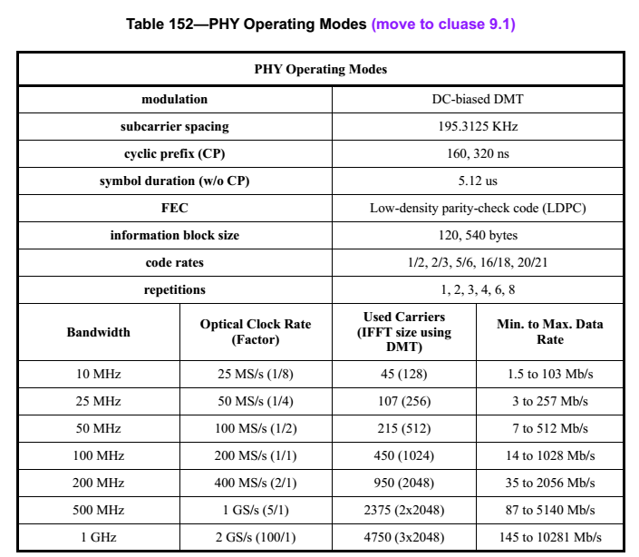

* + - 1. LIFS, SIFS and RIFS is specified in Table-88 of D0, but only for PHY I, II and III. It is proposed to include parameters for PHY VII (which is LIFI) too

To summaize, the following modfication is proposed:

1. See also comment 53: *the wait time between RTS and CTS is SIFS: If the device does not receive the CTS frames during SIFS after it sent the RTS frame, it shall not transmit the data/command frame and shall try to compete to resend the RTS frame.*
2. *Modify Table-88 of D0 with a new entry*

Table-88 Minimum LIFS, SIFS and RIFS periods

|  |  |  |  |  |
| --- | --- | --- | --- | --- |
| ***PHY*** | ***macMinLIFSPeriod*** | ***macMinSIFSPeriod*** | ***macMinRIFSPeriod*** | **Units** |
| PHY I | 400 | 120 | 40 | Optical clocks |
| PHY II | 400 | 120 | 40 | Optical clocks |
| PHY III | 400 | 120 | 40 | Optical clocks |
| PHY VII | 400 | 120 | 40 | Optical clocks |

# Comment 60



## Proposed solution

See comment 58.

# Comment 64



## Proposed solution

The text is provided below:

*6.2.2.1.3 Scan-over-backhaul*

*Scan-over-backhaul may be performed by a prospective coordinator that plans to establish a VPAN if inter-coordinator communication over backhaul is feasible.*

*Scan-over-backhaul is requested by the next higher layer of the prospective coordinator using the MLME-SCAN.request primitive with the ScanType parameter set to indicate a scan-over-backhaul, as defined in x.x.x.x. On reception of the primitive, the MLME of the prospective coordinator shall generate a scan-over-backhaul request command (see x.x.x.x) and send it to neighboring coordinators that are connected to the prospective coordinator through the backhaul. After the prospective coordinator transmitted the scan-over-backhaul request command, it may enable its receiver (on the backhaul) to receive scan-over-backhaul confirmation commands (as specified in x.x.x.x) sent by other coordinators for ScanDuration. Coordinators that have received the scan-over-backhaul request command through the backhaul respond with a scan-over-backhaul confirmation command, with its own VPAN descriptor embedded in it. When the MLME of the prospective coordinator receives a scan-over-backhaul confirmation command, it record the information contained in the unique scan-over-backhaul confirmation command in a local neighboring VPAN descriptor list. A scan-over-backhaul confirmation command frame is assumed to be unique if it contains both a VPAN ID and a source address that has not been seen before. When the ScanDuration time expires, the MLME of the prospective coordinator reports the local neighboring VPAN descriptor list to the next higher layer by issuing a MLME-SCAN.confirm primitive.*

# Comment 113



## Proposed solution

It is proposed that Tcoordination in the text is replaced by a new MAC PIB: *macCoordinationPeriod.* This is a configurable parameter. In addition, Table-62 of D0 shall include a new entry as below

|  |  |  |  |  |  |
| --- | --- | --- | --- | --- | --- |
| Attribute | Identifier | Type | Range | Description | Default |
| *macCoordinationPeriod* | TBD | Integer | 1-256 | The number of superframes that consists of a coordination period. | 10 |

# Comment 114



## Proposed solution

Same as comment 113.

# Comment 180



## Proposed solution

According to our agreement in San Diego, there are four topologies and two network functionalities. It is proposed to modify the text into:

*Peer-to-peer, star, broadcasting and coordinated capabilities, as shown in* *Figure* *1, are provided with a single MAC frame structure. All of these diverse modes are supported via a single low complexity integrated frame structure.*

# Comment 186



## Proposed solution

Huawei has removed section 5 (HUAWEI MAC protocol specification) and integrated it into section 6.2 (MAC functional description). HHI has agreed to remove section 6.5 (in comment 246 - 278). It is suggested that PureLIFI merge section 6.1 (PureLiFi MAC Superframe Structure (16/310r0)) into section 6.2 to ensure a single MAC.

# Comment 187



## Proposed solution

According to LIFI subcommittee’s discussion in San Diego, beacon period is necessary for coordinated topology. But may not be necessary for other topology. So it is suggested to adopt the following text:

*The active portion of each superframe shall be divided into aNumSuperframeSlots equally spaced slots of duration 2SO × aBaseSlotDuration and is composed of three parts: a beacon or a beacon period (BP), a CAP and a CFP. BP exists in coordinated topology. The beacon shall be transmitted, without the use of any random access, at the start of slot 0 if BP doesn’t exist. If BP exists, beacon is transmitted without the use of any random access, in one beacon slot of BP. The CAP shall commence immediately following the beacon. The CFP, if present, follows immediately after the CAP and extends to the end of the active portion of the superframe. Any allocated GTSs shall be located within the CFP.*

# Comment 188



## Proposed solution

Same as comment 187.

# Comment 189

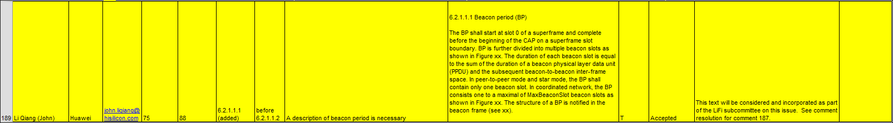

## Proposed solution

According to our discussion, beacon period is necessary for coordinated topology. But may not be necessary for other topology. So it is suggested to adopt the following text:

***6.2.1.1.1 Beacon period (BP)***

*BP exists in coordinated topology. The BP shall start at slot 0 of a superframe and complete before the beginning of the CAP on a superframe slot boundary. BP is further divided into multiple beacon slots as shown in Figure xx. The duration of each beacon slot is equal to the sum of the duration of a beacon physical layer data unit (PPDU) and the subsequent beacon-to-beacon inter-frame space. In peer-to-peer mode and star mode, the BP shall contain only one beacon slot. In coordinated network, the BP consists one to a maximal of MaxBeaconSlot beacon slots as shown in Figure xx. The structure of a BP is notified in the beacon frame (see xx).*

**

***Figure xx – Superframe structure of different topologies***

**

***Figure xx –Structure of beacon period***

# Comment 190



## Proposed solution

The figure is provided in comment 189.

# Comment 191



## Proposed solution

The figure is provided in comment 189.

# Comment 198



## Proposed solution

Section 6.2.1.6 is deleted.

# Comment 200



## Proposed solution

macMaxRABackoffs should be a MAC PIB attribute. It is proposed to insert a new entry in Table-62 of D0 as below.

|  |  |  |  |  |  |
| --- | --- | --- | --- | --- | --- |
| Attribute | Identifier | Type | Range | Description | Default |
| *macMaxRABackoffs* | TBD | Integer | 0-15 | The maximal backoff times for random access. | 4 |

# Comment 201



## Proposed solution

The problem and analysis for bandwidth ambiguity issue are provided in Comment 53. The proposed solution is the same as comment 53.

# Comment 202



## Proposed solution

The problem and analysis for bandwidth ambiguity issue are provided in Comment 53. The proposed solution is the same as comment 53.

# Comment 203



## Proposed solution

The problem and analysis for bandwidth ambiguity issue are provided in Comment 53. The proposed solution is the same as comment 53.

# Comment 205



## Proposed solution

“*macMaxEB*” in figure 63 is actually a typo for “*macMaxBE*”, which is a MAC PIB and already specified in Table 62.

It is proposed to correct the typo in figure 63.

# Comment 218



## Proposed solution

Neighboring VPAN status monitoring is used for interference coordination, handover and VPAN ID resolution. For the example shown below, interference coordination needs a device to monitor the neighboring VPANs and report to the coordinator.



It is proposed to adopt the following text:

*6.2.x Neighboring VPAN status monitoring*

*Neighboring VPANs status monitoring procedure allows the coordinator and the devices to detect and maintain neighboring VPANs information. Neighboring VPAN status monitoring maybe performed for the purposes of VPAN maintenance, interference coordination and handover.*

*Both coordinators and the devices shall participate in the neighboring VPANs status monitoring procedure.*

*The information of neighboring VPANs that can be detected shall be recorded in a neighboring VPANs descriptor list.*

*Both the coordinator and the devices shall each maintain a local neighboring VPANs descriptor list respectively. The local neighboring VPAN descriptor list is maintained by receiving beacon frames or other frames from the neighboring VPANs. When a beacon frame or any other frame from neighboring VPANs is received for the first time, a new record corresponding to the neighboring VPAN shall be added to the list. The record in the list has an ageing time of macAgeingTime superframes. Whenever a beacon frame or any other frame from a neighboring VPAN corresponding to a record in the list has been received, the device shall update the LastTimeDetected of the record instead of adding a new record. Once the beacon frames or any other frame from a neighboring VPAN corresponding to a record in the list has not been received within the ageing time since last time it was detected, the record corresponding to that neighboring VPAN shall be deleted from the list.*

*The devices shall update their local neighboring VPANs descriptor list and send a neighboring VPAN report indication command to the coordinator to report its local neighboring VPANs descriptor list whenever any of the following events occurs:*

* *It has received a beacon frame or any other frames sent by the neighboring coordinators or devices for the first time;*
* *It has been macLastDetect superframes since the neighboring VPAN was detected last time;*
* *A neighboring VPAN report request command is received by the device from the coordinator;*

*The coordinator shall update its local neighboring VPAN descriptor list whenever any of the following events occurs:*

* *It has received a beacon frame or any other frames sent by the neighboring coordinators or devices for the first time;*
* *It has been macLastDetect superframes since the neighboring VPAN was detected last time;*

*The coordinator shall also maintain a global neighboring VPAN descriptor list. The global neighboring VPAN descriptor list is maintained and updated by gathering the reported local neighboring VPAN descriptor lists from devices and its own local neighboring VPAN descriptor list. The global neighboring VPANs descriptor list is shown in Table xx.*

*The coordinator shall update its global neighboring VPAN descriptors list whenever it has received a neighboring VPAN report indication command from devices in the VPAN, or when its own local neighboring VPAN descriptors list has been updated. The coordinator shall also update the global neighboring VPAN descriptors list by deleting the corresponding information if the device which has reported the corresponding information is disassociated from the VPAN.*

***Table xx Global neighboring VPANs descriptor list***

|  |  |  |  |
| --- | --- | --- | --- |
| ***Name*** | ***Type*** | ***Valid range*** | ***Description*** |
| *Number NeighboringVPANRecords* | *Integer* | *0x00-0xff.* | *The number of records of neighboring VPANs that are maintained by the coordinator.* |
| *VPANDescriptor [0]* |  | *Refer to Table yy* | *The record of the first neighboring VPAN that can be detected by devices.* |
| *NumberDetectDevice* | *Integer* | *0x00-0xff.* | *The number of devices that have detected the neighboring VPAN specified by VPANDescriptor [0]. Assuming the total number is K.* |
| *DeviceAddr[0]* | *Integer* |  | *The short address of the first device that has reported it can detect the neighboring VPAN specified by VPANDescriptor [0].* |
| *LinkQuality[0]* |  |  | *The RSS at which the first device receives the beacon frame or other frames from the VPAN specified by VPANDescriptor [0].* |
| *……* |  |  |  |
| *DeviceAddr[K-1]* | *Integer* |  | *The short address of the Kth device that has reported it can detect the neighboring VPAN specified by VPANDescriptor [0].* |
| *LinkQuality[K-1]* |  |  | *The RSS at which the Kth device receives the beacon frame or other frames from the VPAN specified by VPANDescriptor [0].* |
| *……* |  |  |  |
| *VPANDescriptor [N-1]* |  | *Refer to Table yy* | *The record of the Nth neighboring VPAN that can be detected by devices.* |
| *NumberDetectDevice* | *Integer* | *0x00-0xff.* | *The number of devices that have detected the neighboring VPAN specified by VPANDescriptor [N-1]. Assuming the total number is L.* |
| *DeviceAddr[0]* | *Integer* |  | *The short address of the first device that has reported it can detect the neighboring VPAN specified by VPANDescriptor [N-1].* |
| *LinkQuality[0]* |  |  | *The RSS at which the first device receives the beacon frame or other frames from the VPAN specified by VPANDescriptor [N-1].* |
| *……* |  |  |  |
| *DeviceAddr[L-1]* | *Integer* |  | *The short address of the Lth device that has reported it can detect the neighboring VPAN specified by VPANDescriptor [N-1].* |
| *LinkQuality[L-1]* |  |  | *The RSS at which the Lth device receives the beacon frame or other frames from the VPAN specified by VPANDescriptor [N-1].* |

It is also proposed to insert two new entries in Table-62 of D0 as below.

|  |  |  |  |  |  |
| --- | --- | --- | --- | --- | --- |
| Attribute | Identifier | Type | Range | Description | Default |
| *macAgeingTime* | TBD | Integer | 0-255 | The ageing time of local neighboring VPANs descriptor list | 20 |
| *macLastDetect* | TBD | Integer | 0-255 | The time that a neighboring VPAN has not been detected since last detection. Used for update the local neighboring VPAN descriptor list | 20 |

# Comment 220

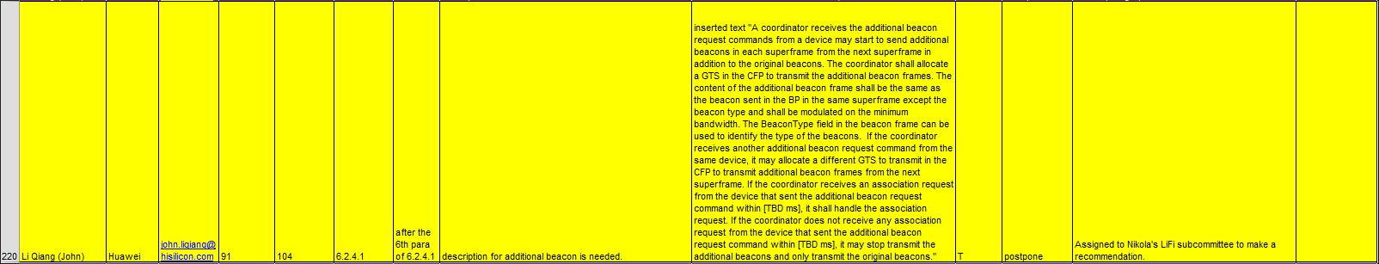

## Proposed solution

Issue: for coordinated network, superframe boundaries are aligned. There could be conflicts in beacon transmissions from neighboring VPANs. For example, as shown in the figure below, there are seven VPANs in the same room. The BP has three beacon slots, each VPAN transmit beacon in one of the slots. However there could be collisions such as VPAN1 and VPAN7, both transmitting beacons in the first slot. So if a device moves into the boundary between VPAN1 and VPAN7, it may find that it cannot detect the beacon.



It is proposed that if a device cannot detect any beacons, it send a “additional beacon request”. The coordinators that received the request allocated a GTS in CFP to transmit an “additional beacon frame” to allow the device to obtain system information. Note that comment 219 is already agreed. The following text is proposed:

*A coordinator receives the additional beacon request commands from a device may start to send additional beacons in each superframe from the next superframe in addition to the original beacons. The coordinator shall allocate a GTS in the CFP to transmit the additional beacon frames. The content of the additional beacon frame shall be the same as the beacon sent in the BP in the same superframe except the beacon type and shall be modulated on the minimum bandwidth. The BeaconType field in the beacon frame can be used to identify the type of the beacons. If the coordinator receives another additional beacon request command from the same device, it may allocate a different GTS to transmit in the CFP to transmit additional beacon frames from the next superframe. If the coordinator receives an association request from the device that sent the additional beacon request command within [TBD ms], it shall handle the association request. If the coordinator does not receive any association request from the device that sent the additional beacon request command within [TBD ms], it may stop transmit the additional beacons and only transmit the original beacons.*

# Comment 224



## Proposed solution

It is suggested that section 6.3 (Fraunhofer Superframe Structure) is merged into section 6.2.1.1 (Superframe structure). See comment 187 and comment 189.

# Comment 225



## Proposed solution

It is suggested that section 6.3 (Fraunhofer Superframe Structure) is merged into section 6.2.1.1 (Superframe structure). See comment 187 and comment 189.

# Comment 228



## Proposed solution

Since the coverage of a VPAN is limited, handover is crucial for user experience. It is proposed to adopt the following text.

***6.2.y Mobility and handover***

*Handover is used when a device moves from the coverage of one VPAN to other. Two types of handover procedures are specified,*

* *Type 1: handover initiated by device*
* *Type 2: handover initiated by global controller*

***6.2.y .1 Type 1: handover initiated by device***

*After association to a VPAN, a device may search the area for available neighboring coordinators and per-form received signal strength (RSS) measurement. The measurement is based on beacons or reference sig-nals.*

*A device may perform alpha-filtering on the measurements based on*

*Where is the latest received measurement result from the physical layer; is the updated filtered measurement result, that is used for evaluation of reporting criteria or for measurement reporting; ${RSS}_{n-1}$ is the old filtered measurement result; $α$ is a filtering-coefficient that can be configured.*

*If the RSS of neighbor cells satisfy*

$${RSS}_{n, target}-{RSS}_{n,associate}>∆_{th,1}$$

*Then the device should initiate the handover to the target coordinator. Here ${RSS}_{n, target}$ is the RSS of the target coordinator and ${RSS}_{n,associate}$ is the RSS of the associated coordinator and $∆_{th,1}$ is a predefined thresh-old.*

*Once the handover is initiated by the device, it sends a re-association request command (see x.x.x) to the target coordinator. The device uses the re-association request to request association as well as to send its preferred QoS requirements to the target coordinator.*

*In the re-association response command (see x.x.x), the target coordinator indicates whether the request is permitted. Besides, the target coordinator also inform the QoS resources allocated to the device, or suggests alternate level of QoS the target coordinator can support.*

*The previous coordinator may continue to send the packets that have been store in the buffer to the device. The device may receive these packets to its best effort. If the previous coordinator does not received acknowledgement from the device for N consecutive frames, then the previous coordinator consider the device has left the VPAN and the transmission is ceased.*

**

***Figure 21—Handover initiated by device***

***6.2.y.2 Type 2: handover initiated by global controller***

*After association to a VPAN, a device may scan the area for available neighboring coordinators and perform received signal strength (RSS) measurement. The measurement is based on beacons or reference signals.*

*A device may perform alpha-filtering on the measurements based on*

*Where is the latest received measurement result from the physical layer; is the updated filtered measurement result, that is used for evaluation of reporting criteria or for measurement reporting; ${RSS}_{n-1}$ is the old filtered measurement result; $α$ is a filtering-coefficient that can be configured.*

*The device may report the measured RSS of neighboring VPANs to the coordinator using the procedure described in x.x.x.*

*The coordinator can send the measurement report to the global controller together with the QoS requirement of the device. If the global controller decides to handover the device to the target coordinator, it sends its decision to the current coordinator. It also notify the target coordinator about the upcoming handover together with QoS requirement. The procedures for the communications between global controller and the coordinator are out the scope of this specification.*

*Current coordinator sends handover command frame to the device.*

*Then the device sends re-association request (see x.x.x) to the target device.*

*In the re-association response command, the target coordinator confirms the handover. Besides, the target coordinator also informs the QoS resources allocated to the device, or suggests alternate level of QoS the target coordinator can support.*

**

***Figure 22—Handover initiated by global controller***omment 229



## Proposed solution

It is suggested that section 6.3 (Fraunhofer Superframe Structure) is merged into section 6.2.1.1 (Superframe structure). See comment 187 and comment 189.

# Comment 239



## Proposed solution

To support various functionalities mentioned above, i.e. interference coordination, bandwidth ambiguity issue, there is a need to modify the current beacon format. It is proposed to adopt the following modification. The detailed description of these modified fields are explained in “15-16-0469-00-007a-Huawei's comments on 15.7r1 D0_companion document”

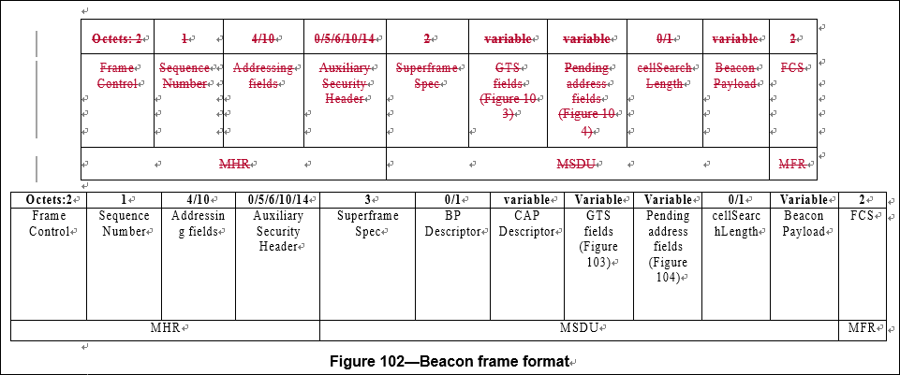

# Comment 242



## Proposed solution

The issue of beacon collision and the necessity to introduce additional beacon is discussed in comment 220. For a device to differentiate a normal beacon and an additional beacon, it is proposed to have a “Beacon type subfield” in the beacon. Therefore it is suggested to adopt the following text:

*The Beacon Type subfield shall be set to one if the beacon frame is a normal beacon which is transmitted in the beacon period regularly, and set to zero if the beacon frame is an additional beacon which is transmitted in a GTS in the CFP period.*

# Comment 244



## Proposed solution

According to our discussion in San Diego, beacon period is necessary for coordinated topology, but may not be necessary for other topology (see comment 187 and 189). To notify the configuration of a BP, a subfield is needed in the beacon. So it is suggested to adopt the following text:

***6.4.6.1.x BP Descriptor field***

*The BP Descriptor field only exists when the VPAN Mode sub-field in Superframe Specification field is set to 10, i.e., the coordinated mode.*

*The BP Descriptor field shall be formatted as illustrated in Figure xx.*

|  |  |
| --- | --- |
| *Bits: 0-3* | *4-7* |
| *Beacon Slot Number* | *Beacon Slot Used* |

***Figure xx - BP descriptor field***

*The Beacon Slot Number subfield shall contain the number of the beacon slots in the BP.*

*The Beacon Slot Used subfield shall indicates which beacon slot is used by this VPAN.*

# Comment 245



## Proposed solution

The bandwidth ambiguity issue and potential solutions are discussed in comment 53. To resolve these issues, CAP configurations needs to be indicated in the beacon. A “CAP descriptor subfield” is needed. It is proposed to adopt the following text:

***6.4.6.1.y CAP Descriptor field***

*The CAP Descriptor field shall be formatted as illustrated in Figure xx.*

|  |  |  |  |
| --- | --- | --- | --- |
| *Octets:1* | *2* | *…* | *N* |
| *Section Number* | *Section[1] Descriptor* | *…* | *Section[N] Descriptor* |

***Figure xx – CAP Descriptor field***

*The Section Number subfield indicates the number of the sections that the CAP is divided into. The CAP Descriptor field shall include N Section Descriptor, and N is the value that the Section Number subfield represents.*

*The Section[i] Descriptor shall be formatted as illustrated in Table xx.*

***Table xx Section descriptor***

|  |  |
| --- | --- |
| ***Bit position*** | ***Function*** |
| *0-7* | *The end time of this section.* |
| *8-11* | *The bandwidth that is allowed to use in this section.*  *000 represents all bandwidth.*  *001-111: Reserved* |
| *12-13* | *If RTS/CTS is used in this section*  *00: No*  *01:Normal RTS/CTS shall be used*  *10: RTS (with minimal bandwidth) /CTS shall be used. If 10 is set, the bit 8-11 shall be set to 000.*  *11: Reserved* |
| *14-15* | *Reserved* |

# Comment 297

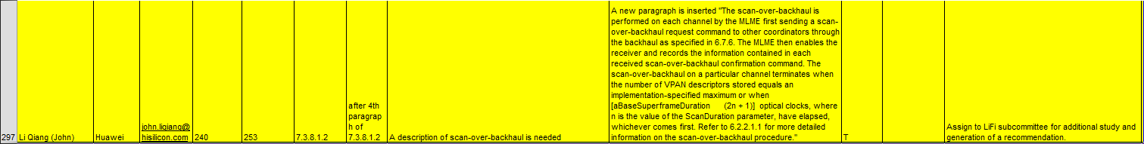

## Proposed solution

As discussed in comment 64 (which is accepted), scan-over-the backhaul is needed for VLC since neighboring VPANs may not be able to see each other. Therefore the corresponding modification to the primitives of MLME-SCAN.request is necessary. It is proposed to adopt the following text.

*The scan-over-backhaul is performed on each channel by the MLME first sending a scan-over-backhaul request command to other coordinators through the backhaul as specified in x.x.x. The MLME then enables the receiver and records the information contained in each received scan-over-backhaul confirmation command. The scan-over-backhaul on a particular channel terminates when the number of VPAN descriptors stored equals an implementation-specified maximum or when [aBaseSuperframeDuration  (2n + 1)] optical clocks, where n is the value of the ScanDuration parameter, have elapsed, whichever comes first. Refer to x.x.x.x.x for more detailed information on the scan-over-backhaul procedure.*

1. “max COODINATOR_Tx_modulation_bandwidth” represents the maximum modulation bandwidth that the transmitter of the coordinator can support. “max DEVICE_Rx_modulation bandwidth” represents the maximum modulation bandwidth that the receiver of a device can support.
2. “max COODINATOR_Rx_modulation_bandwidth” represents the maximum modulation bandwidth that the receiver of the coordinator can support. “max DEVICE_Tx_modulation_bandwidth” represents the maximum modulation bandwidth that the transmitter of a device can support.