IEEE P802.15
Wireless Personal Area Networks

Project | Dependability Interest Group
Title | Meeting Minutes for July 2016
Date Submitted | July 29, 2016
Source | [Jussi Haapola]  [Centre for Wireless Communications / University of Oulu] | Voice: +358 40 8363 018  E-mail: jhaapola@ee.oulu.fi
Re: | Meeting Minutes
Abstract
Purpose | Minutes of Dependability Interest Group sessions
Notice | This document has been prepared to assist the IEEE P802.15. It is offered as a basis for discussion and is not binding on the contributing individual(s) or organization(s). The material in this document is subject to change in form and content after further study. The contributor(s) reserve(s) the right to add, amend or withdraw material contained herein.
Release | The contributor acknowledges and accepts that this contribution becomes the property of IEEE and may be made publicly available by P802.15.

Monday, July 25, 2016, AM1, 08:00

  - Meeting called to order 08:01
By Chair Ryuji Kohno (YNU / CWC-Nippon)
Secretary Jussi Haapola (Centre for Wireless Communication / University of Oulu)

  - Roll Call
Notepad for Attendance circulated.

  - Opening Report

Chair presented Opening report Doc #495

Chair showed IEEE Patent policy.

Chair issued Call for Potentially Essential Patents
No essential intellectual property in the scope of IG DEP was declared.

Approval of previous meeting minutes
Upon no comments on the previous meeting minutes, doc #255 meeting minutes were approved.

Revise Doc #445(r1) Agenda.

  - Revisit CFI

  - Plan for Tutorial

Ryuji presented doc #496.

  - Update Technical Requirements

  - Recess

Recessed at 09:54

  - Attendees

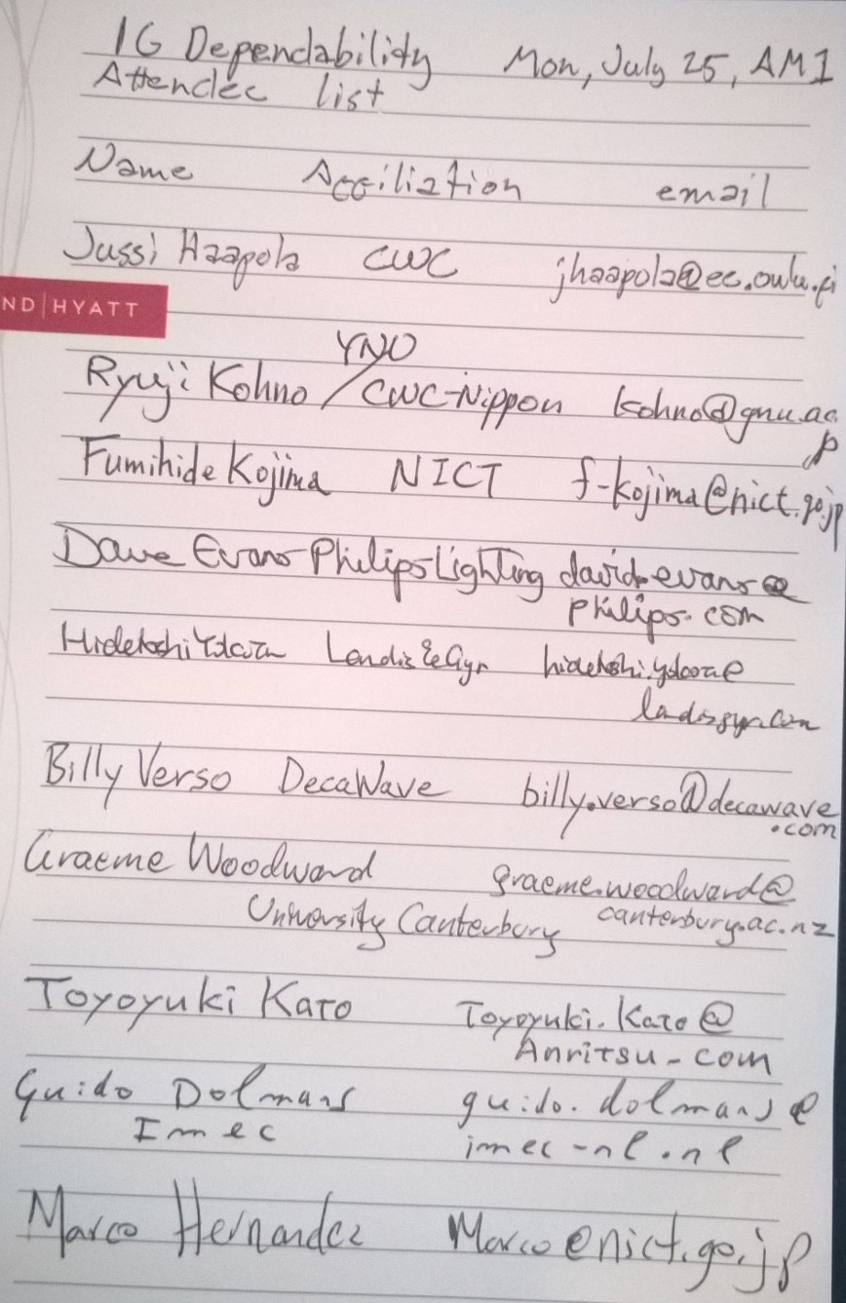

Tuesday, July 26, 2016, PM3, 18:30

  - Meeting called to order 18:32

  - Roll Call

  - Update Technical Requirements

- Created new document doc#557 selected applications technical requirements

  - Recess 20:28

  - Attendees

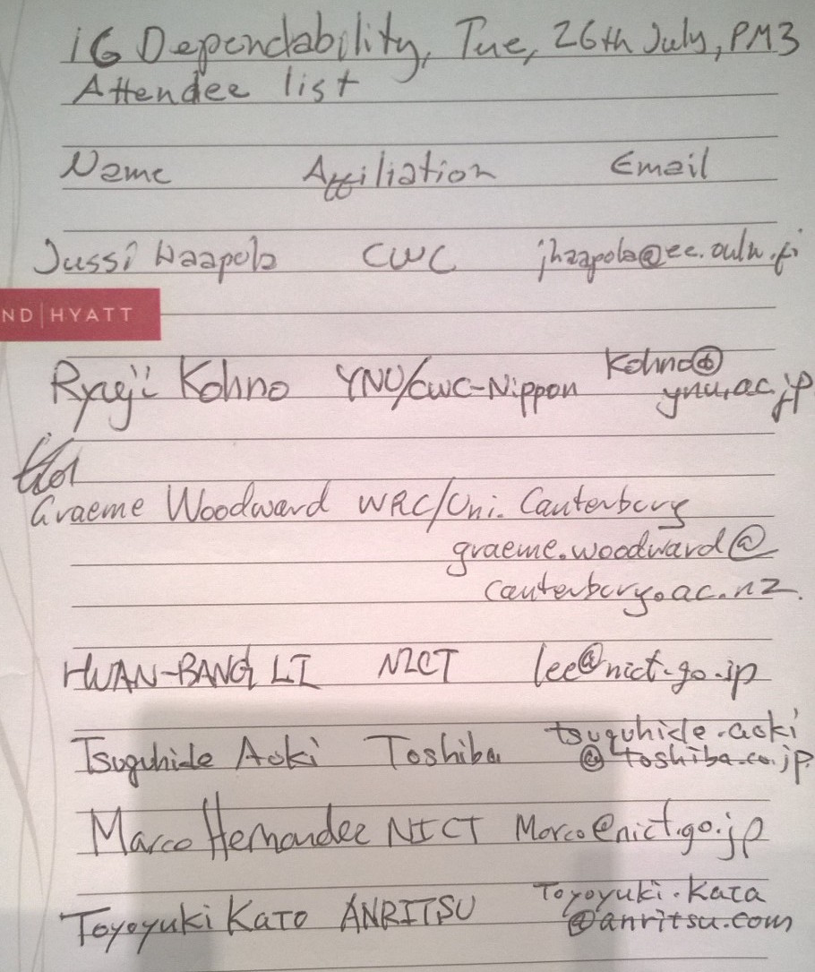

Thursday, July 28, 2016, PM2, 16:00

  - Meeting called to order 16:00

  - Roll Call

  - Discussion on viable PHY and MAC technologies

Doc #517 presented by Ryuji Kohno

  - Plan for tutorial and future progress

Doc #558 presented by Ryuji Kohno

  - Update technical requirements

Doc #557 was updated, lead by Jussi Haapola

  - Future telcos

To be agreed by email, reasonable 7 day notice required via reflector. 2 or 3 telcos required.

  - AoB

Aim for #1 tutorial slot, 3 to 4 presenters, 15+5 minutes each.

  - Adjourn 17:36

  - Attendees
