IEEE P802.15
Wireless Personal Area Networks

Project | IEEE P802.15 Working Group for Wireless Personal Area Networks (WPANs)
Title | PHY/MAC Draft D0 Comments Update for Invisible Data Embedding (Rev1.0)
Date Submitted | July, 2016
Source | Jaesang Cha¹,  Minwoo Lee²,  Vinayagam Mariappan³  [Seoul National University of Science & Technology [SNUST], Korea] | Voice: [ ]  Fax: [ ]  E-mail: [chajs@seoultech.ac.kr]¹
Re:
Abstract | PHY/MAC draft D0 comment updates for Variable invisible data embedded Display Tx schemes for OWC. The Invisible data embedding supports Variable modulation Scheme, Distance adaptive, Angle Free, Asynchronous, Rx Distance and Frame rate adaptive OWC communication.
Purpose | Discussion and approval.
Notice | This document has been prepared to assist the IEEE P802.15. It is offered as a basis for discussion and is not binding on the contributing individual(s) or organization(s). The material in this document is subject to change in form and content after further study. The contributor(s) reserve(s) the right to add, amend or withdraw material contained herein.
Release | The contributor acknowledges and accepts that this contribution becomes the property of IEEE and may be made publicly available by P802.15.

Table of Contents

1.0 PHY Layer Operating Mode(s) 3
2.0 PHY Specifications 4
3.0 PHY Layer Dimming Method 12
4.0 PPDU Format 14
5.0 PHY PIB Attributes 16
6.0 Superframe Structure 17
7.0 MAC Frame Formats 18
8.0 MAC PIB Attributes 21

PHY Layer Operating Mode(s)

The Invisible Data Embedded Display TX Schemes for OCC uses the PHY VI – 2 Dimensional / Screen Source.
The PHY VI Operating Modes system specifications are given in Table 1-1.
PHY Operating Modes
Modulation | RLL Code | Optical Clock Rate | FEC | Data Rate (Kbps)
M-PSK | None | 30Hz | RS(64,32)/ RS(160,128)/None | 16 Kbps
M-FSK | None | 30Hz | RS(64,32)/ RS(160,128)/None | 16 Kbps
HYBRID-PSK/FSK | None | 30Hz | RS(64,32)/ RS(160,128)/None | 32 Kbps
2D-CODE | None | 30Hz | RS(64,32)/ RS(160,128)/None | 128 Kbps
Sequential Scalable 2D Code | None | 30Hz | RS(64,32)/ RS(160,128)/None | 256 Kbps
SS-M-PSK | None | 30Hz | None | 8 Kbps
SS-M-FSK | None | 30Hz | None | 8 Kbps
SS-HYBRID-PSK/FSK | None | 30Hz | None | 16 Kbps
SS- 2D-CODE | None | 30Hz | None | 64 Kbps
SS -Sequential Scalable 2D Code | None | 30Hz | None | 128 Kbps

Table 1-1 - PHY Operating Mode for Invisible Data Embedded Display TX Schemes

The PHY VI FEC support for Invisible Data Embedding is given in Table 1-2.
No | RS Method Used | FECRate
1 | None | 1
2 | RS(64,32) | 32/64
3 | RS(160,128) | 128/160

Table 1-2 – Invisible Data Embedding FEC Support

PHY Specifications

The PHY VI with supported data rates and operating conditions is shown in Table 1-1 for Visible Mode of data Transmission. The Invisible Data Embedded Display TX Schemes works with two data embedding method. The supported data embedding principles are Alpha Blending and Watermarking. The PHY system diagram illustrated in Figure 2-1 for 2 Dimensional / Screen Source for Invisible Data Embedded Display TX Schemes for OCC.

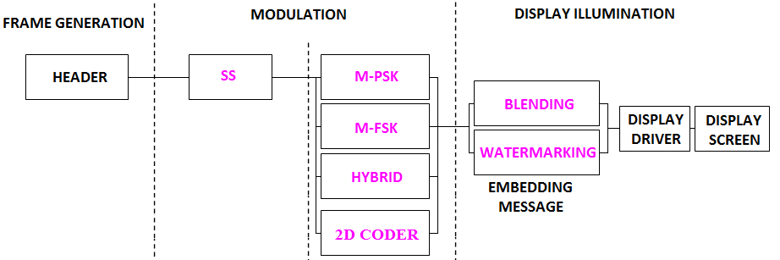

Figure 2-1 – Invisible Data Embedded Display TX Schemes PHY System Diagram
The PHY designed with specific key features in consideration to have error free and effective display to camera communication in the real-time usage of end system. The design goals are,
- Unobtrusive to Screen Viewer
- Works on dynamic visual Scene
- Angle and Distance Free Communication
- Rx Distance Adaptive Communication by Screen with interactive Camera
- Asynchronous Communication
- Rx Frame Rate independent Transmission
- Multi-Display Model for Transmission
To achieve the above described design goal, the PHY design is proposed with Spread Spectrum based M-PSK, M-FSK, Hybrid-M-PSK-FSK, Sequential Scalable 2D Codes. The use cases of the modulation scheme and SS Modulation parameter are described in this section.

2.1 Modulation Schemes
2.1.1 Use Case of Modulation Scheme 1 – M-PSK
The Figure 2-2 describes the M-PSK modulation scheme usage on PHY Layer design.
(a) 2-PSK
(b) 4-PSK
(1) 0
(2) 1 0 1
(1) 00 00
(3) 10 10
(2) 01 01
(4) 11

Figure 2-2 – M-PSK Modulation

2.1.2 Use Case of Modulation Scheme 2 – M-FSK
The Figure 2-3 describes the M-FSK modulation scheme usage on PHY Layer design.

(a) 2-FSK
(b) 4-FSK
(1) 0
(2) 1
f₁
f₂
(1) 00
(2) 01
f₁
f₂

(3) 01
(4) 10
f₃
f₄

Figure 2-3 – M-FSK Modulation

2.1.3 Use Case of Modulation Scheme 3 – Hybrid (M-PSK-FSK)
Hybrid scheme used to achieve double the data rate of M-PSK or F-FSK by combining Frequency and Phase on the modulation. The Figure 2-4 describes the Hybrid modulation scheme usage on PHY Layer design.

(2) 01
(1) 00
(3) 10
(4) 11
Phase Frequency
f₁
f₂
f₁
f₂

Figure 2-4 – Hybrid (M-PSK-FSK) Modulation

2.1.4 Use Case of Modulation Scheme 4 – Sequential Scalable 2D Codes
The Sequential Scalable 2D codes used the QR Code and Color Code to encode the data with visual frame on display. The Sample 2D codes are shown in Figure 2-5.
Figure 2-5 – 2D Codes
The proposed Sequential Scalable 2D Codes for PHY system design to enable distance adaptive data rate control on TX Schemes for OCC.
The use case for Sequential Scalable QR code is shown in Figure 2-6.

Figure 2-6 – Sequential Scalable QR Code
The use case for Sequential Scalable Color code is shown in Figure 2-7.

Figure 2-7 – Sequential Scalable Color Code
2.2 Spread Spectrum
The Spread Spectrum adopted with PHY design for Invisible Data Embedded Display TX Schemes to add built-in adaptation on data recovery and to achieve asynchronous communication with receiver angle free and distance adaptive communication between Display Transmitter and Receiver.
In this PHY model used Gold Sequence based Spreading code for encode data. The Study case of Gold Sequence SS Code Specification is as follows,
- Gold sequence was chosen as a spreading code
- Shifter register length is 5
- Code length is 31 (=2⁵-1)
- 4 family code set was generated via offset 8*n chips of code set 1
- Code Sets
- Code set 1: 0000000010010100100111101010110 (zero offset)
- Code set 2: 1001010010011110101011000000000 (8chip offset)
- Code set 3: 1001111010101100000000010010100 (16chip offset)
- Code set 4: 1010110000000001001010010011110 (24chip offset)
The Figure 2-8 shows the SS Gold Sequence Generator model.
5
4
3
2
1
5
4
3
2
1
Gold-Sequence

Figure 2-8 – Gold Sequence Generator
The Table 2-1 describes the SS Modulation Parameters adopted for simulating proposed PHY Layer design.
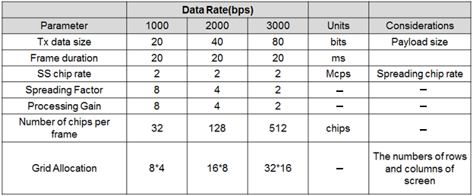
Table 2-1 – SS Modulation Parameters Study Case
2.3 Data Encoder
The Invisible Data Embedded Display TX Schemes works with two data embedding method. The supported data embedding principles are Alpha Blending and Watermarking. The rule to embedding data and data rate achievement vary based on the kind of display used to design the Transmitter.

2.4 Asynchronous Communication Mode
The PHY for Invisible Data Embedded Display TX Schemes designed with Asynchronous communication mode. The Asynchronous communication achieved when transmitting data, different spreading code is used per video frame. Each code sets repeated for spreading data according to spreading factor and each spreading code set 1, 2, 3, and 4 are assigned for successive 4 frames as shown in Figure 2-9.
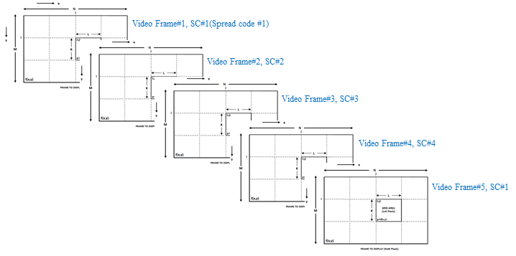
Figure 2-9 – SS Code Assignment
The receiver side spreading code already known with application to synchronize the data automatically. If camera CMOS received same frame, for example #1 video frame receive twice, then receiver will despread video frames using SC#1, SC#2. When processing using SC#2, dominant value will not appear so the video frame will be discarded.
2.5 Angle Free Communication
The PHY for Invisible Data Embedded Display TX Schemes designed with Angle Free Communication between Transmitter and Receiver. The Angle free communication is achieved by Warping the ROI of the transmitter to get the original shape alignment and then the decoded data synchronizing with spread code to extract original information transferred on transmitter. The kind automatic synchronization in receiver is time consuming function but the communication is robust.
2.6 Scalable Bitrate Controller
The PHY for Invisible Data Embedded Display TX Schemes designed with built-in Scalable bitrate Controller. To achieve robust communication, the scalable data transmission mode is proposed in PHY model design is shown in Figure 2-10. The Screen is divided into Multiple regions and each region has different frame rate controlled data transmission is enabled. This approach adds robustness on system performance for frame rate adaptive communication based on the receiver performance.
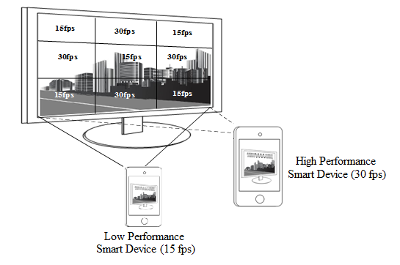
Figure 2-10 – Scalable Bitrate Controller
2.7 Distance Adaptive Data Rate Control
The PHY for Invisible Data Embedded Display TX Schemes designed with distance adaptive data rate control. In this case the Transmitter built-in with camera features as shown in Figure 2.11. The Transmitter Camera Estimate the Receivers distance using camera. There are different methods used to estimate the distance to receiver. Some of these methods are active by sending some signals to the object such as laser range finder, ultrasonic range finder, radio waves, microwaves, infrared, etc. Some others are passive that only receive information about the target position. The distance estimation method decision left up to the system designer.
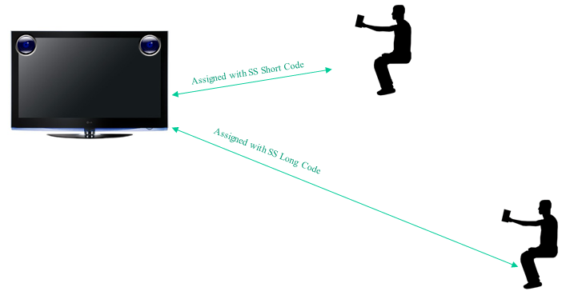
Figure 2-11 – Distance Adaptive Data rate Control
For this conceptual evaluation, Kinect sensor based triangulation method is used for distance estimation. In this approach, the laser source emits a single beam which is split into multiple beams by a diffraction grating to create a constant pattern of speckles projected onto the scene and this pattern is captured by the infrared camera and is correlated against a reference pattern. The reference pattern is obtained by capturing a plane at a known distance from the sensor, and is stored in the memory of the sensor. When a speckle is projected on an object whose distance to the sensor is smaller or larger than that of the reference plane the position of the speckle in the infrared image will be shifted in the direction of the baseline between the laser projector and the perspective center of the infrared camera. These shifts are measured for all speckles by a simple image correlation procedure, which yields a disparity image. For each pixel the distance to the sensor can then be retrieved from the corresponding disparity.
The sequence code length assignment is based the distance of the receiver from transmitter. If the receiver is near then the SF Value is small so Short Sequence Code is assigned otherwise SF values is high so Long Sequence Code is assigned. In this way, PHY model design control the distance adaptive data rate selection.

PHY Layer Dimming Method

The Display to camera communication dimming control is depending on the mode of embedding data (Visible or Invisible) on display system, rate at which data is repeatedly coding on video frame, and rate at which data refresh on display.
The Invisible Data Embedded Display TX Schemes for OCC uses the Alpha Blending or Watermarking to embed the data on Video display frame. The function description of proposed PHY model is given in Figure 3-1. First the payload is coded with SS Code and modulated by M-FSK/M-PSK/2D Code modulation schemes. The modulated data frame the Grid Framing to blend/watermarked with original video frame to display on the screen visual region. The GRID framing size can be in order of 4x4, 8x8, 16x16, 32x32, 64x64 etc. The Grid frame size selection decision left up to the system designer.
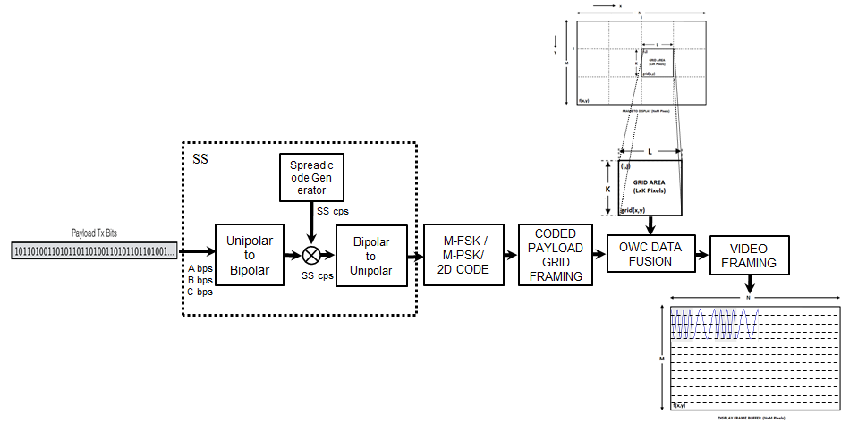
Figure 3-1 – Display Transmitter Functional Block Diagram
The Smart Device Camera Capture Visual Frame from Screen is shown Figure 3-2.
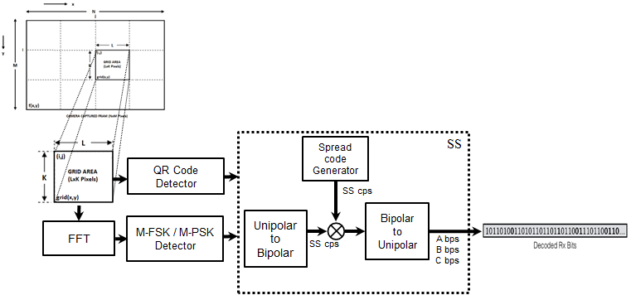
Figure 3-2 – Receiver Functional Block Diagram
To decode the data stream, the ROI of display visual area is extracted from the captured visual frame using image processing methods and then invisibly embedded data extracted using blending or watermark extraction procedure. The blending or watermark based data extraction procedure is applied based on modulation scheme used to invisibly embedding the data on the transmitter system (Supported Modulation scheme is described in 2.1 Modulation Schemes). The data embedded on display is SS Coded data so SS decoding is applied to recover original data from the visual sequence.
In addition, the invisible data embedded display TX schemes designed with built-in scalable bitrate controller by controlling visual refresh rate of the display or by frames in which data to be encoded on visual sequence.

PPDU Format

The PPDU frame structure is formatted as illustrated in Figure 4-1 for PHY VI – 2 Dimensional / Screen Source.
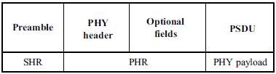
Figure 4-1 – Format of the PPDU
SHR Field:
The SHR field is used by the transceiver to obtain optical clock synchronization with an incoming message is called Preamble. The standard defines one fast locking pattern (FLP) followed by choice of four topology dependent patterns (TDPs) for the purposes of distinguishing different PHY topologies is shown in Table 4-1.
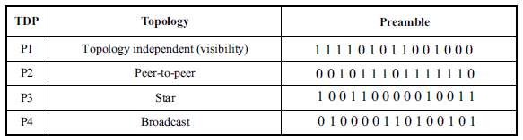
Table 4-1 – Preamble Pattern with Topologies
PHR Field:
The PHY VI header is described as shown in Table 4-2 and shall be transmitted with data to identify the PHY Mode, Data rate, and PSDU length to identify the transmission specification.
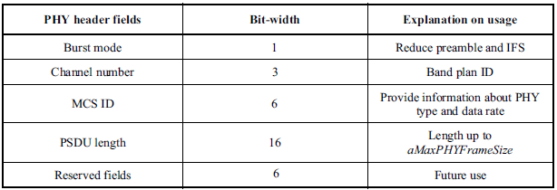
Table 4-2 – PHY Header
Burst Mode Field: The burst mode bit indicates that the next frame following the current frame is part of the burst mode. The Burst Mode bit shall be set TRUE if the burst mode is being used otherwise, the Burst Mode bit shall be set FALSE.
Channel Number Field: The channel number field for PHY shall be the band plan ID of the lowest wavelength. Refer to 9.3.1 for more detailed information.
MCS ID Field: The modulation and coding scheme (MCS) ID shall be indicated in the PHY header based on Table 83.
PSDU Field: The PSDU length field specifies the total number of octets contained in the PSDU.
PSDU Field:
The PSDU field has a variable length and carries the data of the PHY VI frame. The FCS is appended if the PSDU has a non-zero byte payload. The structure of the PSDU field is as shown in Figure 4-2.
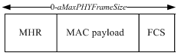
Figure 4-2 – PHY PSDU Field Structure

PHY PIB Attributes

The PHY PIB comprises the attributes required to manage the PHY sublayer of a device. The attributes contained in the IEEE802.15.7-2011 PHY PIB are presented in Table 100 - PHY PIB Attributes.
The additional PHY PIB attributes added on PHY for 2 Dimensional codes is presented the Table 5-1.

PHY PIB Table 100 Additions
Attribute | Identifier | Type | Range | Description
phyINVApplicationSpecificMode | 0x10 | Unsigned | 0~255 | This attribute specifies the application specific PHY mode.  0 : Normal Data (Media Content, Information Content based on the Application used for)  1 : ID Data  2 : Authentication Data

Table 5-1 - PHY PIB Attributes Additions

Superframe Structure

The Invisible Data Embedded Display TX Schemes use unslotted ALOHA; that is, when the Invisible Data Embedded Display transmitter has a packet to send, it just sends it. This support with beacon and without beacon support and the transmitter does not do a listen before talk channel activity check.
The super frame structure for PHY without beacon is shown in Figure 6-1.
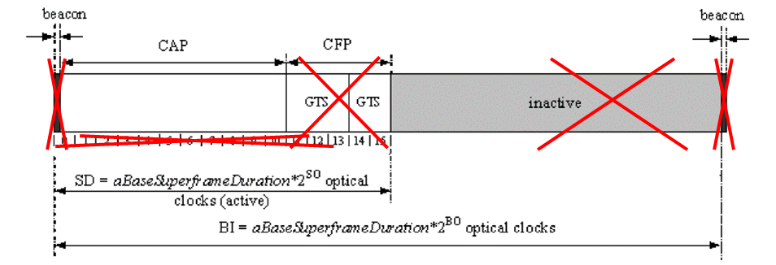
Figure 6-2 – PHY Superframe Structure without Beacon

The super frame structure for PHY with beacon is shown in Figure 6-2.
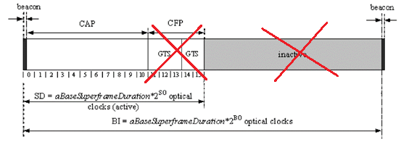
Figure 6-2 – PHY Superframe Structure with Beacon

MAC Frame Formats

The MAC frame structure is formatted as illustrated in Figure 7-1 for 2 Dimensional codes.
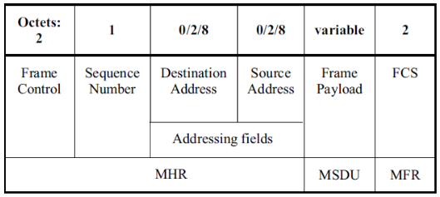
Figure 7-1 – MAC Frame Format
Frame Control Field:
The frame control field is formatted as illustrated in Figure 7-2 for 2 Dimensional codes.
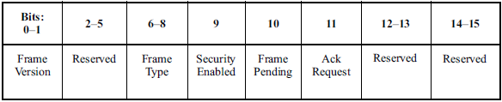
Figure 7-2 –Frame Control Field Format
Frame Version Subfield: Specifies the version number corresponding to the frame. This subfield shall be set to 0b01 to indicate a frame compatible with IEEE Standard 802.15.7r1 and all other subfield values shall be reserved for future use.
Frame Type Subfield: Specifies the Frame Type used in MAC Frame. This field shall be set to one of the non-reserved values listed in Table 7-1.
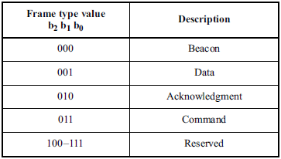
Table 7- 1 – Frame Type Subfield
Security Enabled Subfield: Species the Security on Data Frame is enable or not on transmission. This field is 1 bit in length, and it shall be set to one if the frame is protected by the MAC sublayer and shall be set to zero otherwise. The Auxiliary Security Header field of the MHR shall be present only if the Security Enabled subfield is set to one.
Frame Pending Subfield: Species the Pending on Data Frame is available or not on transmission. This field is 1 bit in length and shall be set to one if the device sending the frame has more data for the recipient. This subfield shall be set to zero otherwise.
Acknowledgment Request Subfield: Specifies whether an acknowledgment is required from the recipient device on receipt of a data or MAC command frame. This field is 1 bit in length and this subfield is set to one, the recipient device shall send an acknowledgment frame. If this subfield is set to zero, the recipient device shall not send an acknowledgment frame.
Sequence Number Field:
The Sequence Number field is 1 octet in length and specifies the sequence identifier for the frame.
For a beacon frame, the Sequence Number field shall specify a BSN. For a data, acknowledgment, or MAC command frame, the Sequence Number field shall specify a DSN that is used to match an acknowledgment frame to the data or MAC command frame.
Destination Address Field:
The Destination Address field, when present, is either 2 octets or 8 octets in length, according to the value specified in the Destination Addressing Mode subfield of the frame control field, and specifies the address of the intended recipient of the frame.
A 16-bit value of 0xffff in this field shall represent the broadcast short address, which shall be accepted as a valid 16-bit short address by all devices currently listening to the channel.
This field shall be included in the MAC frame only if the Destination Addressing Mode subfield of the frame control field is nonzero.
Source Address Field:
The Source Address field, when present, is either 2 octets or 8 octets in length, according to the value specified in the Source Addressing Mode subfield of the frame control field, , and specifies the address of the originator of the frame.
This field shall be included in the MAC frame only if the Source Addressing Mode subfield of the frame control field is 10 or 11.
Frame Payload Field:
The Frame Payload field has a variable length and contains information specific to individual frame types. If the Security Enabled subfield is set to one in the frame control field, the frame payload is protected as defined by the security suite selected for that frame.
FCS Field:
The FCS field is 2 octets in length and the FCS is calculated over the MHR and MSDU parts of the frame. The FCS shall be only generated for payloads greater than zero bytes.
The FCS is an optional filed in MAC frame format and the field information generated based on payload and FCS option used in the MAC frame from RS (64, 32) / RS (160,128) / None.

MAC PIB Attributes
The MAC PIB comprises the attributes required to manage the MAC sublayer of a device. The attributes contained in the IEEE802.15.7-2011 MAC PIB are presented in Table 60 - MAC PIB Attributes. The additional MAC PIB attributes added for 2 Dimensional codes are presented the Table 8-1.
MAC PIB Attributes Table 60 Additions
Attribute | Identifier | Type | Range | Description | Default
macTxMode | 0x91 | Unsigned | 0-255 | This attribute indicates the MAC transmission mode is visible or Invisible.  0 : Visible VTASC Mode  1 : Visible Sequential Scalable 2D Code  2 : Invisible Mode – Blending Method  3 : Invisible Mode – Watermarking Method | 0
macTxCamerEnable | 0x92 | Unsigned | 0-255 | This attribute indicates the Transmitter is Enabled with Camera or not for Interactive Receiver distance specific data transfer control.  0 : Camera not connected  1 : Camera connected | 0
macRxDistance | 0x93 | Unsigned | 0-255 | This attribute notify the Receiver distance from Transmitter | 0
macTxDataType | 0x94 | Unsigned | 0-255 | This attribute indicates the type of data to be transmitted.  0 : Normal Data (Media Content, Information Content based on the Application used for)  1 : ID Data  2 : Authentication Data | 0
maxDataLength | 0x95 | Integer | 0-65535 | This attribute specify the length of the data to be transmitted | 0

Table 8-1 - MAC PIB Attributes Additions

