**IEEE P802.15**

**Wireless Personal Area Networks**

|  |  |  |
| --- | --- | --- |
| Project | IEEE P802.15 Working Group for Wireless Personal Area Networks (WPANs) | |
| Title | **PHY/MAC Draft D0 Comments Update for VTASC Modulation (Rev1.0)** | |
| Date Submitted | July, 2016 | |
| Source | Jaesang Cha 1,  Vinayagam Mariappan2 [Seoul National University of Science & Technology [SNUST], Korea] | Voice: [ ] Fax: [ ] E-mail: [chajs@seoultech.ac.kr]1 |
| Re: |  | |
| Abstract | PHY/MAC draft D0 comment updates for Display Light Pattern based Tx with VTASC. The VTASC method is designed to operate on the application services like LED ID, Digital Signage with Advertisement Information etc. | |
| Purpose | Discussion and approval. | |
| Notice | This document has been prepared to assist the IEEE P802.15. It is offered as a basis for discussion and is not binding on the contributing individual(s) or organization(s). The material in this document is subject to change in form and content after further study. The contributor(s) reserve(s) the right to add, amend or withdraw material contained herein. | |
| Release | The contributor acknowledges and accepts that this contribution becomes the property of IEEE and may be made publicly available by P802.15. | |

**Table of Contents**

**1.0** **PHY Layer Operating Mode(s)** 3

**2.0** **PHY Specifications** 4

**3.0** **PHY Layer Dimming Method** 12

**4.0** **PPDU Format** 13

**5.0** **PHY PIB Attributes** 15

**6.0** **Superframe Structure** 16

**7.0** **MAC Frame Formats** 17

**8.0** **MAC PIB Attributes** 20

# **PHY Layer Operating Mode(s)**

The Display Light Pattern Based Transmitter with Variable Transparent Amplitude-Shape-Color modulation uses the PHY VI – 2 Dimensional / Screen Source.

The PHY VI Operating Modes system specifications are given in Table 1-1.

|  |  |  |  |  |
| --- | --- | --- | --- | --- |
| **PHY Operating Modes** | | | | |
| **Modulation**  **(TxAxSxC)** | **RLL Code** | **Optical Clock Rate** | **FEC** | **Data Rate (Kbps)** |
| 2 Color VTASC Code1  (T = 2,A=2/4/8,S=2/4,C=2) | None | 30Hz | RS(64,32)/ RS(160,128)/ None | 390 Kbps |
| 4 Color VTASC Code1  (T = 2,A=2/4/8,S=2/4, C=4) | None | 30Hz | RS(64,32)/ RS(160,128)/ None | 450 Kbps |
| 8 Color VTASC Code1  (T = 2,A=2/4/8,S=2/4,C=8) | None | 30Hz | RS(64,32)/ RS(160,128)/ None | 506 Kbps |
| 16 Color VTASC Code2  (T = 2,A=2/4/8,S=2/4,C=16) | None | 30Hz | RS(64,32)/ RS(160,128)/ None | 1054 Kbps |
| 2 Color SS VTASC Code1  (T = 2,A=2/4/8,S=2/4,C=2) | None | 30Hz | None | 195 Kbps |
| 4 Color SS VTASC Code1  (T = 2,A=2/4/8,S=2/4,C=4) | None | 30Hz | None | 225 Kbps |
| 8 Color SS VTASC Code1  (T = 2,A=2/4/8,S=2/4,C=8) | None | 30Hz | None | 253 Kbps |
| 16 Color SS VTASC Code2  (T = 2,A=2/4/8,S=2/4,C=16) | None | 30Hz | None | 527 Kbps |

Note: [32x32 Block Size] 1 and [24x24 Block Size] 2

Where, “T” represents Level of transparency, “A” represents Number of Block Size Amplitude

“S” represents Number of Shapes, “C” represents Number of Colors

**Table 1-1 - PHY Operating Mode for VTASC**

The PHY VI FEC support for VTASC is given in Table 1-2.

|  |  |  |
| --- | --- | --- |
| **No** | **RS Method Used** | **FECRate** |
| 1 | None | 1 |
| 2 | RS(64,32) | 32/64 |
| 3 | RS(160,128) | 128/160 |

**Table 1-2 - VTASC FEC Support**

# **PHY Specifications**

The PHY VI with supported data rates and operating conditions is shown in Table 1-1 for Visible Mode of data Transmission using VTASC. The Display Light Pattern Based Transmitter with VTASC works with variable size pattern and different type of patterns. The data embedded on visual frame by overlaying visual patterns displays visual area. The PHY system diagram illustrated in Figure 2-1 for 2 Dimensional / Screen Source for Display Light Pattern Based Transmitter with VTASC.

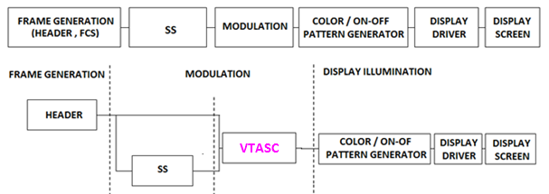

**Figure 2-1 –Display Light Pattern Based Transmitter with VTASC** **PHY System Diagram**

The PHY for VTASC designed with specific key features in consideration to have error free and effective display to camera communication in the real-time usage of end system. The design goals are,

* Angle and Distance Free Communication
* Rx Distance Adaptive Communication by Screen with interactive Camera
* Asynchronous Communication
* Rx Frame Rate independent Transmission
* Multi-Display Model for Transmission

To achieve the above described design goal, the PHY design is proposed with Spread Spectrum based VTASC. The use cases of the modulation scheme and SS Modulation parameter are described in this section.

**2.1 VTASC**

Color Shift Keying (CSK) is one of the promising modulation formats specifically for Display based VLC system. In order to improve the distance and angle free with higher bitrate, the new proposed color based modulation scheme called Variable Transparent Amplitude-Shape-Color (VTASC) Modulation is proposed. VTASC is one of the promising modulation formats specifically for display based VLC system with improved VLC throughput by increasing the bit per symbol rate, and avoiding the single color interference.

The VTASC is coded by T (Transparency) / A (Amplitude) / S (Shape) / C (Color) State as described in the below;

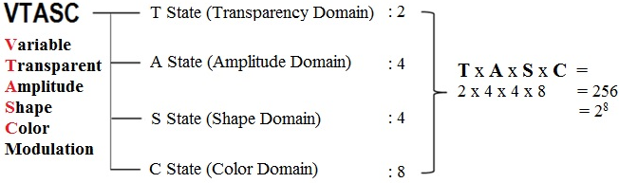

The no of coded Levels in the VTASC schemes (TxAxSxC): 256 = 28 and this makes place to code 8 bit Symbol with 2/4/4/8 (Transparency/Amplitude/Shape/Color). The coded sample model is given Figure 2-2.



**Figure 2-2 – VTASC Coded Pattern Model**

The following Table 2-1 describes the Symbol bit mapping using VTASC schemes. The VTASC is able to expand a Domain size and add a transparency or blinking domain.

|  |  |  |
| --- | --- | --- |
| **VTASC Block Model**  **(TxAxSxC)** | **No of Block Types (T*A*S*C)** | **BitsPerSymbol** |
| T = 2, A = 2,S = 2,C = 2 | 16 = 24 | 4 |
| T = 2, A = 4,S = 2, C = 2 | 32 = 25 | 5 |
| T = 2, A = 4,S = 4, C = 2 | 64 = 26 | 6 |
| T = 2, A = 8,S = 4, C = 2 | 128 = 27 | 7 |
| T = 2, A = 2,S = 4, C = 4 | 64 = 26 | 6 |
| T = 2, A = 4,S = 4, C = 4 | 128 = 27 | 7 |
| T = 2, A = 8,S = 4, C = 4 | 256 = 28 | 8 |
| T = 2, A = 4,S = 2, C = 8 | 128 = 27 | 7 |
| T = 2, A = 4,S = 4, C = 8 | 256 = 28 | 8 |
| T = 2, A = 8,S = 2, C = 8 | 256 = 28 | 8 |
| T = 2, A = 8,S = 4, C = 8 | 512 = 29 | 9 |
| T = 2, A = 8,S = 4, C = 16 | 1024 = 210 | 10 |

**Table 2-1 – VTASC Symbol per Bit Mapping**

The Data Rate calculated using following Mathematical representation,

DataRate = (NoofBlocks * BitsPerSymbol * OpticalClockrate * FECRate) / CodeLength)

Where, “CodeLength” is 1 for without SS Coded schemes and respective code length for with SS Coded Schemes

Note this case study designed with Full HD Display (1920x1080) with minimum block size of 32x32 pixels and this data rate calculation vary from Display Screen Size.

NoofBlocks = (1920/32)* (1080/32) = 60 x 32 (Approximated to even multiplication for coding efficiency)

The Data Rate for 2 Color VTASC Code with 8 size scalability & 4 shapes & 2 transparency Level without SS Coded Code (CodeLength is 1),

BitsPerSymbol = 7 (Refer Table 2-1)

OpticalClockrate = 30

FECRate = 1 (Refer Table 1-2)

DataRate = ((1920/32)* (1080/32) * 7 * 30 * 1) / 1) = 403200 Approximated to 390 Kbps

The Data Rate for 2 Color VTASC Code with 8 size scalability with SS Coded Code (Minimum CodeLength is 2),

BitsPerSymbol = 4 (Refer Table 2-1)

OpticalClockrate = 30

FECRate = 1 (Refer Table 1-2)

DataRate = ((1920/32)* (1080/32) * 4 * 30 * 1) / 2) = 201600 Approximated to 195 Kbps

**2.2 Spread Spectrum**

The Spread Spectrum adopted with PHY model design for Display Light Pattern Based Transmitter with VTASC to add built-in adaptation on data recovery and to achieve asynchronous communication with Angle free and distance free communication between Display Transmitter and Receiver.

In this PHY model used Gold Sequence based Spreading code for encode data. The Study case of Gold Sequence SS Code Specification is as follows,

* Gold sequence was chosen as a spreading code
* Shifter register length is 5
* Code length is 31 (=25-1)
* 4 family code set was generated via offset 8*n chips of code set 1
* Code Sets

1. Code set 1: 0000000010010100100111101010110 (zero offset)
2. Code set 2: 1001010010011110101011000000000 (8chip offset)
3. Code set 3: 1001111010101100000000010010100 (16chip offset)
4. Code set 4: 1010110000000001001010010011110 (24chip offset)

The Figure 2-3 shows the SS Gold Sequence Generator model.

5

4

3

2

1

5

4

3

2

1

Gold-Sequence

**Figure 2-3 – Gold Sequence Generator**

The Table 2-2 describes the SS Modulation Parameters adopted for simulating proposed PHY Layer design.

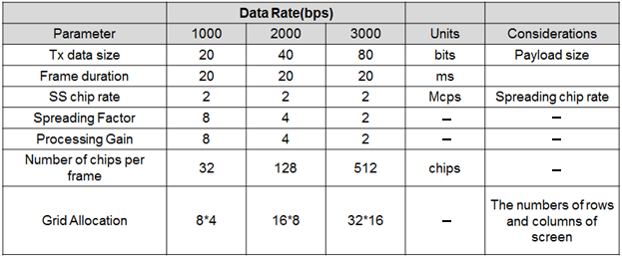

**Table 2-2 – SS Modulation Parameters Study Case**

**2.3 Data Encoder**

The Display Light Pattern Based Transmitter with VTASC Schemes works with two data embedding method. The supported data embedding principles are Alpha Blending and Watermarking. The rule to embedding data and data rate achievement vary based on the kind of display used to design the Transmitter.

**2.4 Asynchronous Communication Mode**

The PHY for Display Light Pattern Based Transmitter with VTASC designed with Asynchronous communication mode. The Asynchronous communication achieved when transmitting data, different spreading code is used per video frame. Each code sets repeated for spreading data according to spreading factor and each spreading code set 1, 2, 3, and 4 are assigned for successive 4 frames as shown in Figure 2-4.

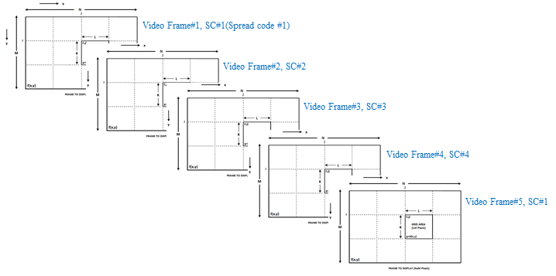

**Figure 2-4 – SS Code Assignment**

The receiver side spreading code already known with application to synchronize the data automatically. If camera CMOS received same frame, for example #1 video frame receive twice, then receiver will despread video frames using SC#1, SC#2. When processing using SC#2, dominant value will not appear so the video frame will be discarded.

**2.5 Angle Free Communication**

The PHY for Display Light Pattern Based Transmitter with VTASC designed with Angle Free Communication between Transmitter and Receiver is shown in Figure 2-5. The Angle free communication is achieved by Warping the ROI of the transmitter to get the original shape alignment and then the decoded data synchronizing with spread code to extract original information transferred on transmitter. The kind automatic synchronization in receiver is time consuming function but the communication is robust.

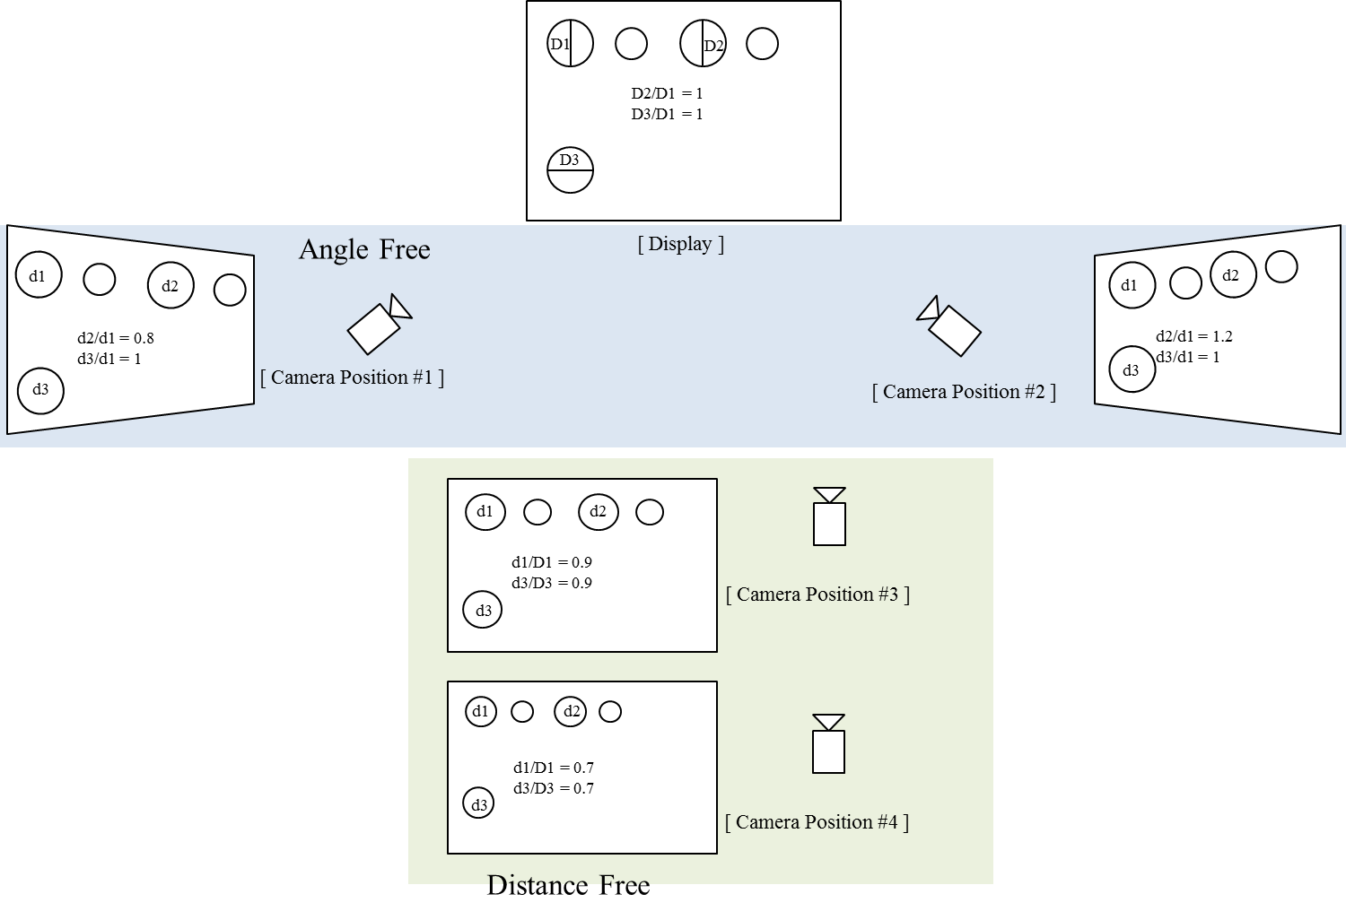

**Figure 2-5 – Angle Free and Distance Adaptive**

**2.6 Scalable Bitrate Controller**

The PHY for Display Light Pattern Based Transmitter with VTASC designed with built-in Scalable bitrate Controller. To achieve robust communication, the scalable data transmission mode is proposed in PHY model design is shown in Figure 2-6. The Screen is divided into Multiple regions and each region has different frame rate controlled data transmission is enabled. This approach adds robustness on system performance for frame rate adaptive communication based on the receiver performance.



**Figure 2-6 – Scalable Bitrate Controller**

**2.7 Distance Adaptive Data Rate Control**

The PHY for VTASC Display TX Schemes designed with distance adaptive data rate control. In this case the Transmitter built-in with camera features as shown in Figure 2-7. The Transmitter Camera Estimate the Receivers distance using camera. There are different methods used to estimate the distance to receiver. Some of these methods are active by sending some signals to the object such as laser range finder, ultrasonic range finder, radio waves, microwaves, infrared, etc. Some others are passive that only receive information about the target position. The distance estimation method decision left up to the system designer.

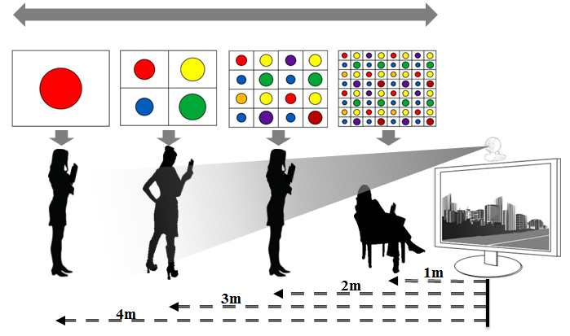

**Figure 2-7 – Distance Adaptive Data rate Control**

For this conceptual evaluation, Kinect sensor based triangulation method is used for distance estimation. In this approach, the laser source emits a single beam which is split into multiple beams by a diffraction grating to create a constant pattern of speckles projected onto the scene and this pattern is captured by the infrared camera and is correlated against a reference pattern. The reference pattern is obtained by capturing a plane at a known distance from the sensor, and is stored in the memory of the sensor. When a speckle is projected on an object whose distance to the sensor is smaller or larger than that of the reference plane the position of the speckle in the infrared image will be shifted in the direction of the baseline between the laser projector and the perspective center of the infrared camera. These shifts are measured for all speckles by a simple image correlation procedure, which yields a disparity image. For each pixel the distance to the sensor can then be retrieved from the corresponding disparity.

The sequence code length assignment is based the distance of the receiver from transmitter. If the receiver is near then the SF Value is small so Short Sequence Code is assigned otherwise SF values is high so Long Sequence Code is assigned. In this way, PHY model design control the distance adaptive data rate selection.

# **PHY Layer Dimming Method**

The Display to camera communication dimming control is depending on the mode of embedding data (Visible or Invisible) on display system, rate at which data is repeatedly coding on video frame, and rate at which data refresh on display.

The Display Light Pattern based Transmitter with VTASC for OCC uses the visibly embedding the data on Video display frame. The function description of proposed PHY model is given in Figure 3-1.



**Figure 3-1 – Display Transmitter Functional Block Diagram**

The Smart Device Camera Capture Visual Frame from Screen is shown Figure 3-2.



**Figure 3-2 – Receiver Functional Block Diagram**

The ROI of Screen Visual Area is extracted from the captured visual frame and then apply the VTASC detector based on mapping scheme applied on the transmitter. The data recovered by applying SS on the data decoded.

The PHY VI for Display Light Pattern based Transmitter with VTASC designed with built-in Scalable bitrate Controller by controlling the Video display refresh rate or by frames in which data to be encoded repeatedly.

# **PPDU Format**

The PPDU frame structure Display Light Pattern Based Transmitter with VTASC is formatted as illustrated in Figure 4-1 for PHY-VI 2-Dimensional codes

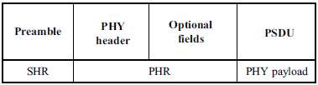

**Figure 4-1 – Format of the PPDU**

**SHR Field:**

The SHR field is used by the transceiver to obtain optical clock synchronization with an incoming message is called Preamble. The standard defines one fast locking pattern (FLP) followed by choice of four topology dependent patterns (TDPs) for the purposes of distinguishing different PHY topologies is shown in Table 4-1.

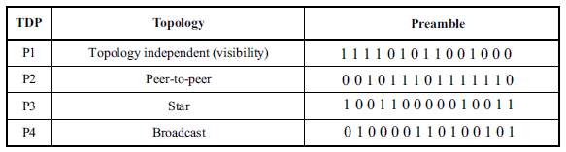

**Table 4-1 – Preamble Pattern with Topologies**

**PHR Field:**

The PHY VI header is described as shown in Table 4-2 and shall be transmitted with data to identify the PHY Mode, Data rate, and PSDU length etc. to identify the transmission specification.

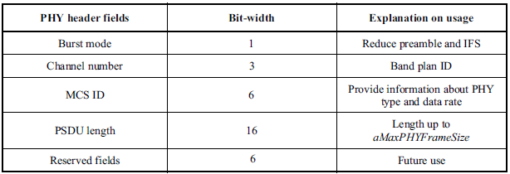

**Table 4-2 – PHY Header**

Burst Mode Field: The burst mode bit indicates that the next frame following the current frame is part of the burst mode. The Burst Mode bit shall be set TRUE if the burst mode is being used otherwise, the Burst Mode bit shall be set FALSE.

Channel Number Field: The channel number field for PHY shall be the band plan ID of the lowest wavelength. Refer to 9.3.1 for more detailed information.

MCS ID Field: The modulation and coding scheme (MCS) ID shall be indicated in the PHY header based on Table 83.

PSDU Field: The PSDU length field specifies the total number of octets contained in the PSDU.

**PSDU Field:**

The PSDU field has a variable length and carries the data of the PHY VI frame. The FCS is appended if the PSDU has a non-zero byte payload. The structure of the PSDU field is as shown in Figure 4-2.

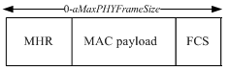

**Figure 4-2 – PHY PSDU Field Structure**

# **PHY PIB Attributes**

The PHY PIB comprises the attributes required to manage the PHY sublayer of a device. The attributes contained in the IEEE802.15.7-2011 PHY PIB are presented in Table 100 - PHY PIB Attributes.

The additional PHY PIB attributes added on PHY for 2 Dimensional codes is presented the Table 5-1.

|  |  |  |  |  |
| --- | --- | --- | --- | --- |
| **PHY PIB Table 100 Additions** | | | | |
| **Attribute** | **Identifier** | **Type** | **Range** | **Description** |
| phyVTASCApplicationSpecificMode | 0x10 | Unsigned | 0~255 | This attribute specifies the application specific PHY mode.  0 : Normal Data (Media Content, Information Content based on the Application used for)  1 : ID Data  2 : Authentication Data |
|  |  |  |  |  |
|  |  |  |  |  |
|  |  |  |  |  |

**Table** **5-1 - PHY PIB Attributes Additions**

# **Superframe Structure**

The Display Light Pattern Based Transmitter with VTASC uses the unslotted ALOHA; that is, when the Display Light Pattern Based Transmitter with VTASC uses has a packet to send, it just sends it. This support with beacon and without beacon support and the transmitter does not do a listen before talk channel activity check.

The super frame structure for PHY without beacon is shown in Figure 6-1.

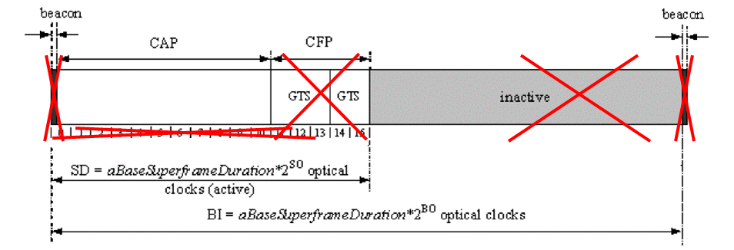

**Figure 6-1 – PHY Superframe Structure without Beacon**

The super frame structure for PHY with beacon is shown in Figure 6-2.

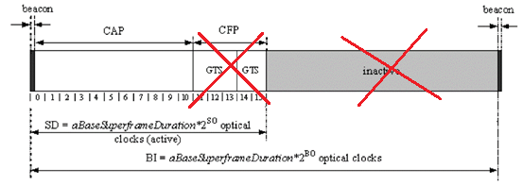

**Figure 6-2 – PHY Superframe Structure with Beacon**

# **MAC Frame Formats**

The MAC frame structure is formatted as illustrated in Figure 7-1 for proposed 2 Dimensional codes.

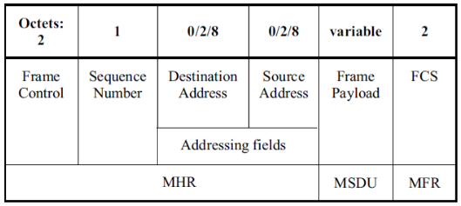

**Figure 7-1 –MAC Frame Format**

**Frame Control Field:**

The frame control field is formatted as illustrated in Figure 7-2 for proposed 2 Dimensional codes.

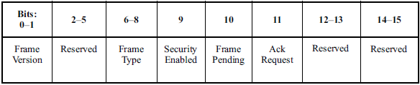

**Figure 7-2 – PHY VI Frame Control Field Format**

Frame Version Subfield: Specifies the version number corresponding to the frame. This subfield shall be set to 0b01 to indicate a frame compatible with IEEE Standard 802.15.7r1 and all other subfield values shall be reserved for future use.

Frame Type Subfield: Specifies the Frame Type used in MAC Frame. This field shall be set to one of the non-reserved values listed in Table 7-1.

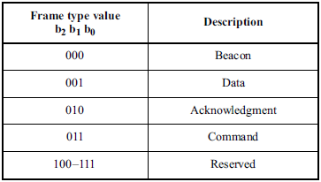

**Table** **7- 1 – PHY VI Frame Type Subfield**

Security Enabled Subfield: Species the Security on Data Frame is enable or not on transmission. This field is 1 bit in length, and it shall be set to one if the frame is protected by the MAC sublayer and shall be set to zero otherwise. The Auxiliary Security Header field of the MHR shall be present only if the Security Enabled subfield is set to one.

Frame Pending Subfield: Species the Pending on Data Frame is available or not on transmission. This field is 1 bit in length and shall be set to one if the device sending the frame has more data for the recipient. This subfield shall be set to zero otherwise.

Acknowledgment Request Subfield: Specifies whether an acknowledgment is required from the recipient device on receipt of a data or MAC command frame. This field is 1 bit in length and this subfield is set to one, the recipient device shall send an acknowledgment frame. If this subfield is set to zero, the recipient device shall not send an acknowledgment frame.

**Sequence Number Field:**

The Sequence Number field is 1 octet in length and specifies the sequence identifier for the frame.

For a beacon frame, the Sequence Number field shall specify a BSN. For a data, acknowledgment, or MAC command frame, the Sequence Number field shall specify a DSN that is used to match an acknowledgment frame to the data or MAC command frame.

**Destination Address Field:**

The Destination Address field, when present, is either 2 octets or 8 octets in length, according to the value specified in the Destination Addressing Mode subfield of the frame control field, and specifies the address of the intended recipient of the frame.

A 16-bit value of 0xffff in this field shall represent the broadcast short address, which shall be accepted as a valid 16-bit short address by all devices currently listening to the channel.

This field shall be included in the MAC frame only if the Destination Addressing Mode subfield of the frame control field is nonzero.

**Source Address Field:**

The Source Address field, when present, is either 2 octets or 8 octets in length, according to the value specified in the Source Addressing Mode subfield of the frame control field, , and specifies the address of the originator of the frame.

This field shall be included in the MAC frame only if the Source Addressing Mode subfield of the frame control field is 10 or 11.

**Frame Payload Field:**

The Frame Payload field has a variable length and contains information specific to individual frame types. If the Security Enabled subfield is set to one in the frame control field, the frame payload is protected as defined by the security suite selected for that frame.

**FCS Field:**

The FCS field is 2 octets in length and the FCS is calculated over the MHR and MSDU parts of the frame. The FCS shall be only generated for payloads greater than zero bytes.

The FCS is an optional filed in MAC frame format and the field information generated based on payload and FCS option used in the MAC frame from RS (64, 32) / RS (160,128) / None.

# **MAC PIB Attributes**

The MAC PIB comprises the attributes required to manage the MAC sublayer of a device. The attributes contained in the IEEE802.15.7-2011 MAC PIB are presented in Table 60 - MAC PIB Attributes. The additional MAC PIB attributes added for 2 Dimensional codes are presented the Table 8-1.

|  |  |  |  |  |  |
| --- | --- | --- | --- | --- | --- |
| **MAC PIB Attributes Table 60 Additions** | | | | | |
| **Attribute** | **Identifier** | **Type** | **Range** | **Description** | **Default** |
| macTxMode | 0x91 | Unsigned | 0-255 | This attribute indicates the MAC transmission mode is visible or Invisible.  0 : Visible VTASC Mode  1 : Visible Sequential Scalable 2D Code  2 : Invisible Mode – Blending Method  3 : Invisible Mode – Watermarking Method | 0 |
| macTxCamerEnable | 0x92 | Unsigned | 0-255 | This attribute indicates the Transmitter is Enabled with Camera or not for Interactive Receiver distance specific data transfer control.  0 : Camera not connected  1 : Camera connected | 0 |
| macRxDistance | 0x93 | Unsigned | 0-255 | This attribute notify the Receiver distance from Transmitter | 0 |
| macTxDataType | 0x94 | Unsigned | 0-255 | This attribute indicates the type of data to be transmitted.  0 : Normal Data (Media Content, Information Content based on the Application used for)  1 : ID Data  2 : Authentication Data | 0 |
| maxDataLength | 0x95 | Integer | 0-65535 | This attribute specify the length of the data to be transmitted | 0 |

**Table** **8-1 - MAC PIB Attributes Additions**