IEEE P802.15
Wireless Personal Area Networks

Project | IEEE P802.15 Working Group for Wireless Personal Area Networks (WPANs)
Title | PHY/MAC Draft D0 Comments Update for Offset-VPWM
Date Submitted | July, 2016
Source | Jaesang Cha ¹,  Minwoo Lee²,  SangWoo Lee,  Vinayagam Mariappan³,  Soonho Jung⁴  [Seoul National University of Science & Technology [SNUST], Nam Seoul University, Korea] | Voice: [ ]  Fax: [ ]  E-mail: [chajs@seoultech.ac.kr]¹,  [alsdnya@gmail.com]²,  [vinayagam_m@hotmail.com]³,  [ppangppangsk@gmail.com]⁴
Re:
Abstract | PHY/MAC draft D0 comment updates for Offset Variable Pulse Width Modulation for Smart Device Flash Light. The Flash Light designed to support LBS, Authentication, IoT/IoL, etc.
Purpose | Discussion and approval.
Notice | This document has been prepared to assist the IEEE P802.15. It is offered as a basis for discussion and is not binding on the contributing individual(s) or organization(s). The material in this document is subject to change in form and content after further study. The contributor(s) reserve(s) the right to add, amend or withdraw material contained herein.
Release | The contributor acknowledges and accepts that this contribution becomes the property of IEEE and may be made publicly available by P802.15.

Table of Contents

1.0 PHY Layer Operating Mode(s) 3
2.0 PHY Specifications 4
3.0 PHY Layer Dimming Method 7
4.0 PPDU Format 8
5.0 PHY PIB Attributes 10
6.0 Superframe Structure 11
7.0 MAC Frame Formats 12
8.0 MAC PIB Attributes 13

PHY Layer Operating Mode(s)

The Offset Variable Pulse Width Modulation for Smart Device Flash Light uses the PHY IV – Singular Point Source /Surface Light Source.
The PHY IV Operating Modes system specifications are given in Table 1-1.

PHY Operating Modes
Modulation | RLL Code | Optical Clock Rate | FEC |  | Data Rate
 |  |  | Outer Code (RS) | Inner Code (CC)
OffsetVPWM | None | 25Hz | None | None | 18 bps

Table 1-1 - PHY Operating Mode for Offset Variable Pulse Width Modulation for Smart Device Flash Light

PHY Specifications

The PHY IV with supported data rates and operating conditions is shown in Table 1-1 for Offset Variable Pulse Width Modulation for Smart Device Flash Light data transmission.
2.1 OFFSET-VPWM
The proposed Offset-VPWM (Variable Pulse Width Modulation) designed with following characteristics,
- Modulation methods includes line coding
- Defining the sum (P + nV) of the unit to be added to the minimum pulse (P) which is a reference pulse width (V) as a Symbol ( P>>V, V>time error(jitter) )
- Can specify a 2bit data symbol, 4bit data symbol according to number of added pulse
- Data is expressed with offset pulse width, 2bits data(for example) were mapped into 4 Offset-VPWM symbols
The data symbol map for two bits symbol with pulse width and respective symbol blinking waveform are shown in Table 2-1 and Figure 2-1 respectively.
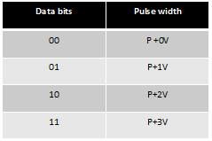
Table 2-1 – Two Bits Symbol Mapping Truth Table
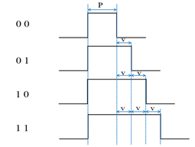
Figure 2-1 – Two Bit Symbol Data Diagram
In offset-VPWM, the data is expressed with offset pulse width, 4bits data (for example) were mapped into 16 Offset-VPWM symbols. The 4 bits symbol mapping truth table is shown in Table 2-2.
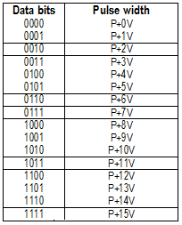
Table 2-2 – Four Bits Symbol Mapping Truth Table
The symbol arrays mapping is described in waveform pattern as shown in Figure 2-2.
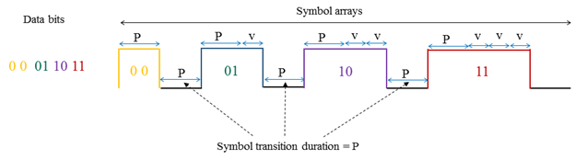
Figure 2-2 – Symbol Array Mapping Timing Diagram

2.2 Receiver Detection Method
Receiver can synchronize rising edge and check pulse width length using Rolling-shutter method. The receiver detection process in the wave formatted approach is show in Figure 2-3.
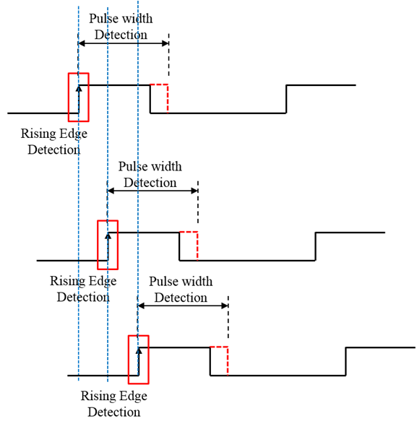
Figure 2-3 – Receiver Detection Process

PHY Layer Dimming Method

In the Offset Variable Pulse Width Modulation for Smart Device Flash Light PHY IV uses the Smartphone Camera LED Flash light sources, no need concerning dimming. The Camera LED Flash light is no using for illumination and blinking speed is very low, then can't control dim.
- Symbol Length : P, P+V, P+2V, P+3V
The Figure 3-1 shows the 2bit symbol map dimming control for Offset Variable Pulse Width Modulation for Smart Device Flash Light.
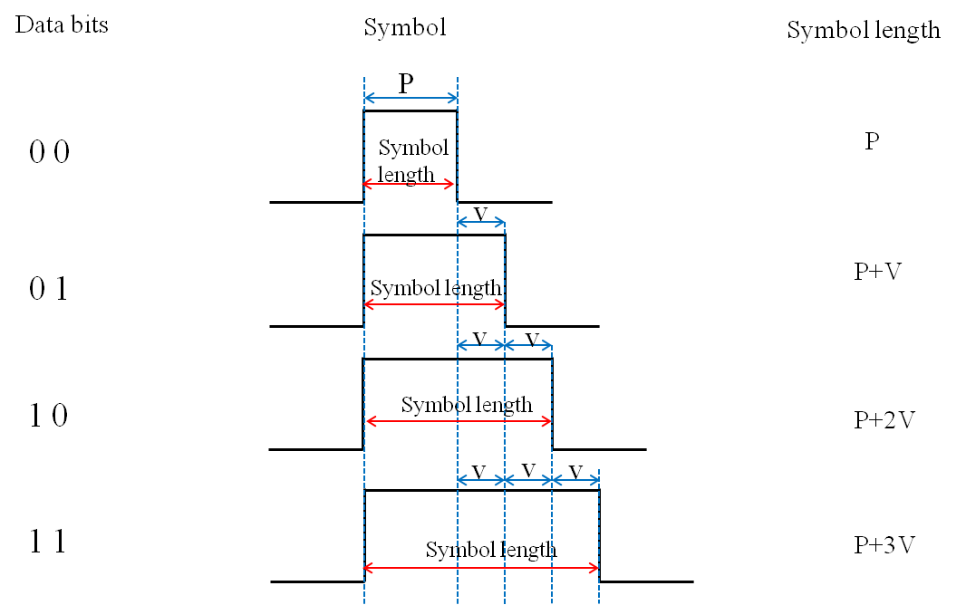
Figure 3-1 – 2 Bit Symbol Map Dimming Control

In accordance with the provisions of the symbol, depending on the data bit transmission because the High Pulse interval being determined brightness is adjustable (P >> V, V>time error (jitter)).

PPDU Format

The PPDU frame structure is formatted as illustrated in Figure 4-1 for PHY-IV Rolling/Global Shutter Cameras and Low Rate PD.
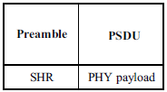
Figure 4-1 –PPDU Format

SHR Field:
The preamble field is used by the transceiver to obtain optical clock synchronization with an incoming message. The standard defines one fast locking pattern (FLP). The MAC shall select the optical clock rate for communication during the clock rate selection process. The preamble shall be sent at a clock rate chosen by the TX and supported by the RX. The preamble is a time domain sequence and does not have any channel coding or line coding.
The preamble first starts with a FLP. The FLP is fixed as a pattern “11010010”. The fast locking pattern length shall not exceed the maximum. The timing information for preamble is shown in Figure 4-2.
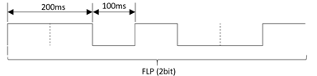
Figure 4-2 – Preamble Timing Diagram
In the Offset Variable Pulse Width Modulation for Smart Device Flash Light PHY uses OOK modulation for preamble transmission using flash light. The Preamble Bit Mapping shown in Figure 4-3.
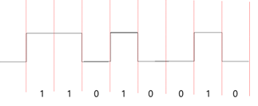
Figure 4-3 – Preamble Transmission – OFFSET VPWM BIT MAPPING
PSDU Field:
The PSDU field has a variable length and carries the data of the PHY IV frame. The FCS is appended if the PSDU has a non-zero byte payload. The structure of the PSDU field is as shown in Figure 4-4.
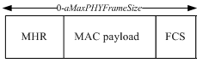
Figure 4-4 – PHY IV PSDU Field Structure

PHY PIB Attributes

The PHY PIB comprises the attributes required to manage the PHY sublayer of a device. The attributes contained in the IEEE802.15.7-2011 PHY PIB are presented in Table 100 - PHY PIB Attributes.
The additional PHY IV PIB attributes added for Offset Variable Pulse Width Modulation for Smart Device Flash Light PHY is presented the Table 5-1.

PHY PIB Table 100 Additions
Attribute | Identifier | Type | Range | Description
phySMFlashLIGHTApplicationSpecificMode | 0x10 | Unsigned | 0~255 | This attribute specifies the application specific PHY mode.  0 : Normal Data (Media Content, Information Content based on the Application used for)  1 : ID Data  2 : Authentication Data

Table 5-1 - PHY PIB Attributes Additions

Superframe Structure

The Offset Variable Pulse Width Modulation for Smart Device Flash Light PHY uses the unslotted ALOHA; that is, when the Smart Device flash light transmitter has a packet to send, it just transmit the data. This support with beacon and without beacon support and the transmitter does not do a listen before talk channel activity check.
The super frame structure for Offset Variable Pulse Width Modulation without beacon is shown in Figure 6-1.
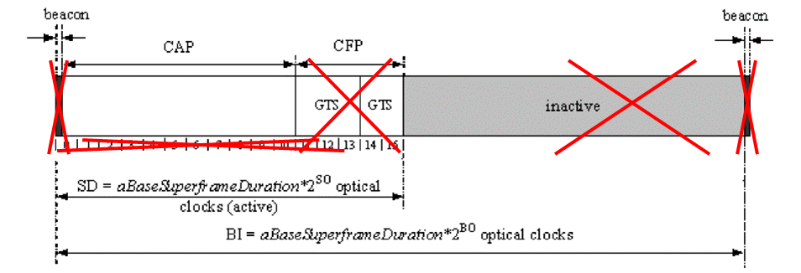
Figure 6-1 –Superframe Structure without Beacon

MAC Frame Formats

The MAC frame structure is formatted as illustrated in Figure 7-1 for Offset Variable Pulse Width Modulation for Smart Device Flash Light.
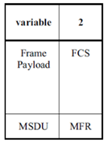
Figure 7-1 –MAC Frame Format

Frame Payload Field:
The Frame Payload field has a variable length and contains information specific to individual frame types. If the Security Enabled subfield is set to one in the frame control field, the frame payload is protected as defined by the security suite selected for that frame.
FCS Field:
The FCS field is 2 octets in length and the FCS is calculated over the MHR and MSDU parts of the frame. The FCS shall be only generated for payloads greater than zero bytes.
The FCS is option is given as an optional option, it is adaptive to RS/CRC/NONE.

MAC PIB Attributes

The MAC PIB comprises the attributes required to manage the MAC sublayer of a device. The attributes contained in the IEEE802.15.7-2011 MAC PIB are presented in Table 60 - MAC PIB Attributes.
The additional MAC PIB attributes added for Offset Variable Pulse Width Modulation for Smart Device Flash Light is presented the Table 8-1.
MAC PIB Attributes Table 60 Additions
Attribute | Identifier | Type | Range | Description | Default
macLEDIDusage | 0x81 | Unsigned | 0-255 | This attribute indicates the type of data transmitted using Flash Light Transmitter.  0 : LED IT  1 : With or Without LED ID and IP address | 0

Table 8-1 - MAC PIB Attributes Additions

