|  |  |  |  |
| --- | --- | --- | --- |
|  | **Radiocommunication Study Groups** | |  |
| **INTERNATIONAL TELECOMMUNICATION UNION** | |  | |
|  | |  | |
| Source: Document 5A/TEMP/2(Rev.1) | | **Annex 28 to Document 5A/114-E** | |
| **24 May 2016** | |
| **English only** | |
| Annex 28 to Working Party 5A Chairman’s Report | | | |
| working document towards a preliminary draft  new report itu-r M.[300GHz_MS_CHAR] | | | |
| Technical and operational characteristics and applications of the land mobile service operating in the frequency band 275-450 GHz | | | |

WRC-19 agenda item 1.15

# 1 Introduction

# 2 Scope

# 3 Related Recommendation and Report

|  |  |
| --- | --- |
| Report ITU-R SM.2352-0: | Technology trends of active services in the frequency range 275‑3 000 GHz |

# 4 List of acronyms and abbreviations

|  |  |
| --- | --- |
| BBU | Base band unit |
| RRH | Remote radio head |

# 5 Definition of terahertz (THz) and others

*[Editor’s note: This section will review section 2.1 to Report ITU-R SM.2352-0 from the points of view of the land mobile service applications and technologies.]*

# 6 Regulatory information above 275 GHz

# 7 System Overview

## 7.1 300 GHz close proximity radiocommunication system

*[Editor’s note: This section will identify the specific frequency bands and land mobile service applications which will be used for sharing and compatibility studies with passive services by WP 1A.]*

## 7.2 Wireless links for data centers

*The goal of wireless data links in addition to the existing fibres is to provide flexibility by introducing reconfigurable routes within a data center. In the figure some examples are illustrated between or inside the server racks (green) for line-of-sight (LOS) or Multi Hop links.*

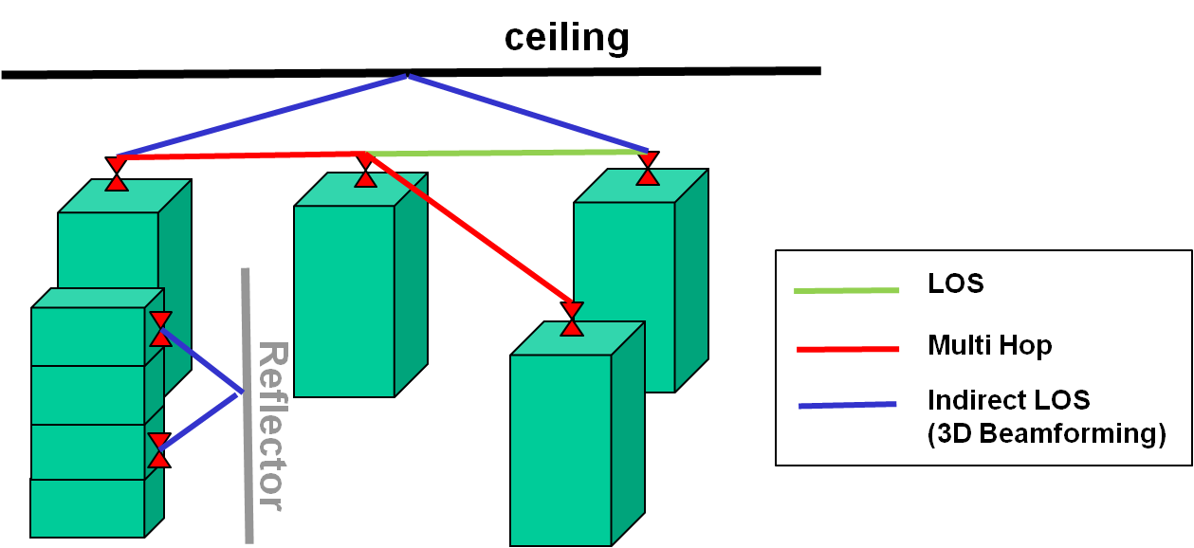

## 7.3 intra-device communications

In intra-device communications, one or more communication links are operated within a device. High speed terahertz wireless links could connect two or more PCBs or even chips on the same PCB. The terahertz band is huge hence several channels could be used in a small area (within one device). The following figure illustrates point-to-point communications between boards, where the color of the beams indicate different frequencies.

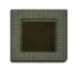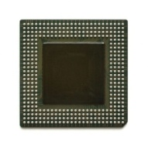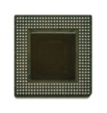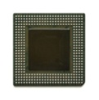

# 8 System characteristics

*[Editor’s note: Technical and operational characteristics of the land mobile radiocommunication system operating in the frequency band 275-450 GHz are invited to be addressed in this section.]*

## 8.1 A close proximity radiocommunication system

A close proximity land mobile radiocommunication system operating in the band 275-320 GHz is shown in Table 1.

TABLE 1

Technical and operational characteristics of a land mobile CPRS applications operating   
in the frequency band 275-321.84 GHz

| Frequency band (GHz) | 275-321.84 |
| --- | --- |
| Deployment density | Depending on outdoor usage |
| Duplex Method | TDD |
| Modulation | OOK/BPSK/QPSK/16QAM/64QAM  8PSK/8APSK |
| Average distance between CPRS[1] fixed and mobile devices (m) | 0.1 |
| Maximum between CPRS fixed and mobile devices (m) | 1 |
| Antenna height (m) | TBD |
| Antenna beamwidth (degree) | 3-10 15? |
| Frequency reuse | 1 |
| Antenna pattern | TBD |
| Antenna polarization | Linear |
| Indoor CPRS fixed device deployment (%) | 90 |
| Indoor CPRS fixed device penetration loss (dB) | >100 |
| Feeder loss (dB) | 2 |
| Maximum CPRS fixed device output power (dBm) | 10 |
| Channel bandwidth (GHz) | 2.16/4.32/8.64/12.96/17.28/25.92/51.84/69.12[2] |
| Transmitter spectrum mask | TBD |
| Maximum CPRS fixed device antenna gain (dBi) | 30 |
| Maximum CPRS mobile device antenna gain (dBi) | 30 |
| Maximum CRPS fixed device output power (e.i.r.p.) (dBm) | 40 |
| Maximum CRPS mobile device output power (e.i.r.p.) (dBm) | 40 |
| Average CPRS fixed device activity (%) | 20 |
| Average CPRS fixed device power (dBm (e.i.r.p)) | 20 |
| Receiver noise figure typical (dB) | 15 |

## 8.2 Wireless links for data centers

The characteristics of wireless links for data centers in the band 275-321.84 GHz is shown in Table 2.

TABLE 2

Technical and operational characteristics of a land mobile wireless links for data centers operating   
in the frequency band 275-321.84 GHz

| Frequency band (GHz) | 275-321.84 |
| --- | --- |
| Duplex Method | TDD, FDD, SDD |
| Modulation | OOK/BPSK/QPSK/16QAM/64QAM  8PSK/8APSK |
| Maximum distance between devices | 100 m |
| Antenna height (m) | TBD |
| Antenna beamwidth (degree) | <25 (expected) |
| Frequency reuse | 1 |
| Antenna pattern | TBD |
| Antenna polarization | Linear |
| Indoor deployment (%) | 100 |
| Indoor penetration loss (dB) | TBD (>100) |
| Maximum device output power (dBm) | 10 |
| Channel bandwidth (GHz) | 2.16/4.32/8.64/12.96/17.28/ 25.92/51.84/69.12[3] |
| Transmitter spectrum mask | TBD |
| Maximum device antenna gain (dBi) | 30 |
| Maximum device output power (e.i.r.p.) (dBm) | 40 |
| Maximum device activity (%) | 100 |
| Receiver noise figure typical (dB) | 10 |

## 8.3 intra-device communications

The characteristics of wireless intra-device links in the band 275-321.84 GHz is shown in Table 3.

TABLE 3

Technical and operational characteristics of a land mobile wireless intra-device links operating   
in the frequency band 275-321.84 GHz

| Frequency band (GHz) | 275-321.84 |
| --- | --- |
| Duplex Method | TDD, FDD, SDD |
| Modulation | OOK/BPSK/QPSK/16QAM/64QAM  8PSK/8APSK |
| Maximum distance between devices | <1 m |
| Antenna height (m) | TBD |
| Antenna beamwidth (degree) | 180 (expected) |
| Frequency reuse | 1 |
| Antenna pattern | TBD |
| Antenna polarization | Linear |
| Maximum device output power (dBm) | 10 |
| Channel bandwidth (GHz) | 2.16/4.32/8.64/12.96/17.28//25.92/51.84/69.12[4] |
| Transmitter spectrum mask | TBD |
| Maximum device antenna gain (dBi) | 20 |
| Maximum device output power (e.i.r.p.) (dBm) | 30 |
| Maximum device activity (%) | 100 |
| Receiver noise figure typical (dB) | 10 |

# 9 Summary

# 10 References

# 11 Annex(s) [if necessary]

1. CPRS stands for Close Proximity Radiocommunication System.
2. The planned applications will operate in the frequency range from 252.72 to 321.84 GHz. Therefore, mentioned bandwidths may exceed the available bandwidth between 275 GHz to 321.84 GHz.
3. The planned applications will operate in the frequency range from 252.72 to 321.84 GHz. Therefore, mentioned bandwidths may exceed the available bandwidth between 275 GHz to 321.84 GHz.
4. The planned applications will operate in the frequency range from 252.72 to 321.84 GHz. Therefore, mentioned bandwidths may exceed the available bandwidth between 275 GHz to 321.84 GHz.