**IEEE P802.15**

**Wireless Personal Area Networks**

|  |  |  |
| --- | --- | --- |
| Project | IEEE P802.15 Working Group for Wireless Personal Area Networks (WPANs) | |
| Title | Transmit spectral mask modification | |
| Date Submitted | 2 June 2016 | |
| Source | Jun Kobayashi, Itaru Maekawa Japan Radio Co., Ltd.  1-1, Shimorenjaku 5-chome,  Mitaka-shi, Tokyo, Japan | E-mail :  [kobayashi.jun@jrc.co.jp](mailto:kobayashi.jun@jrc.co.jp)  [Maekawa.Itaru@jrc.co.jp](mailto:Maekawa.Itaru@jrc.co.jp) |
| Abstract | This document provides Transmit spectral mask modification. | |
| Purpose | Transmit spectral mask modification - CID 1068 and 1069. | |
| Notice | This document has been prepared to assist the IEEE P802.15. It is offered as a basis for discussion and is not binding on the contributing individual(s) or organization(s). The material in this document is subject to change in form and content after further study. The contributor(s) reserve(s) the right to add, amend or withdraw material contained herein. | |
| Release | The contributor acknowledges and accepts that this contribution becomes the property of IEEE and may be made publicly available by P802.15. | |
|  |  | |

***TG3e Editor: replace figure 11a-1 with the following figure***

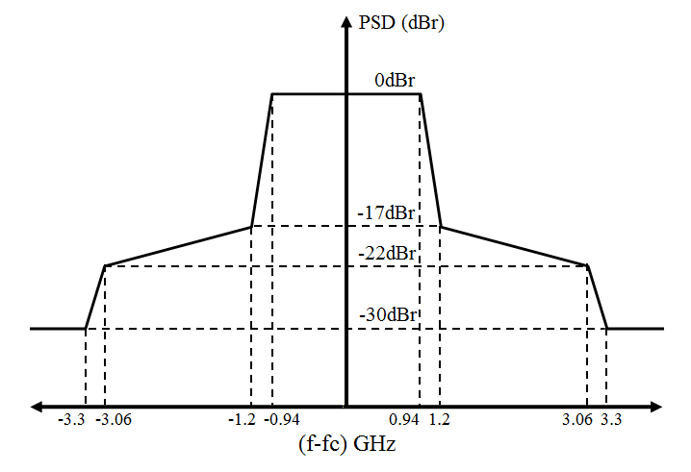

Figure 11a-1 Transmit spectral mask for a single channel operation

***TG3e Editor: replace figure 11a-2 with the following figure***

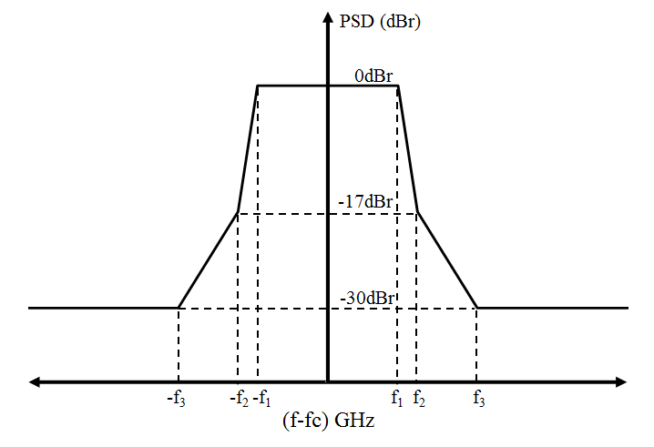

Figure 11a-2 Transmit spectral mask for channel bonding

***TG3e Editor: replace table 11a-2 with the following table***

Table 11a-2 -Transmit spectral mask limit for channel bonding

|  |  |
| --- | --- |
| Frequency | Relative Limit (dBr) |
|  |  |
|  |  |
|  |  |
|  |  |

***TG3e Editor: replace table 11a-3 with the following table***

Table 11a-3 -Transmit spectral mask parameters for channel bonding

|  |  |  |  |
| --- | --- | --- | --- |
| Channel bonding | *f*1 (GHz) | *f*2 (GHz) | *f*3 (GHz) |
| Two-bonded channel transmission | 1.880 | 2.400 | 4.000 |
| Three-bonded channel transmission | 2.820 | 3.600 | 6.000 |
| Four-bonded channel transmission | 3.760 | 4.800 | 8.000 |