IEEE P802.15
Wireless Personal Area Networks

Project | IEEE P802.15 Working Group for Wireless Personal Area Networks (WPANs)
Title | Resolution for comments about capability
Date Submitted | 19 May 2016
Source | Keitarou Kondou⁽¹⁾, Keiji, Akiyama ⁽¹⁾ Itaru Maekawa⁽²⁾ and Jae Seung Lee⁽³⁾  ⁽¹⁾Sony Semiconductor Solutions Corporation  4-14-1 Asahi-cho, Atsugi-shi, Kanagawa 243-0014  ⁽²⁾ Japan Radio Co.,Ltd.  ⁽³⁾ ETRI | Voice:  Fax:  E-mail: Keitarou.Kondou@ jp.sony.com
Re: | In response to CID 22, 82, 95, 96, 97, 98, 99, 100 and 101 (16/0162r4) from LB114 and editorial comments from LB119
Abstract | Revised version of capability table and its description are provided.
Purpose | To apply changes to current draft based on comments from LB114 and LB119.
Notice | This document has been prepared to assist the IEEE P802.15. It is offered as a basis for discussion and is not binding on the contributing individual(s) or organization(s). The material in this document is subject to change in form and content after further study. The contributor(s) reserve(s) the right to add, amend or withdraw material contained herein.
Release | The contributor acknowledges and accepts that this contribution becomes the property of IEEE and may be made publicly available by P802.15.

6.4.11a HRCP PNC Capability IE

Replace Figure 6-88b with the following figure:

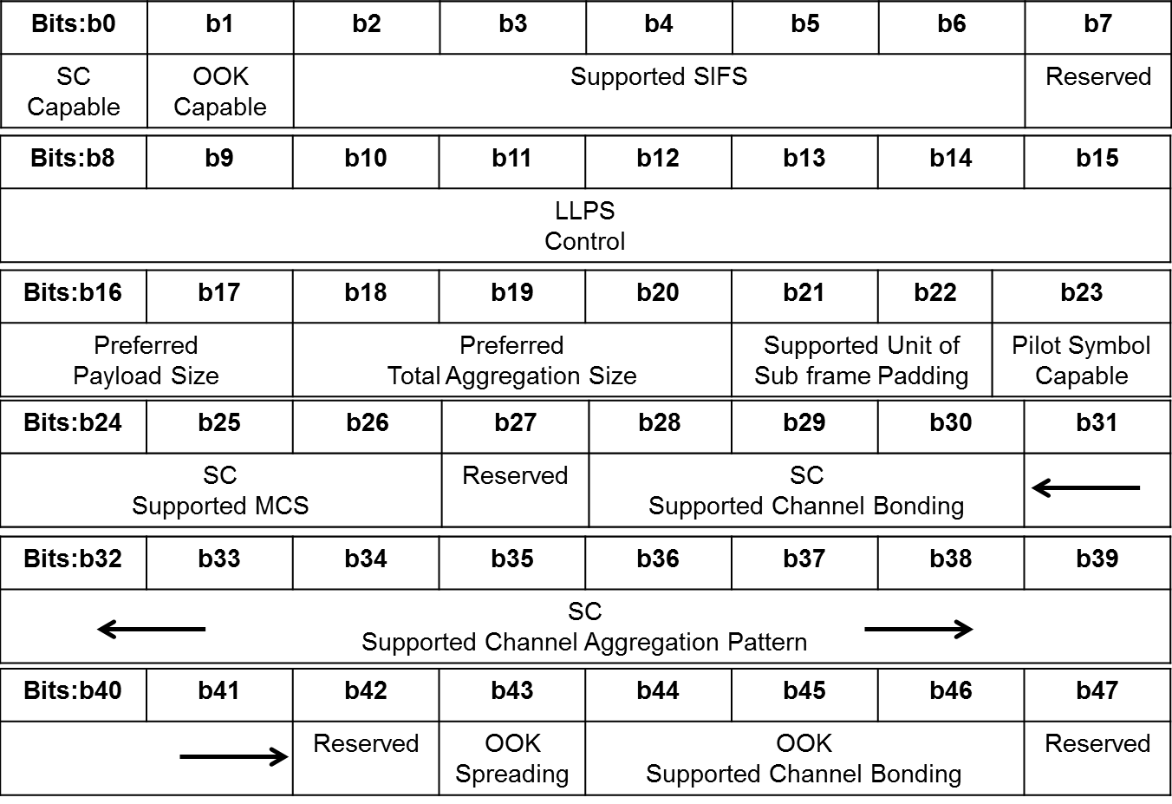
Figure 6-88b HRCP PNC Capability field format

Replace Text and tables after Figure 6-88b as follows.
The SC Capable field shall be set to one if the DEV supports the SC PHY, as defined in 11a.2, and shall be set to zero otherwise.
The OOK Capable field shall be set to one if the DEV supports the OOK PHY, as defined in 11a.3, and shall be set to zero otherwise.
The supported SIFS field contains the value of the shortest SIFS supported by the DEV in units of 0.1 μs encoded as an unsigned integer. For example, a value of 0b01001 indicates that the shortest SIFS supported by the DEV is 0.9μs. Values greater than 2.5 μs are reserved.
The low latency power save (LLPS) Control field contains LLPS related parameters as defined in Figure 6-88c
Bits: b0 | b1 | b2 | b3 | b4 | b5 | b6 | b7
LLPS  Allow | LLPS  Interval |  |  | LLPS  Start |  | LLPS  Extend
Figure 6-88c LLPS Control field format

The LLPS Allow field shall be set to one if the HRCP PNC allows the HRCP DEVs to use power save mode after association is completed, otherwise it is set to zero.
The LLPS Interval field indicates the value of ACK sending interval when the DEV is in HRCP Sleep mode. The field is defined in Table 6-17a.
Table 6-17a LLPS interval field values
Bits: b0 | b1 | B2 | LLPS interval
0 | 0 | 0 | 1 ms
0 | 0 | 1 | 5 ms
0 | 1 | 0 | 10 ms
0 | 1 | 1 | 50 ms
1 | 0 | 0 | 100 ms
1 | 0 | 1 | Reserved
… | … | ...
1 | 1 | 1

The LLPS Start field indicates the value of consecutive ACKs duration to start LLPS. The valid values of the LLPS Start field are given in Table 6-17b.
Table 6-17b LLPS Start field values
Bits: b0 | b1 | LLPS interval
0 | 0 | 0.1 ms
0 | 1 | 1 ms
1 | 0 | 10 ms
1 | 1 | Reserved

The LLPS Extend field indicates the value of consecutive ACKs duration to extend LLPS. The valid values of the LLPS Extend field are given in Table 6-17c.
Table 6-17c LLPS Extend field values
Bits: b0 | b1 | LLPS Extend
0 | 0 | 0.1 ms
0 | 1 | 1 ms
1 | 0 | 10 ms
1 | 1 | Reserved

The Preferred Payload Size field indicates the maximum preferred data size of a single subframe payload to be received by the DEV. This field shall be formatted as illustrated in Table 6-17d.
Table 6-17d Preferred Payload Size field values
Bits: b0 | b1 | Preferred Payload Size
0 | 0 | 2048 octets
0 | 1 | 4096 octets
1 | 0 | 8192 octets
1 | 1 | Reserved

The Preferred Total Aggregation Size field indicates the maximum preferred total data size in a single frame to be received by the DEV when fragmentation is used. This field shall be formatted as illustrated in Table 6-17e.
Table 6-17e Preferred Total Aggregation Size field values
Bits: b0 | b1 | b2 | Preferred Total Aggregation Size
0 | 0 | 0 | 16448 octets
0 | 0 | 1 | 32896 octets
0 | 1 | 0 | 65792 octets
0 | 1 | 1 | 131584 octets
1 | 0 | 0 | 263168 octets
1 | 0 | 1 | 526336 octets
1 | 1 | 0 | 1050624 octets
1 | 1 | 1 | 2099200 octets

The Supported Unit of Subframe Padding field indicates the unit of the subframe padding that can be received by the DEV as defined in Figure 6-88d. Each field shall be set to one for supported capability, and otherwise set to zero.
Bits: b0 | b1
64 bit unit of padding supported | 128 bit unit of padding supported
Figure 6-88d Supported Unit of Subframe Padding field format

The Pilot Symbol capable field shall be set to one if the DEV is capable of decoding the frame with pilot symbols, and shall be set to zero otherwise.
The SC Supported MCS field shall be formatted as illustrated in Figure 6-88e.
Bits: b0 | b1 | b2
SC 16-QAM supported | SC 64-QAM supported | SC 256-QAM supported
Figure 6-88e SC Supported MCS field format
The SC 16-QAM field shall be set to one if 16-QAM modulation is supported by the SC PHY DEV and shall be set to zero otherwise. The SC 64-QAM field shall be set to one if 64-QAM modulation is supported by the SC PHY DEV and shall be set to zero otherwise. The SC 256-QAM field shall be set to one if 256-QAM modulation is supported by the SC PHY DEV and shall be set to zero otherwise.
The SC Supported Channel Bonding field indicates the number of bonded channels supported by the SC-PHY DEV. The Supported OOK Channel bonding field shall be formatted as illustrated in Figure 6-88f.
Bits: b0 | b1 | b2
SC 2 channel bonding is supported | SC 3 channel bonding is supported | SC 4 channel bonding is supported
Figure 6-88f SC Supported Channel Bonding field format
SC 2 channel bonding uses CHNL_ID 2 and 3. SC 3 channel bonding uses CHNL_ID 1, 2 and 3. SC 4 channel bonding uses CHNL_ID 1, 2, 3 and 4.
The SC Supported Channel Aggregation pattern field indicates the supported combinations of CHNL_IDs used for channel aggregation by the SC-PHY DEV. The SC Supported Channel Aggregation field shall be formatted as illustrated in the Figure 6-88g and Table 6-17f. Each field shall be set to one for supported combinations, and shall be set to zero otherwise. Hence, if all bits set to be zero, the SC-PHY DEV does not support any channel aggregation pattern. Check mark in the Table 6-17e means the allowable aggregation channel for each pattern.
Bits: b0 | b1 | b2 | b3 | b4 | b5 | b6 | b7 | b8 | b9 | b10
pattern0 | pattern1 | pattern2 | pattern3 | pattern4 | pattern5 | pattern6 | pattern7 | pattern8 | pattern9 | pattern10
Figure 6-88g SC Supported Channel Aggregation pattern field

Table 6-17f Channel Aggregation Patterns for SC PHY in Figure 6-88c
CHNL_ID | 1 | 2 | 3 | 4
pattern0
pattern1
pattern2
pattern3
pattern4
pattern5
pattern6
pattern7
pattern8
pattern9
pattern10

The OOK spreading field shall be set to one if spreading factor 2 is supported by the HRCP-OOK PHY DEV and shall be set to zero if spreading is not supported by the DEV.
The OOK Supported Channel Bonding field indicates the number of bonded channels supported by the OOK-PHY DEV. The Supported OOK Channel bonding field shall be formatted as illustrated in Figure 6-88h.
Bits: b0 | b1 | b2
OOK 2 channel bonding is supported | OOK 3 channel bonding is supported | OOK 4 channel bonding is supported
Figure 6-88h OOK Supported Channel Bonding field format
The CHNL_ID used for OOK channel bonding is specified in 11a.3.1.1.

6.4.11b HRCP DEV Capability IE

Change the sentence after figure 6.4.11h as follows:

The DEV Capability field shall be formatted as illustrated in Figure 6-88b except for the LLPC Control field being reserved.

Delete Figure 6-88i

Replace Text after Figure 6-88i as follows.

The SC Capable field is defined in 6.4.11a.
The OOK capable field is defined in 6.4.11a.
The Supported SIFS field is defined in 6.4.11a.
The Preferred Payload Size field is defined in 6.4.11a.
The Preferred Total Aggregation Size field is defined in 6.4.11a.
The Supported Unit of Subframe Padding field is defined in 6.4.11a.
The Pilot Symbol Capable field is defined in 6.4.11a.
The SC Supported MCS field is defined in 6.4.11a.
The SC Supported Channel Bonding Capability field is defined in 6.4.11a.
The SC Supported Channel Aggregation Pattern field is defined in 6.4.11a.
The OOK Spreading field is defined in 6.4.11a.
The OOK Supported Channel Bonding field is defined in 6.4.11a.

6.4.11c HRCP Operation Parameters IE

Replace Figure 6-88k with the following figure:

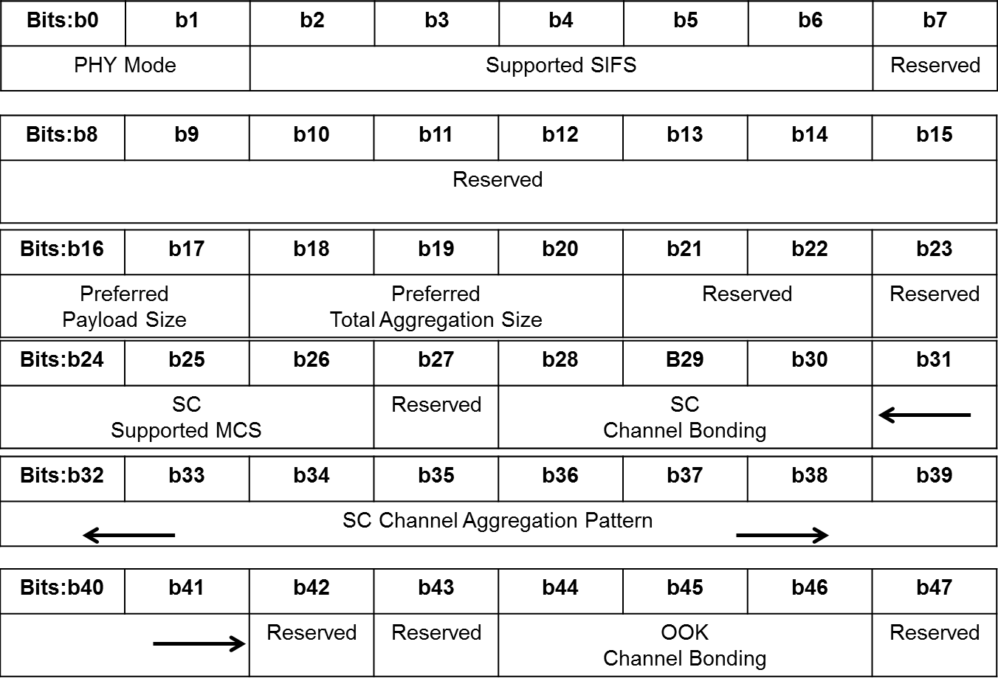
Figure 6-88k HRCP Operation Parameters field format

Replace Text after Figure 6-88k as follows.

The PHY Mode field indicates which PHY mode is used in the session as defined in Table 6-17l. 10b indicates SC PHY is used, 01b indicates OOK PHY is used and other bit patterns shall not be used.
Table 6-17l PHY Mode field values
Bits: b0 | b1 | PHY Mode
1 | 0 | SC
0 | 1 | OOK
0 | 0 | Reserved
1 | 1

The Supported SIFS field is defined in 6.4.11a. The larger value of SIFS in PPC and DEV capability shall be encoded in this field.
The Preferred Payload Size field is defined in 6.4.11a. The smaller value of Preferred Payload Size in PPC and DEV capability shall be encoded in this field.
The Preferred Total Aggregation Size field is defined in 6.4.11a. The smaller value of Preferred Total Aggregation Size in PPC and DEV capability shall be encoded in this field.
The SC Supported MCS field is defined in 6.4.11a. Each bit in this field shall be set to one if both of the bits in SC Supported MCS field in PPC capability IE and DEV capability IE are set to one and shall be set to zero otherwise.
The SC Channel Bonding field indicates the number of bonded channels that shall be used in the current session as defined in the Figure 6-88l and only one bit in the field is allowed to be set to one. All bits of the field shall be set to 0 if the channel bonding is not used.
Bits: b0 | b1 | b2
SC 2 channel bonding is used | SC 3 channel bonding is used | SC 4 channel bonding is used
Figure 6-88l SC Channel Bonding field format
The SC Channel Aggregation Pattern field indicates the combinations of CHNL_IDs used for channel aggregation in the current session as determined by HRCP PNC. The SC Channel Aggregation pattern field shall be formatted as illustrated in the Figure 6-88f and only one bit in the field is allowed to be set to one.
The OOK Channel Bonding field indicates the number of bonded channels that shall be used in the current session as defined in the Figure 6-88m and only one bit in the field is allowed to be set to one. All bits of the field shall be set to 0 if the channel bonding is not used.
Bits: b0 | b1 | b2
OOK 2 channel bonding is used | OOK 3 channel bonding is used | OOK4 channel bonding is used
Figure 6-88m OOK Channel Bonding field format

