IEEE P802.15
Wireless Personal Area Networks

Project | IEEE P802.15 Working Group for Wireless Personal Area Networks (WPANs)
Title | Proposed comment resolution for CID3088 from LB116
Date Submitted | 17 March 2016
Source | *[Jaehwan Kim, Sangjae Lee, Sangsung Choi, Cheolho Shin], [Jaebeom Kim], † [Soo-Young Chang]  *[ETRI], †[SYCA] | Voice: [+82-42-860-5338]  Fax: []  E-mail: [kimj@etri.re.kr]
Re: | 802.15.10 Consolidated Comment Entry Form, CID3088
Abstract | Provides a proposed resolution to CID3088
Purpose | To be used by the technical editor to apply the necessary changes to the draft to resolve CID3088
Notice | This document has been prepared to assist the IEEE P802.15. It is offered as a basis for discussion and is not binding on the contributing individual(s) or organization(s). The material in this document is subject to change in form and content after further study. The contributor(s) reserve(s) the right to add, amend or withdraw material contained herein.
Release | The contributor acknowledges and accepts that this contribution becomes the property of IEEE and may be made publicly available by P802.15.
Comment

Commenter | Page | Clause | Line | Comment | Proposed change
Don Sturek | 45 | 5.2.7.2 | 13 | If I am understanding P2P routing correctly, the Figure 21 is extremely misleading. Isn't P2P just a controlled flood where the intermediate devices accept and either forward or drop the forwarding messages to the destination? Certainly in that scenario while the P2P RP IE will look like wha tis shown the P2P RQ IE will not. It will go to nearly all devices until the cost is deemed higher than a better path. | Fix the diagram or explain why it is correct as shown

Resolution: Revise

Replace the figure 21 and add figure 22
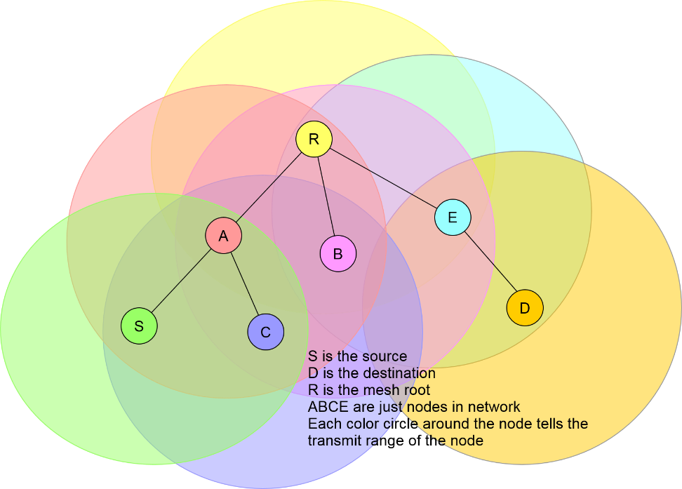

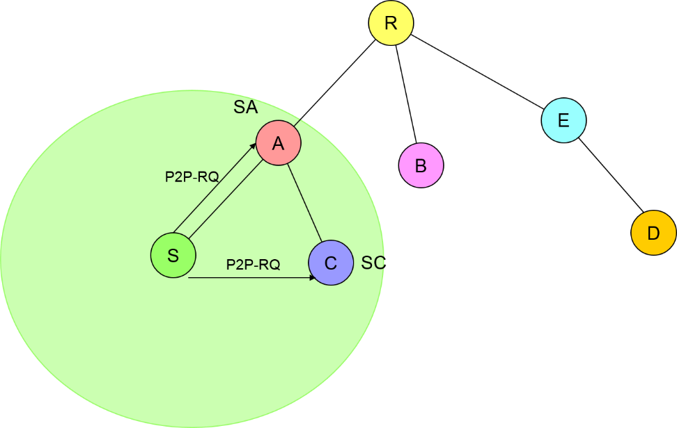
Step 1 S transmits (P2P-RQ)
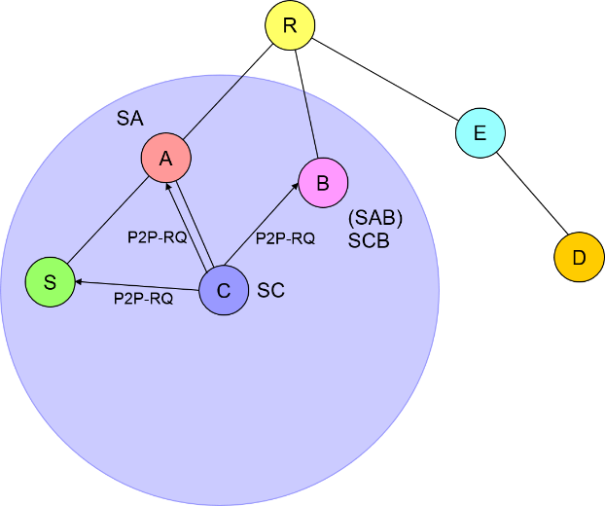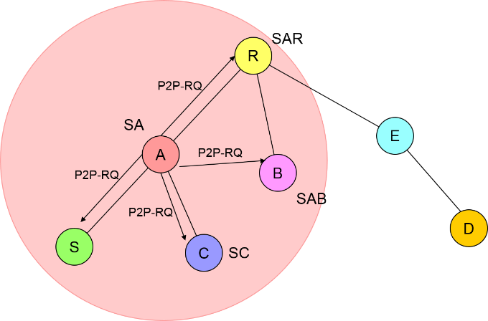
Step 2 C transmits (P2P-RQ) A transmits (P2P-RQ)

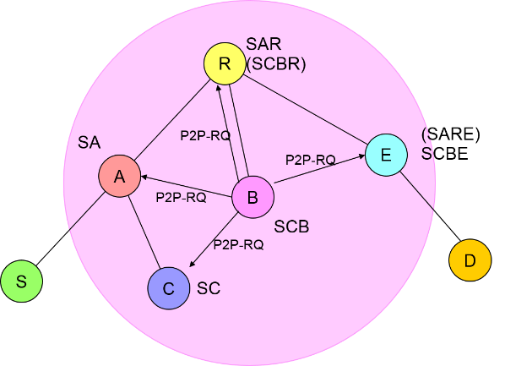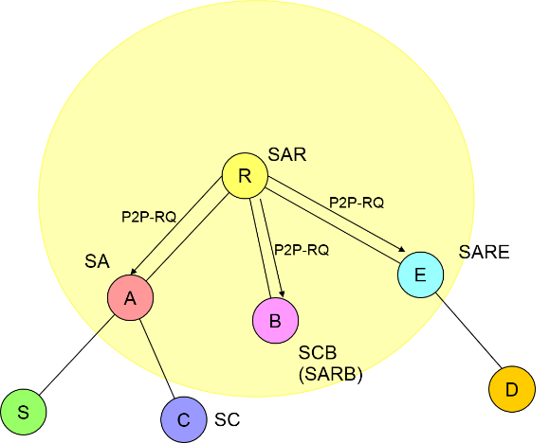
Step 3 B transmits (P2P-RQ) R transmits (P2P-RQ)

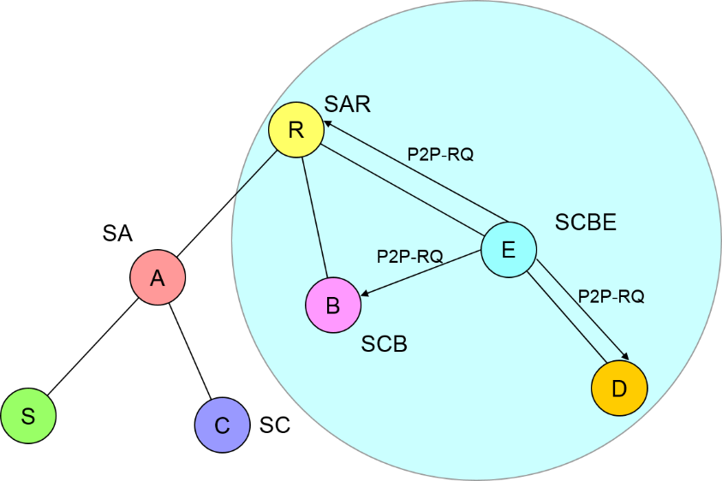
Step 4 E transmits (P2P-RQ)
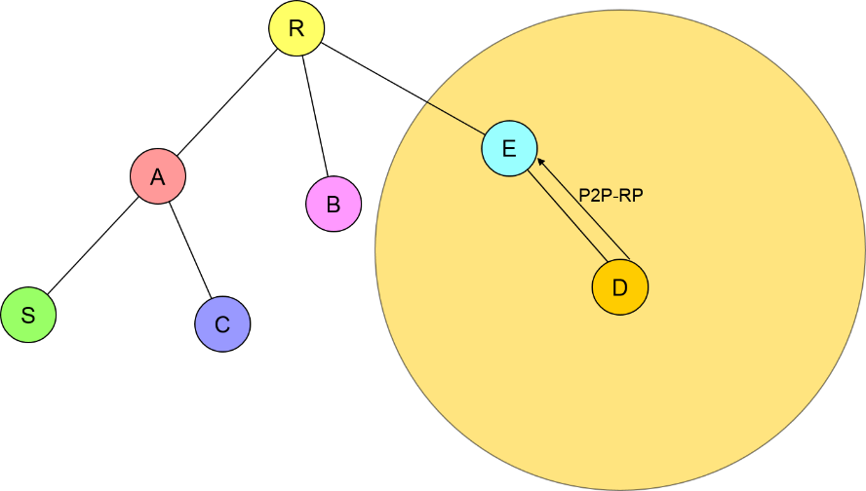
Step 5 D transmits (P2P-RP)
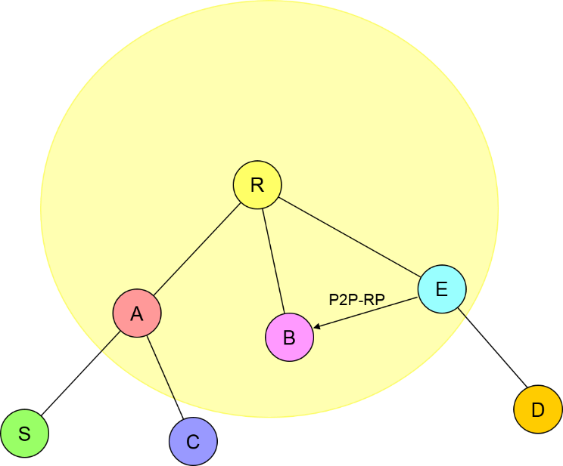
Step 6 E transmits (P2P-RP)
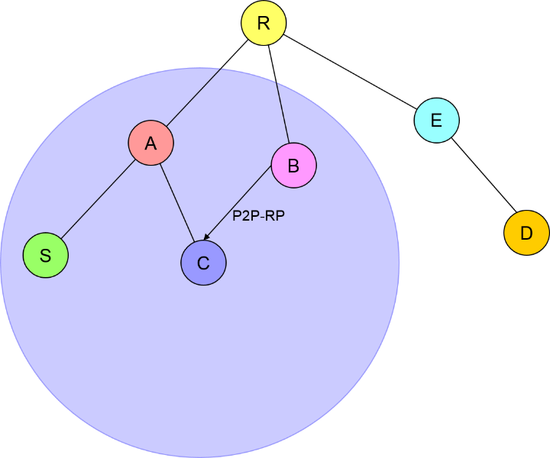
Step 7 B transmits (P2P-RP)
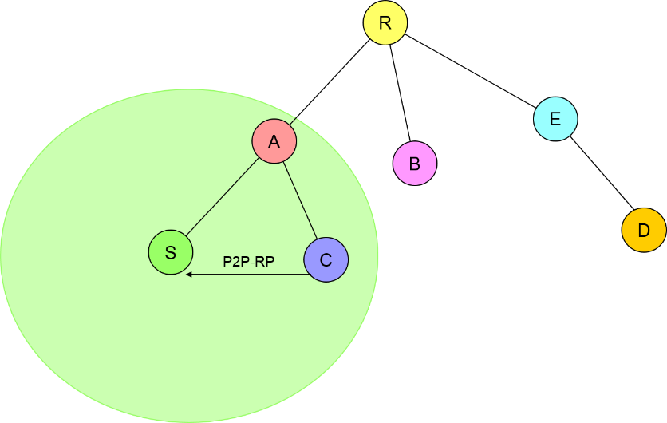
Step 8 C transmits (P2P-RP)
Figure 21 – P2P route establishment

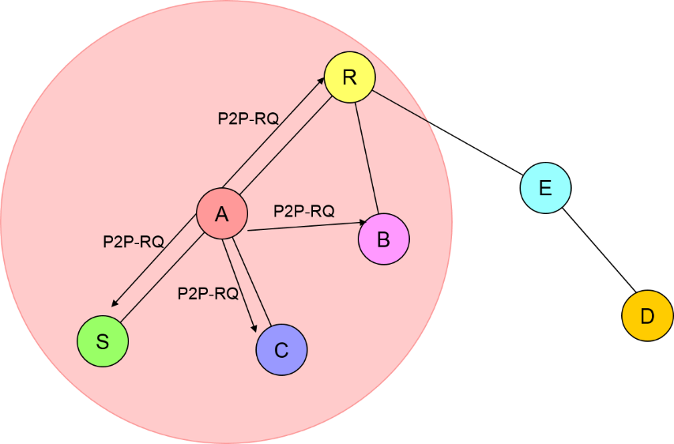
Step 1 A transmits (P2P-RQ)

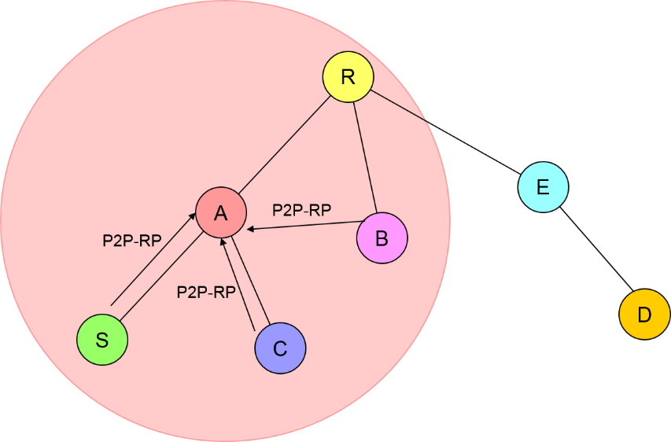
Step 2 S,C,B transmits (P2P-RP) (Intermediate response)
Figure 22 – P2P route establishment with intermediate response

Replace
“Figure 21 shows an example of the P2P route establishment between devices D and H. If G has a path to H and if intermediate response is enabled, G responds with a P2P-RP IE without forwarding an incoming P2PRQ IE. Otherwise, all devices forward the P2P-RQ IE. For simplicity, only the P2P-RQ and P2P-RP IEs exchanged on the path D-E-F-G-H are depicted.”
With
“Figure 21 shows an example of the P2P route establishment between devices S and D. If E has a path to D and if intermediate response is enabled, E responds with a P2P-RP IE without forwarding an incoming P2P-RQ IE. Otherwise, all devices forward the P2P-RQ IE. In addition, for depth 3, B forwards P2P-RQ IE which is the first received. The device B updates local information for better route, but do not distributes it forward when the next received P2P-RQ has better PQM.
An example of the P2P route establishment with intermediate response is illustrated in Figure 22. After P2P route establishment with Figure 21, if A wants to find a route to D, A transmits P2P-RQ IE to S, C, B, and R. If the intermediate response is enabled, since C, B, and R already know the route to D, they transmit P2P-RP IE to A. Then, A chooses the shortest path to D and the route from A to D is established.”

