IEEE P802.15
Wireless Personal Area Networks

Project | IEEE P802.15 Working Group for Wireless Personal Area Networks (WPANs)
Title | Text Input Template
Date Submitted | 17 March 2016
Source | [Roberts, Richard D]  [<company>]  [address] | Voice: [ ]  Fax: [ ]  E-mail: [ ]
Re: | [If this is a proposed revision, cite the original document.]  [If this is a response to a Call for Contributions, cite the name and date of the Call for Contributions to which this document responds, as well as the relevant item number in the Call for Contributions.]  [Note: Contributions that are not responsive to this section of the template, and contributions which do not address the topic under which they are submitted, may be refused or consigned to the “General Contributions” area.]
Abstract | [Description of document contents.]
Purpose | [Description of what the author wants P802.15 to do with the information in the document.]
Notice | This document has been prepared to assist the IEEE P802.15. It is offered as a basis for discussion and is not binding on the contributing individual(s) or organization(s). The material in this document is subject to change in form and content after further study. The contributor(s) reserve(s) the right to add, amend or withdraw material contained herein.
Release | The contributor acknowledges and accepts that this contribution becomes the property of IEEE and may be made publicly available by P802.15.
PHY Layer Operating mode(s)
Dear Proposer: please fill in this section with your PHY operating mode(s). You may modify this table as you see fit.

See table 73, 74 or 75 from IEEE802.15.7-2011 for an example table.
PHY Operating Modes
Modulation | RLL Code | Optical Clock Rate | FEC | Data Rate

2.0 PHY specifications
Dear Proposer: please fill in this section with your PHY specifications

See IEEE802.15.7-2011 sections 10, 11 or 12 for current specifications.
< Enter PHY specifications here >

PHY Layer Dimming Method
Dear Proposer: in this section we need you to describe your dimming method. If you proposed one or more OCC PHY modes that support dimming than please write a paragraph to describe how the dimming works. You may include figures and drawings as needed.

< Enter paragraph here >

4.0 PPDU format
Dear Proposer: for each of the PHY modes of interest, please describe to the best of your ability your envisioned PPDU format. You can take the present PPDU and modify it accordingly. If possible, describe what you envision for each of the PPDU fields.

Current IEEE802.15.7-2011 PPDU

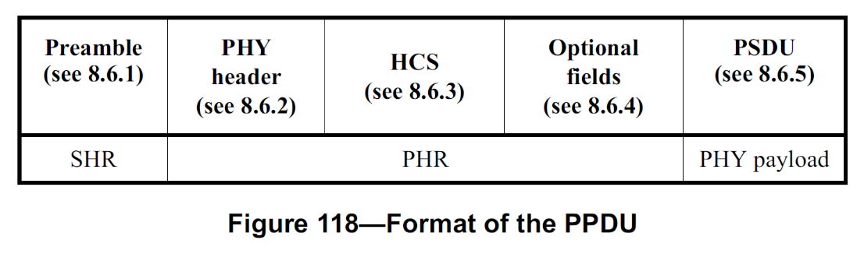
< Enter PPDU format here >

5.0 PHY PIB attributes
Dear Proposer: add any anticipated PHY PIB attributes here

See IEEE802.15.7-2011 Table 100 for the current PHY PIB Table

PHY PIB Table 100 Additions
Attribute | Identifier | Type | Range | Description

6.0 Superframe Structure
Dear Proposer: if you have an opinion as to the superframe structure then please express your opinion below; otherwise, you can leave this section blank.

Current 802.15.7-2011 superframe is shown below.

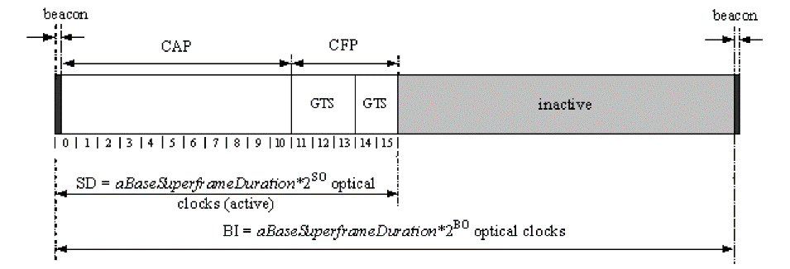

< Enter Superframe Structure here >

7.0 MAC frame formats
Dear Proposer: in the section below you can express your opinion as to the MAC frame format. If you have no opinion then you can leave this section blank.

Current 802.15.7-2011 MAC frame format.
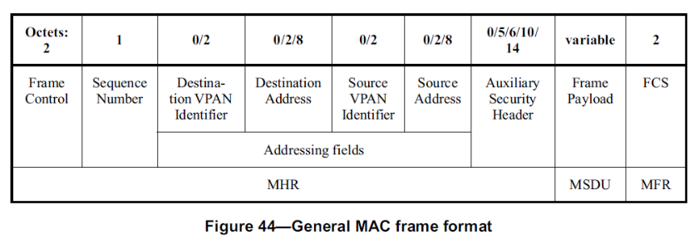
< Enter MAC frame format here >

8.0 MAC PIB attributes
Dear Proposer: add any anticipated MAC PIB attributes here

See table 60 in IEEE802.15.7-2011 for the current MAC PIB Table.
MAC PIB Table 60 Additions
Attribute | Identifier | Type | Range | Description | Default

