**IEEE P802.15**

**Wireless Personal Area Networks**

|  |  |  |
| --- | --- | --- |
| Project | IEEE P802.15 Working Group for Wireless Personal Area Networks (WPANs) | |
| Title | **Detailed description of singlecarrier modulation for OFDM** | |
| Date Submitted | 16 March 2016 | |
| Source | [Jungnickel, Volker] [Fraunhofer HHI] [Einsteinufer 37, 10587 Berlin] | Voice: [ ] Fax: [ ] E-mail: [ volker.jungnickel@hhi.fraunhofer.de ] |
| Re: | [If this is a proposed revision, cite the original document.]  [If this is a response to a Call for Contributions, cite the name and date of the Call for Contributions to which this document responds, as well as the relevant item number in the Call for Contributions.]  [Note: Contributions that are not responsive to this section of the template, and contributions which do not address the topic under which they are submitted, may be refused or consigned to the “General Contributions” area.] | |
| Abstract | This document contains a detailed description of singlecarrier modulation using OFDM to be included in D0. | |
| Purpose | Provide a fully implementable specification of the transmitter. | |
| Notice | This document has been prepared to assist the IEEE P802.15. It is offered as a basis for discussion and is not binding on the contributing individual(s) or organization(s). The material in this document is subject to change in form and content after further study. The contributor(s) reserve(s) the right to add, amend or withdraw material contained herein. | |
| Release | The contributor acknowledges and accepts that this contribution becomes the property of IEEE and may be made publicly available by P802.15. | |

#### Single-carrier modulation using OFDM

Optional pre-coding before the OFDM modulator can be used to reduce the probability of clipping and enhance power efficiency while sacrificing no or minor spectral efficiency [2, 3].

For single-carrier (SC) transmission, “outer” pre-coding, together with an “inner” OFDM transmitter is used to emulate SC transmitter inside the OFDM concept. These schemes require little more advanced signal processing, and the same minor increase of sophistication can be expected at the receiver, i.e. the decoding is straightforward. The schemes are shown in principle in Figure 5. More details can be found in [2, 3].

|  |
| --- |
| Figure 5 - Different precoding schemes can be used to improve the power efficiency of the OFDM transmitter. Top: Pure DFT precoding emulates a Nyquist pulse with roll-off factor =0, as introduced in 3GPP LTE Rel. 8. Center: A root-raised-cosine filter can be added in the frequency domain, to realize >0. Bottom: A Gaussian filter can used in the same way and a minimum-shift keying (MSK) modulation can be added in the time domain. In this way, the classical GMSK waveform can be realized inside an OFDM system. |

#### DFT-pre-coded OFDM

The SC-FDMA transmitter from 3GPP LTE is shown in Figure 5, row A. First, the symbol sequence is passed through the N-DFT and then mapped directly onto the desired frequency sub-band using a cyclic shift (CS) so that the DC signal is in the center[1]. Finally, the precoded sequence is passed through the M-IDFT and the cyclic prefix (CP) is added.

As shown in [2], this procedure yields a SC signal with a Nyquist pulse-shape having a roll-off factor of =0. The rectangular filtering causes some “ringing” in the time domain which effectively increases the peak-to-average power ratio. As this is a special case of the filtered SC transmission, details are described in the next subsection.

#### RRC-filtered SC modulation

In the middle row in Figure 5, an additional root-raised-cosine filter is introduced in the frequency domain where >0. In order to realize filtering in the frequency domain, first, oversampling is emulated by repeating the DFT output block in the frequency domain. Afterwards, the root-raised cosine (RRC) filter is applied in the frequency domain. The sequence is then mapped directly onto the desired frequency sub-band using a cyclic shift (CS) so that the DC signal is in the center. In the following, these steps are described in detail.

A data sequence a(n) of length N is used where n = 1, 2, …, N. The sequence is up-sampled by factor *F* as follows

$b\left(k\right)=\left\{\begin{aligned}a\left(n\right) if k=F∙n \\ 0 else\end{aligned}\right.$

with $F=\left\lfloor \frac{M}{N}-0.5\right\rfloor$, where *k =* 1, 2*, …, F∙N* and *M* is the number of samples in the final waveform. The notation $\left\lfloor z\right\rfloor$ is used here to indicate that *z* is rounded to the nearest integer less than or equal to *z*.[2] Note that F-times up-sampling followed by *M*-DFT is equivalent to *N*-DFT and subsequent spectral repetition, provided that the ratio $\frac{M}{N}$ is an integer. The proof is given in [3]. Accordingly, up-sampling and *M*-DFT can be replaced by *N*-DFT and repeating the output signal in the frequency domain.

Next step is a flexible frequency-domain filter. It is implemented so that bandwidth can be easily changed as a function of the block size *N*. Therefore, a vector is defined with running index s = [-N, …, N] the bell-shape part of the filter is computed as

$$G_{l}=\sqrt{0.5\left(1+cos\left[\frac{π\left(\left|s_{l}\right|\right)-(1-α)∙\frac{N}{2}}{α∙N}\right]\right)}$$

where l = 1, 2, …2N+1. The filter is transparent in the range

$$a=\left[N+1-\left\lfloor \frac{\left(1-α\right)∙N}{2}\right\rfloor , …, N+1+\left\lfloor \frac{\left(1-α\right)∙N}{2}\right\rfloor \right]$$

There are two regions where the filter attenuates totally. They are given by

$$b=\left[1, …, N+1-\left\lfloor \frac{\left(1+α\right)∙N}{2}\right\rfloor \right]$$

$$c=\left[N+1+\left\lfloor \frac{\left(1+α\right)∙N}{2}\right\rfloor , …, 2N+1 \right]$$

G*l* is now set as G***a*** = 1, G***b*** = 0 and G***c*** = 0 in the respective regions indicated by vectors ***a***, ***b*** and ***c***. Note that up-conversion is equivalent to performing sequentially M-DFT of the time-domain sequence, a cyclic shift by *Ncenter* and *M*-IDFT of the shifted signal, as shown in [3].

In row B. in Fig. 1, the synthesis of filtered QAM is summarized in the frequency domain. First the data symbol sequence is passed through the N-DFT and the output is repeated in the frequency domain. Next, the signal is filtered in the frequency domain and the cyclic shift is applied to up-convert the signal to the desired center sub-carrier *Ncenter*. Finally, the signal is passed through the *M*-IDFT and the cyclic prefix is added [2].

Note that in the SC transmitter, carrier mapping has been modified compared to LTE. In this way, waveforms become comparable to time-domain single-carrier signal, see [2]. The new mapping is sketched in Figure 5.

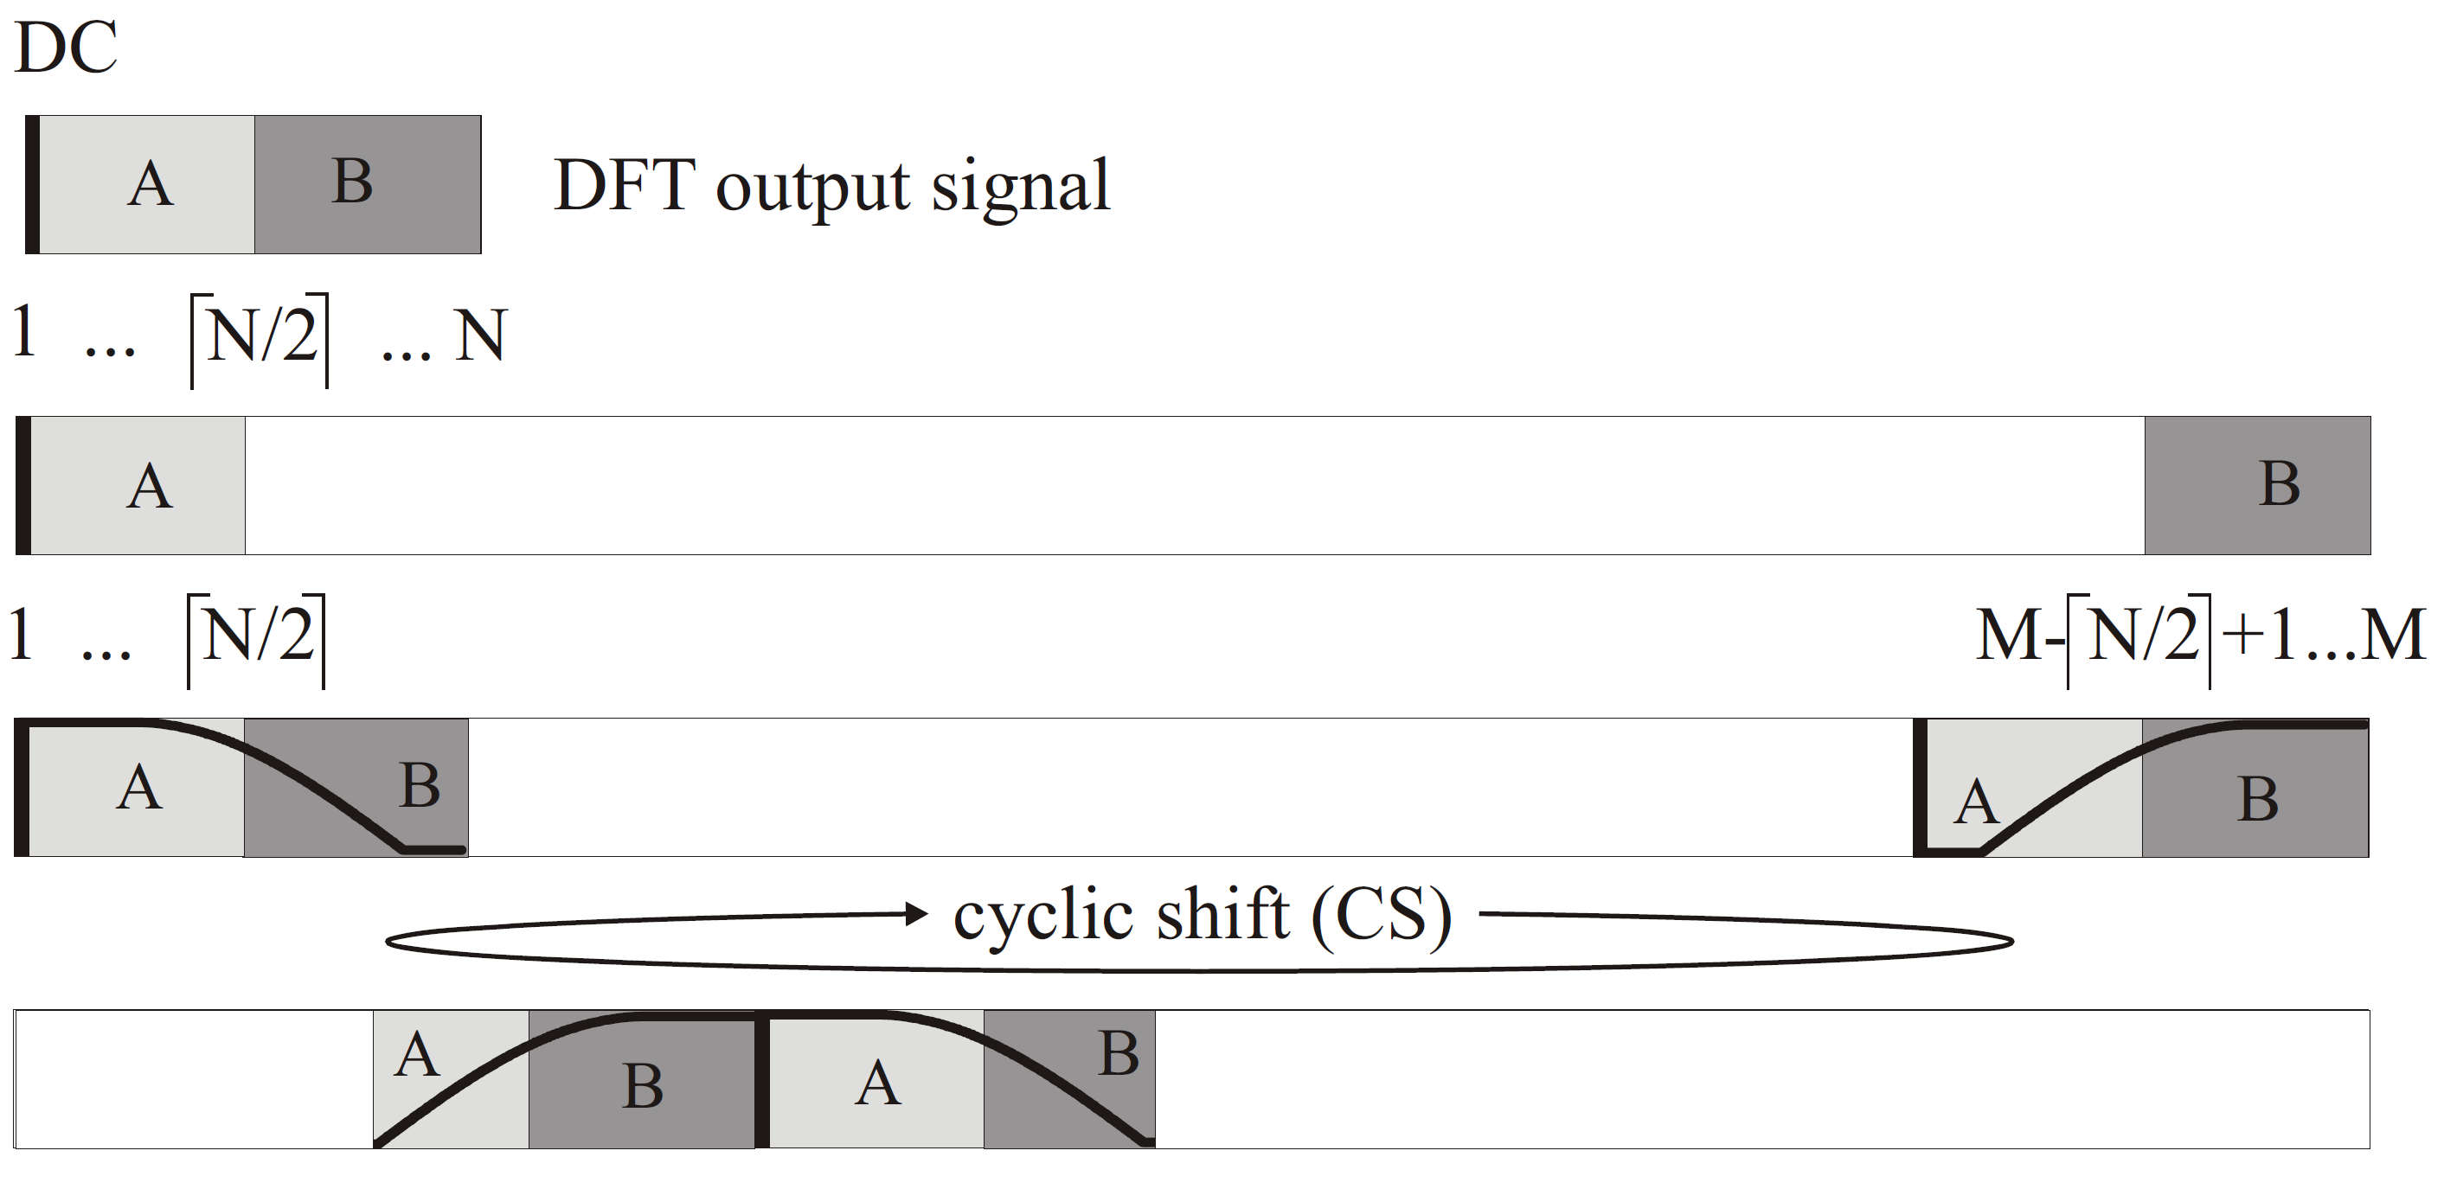

The direct current (DC) sub-carrier of the N-DFT output vector (having index 1) is first mapped onto the DC sub-carrier of the M-IDFT. The two blocks

$A=\left[2…\left\lceil \frac{N}{2}\right\rceil \right]$ and $B=\left[\left\lceil \frac{N}{2}\right\rceil +1…N\right]$

are then mapped onto the first and last sub-carriers, see Fig. 2. Periodic replica are added in the frequency domain as described above to emulate the up-sampling. Finally, the frequency-domain filter described above is applied and the cyclic shift is used to modulate the signal onto the center subcarrier.

#### Gaussian minimum shift keying

First, the classical time-domain GMSK single-carrier transmitter is reviewed. The serial data symbol sequence *a*(n) is up-sampled as in (1) yielding *b*(k). After applying a Gaussian filter in the time domain, the filtered signal c(k) is obtained. The classical Gaussian filter is approximated in the time domain using a finite impulse response (FIR) with some memory. Next, c(k) is passed into a minimum shift keying (MSK) modulator where it is first accumulated yielding the phase

$φ\left(k\right)=φ\left(k-1\right)+\frac{π}{2F}c\left(k-1\right)$

and then inserted into the complex amplitude

$$x\left(k\right)=I+jQ=\cos\left(φ\left(k\right)\right)+j∙sin⁡(φ\left(k\right))$$

Note that in-phase I and quadrature signal Q in (10) are fed by the same phase but at a shift of 90° yielding single side band (SSB) modulation when up-converting the sequence to the desired center frequency. This is often performed using an analog IQ modulator.

The same SSB up-conversion can be reached using digital signal processing. Therefore, the complex-valued GMSK baseband signal is multiplied sample-by-sample with a digitally synthesized complex-valued oscillation due to single OFDM sub-carrier, being the center frequency of the desired GMSK-modulated signal. Finally, a window of length M is applied in the time domain.

The equivalent processing for GMSK using OFDM is summarized on row C. in Figure 5. As before, the data sequence *a*(n) is fed into the N-DFT and up-sampling is emulated by repeating the output signal in the frequency domain. Next, a Gaussian filter is applied in the frequency domain. A vector is created with running index s = [-R, …, R] where R≤N, the filter is computed as

$G_{n}=e^{-β^{2}∙s_{n}^{2}}$ where $β=\sqrt{\frac{ln⁡(2)}{2}}∙\frac{1}{N∙BT}$

where *n* = 1*,* 2*, ...,* 2*R* + 1 and *BT* is the bandwidth-time product. GMSK is a non-linear SSB phase modulation. Thus, the two functions of accumulating the signal and generating the in-phase and quadrature signals are better realized in the time domain. The main idea is to insert the GMSK modulator after frequency-domain filtering, but in the time domain. Using *M*-IDFT of the filtered data sequence, *c*(*k*) is obtained. Next, *c*(*k*) is normalized to unit peak amplitude and feed it into the time-domain MSK modulator described above. Then up-conversion is applied. It can be equivalently implemented as shown in Figure 5 or in the time-domain as described above. Finally, the cyclic prefix is applied for frequency-domain equalization at the receiver. All processing is shown on row *C.* in Figure 5.

GMSK implies adjacent channel interference since single-sideband phase modulation is a non-linear process in general. Even if the GMSK modulator input is confined in the frequency domain, fourwave mixing between in-band sub-carriers creates out-of-band interference. Such interference can be cut using an optional post-modulation filter in the frequency domain attenuating totally outside the range s = [−R, ...,R] and correct the power, accordingly.

#### From complex- to real-valued SC transmission

It is understood that the above waveforms yield complex-valued sequences. Same as in the adaptive OFDM approach, hence, the complex-valued waveform covers only the first N/2 subcarriers and then Hermetian symmetry is enforced. Conjugate symmetry is enforced as

$x_{2N-i}=x_{i}, i=1,2,…N/2-1$.

The resulting discrete multi-tone (DMT) signal is real-valued, even if symbols *xn* are complex.

1. actually, this is step is left out in the 3GPP LTE specification but needed in the more sophisticated schemes described in following subsections.
2. In Matlab, this is the function floor(*z*).