IEEE P802.15
Wireless Personal Area Networks

Project | IEEE P802.15 Working Group for Wireless Personal Area Networks (WPANs)
Title | Suggested discovery definition and changes in one-to-one de-peering procedure
Date Submitted | March 2016
Source | Huan-Bang Li (NICT)  Marco Hernandez (NICT)  Igor Dotlić (NICT)  Ryu Miura (NICT)
Re: | TG8 draft text for discovery definition and changes in one-to-one de-peering procedure for 802.15.8
Abstract | This is the work in progress text of the MAC component for IEEE 802.15.8 group for PAC.
Purpose | This document provides the details of draft text to IEEE 802.15.8
Notice | This document does not represent the agreed views of the IEEE 802.15 Working Group or IEEE 802.15.8 Task Group. It represents only the views of the participants listed in the “Source(s)” field above. It is offered as a basis for discussion and is not binding on the contributing individual(s) or organization(s). The material in this document is subject to change in form and content after further study. The contributor(s) reserve(s) the right to add, amend or withdraw material contained herein.
Release | The contributor acknowledges and accepts that this contribution becomes the property of IEEE and may be made publicly available by P802.15.
Patent Policy | The contributor is familiar with the IEEE-SA Patent Policy and Procedures:  <http://standards.ieee.org/guides/bylaws/sect6-7.html#6> and  <http://standards.ieee.org/guides/opman/sect6.html#6.3>.  Further information is located at <http://standards.ieee.org/board/pat/pat-material.html> and  <http://standards.ieee.org/board/pat>.

[This is draft text for definition of discovery and one-to-one de-peering procedure TG8]

  - Discovery
Discovery is
Discovery is a procedure that a PD sends a message to surroundings for detecting the existence of other PDs. The sending message can be a dedicated message to particular PDs or a non-dedicated message. Other PDs receiving this message can response or do not response depending on if the sending PD soliciting a response.

      - One-to-one de-peering procedure
As illustrated in Figure 41, a one-to-one De-peering procedure may contain the following steps.
- A PD’s Higher Layer (i.e. PD1’s Higher Layer) triggers De-peering procedure with a De-peering Request to its MAC (i.e. PD1’s MAC).
- The MAC receiving the Higher Layer’s De-peering Request (i.e. PD1’s MAC) sends the De-peering Request message to the targeted PD’s MAC (i.e. PD2’s MAC).
- The targeted PD’s MAC (i.e. PD2’s MAC) receives the De-peering Request message and sends ACK/NACK message to the PD requesting de-peering (i.e. PD1’s MAC).
- The targeted PD’s MAC (i.e. PD2’s MAC), sends the received De-peering Request message to its Higher Layer (i.e. PD2’s Higher Layer).
- Optional: the Higher Layer receiving the De-peering Request (i.e. PD2’s Higher Layer) decides either to accept the De-peering Request or not and indicates it to the MAC (i.e. PD2’s MAC) accordingly.
- Optional: the targeted PD’s MAC (i.e. PD2’s MAC) sends De-peering Response message to the PD requesting de-peering (i.e. PD1’s MAC) as directed by the Higher Layer.
- Optional: the PD’MAC receiving the De-peering Response message (i.e. PD1’s MAC) sends ACK/NACK message to the target PD (i.e. PD2’s MAC).
- Optional: the PD’MAC receiving the De-peering Response message (i.e. PD1’s MAC) sends the De-peering Response message to its Higher Layer (i.e. PD1’s Higher Layer).
- Optional: the link between PD1 and Pd2 is disconnected.
Figure 41—One-to-one de-peering procedure message sequence chart

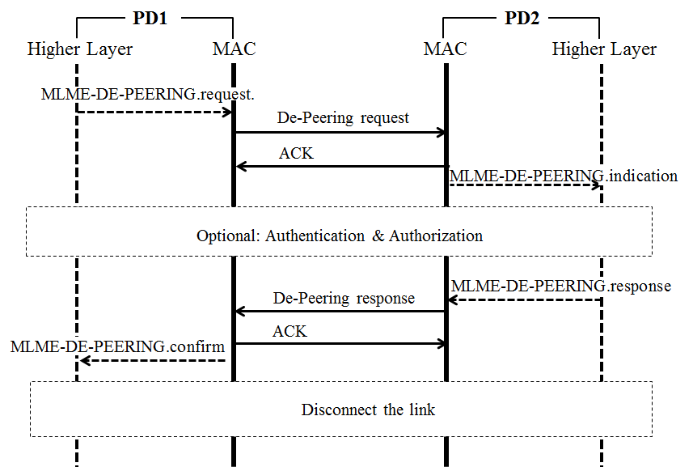
Figure 41—One-to-one de-peering procedure message sequence chart

