IEEE P802.15
Wireless Personal Area Networks

Project | Dependability Interest Group
Title | Meeting Minutes for November 2015
Date Submitted | March 15, 2016
Source | [Jussi Haapola]  [Centre for Wireless Communications / University of Oulu] | Voice: +358 40 8363 018  E-mail: jhaapola@ee.oulu.fi
Re: | Meeting Minutes
Abstract
Purpose | Minutes of Dependability Interest Group sessions
Notice | This document has been prepared to assist the IEEE P802.15. It is offered as a basis for discussion and is not binding on the contributing individual(s) or organization(s). The material in this document is subject to change in form and content after further study. The contributor(s) reserve(s) the right to add, amend or withdraw material contained herein.
Release | The contributor acknowledges and accepts that this contribution becomes the property of IEEE and may be made publicly available by P802.15.

Tuesday, November 10, 2015, PM1, 13:30

  - Meeting called to order 10:30
By Chair Ryuji Kohno (YNU / CWC-Nippon)
Secretary Jussi Haapola (Centre for Wireless Communication / University of Oulu)

  - Roll Call
Notepad for Attendance circulated.

  - Opening Report

Chair presented Opening report Doc #242

Chair showed IEEE Patent policy.

Chair issued Call for Potentially Essential Patents
No essential intellectual property in the scope of IG DEP was declared.

  - Approval of previous meeting minutes
Upon no comments on the previous meeting minutes, doc #096 meeting minutes were approved.

  - Review of CFI

Doc #14-449r6
Doc #15-217r6

  - Review of responses to CFI

  - Scope and Focused Applications with Different QoS Levels

  - Drafting PAR and CSD
Delete robustness -> marketing term
Delete safe -> IEEE does not use that
Use fault tolerant, predictable, reliable, secure. Dependability is a combination of the terms.
Graceful degradation would be useful.
Network health monitoring is desirable.
Security focuses on physical layer security. Monitoring network state from cyber-attack point of view desirable.
Look at 802.1 DetNet wording
Itemize dependability requirements:
- over all circumstances
- over specific circumstances

Limit stakeholders
Detailed definition of dependability

- Why existing networks cannot satisfy the criteria?
  - Standard or a recommended practice.
- Tutorial by domain experts needed.
- What components of automotive are we addressing?
  - Affects delay limits.

  - Recess at 15:35.

  - Attendees
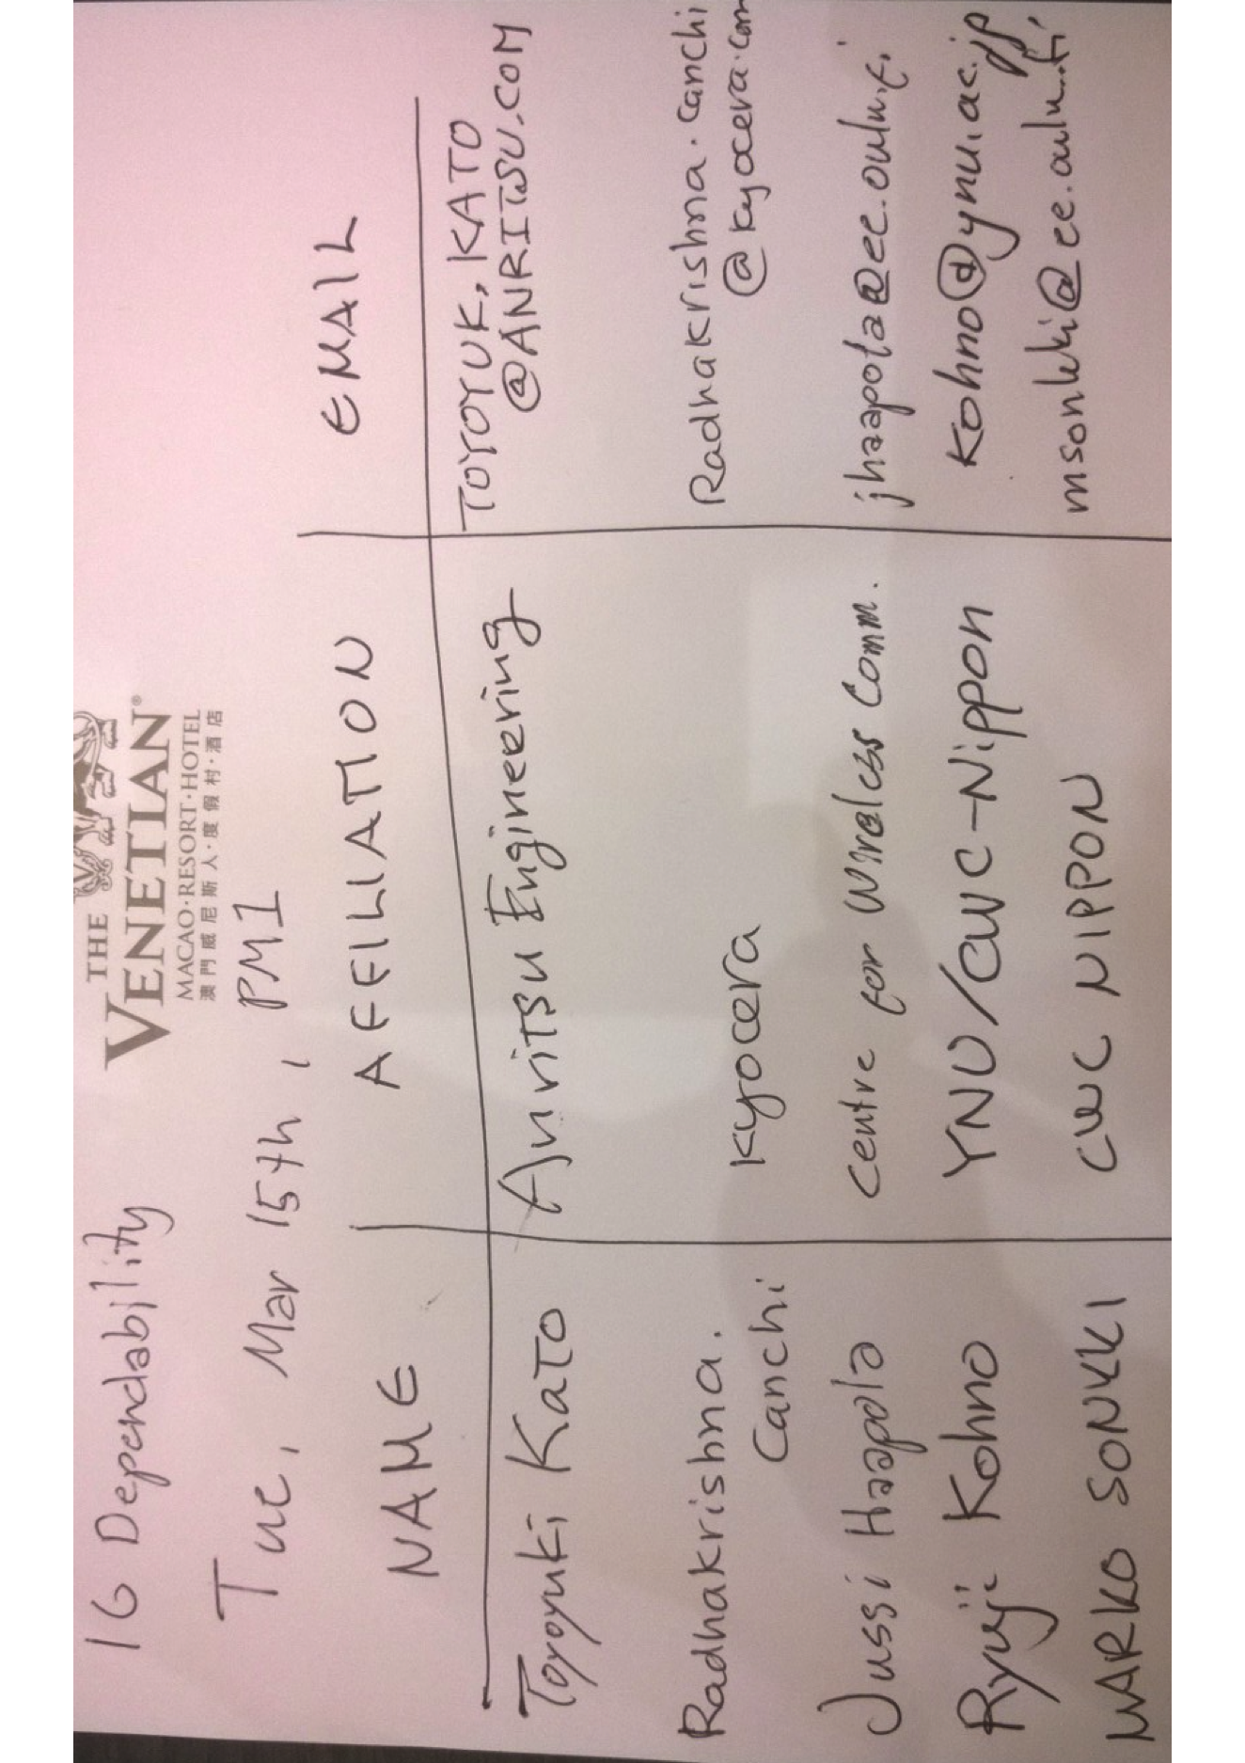

  - Meeting called to order 08:04

  - Roll Call

  - Continue Drafting PAR

  - Recess at 9:59

  - Attendees

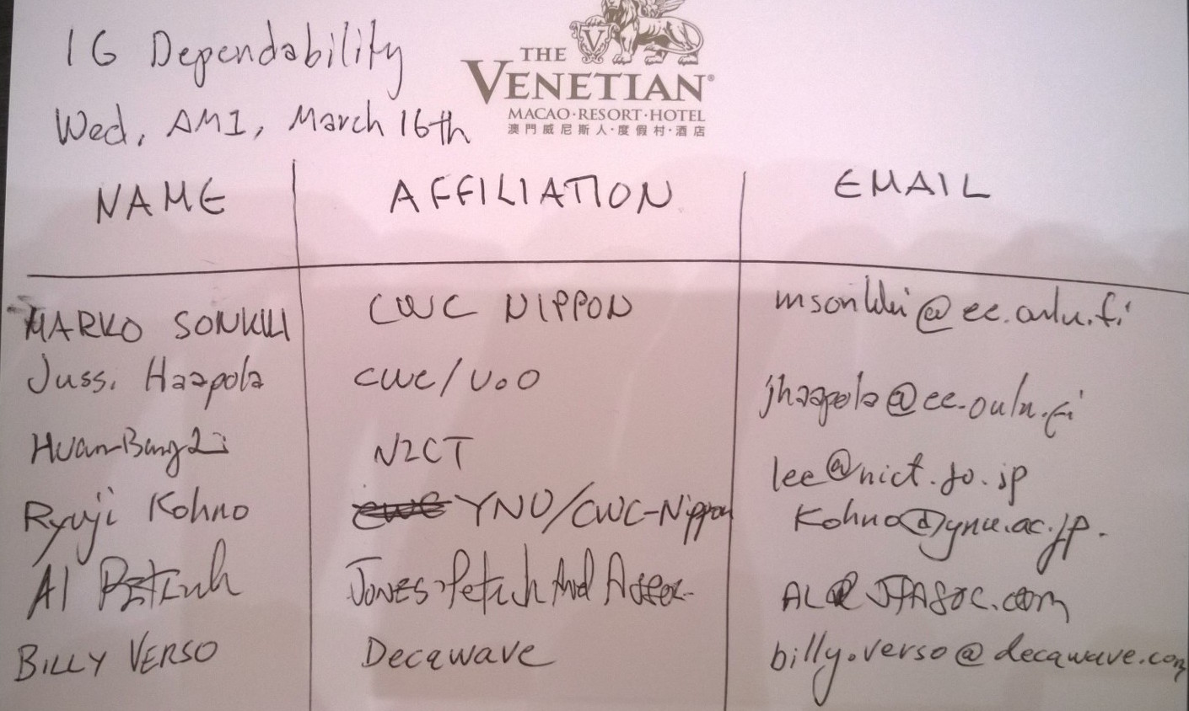

  - Meeting called to order 16:03

  - Roll Call

  - Continue Drafting PAR

Completed a preliminary PAR for comments from WG15 experts.
Further PAR and CSD development is continued off-line and by telcos, if needed.

  - AoB
Ryuji will invite representatives from automotive industry to present their demand and use cases in a 802 tutorial during May Waikoloa or July San Diego meeting.

  - Adjourn 17:41

  - Attendees
