IEEE P802.15
Wireless Personal Area Networks

Project | IEEE P802.15 Working Group for Wireless Personal Area Networks (WPANs)
Title | TG8 UWB PHY Coexistence Assurance Document and Analysis
Date Submitted | [14 March, 2016]
Source | Igor Dotlić (NICT)  Huan-Bang Li (NICT)  Marco Hernandez (NICT)  Ryu Miura (NICT)  Billy Verso (DecaWave),  Michael McLaughlin (DecaWave) | dotlic @ nict.go.jp  lee @ nict.go.jp  marco @ nict.go.jp  ryu @ nict.go.jp  billy.verso @ decawave.com  michael.mclaughlin @ decawave.com
Re: | [Text for UWB PHY coexistence for IEEE 802.15.8 group for Peer Aware Communications]
Abstract | [This Coexistence Assurance Document is being provided by the IEEE 802.15.8 as Task Group to satisfy the requirements of the IEEE 802.19 Task Group.]
Purpose | [Provide Coexistence Assurance analysis as a part of 802.15 TG8 standardization.]
Notice | This document has been prepared to assist the IEEE P802.15. It is offered as a basis for discussion and is not binding on the contributing individual(s) or organization(s). The material in this document is subject to change in form and content after further study. The contributor(s) reserve(s) the right to add, amend or withdraw material contained herein.
Release | The contributor acknowledges and accepts that this contribution becomes the property of IEEE and may be made publicly available by P802.15.
Patent Policy | The contributor is familiar with the IEEE-SA Patent Policy and Procedures:  <http://standards.ieee.org/guides/bylaws/sect6-7.html#6> and  <http://standards.ieee.org/guides/opman/sect6.html#6.3>.  Further information is located at <http://standards.ieee.org/board/pat/pat-material.html> and  <http://standards.ieee.org/board/pat>.

Table of Contents
1 General Coexistence Issues for the UWB PHY 3
1.1 UWB modulation with extremely low power spectral density (PSD) 3
1.2 Low Duty Cycle 3
1.3 Low Transmit Power 3
1.4 Clear Channel Assessment (CCA) 4
2 Other IEEE 802 Standards Occupying Same Frequency Bands as IEEE 802.15.8 UWB PHY 4
3 Coexistence Assurance: Methodology and Assumptions 4
3.1 UWB PHY Coexistence 5
3.2 Path Loss Model 6
3.3 BER as a function of SIR 7
3.4 Temporal Model 8
4 Coexistence Analysis 9
4.1 Impact of TG8 devices on 802.16 networks 9
4.2 Impact of an 802.16 devices on TG8 UWB networks 11
4.3 Impact of TG8 devices on ECMA-368 networks 14
4.4 Impact among different IEEE 802.15 UWB PHY 17
5 Conclusions 20
6 References 20

General Coexistence Issues for the UWB PHY
The draft standard created by TG8 provides several mechanisms that enhance coexistence with other wireless devices operating in the same spectrum. This section describes the mechanisms that are defined in the standard, which include:
- UWB modulation with extremely low power spectral density (PSD)
- Low duty cycle
- Low transmit power

These mechanisms are each described briefly in the following sub-sections.

UWB modulation with extremely low power spectral density (PSD)
The UWB PHY specified for IEEE STD 802.15.8 uses pulsed UWB modulation. This power-efficient modulation method achieves low requirements for signal-to-noise ratio (SNR) and signal-to-interference ratio (SIR) through the use of a signal bandwidth that is significantly larger than the symbol rate. A defining feature of systems that use UWB modulation is that they are less likely to cause interference in other devices due to their reduced power spectral density. In fact, even the least restrictive regulations for UWB devices today require the emission PSD levels to be at or below the levels allowed for unintentional emissions by other electrical or electronic devices. In some cases the UWB PSD limits are as much as 35 dB below these same unintentional emissions limits. For the same reason, UWB devices have some degree of immunity from interfering emitters, making them a good choice for environments where coexistence may be an issue.

Low Duty Cycle
The specifications of IEEE STD 802.15.8 UWB PHY are tailored for applications with low power and low data rates. Typical applications for IEEE 802.15.8 UWB PHY devices are anticipated to run with low duty cycles (under 5%). This will make IEEE 802.15.8 UWB PHY devices less likely to cause interference to other standards.

Low Transmit Power
The new UWB PHY defined by Task Group 8 will operate under strict regulations for unlicensed UWB devices worldwide. At the time of this writing, the least restrictive regulations for UWB are available under the FCC rules, US 47 CFR Part 15, subpart F. Under these rules, the highest allowable limits for UWB emissions are based on an equivalent emission PSD of -41.3 dBm/MHz. Under these limits, the allowable transmit power for a 500 MHz bandwidth UWB device would be less than -14 dBm, or about 37 µW transmit power. This transmit power level is at or below the limits for unintentional emissions from other electrical or electronic devices, as well as less than the out-of-band emission limits for other unlicensed devices operating in designated bands such as the 2.4 GHz ISM or 5 GHz UNII bands. Additionally, since this transmission power is spread over at least 500 MHz of bandwidth, the highest power in the operating bandwidth of a typical narrowband 20 MHz victim system is less than -28 dBm, or about 1.5 µW of transmit power per 20 MHz. These very low power levels emitted into the operating band of any potential victim system will reduce the likelihood that these devices might interfere with other systems.

IEEE 802.15.8 UWB PHY
Despite the wide bandwidth of the UWB PHY, there is only one non-UWB IEEE standard waveform that may occupy the same frequency bands – namely, 802.16 systems below 10 GHz. Cognizant of the potential for coexistence issues, regulators in those parts of the world where 802.16 systems (such as WiMAX) may be deployed in bands overlaid by UWB spectrum have created specific regulatory requirements to further reduce the likelihood of any coexistence problems.
Other IEEE 802 standards that include UWB PHYs are IEEE 802.15.4-2011 (including IEEE 802.15.4a-2007), IEEE 802.15.4f-2012 and IEEE 802.15.6-2012. All these UWB PHYs and IEEE 802.15.8 PHY have data rates considerably lower than their corresponding channel bandwidths and employ different types of impulse modulation. This fact gives to these radios potential to be resilient to interference from other UWB impulse radios occupying the same band by virtue of high processing gains of the modulation schemes employed. In addition, while the BMP-BPSK modulation mode is like that of the 802.15.4a UWB PHY, the Task Group 8 UWB PHY includes 45 separate unique preamble code / PRF options that do not correlate with those of 802.15.4a.

Coexistence Assurance: Methodology and Assumptions
In order to quantify the coexistence performance of the 802.15.8 UWB PHY, we have adapted the techniques described in [1], “Estimating Packet Error Rate Caused by Interference – A Coexistence Assurance Methodology”.
The Coexistence Assurance Methodology predicts the Packet Error Rate (PER) of an Affected Wireless Network (AWN, or victim) in the presence of an Interfering Wireless Network (IWN, or assailant). It its simplest form, the methodology assumes an AWN and an IWN each composed of a single transmitter and a receiver. The methodology takes as input a path loss model, a quantitative model for the bit error rate of the AWN, and predicted temporal models for packets generated by the AWN and for “pulses”, i.e. packets generated by the IWN. Based on these inputs, the Methodology predicts the PER of the AWN as a function of the physical spacing between the IWN transmitter and the AWN receiver.
The appeal of the Coexistence Assurance Methodology is that multiple networking standards can be characterized and compared with just a few parameters, notably:
- Bandwidth of AWN and IWN devices
- Path Loss Model for the networks
- BER as a function of Signal to Interference Ratio (SIR) of AWN devices.
- Temporal model for AWN packets and IWN “pulses” (interfering packets)
The following sub-sections describe the general assumptions made across all of the PHYs covered under this document.

UWB PHY Coexistence

Victims and Assailants
The only non-UWB IEEE wireless standard waveforms that overlap this same spectrum are 802.16 systems occupying 3400 to 3800 MHz licensed frequency bands in some regions.
In addition to IEEE standardized UWB wireless systems (IEEE 802.15.4-2011 (including IEEE 802.15.4a-2007), IEEE 802.15.4f-2012 and IEEE 802.15.6-2012), another UWB standard produced by ECMA is specified in ECMA 368. We also provide a limited analysis of the coexistence between this system and the TG8 draft standard waveform.
In our analysis, we assume that all the PHYs mentioned above will serve as both ‘victims’ (participants in Affected Wireless Networks) and as ‘assailants’ (participants in Interfering Wireless Networks).

Bandwidth for UWB systems
The minimum and maximum bandwidths of the considered UWB radios are given in Table 1.

Standard | Minimum Bandwidth (MHz) | Maximum Bandwidth (MHz)
ECMA 368 | 1500 | 1500
IEEE 802.15.4-2011 | 500 | 1300
IEEE 802.15.6-2012 | 500 | 500
IEEE 802.15.4f-2012 | 500 | 2147
IEEE 802.15.8 | 500 | 4600
Table 1: Minimum and maximum bandwidths of considered UWB radios.

In contrast to these UWB systems, the narrowband 802.16 PHYs that operate in the 2-10 GHz band have multiple defined channels, each 20 MHz wide or less. The Coexistence Methodology assumes that any UWB device in an AWN or IWN will have a much greater bandwidth than a narrowband device in a corresponding AWN or IWN (so B_{UWB} >> B_{NB}).

Path Loss Model
The Coexistence Methodology uses a variant of the path loss model described [3], which stipulates a two-segment function with a path loss exponent of 2.0 for the first 8 meters and then a path loss model of 3.3 thereafter. The formula given in [3] is:
(5.3-1)
The constants in this formula are based on a 2.4GHz center frequency. To adapt the model to a typical center frequency in the 3100 to 4800 MHz frequency band, we can generalize this as:
(5.3-2)
where pl(1) is the path loss at one meter (in dB) , γ₁ is the path loss exponent at 1 meter (2.0), and γ₈ is the path loss exponent at 8 meters (3.3). We compute the initial condition of pl(1) as:
(5.3-3)
With γ₁=2.0, f=3400MHz, and C=speed of light=299792458 ms⁻¹, we can compute pl(1)=43.08 and pl(8)=61.14. The path loss function modified for 3400MHz is therefore:
(5.3-4)
A plot of the path loss as a function of device separation distance at 3400MHz is given in Figure 1.
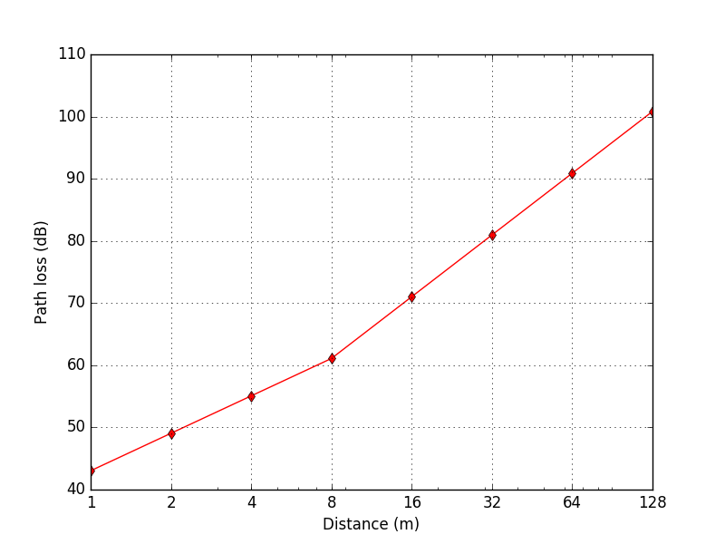
Figure 1: Path loss vs distance at 3400MHz.

BER as a function of SIR
For the PHY specifications analyzed in this document, there are no analytic expressions for the BER or SER of the signal due to the use of forward error correction methods to improve reliability.
In this analysis, we will use a method that is equivalent to using interpolation of table values. In order to simplify the calculations and still provide meaningful results, we will approximate the relationship between the changes in BER (on a logarithmic scale) and varying SNR as a linear with a slope of 0.6 dB per order of magnitude (10x) change in BER over the range of BER that is relevant to this analysis (about 1e-8 to 1e-5 BER). This approximation is reasonable for the FEC methods used for 802.16 and UWB PHYs given in Table 1.
For each of the systems, we will characterize the effect of the IWN on the AWN by computing the rise in the effective operating noise floor of the AWN by the interference of the IWN (modeled as uncorrelated wideband noise). The analysis will assume a baseline operating effective noise floor (including effects of thermal noise floor, noise figure and an operating margin to account for other real-world effects such as multipath propagation effects and co-channel or adjacent channel interference). This approach will allow us to characterize the effect of the IWN on the AWN as the IWN is moved from a large separation distance (when the AWN has a baseline nominal PER) to a very close distance where the interference effect of the IWN dominates the PER during periods of operation (subject to duty cycle assumptions).
Although this analysis approach is perhaps not as elegant as the use of an analytic expression (not possible in these cases), it will provide a good characterization of the coexistence of these systems under real world conditions and can be used to estimate a range of effects for an equivalent range of assumptions about operating margin.

Temporal Model
For our coexistence methodology, we assume all frames, whether belonging to the AWN or IWN, to be 32 bytes.
Although there is no duty-cycle limitation in the authorized UWB bands at this point, many 802.15.8 UWB PHY Peer-Aware networks are expected to operate at well under 5% duty cycle, particularly those devices that are used for localization. For purposes of modeling coexistence, we assume that all 802.15.8 UWB PHY devices are used for localization operating will have a shared duty cycle of 10% and that such networks will operate within a range of a few tens to a few hundreds of meters.
Applications of other IEEE 802.15 UWB PHYs given in Table 1 also make assumption of their shared duty cycle of 10% reasonable; hence, such assumption will also be made here.
For the high data rate systems considered in this analysis (802.16 and ECMA-368), applications are higher bandwidth connectivity over wide areas for 802.16 and over short WPAN ranges for ECMA-368. For this analysis, we therefore initially assume a very conservative continuous operation as a baseline worst-case scenario.

Coexistence Analysis
In this section, we detail the assumptions for the coexistence analysis an present the results for each of the cases analyzed.

Impact of TG8 devices on 802.16 networks
Assumptions:
- The 802.16 receiver is the victim (AWN) and is an indoor fixed or nomadic client node of the network. We assume that the base station node will not be susceptible to TG8 UWB interference due to site positioning. The AWN operates in 3.4 to 3.8 GHz licensed bands (available in most of world except the United States).
- We assume the 802.16 receiver is operating in a real-world environment in the presence of multipath fading and interference and assume 3 to 10 dB margin above sensitivity to function well. UWB interference is wideband uncorrelated noise since the bandwidth is much wider than victim receiver. We assume a 10 dB difference in antenna gains since the indoor or outdoor 802.16 antenna will have gain in the direction of the desired base station downlink signal and we assume the UWB device will not directly block the LOS.
- The 802.16 received signal is assumed to be 20 dB above the noise floor, excluding the margin of operation. Such high signal level is assumed to be realistic in the case of line of sight propagation and relative proximity of 802.16 transmitter. We assume a baseline BER of BPSK modulation with 1.5 dB coding gain.

Coexistence Methodology Results
Table 2 shows the calculation of the allowable path loss that would result in a TG8 UWB emission level at the AWN equal to the effective operating noise floor. Base on this path loss, we compute the effect on AWN PER as a function of separation distance, shown in Figure 2.

Quantity | Value | Units | Notes
UWB Transmit PSD Limit (P_{LIM}) | -41.3 | dBm/MHz | Set by regulatory authority
Average margin to limit (M_{BO}) | 1.7 | dB | Transmit power back-off due to spectral ripple (0.5+ dB) and ~1 dB margin for manufacturing tolerance, etc.
Average UWB antenna gain (G_{UWB}) | -2 | dBi | Average gain from small, low cost UWB antenna to arbitrary victim receiver over 360°
802.16 Antenna gain differential between desired signal and interfering UWB signal | 10 | dB | Difference in gain of 802.16 antenna in main beam (to desired remote 802.16 base station, + 6 dBi) and nearby UWB interferer (not blocking antenna main beam, -4 dBi)
Average emissions PSD (P_{TX}= P_{LIM} -M_{BO}+G_{UWB} - D_{ANT}) seen by 802.16 device receiver | -55 | dBm/MHz | Average PSD seen in direction of arbitrary victim receiver
802.16 Thermal noise floor (kTB) | -114 | dBm/MHz | Thermal noise floor (room temperature)
802.16 NF (NF₁₆) | 6 | dB | Noise figure for indoor 802.16 terminal
802.16 operating margin (M_{OP}) | 3-10 | dB | Operating margin for acceptable performance in presence of multipath fading and adjacent cell/channel interference
802.16 Effective operating noise floor for UWB interference susceptibility:(N_{E})  (N_{E} =kTB + NF₁₆ + M_{OP}) | -105 to -98 | dBm/MHz | This is the effective operating noise floor level for the 802.16 operating receiver
Level of wideband TG8 UWB interference that result in a 3 dB rise in 802.16 effective operating noise floor | -105 to -98 | dBm/MHz | For 3 dB rise, wideband UWB emissions in-band can be at the same level as effective operating noise floor for indoor 802.16 node receiver
Path loss (range) from UWB to 802.16 receiver (average case) for 3 dB rise in effective operating noise floor | 43 to 50  (1 to 2.2) | dB  (m) | For 3 dB rise, wideband UWB emissions in-band can be at the same level as effective operating noise floor for indoor 802.16 node receiver
Path loss (range) from UWB to 802.16 receiver (average case) for 1 dB rise in effective operating noise floor | 49 to 56  (2 to 4.5) | dB  (m) | For 1 dB rise, wideband UWB emissions in-band must be 6 dB below effective operating noise floor for indoor 802.16 node receiver

Table 2: Computation of the acceptable levels of TG8 device emissions for an operating 802.16 client node
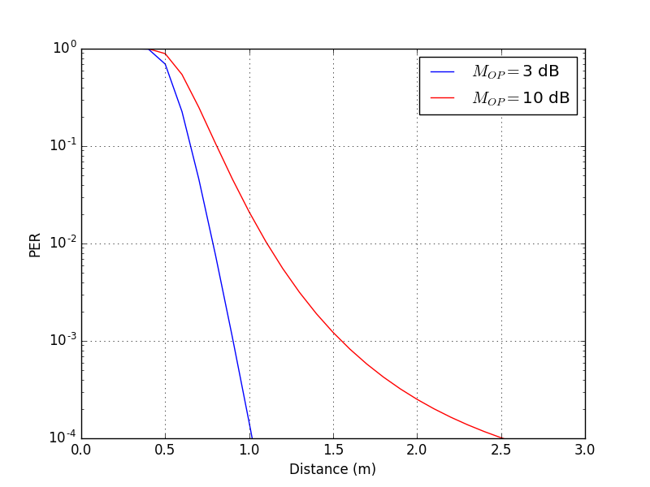
Figure 2: Effect on 802.16 AWN as a function of separation distance from TG8 UWB device.

Impact of an 802.16 devices on TG8 UWB networks
Assumptions:
- The TG8 UWB device is the affected device (AWN) and the 802.16 device is the interferer (IWN) and is an indoor fixed or nomadic client node of the network. We assume that the base station node will have less interference effects on TG8 UWB devices due to UWB device deployment much closer to subscriber or mobile 802.16 devices. The IWN operates in 3.4 to 3.8 GHz licensed bands.
- We assume the TG8 UWB receiver is operating in a real-world environment in the presence of multipath fading and interference and assume 3 dB margin above sensitivity during operation. We assume 10 dB receiver NF.
- We assume a 10 dB difference in antenna gains since the indoor or outdoor 802.16 antenna will have gain in the direction of the desired base station downlink signal and we assume the UWB device will not directly block the LOS.
- TG8 received signal is assumed to be 15 dB above noise floor, excluding the margin of operation. We assume a baseline BER of BPSK modulation with 1.5 dB coding gain.

Coexistence Methodology Results
Table 2 shows the calculation of the allowable path loss that would result in a TG8 UWB emission level at the AWN equal to the effective operating noise floor. Base on this path loss, we compute the effect on AWN PER as a function of separation distance, shown in Figure 2.

Quantity | Value | Units | Notes
802.16 client device transmit power (P₁₆) | 17 | dBm | Assumes subscriber station in small cell
802.16 client device bandwidth | 5 | MHz
TG8 UWB device bandwidth | 500 | MHz
Average 802.16 antenna gain (G₁₆) | -2 | dBi | Average gain from antenna to arbitrary victim receiver over 360° (IWN typically not in main beam)
Average emissions PSD (P_{TX}= P₁₆+G₁₆ – 10Log(B_{UWB}) seen by TG8 UWB device receiver | -12 | dBm/MHz | Average PSD seen in direction of arbitrary victim receiver (assumes that UWB receiver can spread interference epower into receiver bandwidth)
TG8 UWB Thermal noise floor (kTB) | -114 | dBm/MHz | Thermal noise floor (room temperature)
TG8 UWB NF | 10 | dB | Noise figure for low cost TG4a device
TG8 UWB operating margin (M_{UWB}) | 3 | dB | Operating margin for acceptable performance in presence of multipath fading (assumes no interference other than IWN)
TG8 UWB effective operating noise floor for UWB interference susceptibility: (N_{E})  (N_{E}=kTB + NF_{UWB} + M_{UWB}) | -101 | dBm/MHz | This is the effective operating noise floor level for the TG8 operating receiver
Level of interference power density to achieve a 3 dB rise in TG8 UWB effective operating noise floor | -101 | dBm/MHz | For 3 dB rise, 802.16 power emissions in-band can be at the same level as effective operating noise floor for UWB receiver
Path loss (range) from 802.16 to UWB receiver (average case) for 3 dB rise in effective operating noise floor | 89  (48) | dB  (m) | For 3 dB rise, 802.16 power emissions in-band can be at the same level as effective operating noise floor for UWB receiver
Path loss (range) from 802.16 to UWB receiver (average case) for 1 dB rise in effective operating noise floor | 95  (75) | dB  (m) | For 1 dB rise, wideband UWB emissions in-band must be 6 dB below effective operating noise floor for indoor 802.16 node receiver

Table 3: Computation of the acceptable levels of TG8 device emissions for an operating 802.16 client node
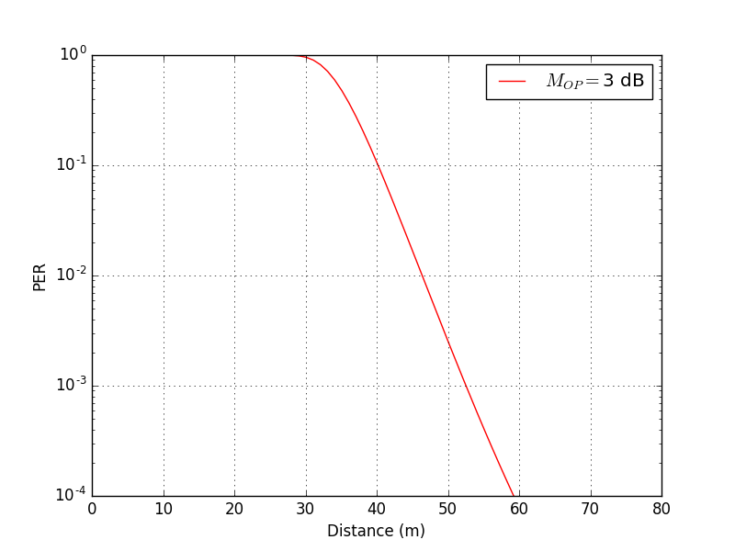
Figure 3: Effect on TG8 UWB AWN as a function of separation distance from 802.16 IWN device.

Impact of TG8 devices on ECMA-368 networks
Assumptions:
- The ECMA-368 receiver is the victim (AWN). The AWN operates using frequency hopping in bands across the 3.1 to 4.8 GHz unlicensed UWB bands (available only in the United States at this time), but the TG8 device operates only in band 3.
- We assume the ECMA-368 receiver is operating in a real-world environment in the presence of multipath fading and interference and assume a 5 dB margin above sensitivity to function well. We assume 6 dB receiver NF.
- We assume the UWB device will not directly block the LOS.
- ECMA-368 received signal is assumed to be 15 dB above noise floor, without margin of operation accounted in. We assume a baseline BER of BPSK modulation with 1.5 dB coding gain.

Coexistence Methodology Results
Table 3 shows the calculation of the allowable path loss that would result in a TG8 UWB emission level at the AWN equal to the effective operating noise floor. Base on this path loss, we compute the effect on AWN PER as a function of separation distance, shown in Figure 3.

UWB Transmit PSD Limit (P_{LIM}) | -41.3 | dBm/MHz | Set by regulatory authority
Average margin to limit (M_{BO}) | 1.7 | dB | Due to spectral ripple (0.5+ dB) and ~1 dB margin for manufacturing tolerance, etc.
Average UWB antenna gain (G_{UWB}) | -2 | dBi | Average gain from small, low cost UWB antenna to arbitrary victim receiver over 360°
Average emissions PSD (P_{LIM}-M_{BO}+G_{UWB}) | -45 | dBm/MHz | Average PSD seen in direction of arbitrary victim receiver
UWB victim Thermal noise floor (kTB) | -114 | dBm/MHz | Thermal noise floor (room temperature)
UWB victim NF | 6 | dB | Noise figure for the ECMA-368 receiver
UWB victim frequency diversity (D_{FD}) | 3 | dB | ECMA UWB system uses 2x band frequency diversity for then encoding of each bit as part of its frequency hopping scheme
UWB victim operating margin (M_{ECMA}) | 5 | dB | Operating margin for acceptable performance in presence of multipath fading and RF interference
802.16 Effective operating noise floor for UWB interference susceptibility:  (kTB + NF_{ECMA368} + D_{FD} + M_{OP}) | -100 | dBm/MHz | This is the effective allowable interference power level for the ECMA-368 operating receiver
Level of wideband UWB emissions that result in 3 dB rise in ECMA-368 effective operating noise floor | -100 | dBm/MHz | For 3 dB rise, TG8 UWB emissions in-band can be at the same level as effective operating noise floor for AWN device receiver
Path loss (range) from UWB to ECMA-368 receiver (average case) for 3 dB rise in effective operating noise floor | 55  (3) | dB  (m) | For 3 dB rise, wideband UWB emissions in-band can be at the same level as effective operating noise floor for AWN device receiver
Path loss (range) from UWB to ECMA-368 receiver (average case) for 1 dB rise in effective operating noise floor | 61  (6) | dB  (m) | For 1 dB rise, wideband UWB emissions in-band must be 6 dB below effective operating noise floor for indoor 802.16 node receiver

Table 4: Computation of the acceptable levels of TG8 device emissions for an operating ECMA-368 device

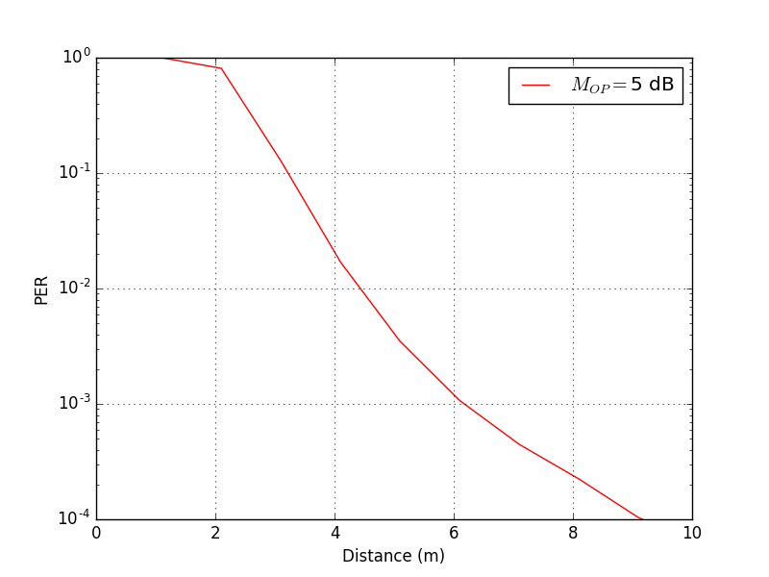

Figure 4: Effect on ECMA-368 AWN as a function of separation distance from TG8UWB device.

Impact among different IEEE 802.15 UWB PHY
Assumptions:
- Any of IEEE 802.15 UWB PHY devices listed in Table 1 is the affected device (AWN) and any such device is the interferer (IWN). Both radios operate in the same band spanning 500 MHz.
- We assume the AWN receiver is operating in a real-world environment in the presence of multipath fading and interference and assume 3 dB margin above sensitivity during operation. We assume 10 dB receiver NF.
- AWN received signal is assumed to be 15 dB above noise floor, excluding the margin of operation. We assume a baseline BER of BPSK modulation with 1.5 dB coding gain.
- AWN operates at data rate of 1 Mbps, hence has processing gain of G_{P}= 27 dB

Coexistence Methodology Results
Table 2 shows the calculation of the allowable path loss that would result in a IWN emission level at the AWN equal to the effective operating noise floor. Base on this path loss, we compute the effect on AWN PER as a function of separation distance, shown in Figure 1.

Quantity | Value | Units | Notes
UWB Transmit PSD Limit (P_{LIM}) | -41.3 | dBm/MHz | Set by regulatory authority
Average margin to limit (M_{BO}) | 1.7 | dB | Transmit power back-off due to spectral ripple (0.5+ dB) and ~1 dB margin for manufacturing tolerance, etc.
Average UWB antenna gain (G_{UWB}) | -2 | dBi | Average gain from small, low cost UWB antenna to arbitrary victim receiver over 360°
AWN Processing gain (G_{P}) | 27 | dB | Processing gain of AWN signaling scheme, available to suppress interference of similar signaling schemes.
Average emissions PSD (P_{TX}= P_{LIM} -M_{BO}+G_{UWB}- G_{P}) seen by 802.16 device receiver | -72 | dBm/MHz | Average PSD seen in direction of arbitrary victim receiver
AWN Thermal noise floor (kTB) | -114 | dBm/MHz | Thermal noise floor (room temperature)
AWN NF (NF₁₆) | 10 | dB | Noise figure for indoor AWN terminal
AWN operating margin (M_{OP}) | 3 | dB | Operating margin for acceptable performance in presence of multipath fading and adjacent cell/channel interference
AWN Effective operating noise floor for UWB interference susceptibility:(N_{E})  (N_{E} =kTB + NF₁₆ + M_{OP}) | -101 | dBm/MHz | This is the effective operating noise floor level for the AWN operating receiver
Level of wideband IWN UWB interference that result in a 3 dB rise in AWN effective operating noise floor | -101 | dBm/MHz | For 3 dB rise, wideband UWB emissions in-band can be at the same level as effective operating noise floor for indoor AWN node receiver
Path loss from IWN UWB to AWN receiver (average case) for 3 dB rise in effective operating noise floor | 29  0.2 | dB  (m) | For 3 dB rise, wideband UWB emissions in-band can be at the same level as effective operating noise floor for indoor AWN node receiver
Path loss from IWN to AWN receiver (average case) for 1 dB rise in effective operating noise floor | 35  0.4 | dB  (m) | For 1 dB rise, wideband UWB IWN emissions in-band must be 6 dB below effective operating noise floor for indoor AWN node receiver

Table 2: Computation of the acceptable levels of IWN 802.15 UWB device emissions for an operating AWN 802.15 UWB node.
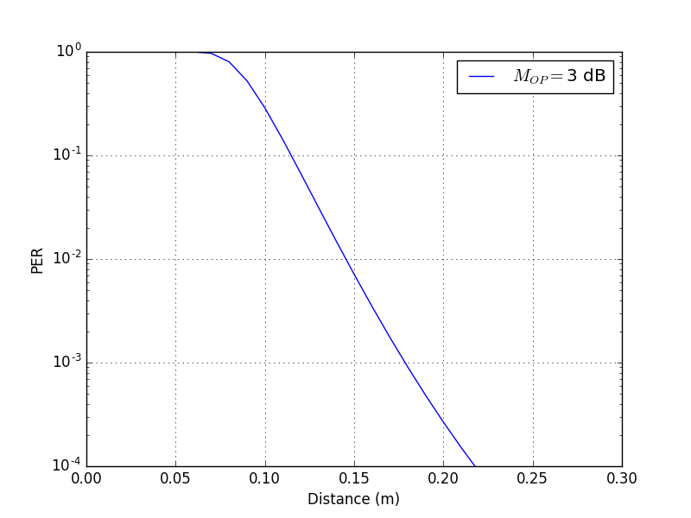
Figure 2: Effect on 802.15 UWB AWN as a function of separation distance from 802.15 UWB IWN device.

Conclusions
These analyses characterize the expected coexistence behavior between TG8 UWB devices and 802.16 devices. Also described are the expected effects of a TG8 device on an ECMA-368 receiver. One conclusion that can be drawn is that the relative effects of the TG8 device and 802.16 device to each other are quite different. The TG8 device is impacted by the 802.16 device at much longer range than vice versa. The implication is that the TG8 device would not be able to operate at all at ranges where its emissions would impact the 802.16 device because of the large asymmetry in the transmit power levels (+17 dB for 802.16 versus -45 dBm/MHz for the TG8 device). In such case, the TG8 device would either accept the much higher PER or else it could use a different channel or some other form of interference mitigation. Different 802.15 UWB PHYs are shown to be able to be co-located and working on same channel with relatively small distance. This is due to their low transmit power and high processing gain, i.e. bandwidths used that are considerably higher than symbol rates employed.

References
- S. J. Shellhammer, Estimating Packet Error Rate Caused by Interference – A Coexistence Assurance Methodology, IEEE 802.19-05/0029r0, September 14, 2005.
- S. J. Shellhammer, Estimation of Packet Error Rate Caused by Interference using Analytic Techniques – A Coexistence Assurance Methodology, IEEE 802.19-05/0028r0, September 14, 2005.
- IEEE Std 802.15.2-2003, IEEE Recommended Practice for Information technology -Telecommunications and information exchange between systems - Local and metropolitan area networks - Specific requirements. Part 15.2: Coexistence of Wireless Personal Area Networks with Other Wireless Devices Operating in Unlicensed Frequency Bands, August 28, 2003.
- IEEE LAN/MAN Standards Committee, IEEE Std 802.15.4™-2003, IEEE Standard for Information technology—Telecommunications and information exchange between systems—Local and metropolitan area networks—Specific requirements Part 15.4: Wireless Medium Access Control (MAC) and Physical Layer (PHY) Specifications for Low-Rate Wireless Personal Area Networks (LR-WPANs), IEEE, New York, NY, October 1, 2003.
- Sklar, Bernard, Digital Communications, Fundamentals and Applications (2nd Edition), Prentice Hall PTR, January 11 2001.
- FCC Code of Federal Register (CFR), Part 47, Section 15.35, Section 15.205, Section 15.209, Section 15.231, Section 15.247, and Section 15.249. United States.
- CHARACTERISTICS OF IEEE 802.16 SYSTEMS IN 2500-2690 MHz, Submission to ITU-R by IEEE802.16 WG, Document number: IEEE L802.16-04/42r3

Although the methodology described in [1] uses Symbol Error Rate (SER) to characterize PHY performance, we have chosen to use Bit Error Rate (BER) in this document instead because available error models are more commonly defined as BER rather than SER.

