IEEE P802.15
Wireless Personal Area Networks

Project | IEEE P802.15 Working Group for Wireless Personal Area Networks (WPANs)
Title | <IG 6tisch Minutes>
Date Submitted | [22 Jan 2016]
Source | [Pat Kinney]  [<Kinney Consulting LLC>]  [address] | Voice: [ ]  Fax: [ ]  E-mail: [ ]
Re: | [Interest Group 6tisch Plenary Meeting in Atlanta]
Abstract | [Interest Group 6tisch Minutes.]
Purpose | [Official minutes of the Task Group Session
Notice | This document has been prepared to assist the IEEE P802.15. It is offered as a basis for discussion and is not binding on the contributing individual(s) or organization(s). The material in this document is subject to change in form and content after further study. The contributor(s) reserve(s) the right to add, amend or withdraw material contained herein.
Release | The contributor acknowledges and accepts that this contribution becomes the property of IEEE and may be made publicly available by P802.15.
IEEE 802.15 Interim Meeting – Session #100
Hyatt Regency, Atlanta
Jan 18-21, 2016
Tuesday, 19 Jan 2016, 13:30 (PM1) 2

Tuesday, 19 Jan 2016, 13:30 (PM1)
13:35 IG 6tisch chair, Pat Kinney, called meeting to order.
Chair presented opening report 15-16-0089-00-ig6t:
Chair displayed administration slide showing the URL for the IEEE-SA slides #1 through #4 of the IEEE patent policy.
Chair asked if anyone in the meeting was personally aware of the holder of any patent claims that are potentially essential to implementation of the proposed standard(s) under consideration by this group and that are not already the subject of an Accepted Letter of Assurance? There were no responses.

Agenda for Atlanta
  - 6tisch issues discussion
    - Guidance documents sent from 6T to 6tisch
    - 6lo routing header changes
    - Minimal draft
  - Approval of agenda (15-16-980-00)
    - Upon neither discussion nor objection the agenda was approved
  - Approval of minutes from Dallas (15-15-0956-00)
    - Upon neither discussion nor objection the minutes from Dallas were approved
- Guidance documents
  - Payload IE format proposal
    - In response to a request from the 6tisch chair, the 6T group in Dallas had generated a proposal for the format of the IETF’s assigned ID for Payload IEs
    - Chair wrote up the proposal in a letter to 6tisch (15-15-0939-020) and emailed it the 6tisch mailing list (ML)
    - Chair reviewed that email, there was no discussion.
  - PAN ID compression bit settings
    - In response to 6tisch emails concerned about the proper settings for the PAN ID compression bit, T Kivinen and P Kinney wrote an email to 6tisch (15-15-0911-01) and emailed it the 6tisch ML
    - Chair reviewed that email, there was no discussion.
- 6lo routing headers
  - the current routing headers for 6lo were excessive at 16 octets, P Thubert proposed modifying the headers, 6LoRH
  - The picture below illustrates how the RH3 6LoRH works with draft 03 in a case like Root -> A -> B -> C -> leaf
  - The first 6LoRH is expected to be a full address (128 bits) to set up a reference and the next 6LoRH are expected to be smaller and just override the rightmost bits which form the delta from the reference.
  - Proposal: we could consider that the 128bits source of the IP header before the RH3 is the reference to start with.
  - With that even the first hop could be compressed the same way as the other hops. With RPL, the root is the encapsulator if IP in IP in used. Good thing, in that case the root is totally elided with the IP-in-IP 6LoRH.
  - So this simple proposal saves up to 16 octets (that’s in the case with a single subnet and all addresses differ only by the last 2 bytes). I’m willing to add it in the next revision.
  - As captured in doc 15-15-0939-02, the consensus was to limit nesting the sub-types to one, allowing concatenation of the Payload IEs rather than the method used in 802.15.4-2015 of nesting sub-types
  - The following figures illustrates an overview of this concept compared to the 802.15.4-2015 technique:
    - 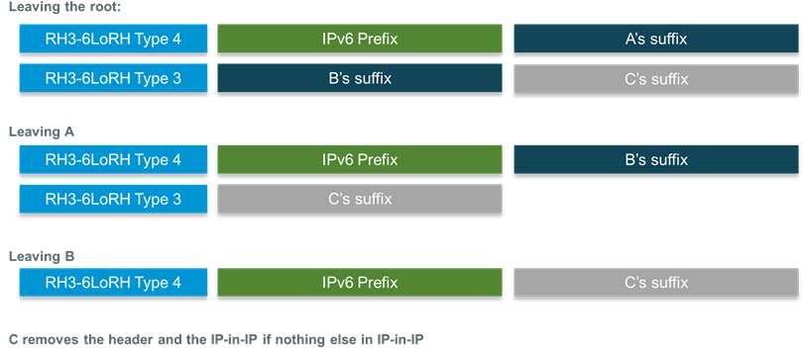

- question on the figure was due to confusion between the types mentioned in the figure and a proposal for 802.15.12, there is no relation between the two.
- Minimal Draft
    - Chair reviewed the 14th version of the minimal draft, https://datatracker.ietf.org/doc/draft-ietf-6tisch-minimal/
    - Numerous errors were discovered in the draft such as copying large amounts of text from 802.15.4. The draft should really be a profile defining the values for the configuration parameters rather than stating behavior.
    - Chair stated that he would redline the draft and then send it out to the 6T reflector for comments
15:00 Meeting adjourned

