IEEE P802.15
Wireless Personal Area Networks

Project | IEEE P802.15 Working Group for Wireless Personal Area Networks (WPANs)
Title | Suggested changes for subclause 5.1.4 peering and de-peering
Date Submitted | January 2016
Source | Huan-Bang Li (NICT)  Marco Hernandez (NICT)  Igor Dotlić (NICT)  Ryu Miura (NICT)
Re: | TG8 draft text for peering and de-peering procedue for 802.15.8
Abstract | This is the work in progress text of the MAC component for IEEE 802.15.8 group for PAC.
Purpose | This document provides the details of draft text to IEEE 802.15.8
Notice | This document does not represent the agreed views of the IEEE 802.15 Working Group or IEEE 802.15.8 Task Group. It represents only the views of the participants listed in the “Source(s)” field above. It is offered as a basis for discussion and is not binding on the contributing individual(s) or organization(s). The material in this document is subject to change in form and content after further study. The contributor(s) reserve(s) the right to add, amend or withdraw material contained herein.
Release | The contributor acknowledges and accepts that this contribution becomes the property of IEEE and may be made publicly available by P802.15.
Patent Policy | The contributor is familiar with the IEEE-SA Patent Policy and Procedures:  <http://standards.ieee.org/guides/bylaws/sect6-7.html#6> and  <http://standards.ieee.org/guides/opman/sect6.html#6.3>.  Further information is located at <http://standards.ieee.org/board/pat/pat-material.html> and  <http://standards.ieee.org/board/pat>.

[This is draft text for subclause of Peering related command for TG8]
Black = existing text
Blue = proposed text

MAC Layer

  - MAC functional description
    - Peering and de-peering
This subclause specifies the procedures for peering and de-peering.
      - Peering
The next higher layer shall attempt to peer only after having first performed discovering PD(s) successfully, as defined in 5.1.2. The results of the discovery would have then been used to peer with PD(s).
Following the decision of peering with a PD, the next higher layers shall request through the MLME-PEERING.request primitive, as described in 6.1.3.1, that the MLME configures the following PHY and MAC PIB attributes to the values necessary for peering:
- phyCurrentChannel shall be set equal to the ChannelNumber parameter of the MLME-PEERING.request primitive.
- phyCurrentPage(??) shall be set equal to the ChannelPage parameter of the MLME-PEERING.request primitive.
- macGroupId shall be set equal to the MulticastGroup_ID parameter of the MLME-PEERING.request primitive.
A PD shall allow peering only if macPeerPermit is set to TRUE. Similarly, a PD should attempt to peer only with a PD that is currently allowing peering, as indicated in the results of the discovery procedure. If a PD with macPeerPermit set to FALSE receives a peering request command from a device, the command shall be ignored.
A PD that is instructed to peer with a PD, through the MLME-PEERING.request primitive.
The MAC sublayer of a PD (i.e. the peering initiator) shall initiate the peering procedure by sending a peering request command, as described in 5.7, to the PD (i.e. the peering responder); if the peering request command cannot be sent due to a channel access failure, the MAC sublayer shall notify the next higher layer.
The acknowledgment to a peering request command does not mean that the peering has been accepted. The next higher layer should make this peering decision within macResponseWaitTime. If the next higher layer of the peering responder finds that the peering requestor was previously, all previously obtained device-specific information should be replaced. If sufficient resources are available, short address the MAC sublayer shall generate a peering response command, as described in 5.7, to indicate a successful peering. If sufficient resources are not available, the next higher layer of the peering responder should inform the MAC sublayer, and the MLME shall generate a peering response command containing a status indicating a failure, as defined in Table 40.
On receipt of the acknowledgment to the peering request command, the peering requestor shall wait for at most macResponseWaitTime for the PD to make its peering decision. The peering requestor shall attempt to extract the peering response command from the peering responder after macResponseWaitTime. If the peering requestor does not receive a peering response command frame from the peering responder within macResponseWaitTime, the MLME shall issue the MLME-PEERING.confirm primitive, as described in Table 38, with a status of FAILURE, and the peering attempt shall be deemed a failure.
If the Peering Status field of the peering response command indicates that the peering was successful, the peering requestor shall store the address contained in the Address field of the command in macAddress; communication on the PAC uses this address.
If the value of the Peering Status field of the command is not “Peering successful,” if there were a communication failure during the peering process due to a missed acknowledgment, or if the peering response command frame were not received, the peering requestor shall set macGroupId to the default value (0xffff).
A message sequence chart for peering is illustrated in Figure 9.
Figure 9 illustrates a sequence of messages that may be used by a first PD to successfully peer with a second PD.

Figure 9—Peering message sequence chart
      - De-peering
The de-peering procedure is initiated by the next higher layer by issuing the MLME- DEPEERING.request primitive, as described in 6.1.4, to the MLME.
When a PD (i.e. the de-peering requestor) wants to leave from the peered PD or one of its peered PDs (i.e. de-peering responder) to leave , the MLME of the de-peering requestor shall send the de-peering request command to the peering responder.

Figure 10—Message sequence chart for peering
If the de-peering request command cannot be sent due to a channel access failure, the MAC sublayer shall notify the next higher layer.
If the transmission fails, the de-peering requestor should consider the second PD de-peered.
The de-peering responder receiving the de-peering request command shall verify that the source address corresponds to one of its peered PDs; if so, the de-peering responder should consider the de-peering requestor is valid. If this condition is not satisfied, the de-peering request command shall be ignored.
A peered PD shall de-peer itself by removing all references to the counterpart PD or PDs; the MLME shall re-set macGroupId, macLinkId. The next higher layer of a de-peering requestor shall de-peer a de-peering responder by removing all references to that PD.
The next higher layer of the requesting PD shall be notified of the result of the de-peering procedure through the MLME-DEPEERING.confirm primitive, as described in TBD.
Figure 11 illustrates the sequence of messages for a first PD to de-peer itself from a second PD.
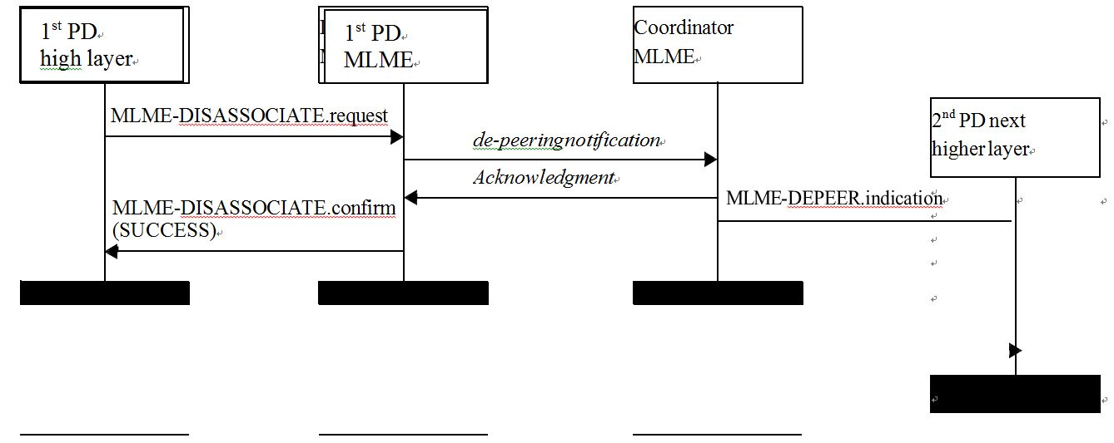
Figure 11—Message sequence chart for de-peering initiated by a PD.

