IEEE P802.15
Wireless Personal Area Networks

Project | Dependability Interest Group
Title | Meeting Minutes for January 2016
Date Submitted | January 21, 2016
Source | [Ryuji Kohno]  [Yokohama National University / CWC-Nippon Co.] | Voice: +81 45 339 4115  E-mail: kohno@ynu.ac.jp  Voice;+358 40 354 0034  Email: ryuji.kohno@oulu.fi
Re: | Meeting Minutes
Abstract
Purpose | Minutes of Dependability Interest Group sessions
Notice | This document has been prepared to assist the IEEE P802.15. It is offered as a basis for discussion and is not binding on the contributing individual(s) or organization(s). The material in this document is subject to change in form and content after further study. The contributor(s) reserve(s) the right to add, amend or withdraw material contained herein.
Release | The contributor acknowledges and accepts that this contribution becomes the property of IEEE and may be made publicly available by P802.15.

Tuesday, January 19, 2016, AM1, 8:00

  - Meeting called to order 8:00
By Chair Ryuji Kohno (Yokohama National University/CWC-Nippon)
Secretary Ryuji Kohno (Yokohama National University/CWC-Nippon)

  - Roll Call
Notepad for Attendance circulated.

Ryuji Kohno presented Opening report Doc #888

Chair showed IEEE Patent policy.

Chair issued Call for Potentially Essential Patents
No essential intellectual property in the scope of IG DEP was declared.

  - Review and Approval of minutes of the last meeting in Dallas, November, 2015
Ryuji Kohno showed and approved the document #15-15-894-00

  - Review of summary of responses for Call for Interest(CFI)
Ryuji Kohno showed doc. #15-15-217-05

Discussion
Due to sudden exchange sessions with 802.15.4s between AM1 and AM2 based on 4s requested, IG-DEP session scheduled in AM2 had very limited participants.

1.5 Recess at 12:03.

Tuesday, January 19, 2016, PM1, 13:30

  - Meeting called to order 13:30
By Chair Ryuji Kohno (Yokohama National University/CWC-Nippon)
Secretary Ryuji Kohno (Yokohama National University/CWC-Nippon)

  - Reporting Interviews for CFI by Ryuji Kohno

  - New Presentation: Update of Reviewing Responses to CFI as for Application to FA by Hiroshi Kobayashi(Nissan Automotive)
doc. #15-16-0077-00

Ryuji Kohno asked Hiroshi Kobayashi to figure up major difference from the previous response.
Kobayashi answered that demand for real-time feedback sensing and controlling for diagnosis in a manufacturing line of car factory becomes increasing.

  - New Presentation: Updated Reports of Interview for CFI as for Application to Social Public Services(Water/GAS/Electricity, Disaster etc) by NEC )
doc. #15-16-0078-00

Ryuji Kohno reported interview to NEC public service business unit which has been servicing social public services such as water, gas, and electricity pipelines and waste collection infra services at Santander City in Spain.

Demand for dependable public services in particular public safety has been discussed as well as social medical services. QoS of social services may be defined differ from commercial services.

Bob Heile requested to describe clear scope of IG Dependability in order to consider if start SG, TG in March.

  - AoB

  - Recess at 15:23
.
  - Attendees
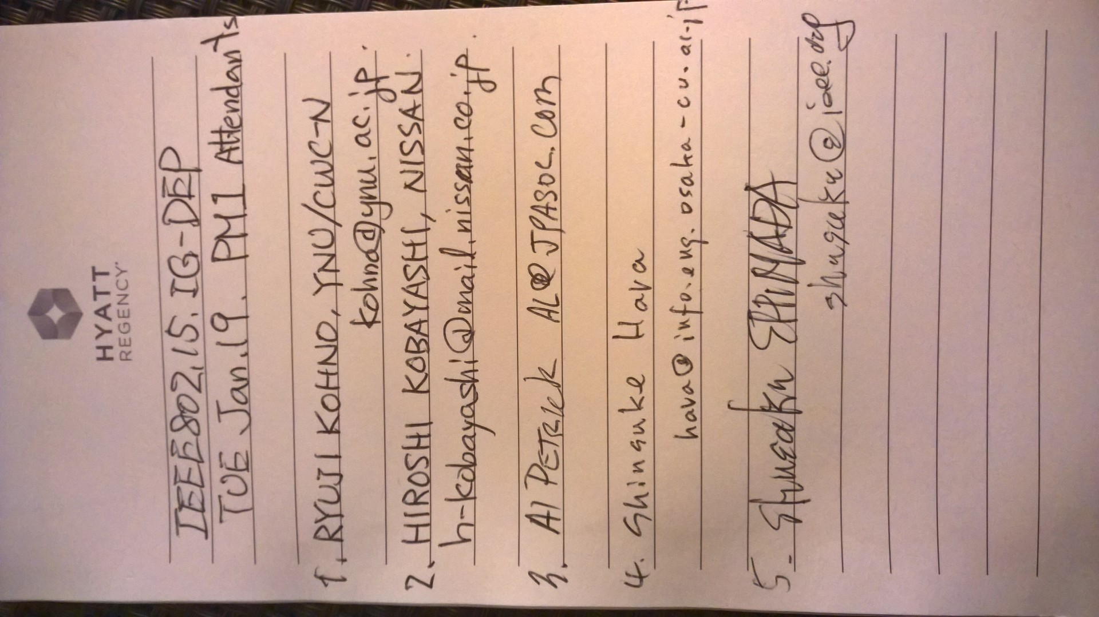

Wedensday, January 20, 2016, PM1, 13:30

  - Meeting called to order 13:30
By Chair Ryuji Kohno (Yokohama National University/CWC-Nippon) Secretary Ryuji Kohno (Yokohama National University/CWC-Nippon)

  - Presentation on updated summary of responses for CFI including new presentations at the last session by Ryuji Kohno doc. #15-15-0217-06

  - New Presentation: Summary of necessary technical requirement for focused applications by defining classes of application with various QoS levels corresponding requested levels of Dependability. This is quite important to make IG to SG, TG. By Ryuji Kohno doc. #15-15-111-00

Necessary Process and Possible Timeline to SG and next steps, and request to attend to IG-DEP more from clients such as car, building, and infrastructure manufactures as well as developers has been discussed.

A draft map of three selected focused applications to make clear scope for focused applications by classified QoS levels for required dependability was shown.

To finalize technical requirement for the classified QoS levels, QoS 1 level of highest priority for demand of dependability could be selected.

Until March meeting, a draft of necessary documents for SG may be redeay.

  - Adjourned at 15:33.

  - Attendees
