IEEE P802.15
Wireless Personal Area Networks

Project | IEEE P802.15 Working Group for Wireless Personal Area Networks (WPANs)
Title | 802.15 TG10 (L2R) Comment Resolution for CIDs #2130, #2340, #2345
Date Submitted | [20 January, 2016]
Source | [Charlie Perkins]  [Futurewei] | Voice: [+1-408-330-4586]  Fax: [+1-408-330-5088]  E-mail: [charliep@computer.org]
Re: | [TG10 (L2R) comment resolution.]
Abstract | Comment Resolution for comments CIDs #2130, #2340, #2345 related to metric definitions and mesh configuration parameters
Purpose | [TG10 (L2R) comment resolution to produce next draft.]
Notice | This document has been prepared to assist the IEEE P802.15. It is offered as a basis for discussion and is not binding on the contributing individual(s) or organization(s). The material in this document is subject to change in form and content after further study. The contributor(s) reserve(s) the right to add, amend or withdraw material contained herein.
Release | The contributor acknowledges and accepts that this contribution becomes the property of IEEE and may be made publicly available by P802.15.

Comments #2130, #2340, #2345

2130 | Jussi Haapola | Centre for Wireless Communications / University of Oulu | 30 | 5.2.2.2 | 29 - 32 | The text leaves a lot for interpretation. Since the unit is .001 and the length is two octets, does this mean that the entire path ETX count maxes out at 65.535 (sixty five plus change) hops? | Describe the relation between the unit and the length field unambiguously.
2340 | Verotiana Rabarijaona | NICT | 107 | 7.3 | 6 | Should "l2rDefaultTTL" and "l2rDefaultRL" be set per device or per mesh? | Move to table 48 if set per device
2345 | Jussi Haapola | Centre for Wireless Communications / University of Oulu | 29 - 30 | 5.2.2.1 | all | The described algortihm does not really function as intended. The intention according to 2) is that the metric should rapidly increase with decrasing singal strength. However, as power factor 8 is used on a number between (0,1), the result heavily tends toward 0 rather than 1. As a result, the \mu(P) heavily tends to MinRSW rather than MaxRSW. | Change calculation of P = (Pmeas - Pmin) / (Pmax - Pmin) and then \mu0(P) = 1 - P^8.

CID 2130:
In order to increase the useful range of ETX, the precision of the metric can be reduced. Instead of counting in units of .001, it is proposed to count in units of .01. This increases the maximum value of the metric to something over 655. This modification does not affect the frequent outcome that ETX will produce routing decisions very similar to using the hop count metric.

Resolution: Accept with revision
- Replace the following text on page 31, line 29 of 5.2.2.2
.001 .01

- Replace the following text on page 30, line 32 of 5.2.2.2
Expected transmission count

CID 2340:
Resolution: Accept
- Move the rows containing l2rDefaultTTL and l2rDefaultRL from table 49 to table 48

CID 2345:
The original formulation does not have the preferred dependence on signal strength. The intended design suggests that even moderately weak signals should be strongly disfavored. In other words, as P_{meas} increases from P_{min} to P_{max}, the metric value should decrease, slowly at first, from its maximum value MaxRSW to its minimum value MinRSW. The normalizing equation on line 4 does allow strong signals to produce computed values near MinRSW.
Also, note that the shape of the RSW metric is not exponential.
It is likely that some implementations would prefer greater or less penalty for moderate values of received signal strength. To enable this additional control, an additional mesh-wide parameter should be added to Table 49, called l2rRswExponent that takes values in the range (0,1). Values of l2rRswExponent closer to zero provide a stronger penalty for reduced signal strength, whereas of l2rRswExponent closer to one provide a more linear increase in the cost of routes as their signal strength weakens. Using P_{min}=1 and P_{max}=100, Figures 1, 2, and 3 show a visual representation of the effect of increasing values of l2rRswExponent, namely 0.125, 0.25, and 0.5. are shown in the normalized range (0,1). The default value for l2rRswExponent is 0.125.

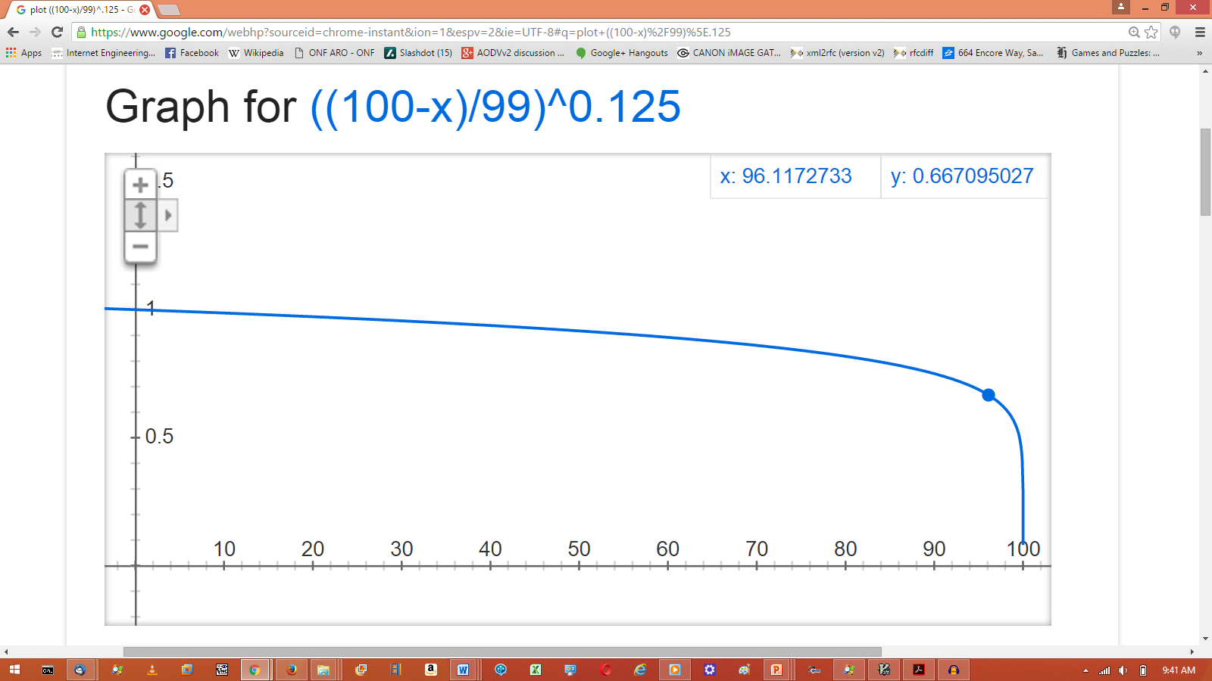
Figure 1: l2rRswExponent = 0.125

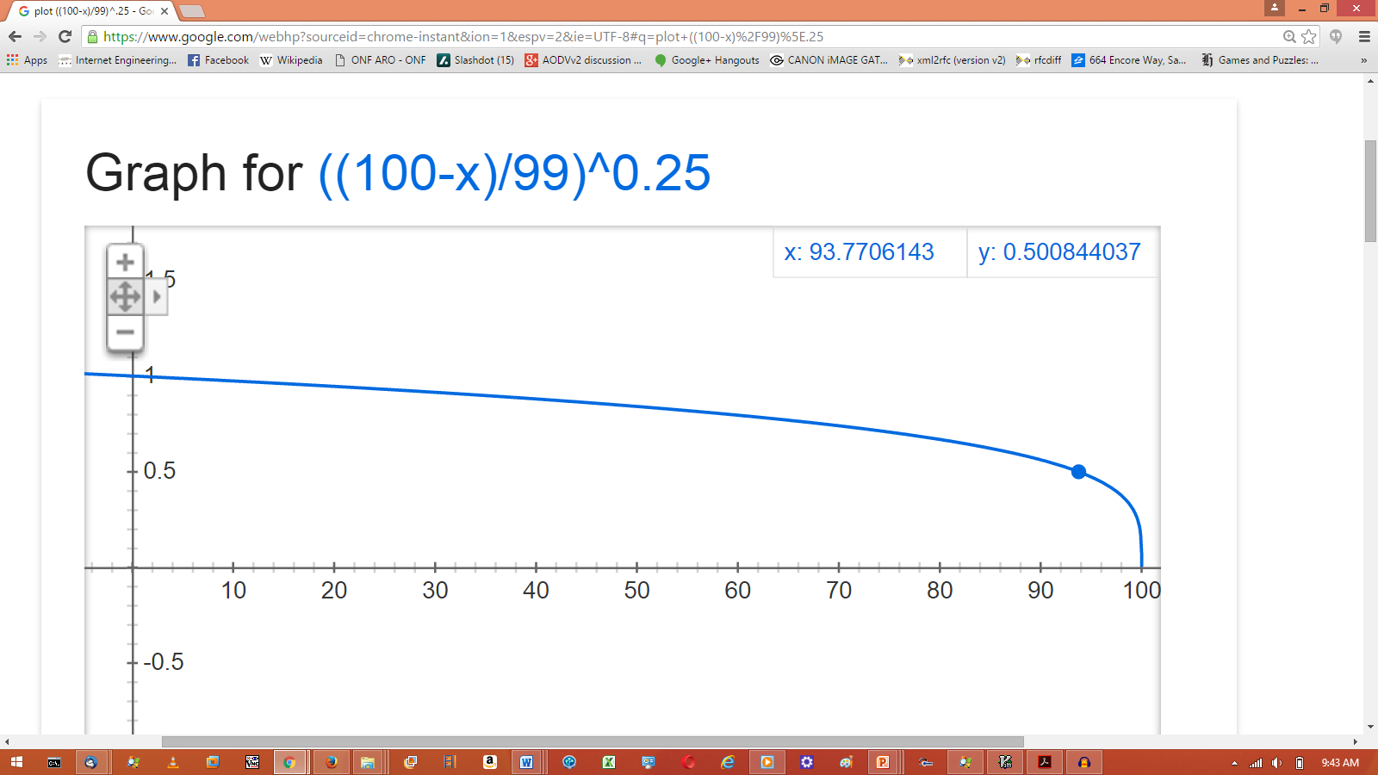
Figure 2: l2rRswExponent = 0.25

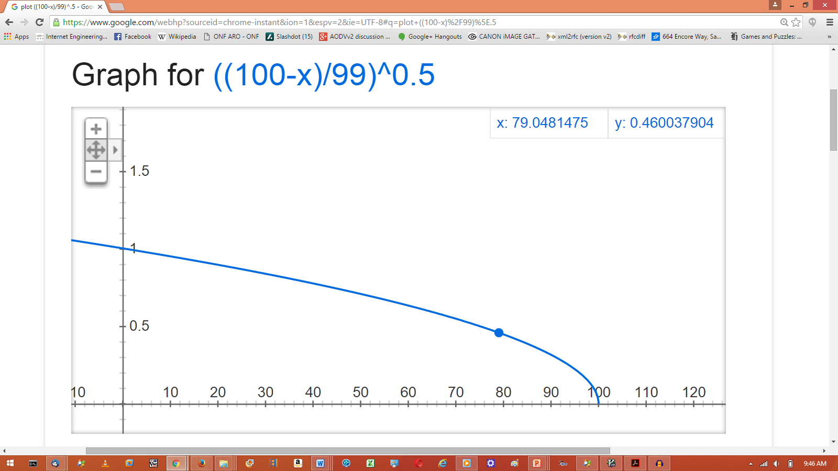
Figure 3: l2rRswExponent = 0.5

Resolution: Accept with revision
- Replace the following text at page 29, line 35 of 5.2.2.1
RSW value increases exponentially rapidly

- Add the following sentence in the text at page 30, line 3 of 5.2.2.1
The exponent l2rRswExponent is chosen to have a value between 0 and 1. Values of l2rRswExponent closer to zero provide a stronger penalty for reduced signal strength, whereas of l2rRswExponent closer to one provide a more linear increase in the cost of routes as their signal strength weakens. Using P_{min}=1 and P_{max}=100, Figures 1, 2, and 3 show a visual representation of the effect of increasing values of l2rRswExponent, namely 0.125, 0.25, and 0.5. Computed values are shown in the normalized range (0,1). The default value for l2rRswExponent is 0.125.

Begin a new paragraph with the text “The following formula satisfies properties 1) - 3) above:”

- Modify the exponent for the factor P in the text at page 30, line 9 of 5.2.2.1, as shown
P⁸ ^{l2rRswExponent}

- Insert Figures 1, 2, and 3 with their captions at page 29, line 35 of 5.2.2.1
RSW value increases exponentially rapidly

- Add a row containing l2rRswExponent in table 49

l2rRswExponent | enumeration | One_sixteenth  One_eighth  Three_sixteenths  One_quarter  Five_sixteenths  Three_eighths  One_half | Indicates the fractional exponent to be used in the calculation for the RSW metric | One_eighth

