**Project: IEEE P802.15 Working Group for Wireless Personal Area Networks (WPANs)**

**Submission Title:** Channel Model for Intra-Device Communications

Text Proposal

**Date Submitted:**  19 January 2016

**Source:** Alexander Fricke, Thomas Kürner, TU Braunschweig

Mounir Achir, Philippe LeBars, CANON

E-Mail: fricke@ifn.ing.tu-bs.de/t.kuerner@tu-bs.de

mounir.achir@crf.canon.fr / philippe.lebars@crf.canon.fr

**Re:** n/a

**Abstract:** In this contribution, a CMD text proposal for the modeling methodology and results for the propagation channel encountered in the application intra-device communications is presented.

**Purpose:** Contribution towards developing an intra-device channel model for use in TG 3d

**Notice:** This document has been prepared to assist the IEEE P802.15. It is offered as a basis for discussion and is not binding on the contributing individual(s) or organization(s). The material in this document is subject to change in form and content after further study. The contributor(s) reserve(s) the right to add, amend or withdraw material contained herein.

**Release:** The contributor acknowledges and accepts that this contribution becomes the property of IEEE and may be made publicly available by P802.15.

# General Structure of the Channel Model

The channel model is realized as a set of channel transfer functions which give a complete description of the propagation channel over the whole frequency range under consideration. The Inverse Fourier Transform represents the signal that is received after a single symbol has been transmitted through the channel with respect to the employed antenna characteristics. The channel transfer function in its general structure may be written as

|  |  |  |
| --- | --- | --- |
|  | $$H\left(f,ϑ_{Tx},φ_{Tx},ϑ_{Rx},φ_{Rx},P_{Tx},P_{Rx}\right)=\sum_{i}{A_{Rx}\left(ϑ_{Rx}-ϑ_{AoA,i},φ_{Rx}-φ_{AoA,i},P_{Rx}\right)∙{CTF}_{i}\left(f,H_{i}\right)∙A_{Tx}\left(ϑ_{Tx}-ϑ_{AoD,i},φ_{Tx}-φ_{AoD,i},P_{Tx}\right)}$$ | (1) |

In this, *f* ist the vector of frequencies under consideration, ϑTx and φTx are the elongation and azimuth coordinates of the transmitter antenna pattern, ϑRx and φRx are the elongation and azimuth coordinates of the receiver antenna pattern and PTx and PRx are the polarization vectors of the antennas. The expression to the right is the sum over each propagation cluster *i*. The contribution of every cluster is its polarimetric channel transfer function *CTFi*, multiplied with the direction-dependent gain of the antenna radiation patterns *ATx* and *ARx*.

The structure of the channel transfer functions of the separate clusters is

|  |  |
| --- | --- |
| $${CTF}_{i}(f,H_{i})=\left(\begin{matrix}H_{i,11}(f) & H_{i,12}(f) \\ H_{i,21}(f) & H_{i,22}(f)\end{matrix}\right)$$ | (2) |

Here, the Hi,11 – Hi,22 are the entries of the polarimetric channel matrix for every cluster according to the Jones Calculus [1]. Note that every entry is a function of frequency, to generate the desired channel transfer functions.

Finally, the terms for the transmitting and receiving antenna are

|  |  |
| --- | --- |
| $$A_{Tx/Rx}=g_{\frac{Tx}{Rx}}(ϑ_{Tx/Rx}-ϑ_{i},φ_{Tx/Rx}-φ_{i})∙\left(\begin{matrix}J_{ϑ,Tx/Rx} \\ J_{φ,Tx/Rx}\end{matrix}\right)$$ | (3) |

Where *gTx/Rx* is the direction-dependent gain of the respective antenna evaluated at the angular positions where the *ith* ray hits the respective antenna radiation pattern and ***J*** is the Jones-vector of the Antenna according to [1].

# Generation of the Channel Transfer Functions

The channel transfer functions (CTFs) introduced in Chapter 1 are generated by a specific tool for generating channel transfer functions which is termed *channel realization generator* (CRG). The CRG evaluates a set of stochastic interdependencies for the channel properties that underlie the channel transfer function, such as cluster composition, angular profiles at Tx and Rx, path losses and times of arrival and polarization properties. The channel model is derived from a ray-tracing approach that has been developed to account for the peculiarities of close-proximity and intra-device communications in the THz – range. It includes the electromagnetic influence of plastic layers, metals and printed circuit boards. Moreover, the characteristics of Gaussian antenna profiles are included.

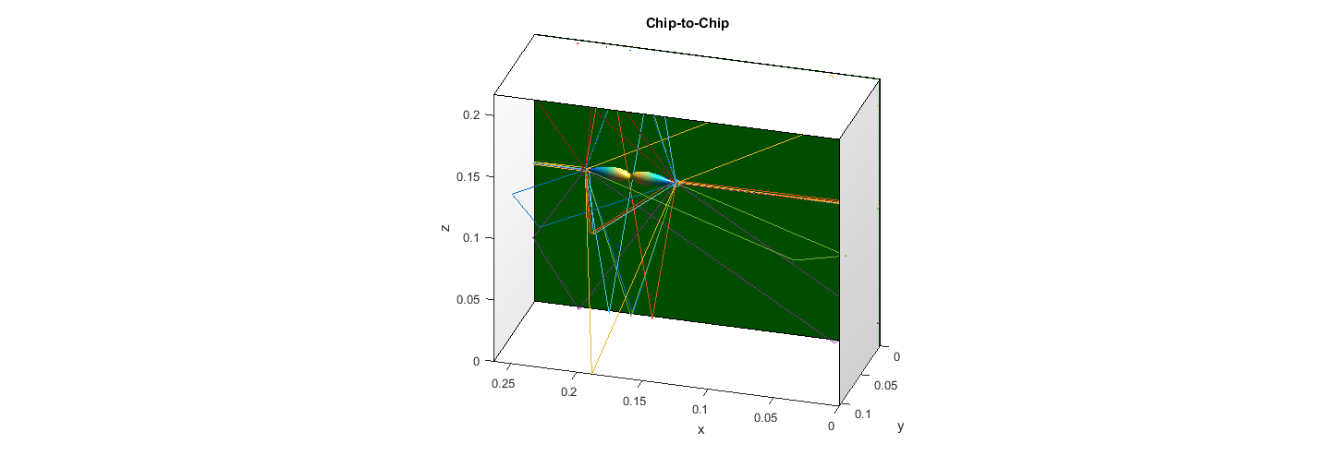

Figure 1: Ray Tracing weighted with Gaussian Antenna Profiles  
a) Board to Board Case, b) Chip to Chip Case

From the ray-tracing results, which are exemplarily visualized in Figure 1, the characteristics of the channel regarding cluster composition, path loss and polarization properties as well as angular and temporal profiles are extracted. These characteristics are used to configure the CRG which is utilized to generate a large number of realistic channel realizations (i.e. frequency responses) for the corresponding use cases. The structure of the employed channel statistics is depicted in Figure 2.

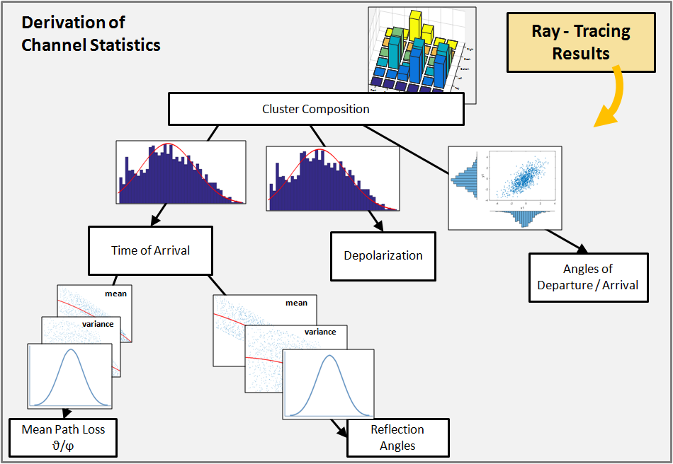

Figure 2: Structure of the Underlying Channel Statistics

## Cluster Composition

The most important component of the CRG is the cluster composition of each channel. The cluster composition is the actual set of multipath components that occur in a channel realization. It is obvious, that an incorrect assumption regarding the cluster composition will lead to invalid channel realizations. The cluster composition implicitly holds the geometric structure of the underlying ray-tracing simulations. For example, analyzing a long hallway will lead to a different set of clusters and cluster interrelationships than a square-shaped office room with room dividers that may in some cases block the line of sight.

For the stochastic generation of channel transfer functions, statistics are extracted for every cluster type and reflection order. The considered cluster types are defined by the reflection processes that occur along their respective propagation path. This results in the cluster types LOS (direct path), TMM (reflection on plastic surfaces), METAL (reflection on metal surfaces) and MIXED (different reflection types along the path). To further illustrate the concept, Figure 3 shows the exemplary propagation path, the corresponding wall indices and the resulting matrix-structure (along with two other paths) holding the depicted second-order path. The matrix-structure is in the following referred to as *composition tensor*.

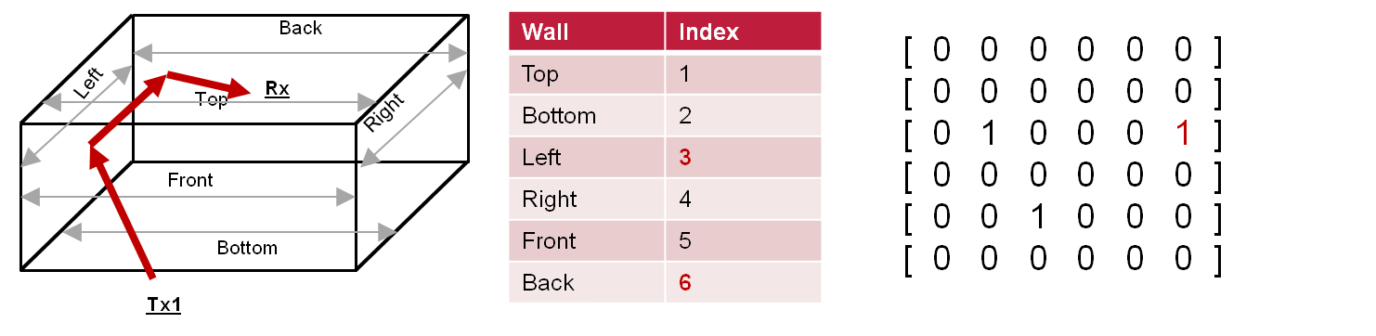

Figure 3: Cluster Composition

After the evaluation of the clusters in terms of composition tensors, the relative probabilities of occurrence are generated. In the current version of the model, this is done by means of Gaussian Mixture Models (GMM). A GMM is capable of modeling multivariate distributions over correlated features. This way, the characteristics of the cluster tensors (e.g. mutually exclusive occurrence of certain reflections) can be accounted for. After the number *n* of paths with possibility < 1 and > 0 has been determined, a GMM is set up for each cluster type. Each respective GMM has a number of *n* variables that are drawn from *n* Gaussian components. Thus, a single draw from such GMM produces a vector of *n* logical values, expressing the presence or absence of the *n* cluster component for a given channel realization.

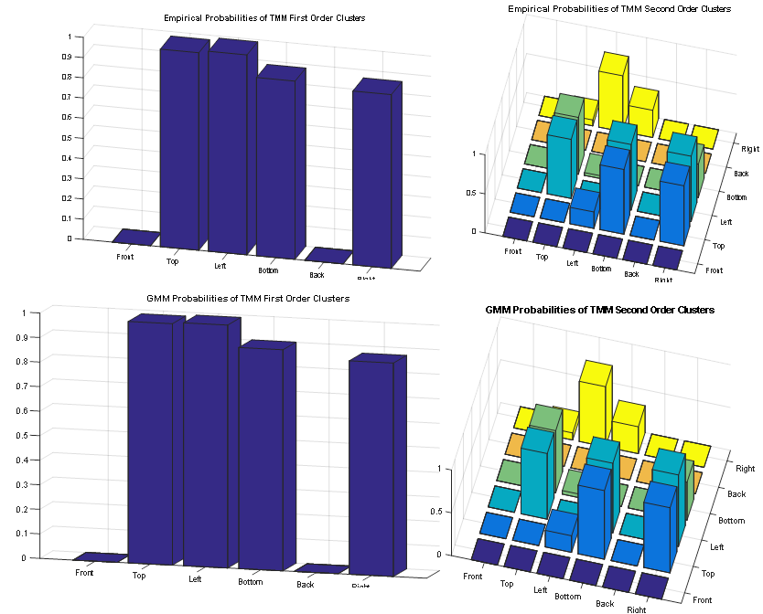

## Time of Arrival

After generating the cluster composition, the propagation time of each path (Time of Arrival, ToA), is generated. It is assumed, that the propagation delays of the various cluster types follow normal distributions. For the direct path clusters, the propagation times are modeled directly based on their delay from the ray-tracing results. For the reflected paths, the delay is modeled based on the relative delay to the corresponding direct path; this way, it is assured that no reflected clusters are generated that have a shorter propagation time than the direct path, which would be physically unrealistic. Figure 4 depicts two exemplary distributions that have been generated for mixed propagation clusters from one specific communication scenario.

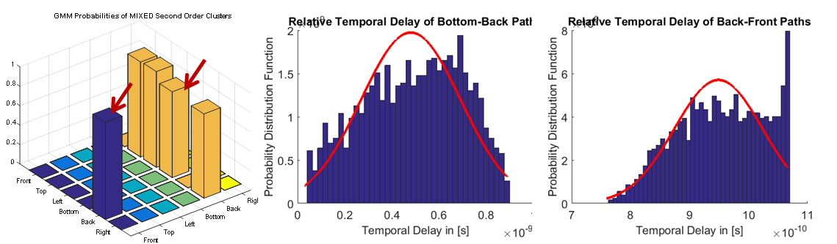

Figure 4: Exemplary Delay Distributions of two twice-reflected Clusters

As the modelling methodology for the stochastic generation of CTFs is based on the evaluation of probability distributions, for each cluster occurrence one corresponding probability distribution is generated. For the introduced example of clusters, this fact is further illustrated in Figure 5.

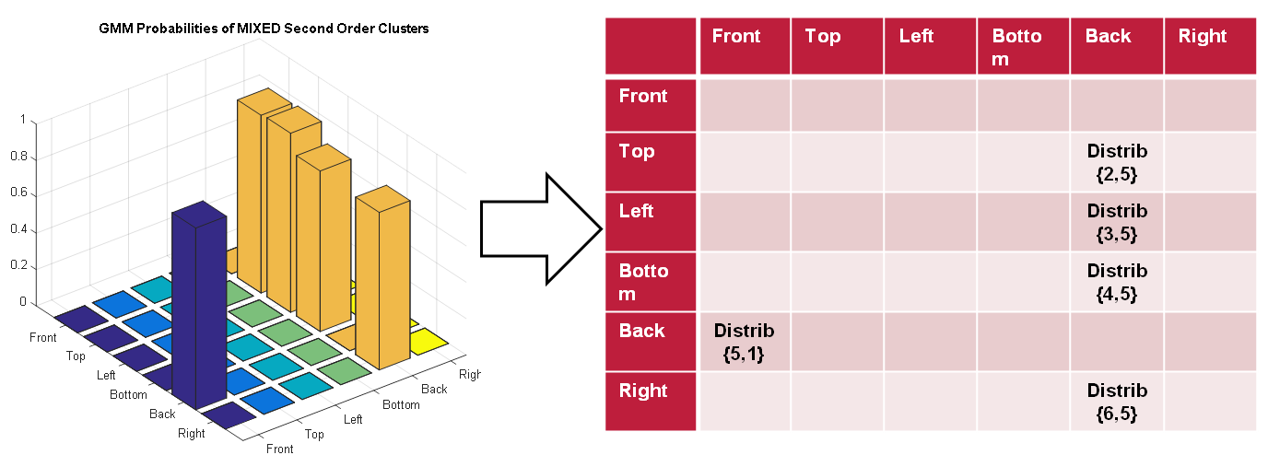

Figure 5: Generation of Distributions for each observed Cluster

Note that each distribution is truncated to the interval of the maximum and minimum observed delay value. This way, it is ensured that the stochastic generation process does not produce any unrealistically high or negative delay values. The above introduced methodology for the derivation of probability distributions for each object of the cluster composition tensors is applied in each of the following steps. This way, the model is further configured with the implicit information on the channel geometry such as interrelationships between cluster arrival times, reflection angles, polarization and so on.

## Mean Path Loss

Based on the cluster arrival times, the mean path loss of each cluster is generated. The mean path loss is defined as the mean absolute value over frequency for the ray-tracing frequency responses of each cluster. The mean path loss is evaluated for both polarizations. It is considered physically meaningful that the path loss is a function of path delay. For the path loss and all other characteristics that are modeled as functional relationships, the underlying form of the functions are second order polynomials. Even though some dependencies may follow different functional shapes on the large scale (e.g. the path loss in a channel is usually considered to follow a negative-exponential relationship with the propagation delay), second-order polynomials are a sufficient way to model the relationships for relatively small value ranges. Since each cluster (e.g. left-wall reflection, ceiling-reflection and so on) is modeled separately, there is always a second-order relationship that has a very good agreement. Figure 6 depicts the path loss approximation of the theta-component of the LOS component transmitted through a plastic layer.

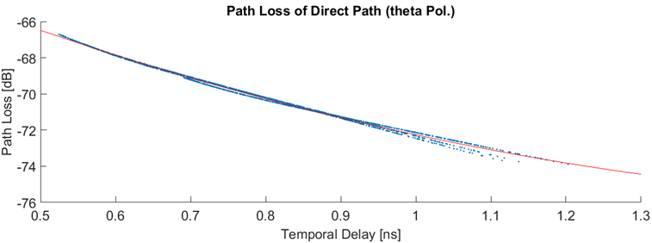

Figure 6: Path Loss of an Exemplary LOS component

As it can be seen, the agreement between the second-order polynomial and the sample values from the ray-tracing simulations is very good. The presented relationship is treated as the mean value of the propagation path loss as a function of frequency.

Evaluating the derivation of the sample points from the generated second-order model, another second order relationship is derived to characterize the mean absolute error (MAE) of this approximation. An example is shown in Figure 7.

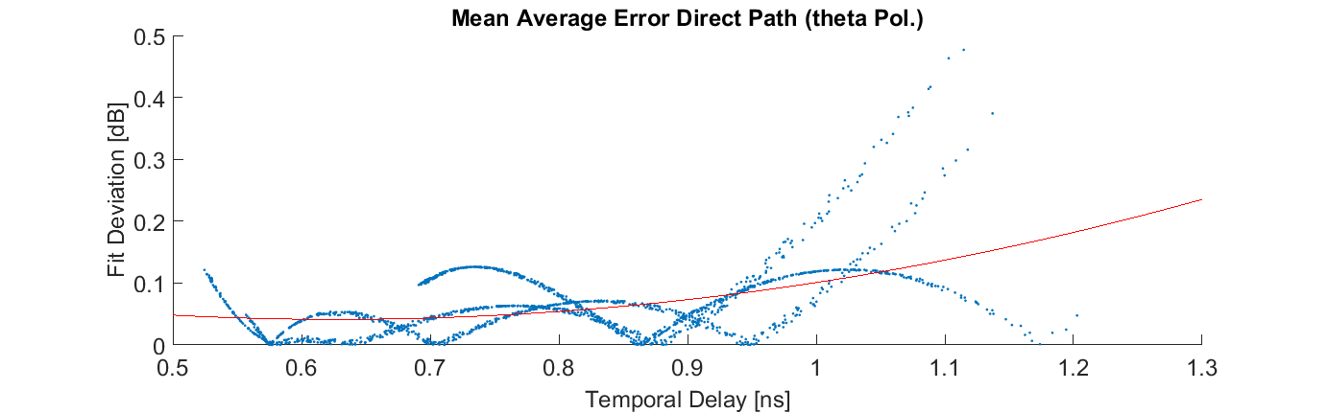

Figure 7: Mean Average Error of the Exemplary LOS Component

For the channel model, the functions for the mean value and the mean average error are used to parameterize a Gaussian Distribution (GD) from which the values for the stochastic channel transfer functions are generated. This is depicted schematically in Figure 8.

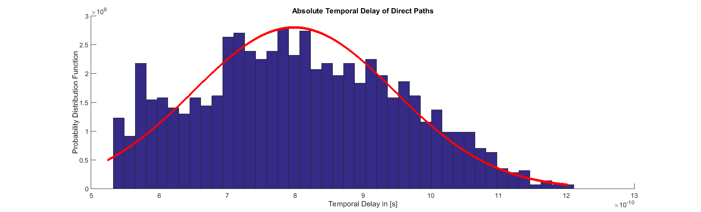

**MAE**

**mean()**

Figure 8: Derivation of a Gaussian Distribution from Mean and MAE Values

## Reflection Angles

In the same manner as the path delays, the initial reflection angles of all reflected paths are modeled as functions of the path delay. However, it is not necessary that these functions are monotonically decreasing. Instead, different geometries may lead to varying types of relationships as is illustrated in Figure 9.

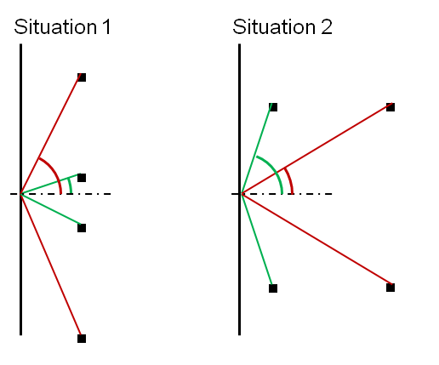

Figure 9: Geometrical Relationship between Path Length and Reflection Angle

In the example, it becomes obvious that a shorter propagation path (green) may lead to a smaller angle of reflection in situation one while it leads to a larger angle of reflection in situation b. Due to the fact that every cluster is tracked separately in its behavior and a function of this relationship is generated for every cluster, the amount of implicit information on the channel geometry is again increased. In the case of second order-reflections, the reflection angle is modeled as a function of the corresponding first order reflection angle. This choice has been made due to the fact that no clear functional relationship was obvious anymore between path delay and reflection angle for subsequent reflections after the first one.

## Depolarization

To this point, the statistical channel properties have been evaluated for the phi and theta components of the electromagnetic field after transmission through the channel. However, the channel matrix of a polarimetric radio channel consists of four elements to account for the phenomenon of depolarization:

|  |  |  |
| --- | --- | --- |
|  |  | (4) |
|  |  | (5) | |

In the above expressions, the elements H11 and H22 lead to a talk-over between the two canonic polarizations that has to be accounted for if antennas other than horizontally or vertically polarized antennas shall be employed in the channel simulations. Thus, after the generation of the mean path losses for theta- and phi-polarization, the polarization angle of each cluster is derived by

|  |  |  |
| --- | --- | --- |
|  | $$γ_{depol}=\operatorname{atan}\left(\frac{H_{12}}{H_{11}}\right)=atan⁡(\frac{H_{21}}{H_{22}})$$ | (6) |

As no functional dependency (e.g. to the time of arrival) could be observed, all depolarization angles for all reflection processes are modeled as Gaussian distributions.

## Angles of Departure and Arrival

The final component necessary to fully characterize the Terahertz communication channel is the angular profile at the transmitter and the receiver site. With this, the impact of different antenna types with varying radiation patterns and polarization properties can be incorporated into the channel model. As it is considered geometrically meaningful, the angle of departure at the Tx and the angle of arrival at the Rx are modeled jointly for elongation theta and azimuth phi. The following Figure 10 illustrates this assumption.

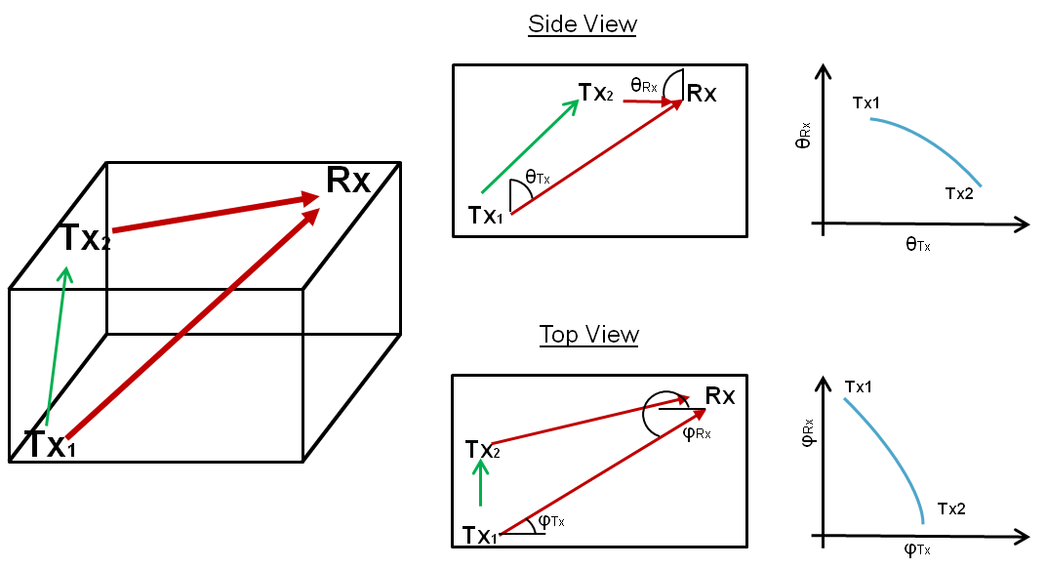

Figure 10: Illustration of AoD/AoA Correlation

In the figure, the transmitter is moved along the path depicted by the green arrow from position Tx1 to position Tx2. The Rx remains at a fixed position and the effect of the movement on the elongation of departure at the transmitter is observed. As it can be seen on the four pictures to the right, the relationship between these angles in the elongation and azimuth domain is correlated for the direct path. Similar but less graphic relations exist for reflected clusters.

As a consequence of the above observations, the AoA and AoD profiles in theta and phi are modeled as correlated probability densities. To extract the parameters of these distributions, the method of copula distributions is applied. In this methodology, the marginal univariate distributions of the AoA and AoD of a certain cluster are generated; in a second step, a copula structure is generated to provide the correlation between the variables. The output in the case of angular profiles is a Gaussian distribution that is not defined over a single value but over both AoA and AoD in a correlated manner.

## Dispersion Functions

From the generated statistics, the clusters of each channel have to be evaluated with dispersion functions as well as antenna profiles to generate the final channel transfer function of each channel realization. The structure of this process is depicted in Figure 11.

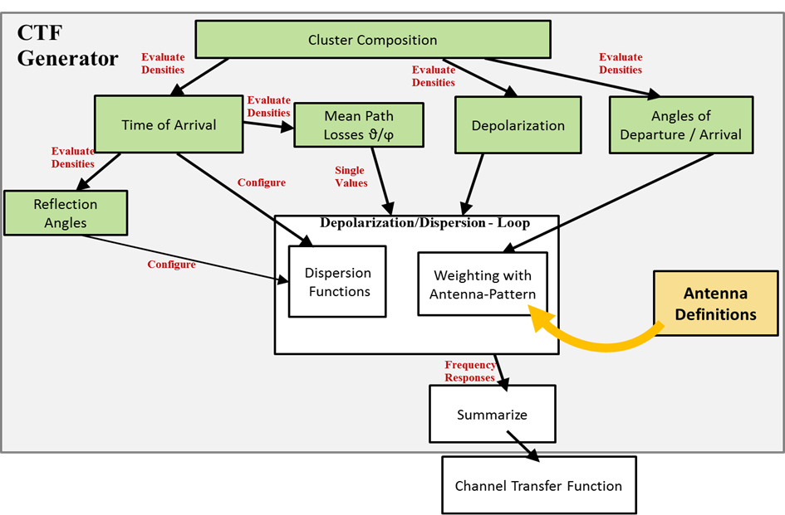

Figure 11: Gereration of the Channel Transfer Function

Due to the broadband nature of the investigated propagation channels, a single mean path-loss value is not enough information to characterize the propagation paths. Instead, the path loss is always a function of frequency due to dispersion stemming from Friis Transmission Equation as well as from the reflection processes at thin layers and printed circuit boards. To illustrate this behavior, the effects of the three dispersion mechanisms are illustrated in Figure 12.

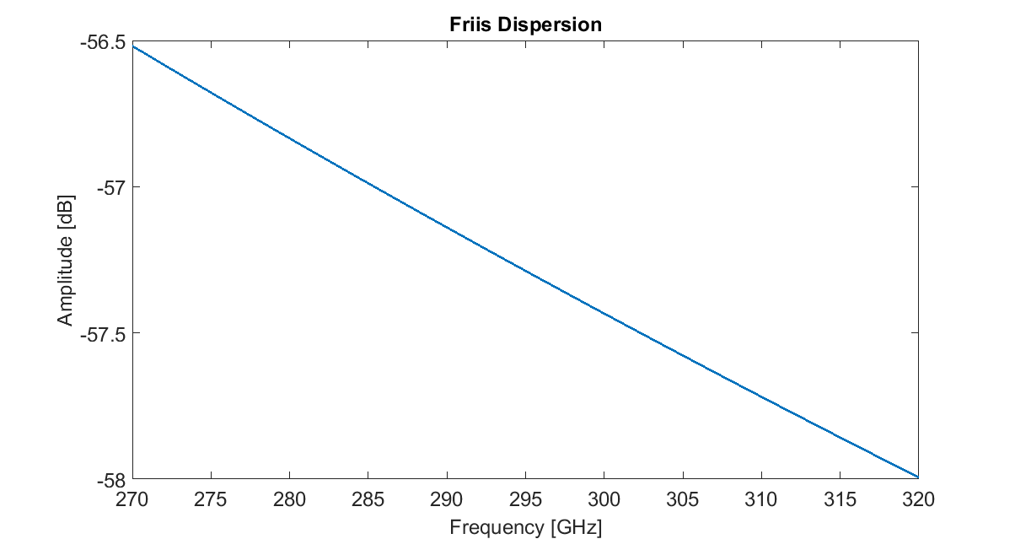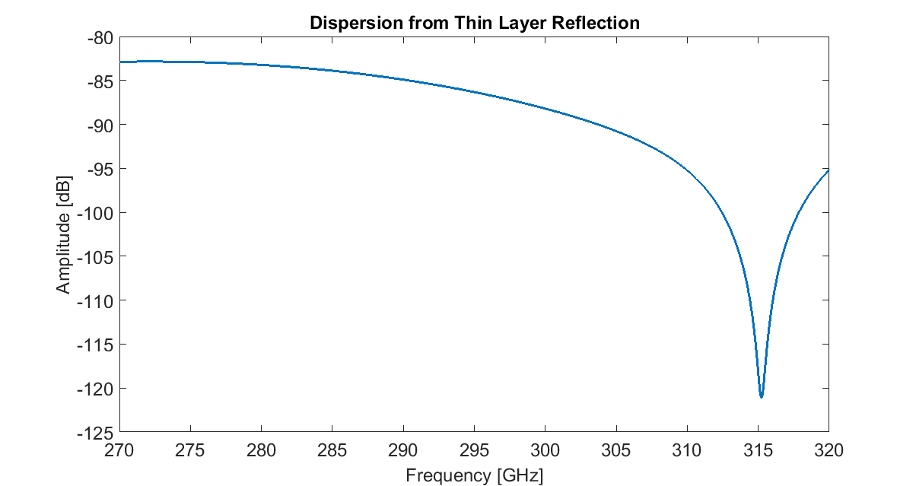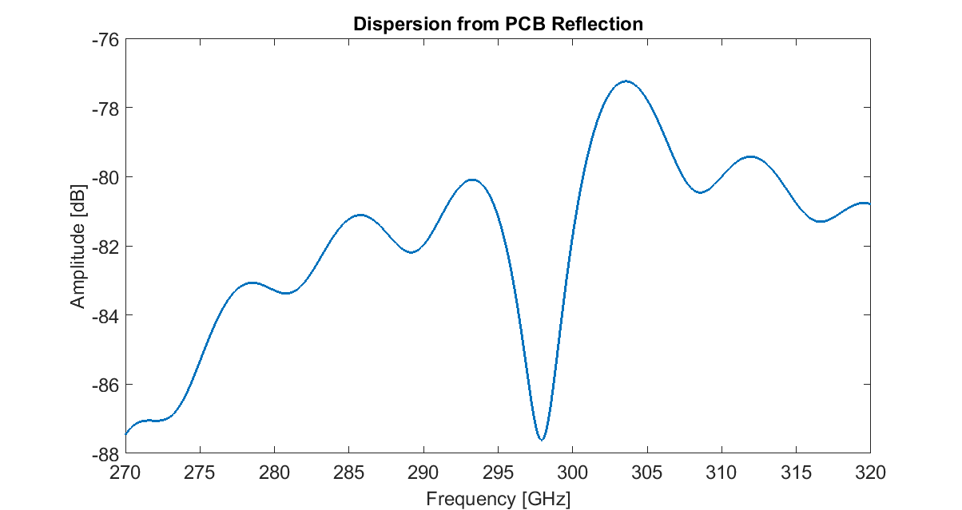

Figure 12: Exemplary Dispersion Functions

In figure a), the characteristic slope of an ultra-broadband channel due to the decreasing effective aperture of a given antenna over a large frequency range is observed, while figure b) shows the typical interference pattern from a reflection at a thin plastic surface. Figure c) shows the frequency response of a path that has been reflected by a PCB surface. In the ray-tracing algorithm, relatively complex models of the electromagnetic behavior at reflection processes are employed. Resulting from this, the ray-tracing algorithm has a high computational complexity leading to a simulation time of up to a minute for the generation of a single channel transfer function. The CRG uses parameterized functions instead of the actual physical models to reduce this complexity while maintaining realistic properties of the dispersion processes.

# Intra-Device Communications

In this chapter, a summary of the channel characteristics for the defined scenarios with the investigated antenna configurations is presented. The summary comprises an analysis of the mean path loss over distance for the envisaged application cases along with an envelope function of the impulse responses for each case.

## Scenario Definitions

For Intra-Device Communications, the cases of Chip to Chip Communications under LOS condition, Chip to Chip Communications under NLOS condition and Board to Board Communication are distinguished. They are depicted schematically in Figure 13.

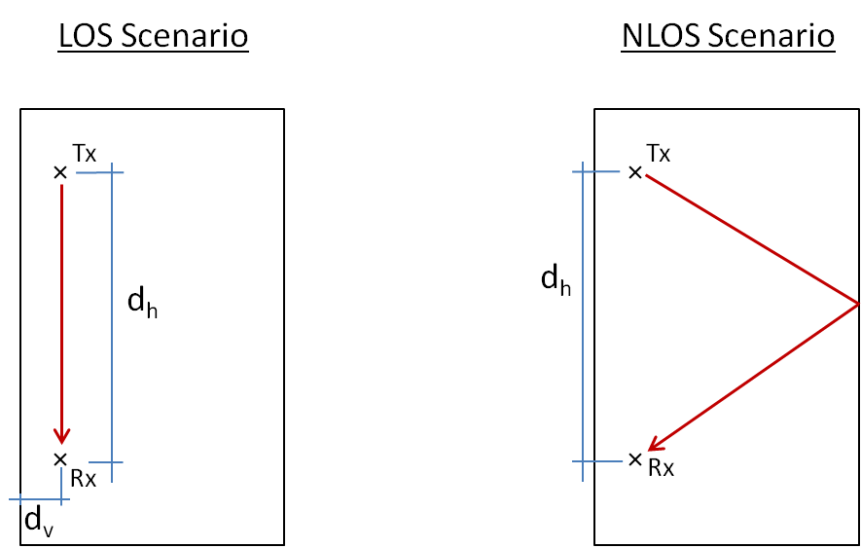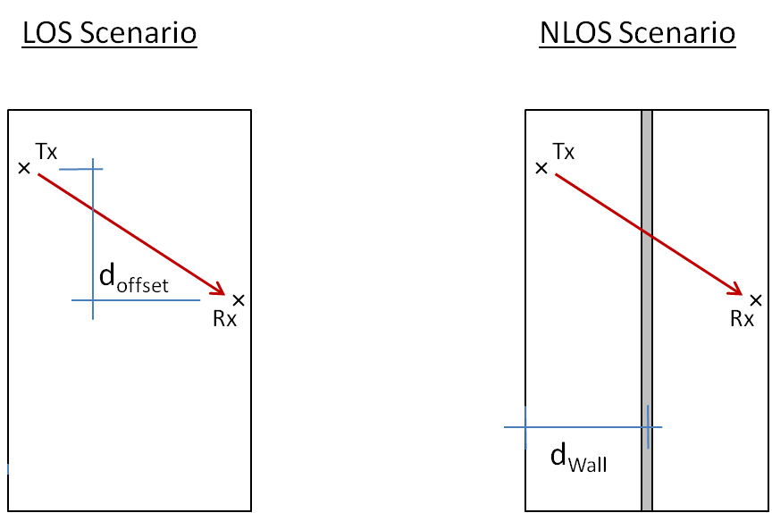

Chip to Chip

Board to Board

Figure 13: Operational Modes for Intra-Device Communication

The parameters of the operational modes are summarized in Table 1

Table 1: Parameters of the Intra-Device Operational Modes

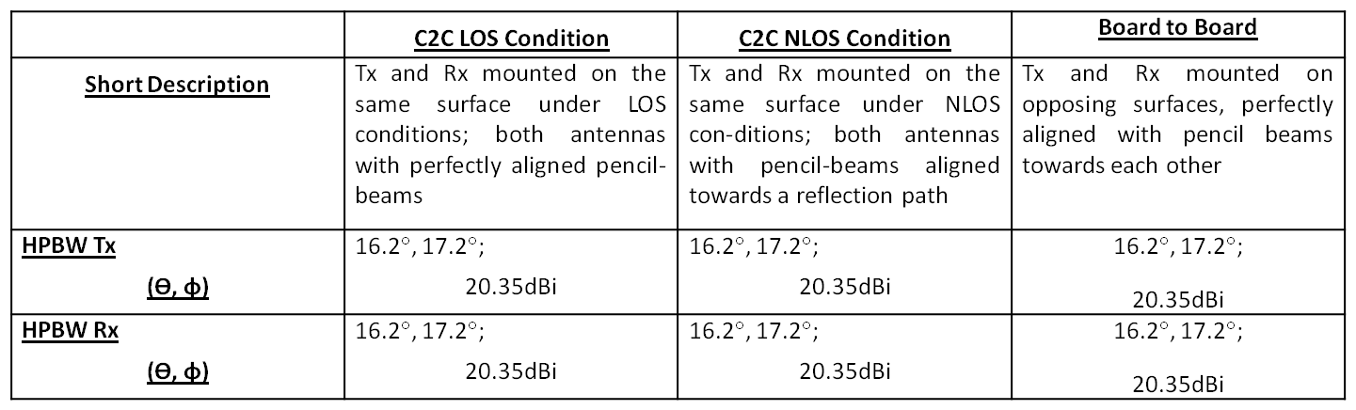

## Simulation Results

### Chip-to-Chip Communications

Figure 14 and Figure 15 present the mean path loss over distance for the two different operational modes (LOS and NLOS) and polarizations. Again, a numerically fitted function describing the relationship between the separation between Tx and Rx and the observed path losses is shown.

The path-loss of the main signal follows a log-distance dependent behaviour under LOS conditions. This behaviour is illustrated in Figure 14.



b)

a)

Figure 14: Mean Path Loss for Chip to Chip Communications under LOS condition  
a) Linear Vertical Polarization b) Left-Hand Circular Polarization

For modelling the path loss of chip to chip communications under LOS conditions, the relationship between the path loss and the distance is defined as follows:

|  |  |  |
| --- | --- | --- |
|  | $${PL(d[m])}_{total}\left[dB\right]={PL}_{d_{0}}\left[dB\right]+10∙γ∙\log_{10}\left(\frac{d\left[m\right]}{d_{0}\left[m\right]}\right)+χ_{g}$$ | (7) |

In this expression, ${PL}_{total}$ is the total path loss, ${PL}_{d_{0}}$ is the path loss at the reference distance $d_{0}$, $γ$ is the path loss exponent, $d$ is the distance at which the expression is evaluated and $χ_{g}$ is a normally distributed random variable with zero mean.

The corresponding parameters of the equation are listed in Table 2.

Table 2: Parameters of the Path Loss Model for Chip to Chip Communications under LOS Conditions

|  |  |  |  |  |
| --- | --- | --- | --- | --- |
| **Scenario** | $${PL}_{d_{0}}$$ | $$d_{0}$$ | $$γ$$ | **RMSE(*χg*)** |
| Chip to Chip LOS,  vertical | 16.5 | 0.05 | 2.007 | 1.1934 |
| Chip to Chip LOS,  circular | 16.5 | 0.05 | 1.969 | 1.1020 |

For the directed NLOS operational mode, the log-distance dependency of the path loss is not valid anymore. As seen in Figure 15, the simulated path losses are rather equally distributed over a certain amplitude range incorporating only a weak relationship between the distance between Tx and Rx and the signal path loss. Comparing the results for linear ( Figure a) ) and circular ( Figure b) ) polarization, it can be seen that the directed NLOS signal is around 5dB weaker in case of circular polarization, which is consistent to the expected behaviour of reflected circularly polarized propagation paths.



b)

a)

Figure 15: Mean Path Loss for Chip to Chip Communications under NLOS condition  
a) Linear Vertical Polarization b) Left-Hand Circular Polarization

As mentioned above, the path loss of the NLOS configuration does not follow a log-distance dependency regarding the separation between Tx and Rx. This is comprehensible since the length of the propagation path is only indirectly coupled to the separation between Tx and Rx. In addition to the separation, the implicit variation of box size between the maximum size of L and the minimum size of M leads to a rather uniform distribution of the directed NLOS propagation path length. However, the reflection angle of that path is also influenced by the Tx-Rx separation, leading to a slight variation of the reflection loss over distance. The overall impact on the main signal for the NLOS transmission mode can be modeled by means of a linear equation

|  |  |  |
| --- | --- | --- |
|  | $${PL(d[m])}_{total}\left[dB\right]={PL}_{0}\left[dB\right]+ζ∙d\left[m\right]+χ_{g}$$ | (8) |

In this, ${PL(d)}_{total}$ is the distance-dependent path loss, ${PL}_{0}$ is the path loss when the separation between Tx and Rx becomes zero, $ζ$ is the path-loss coefficient, $d$ is the separation between Tx and Rx and $χ_{g}$ is a normal-distributed random variable with zero mean. Note that the path loss does not become zero for zero antenna separation; as explained above, the target NLOS propagation path is still of a certain length that leads to the path loss of ${PL}_{0}$. The parameters of (8) are listed in Table 3.

Table 3: Parameters of the Path Loss Model for Chip to Chip Communications under NLOS Conditions

|  |  |  |  |
| --- | --- | --- | --- |
| **Scenario** | $${PL}_{0}$$ | $$ζ$$ | **RMSE(*χg*)** |
| Chip to Chip NLOS,  vertical | 44.85 | 40.64 | 1.1934 |
| Chip to Chip NLOS,  circular | 51.49 | 43.13 | 1.1020 |

Figure 16 and Figure 17 present the envelopes of the channel impulse responses generated for every scenario. Along with the path loss, they can be utilized to create a mask in time domain that represents the worst-case assumption regarding temporal channel dispersion.



b)

a)

Figure 16: Envelope of the Channel Impulse Responses for Chip to Chip Communications   
under LOS Condition  
a) Linear Vertical Polarization b) Left-Hand Circular Polarization

From Figure 16, it becomes evident that a multipath profile exists even under the assumption of high-gain antennas for chip-to-chip communications. However, comparing Figure a) and Figure b), the multipath richness can be significantly reduced if circular polarization is applied.



b)

a)

Figure 17: Envelope of the Channel Impulse Responses for Chip to Chip Communications  
under NLOS Condition  
a) Linear Vertical Polarization b) Left-Hand Circular Polarization

In the case of directed NLOS communications, as depicted in Figure 17, a couple of very strong multipath components might occur for some geometrical configurations. As seen in Figure a), these reflected paths can reach the amplitude of the main signal and thus lead to strong intersymbol interference when not properly treated e.g. by equalization techniques or forward error coding. Again, the application of circular polarization provides a flatter temporal profile of the channel. In Figure b), the strongest multipath components are already attenuated by around -10dB compared to the case of linear polarization, providing a much better position for deploying a communication system.

### Board-to-Board Communications

Figure 18 shows the mean path loss for Board to Board Communications over Tx-Rx separation for the two different polarizations.



b)

a)

Figure 18: Mean Path Loss for Board to Board Communications  
a) Linear Vertical Polarization b) Left-Hand Circular Polarization

As depicted above, the path-loss characteristics for board to board communications show the same log-distance dependent behavior as for the chip to chip types. The corresponding equations for the log-distance path loss models of the two polarizations are

|  |  |  |  |  |
| --- | --- | --- | --- | --- |
| **Scenario** | $${PL}_{d_{0}}$$ | $$d_{0}$$ | $$γ$$ | **RMSE(*χg*)** |
| Board to Board,  vertical | 16.5 | 0.05 | 1.977 | 1.1502 |
| Board to Board,  circular | 16.5 | 0.05 | 1.951 | 1.1437 |

Figure 19 presents the envelopes of the channel impulse responses. Compared to the situation of chip to chip communications, the multipath profile features a similar number of multipath components. However, their amplitude does not reach above -20dB below the main signal and is again effectively attenuated by the application of circularly polarized antennas.



b)

a)

Figure 19: Envelope of the Channel Impulse Responses for Bord to Board Communications  
a) Linear Vertical Polarization b) Left-Hand Circular Polarization

# References

[1] R. Jones, “A new Calculus for the Treatment of Optical Systems”, Journal of the

optical Society of America, vol. 32, no. 7, pp. 500-503, 1941