IEEE P802.15
Wireless Personal Area Networks

Project | IEEE P802.15 Working Group for Wireless Personal Area Networks (WPANs)
Title | Draft text of discovery procedure for forming many-to-many group
Date Submitted | November 2015
Source | Huan-Bang Li (NICT)  Marco Hernandez (NICT)  Igor Dotlić (NICT)  Ryu Miura (NICT)
Re: | TG8 draft text for peering related command for 802.15.8
Abstract | This is the work in progress text of the MAC component for IEEE 802.15.8 group for PAC.
Purpose | This document provides the details of draft text to IEEE 802.15.8
Notice | This document does not represent the agreed views of the IEEE 802.15 Working Group or IEEE 802.15.8 Task Group. It represents only the views of the participants listed in the “Source(s)” field above. It is offered as a basis for discussion and is not binding on the contributing individual(s) or organization(s). The material in this document is subject to change in form and content after further study. The contributor(s) reserve(s) the right to add, amend or withdraw material contained herein.
Release | The contributor acknowledges and accepts that this contribution becomes the property of IEEE and may be made publicly available by P802.15.
Patent Policy | The contributor is familiar with the IEEE-SA Patent Policy and Procedures:  <http://standards.ieee.org/guides/bylaws/sect6-7.html#6> and  <http://standards.ieee.org/guides/opman/sect6.html#6.3>.  Further information is located at <http://standards.ieee.org/board/pat/pat-material.html> and  <http://standards.ieee.org/board/pat>.

[This is draft text for subclause of Peering related command for TG8]
Black = existing text
Blue = proposed text

- MAC protocol
  - MAC functional description
    - Channel access

  - MPDU formats

  - Synchronization procedure

  - Discovery

    - Discovery types

    - Discovery information

    - Discovery procedure

      - One-way discovery

      - Untargeted two-way discovery

      - Targeted two-way discovery

      - Discovery procedure for many-to-many group
Many-to-many group is defined as a PD group, in which any PD shall be able to communicate with all other PDs in the group. Therefore, physical links must be available between any pair of PDs in the group. Discovery procedure for forming many-to-many group follows the steps as shown in Figure aa.
- The higher layer of an initiator PD (I-PD) triggers discovery procedure with a discovery request (Discov_req.) with a group ID (G-ID) to its MAC layer.
- The I-PD’s MAC layer broadcasts Discover Request with its own PD ID (I-PD ID) and the G-ID received from the higher layer during the discovery period.
- Each of the other PDs that captured the Discovery Request sends a discovery request indication (req._indicat.) to its higher layer. A PD, that receives a response decision (Resp._decis.) from its high layer, broadcasts a Discovery Response with its own ID. Hereafter, the responded PD is referred to as responder PD (R-PD).
- The I-PD broadcasts a group ACK with I-PD ID, G-ID, and a list of R-PDs that it receives Discovery Response from. The time period from broadcasting the Discovery Request to broadcasting a group ACK is referred to as a random access response duration, T_rar, which is much smaller than the discovery period within a super frame.
- Upon receiving the group ACK, R-PDs that sent a Discovery Response but are not appear in the list of R-PDs within the group ACK re-broadcast Discovery Response.
- The I-PD broadcasts a group ACK with I-PD ID, G-ID, and a updated list of R-PDs. The time period between two neighbor group ACKs (or between a group ACK and the Discovery Report Request as in the next step) is referred to as a repeat random access response duration, T_rrar, which is smaller than T_rar.
- During T_rar and T_rrar, each of the R-PDs keeps its receiver on to capture the Discovery Response from all other R-PDs and make its own list of captured PDs (C-PDs list).
- The repeat random access response duration is repeated until the I-PD’s higher layer sends a discovery report request (Disco._report_req.) to its MAC layer or until a pre-assigned maximum repeating number N_rrar. Then the I-PD’s MAC layer multicasts a Discovery Report Request to all R-PDs in the updated list of R-PDs.
- Each of the R-PDs received the Discovery Report Request multicasts its Discovery Report Response with its own R-PD ID and C-PDs list.
- The I-PD MAC layer unicasts a ACK to each of the R-PDs that it receives the Discovery Report Response.
- The I-PD MAC layer sends each pair of the received R-PD and C-PDs list to its higher layer.
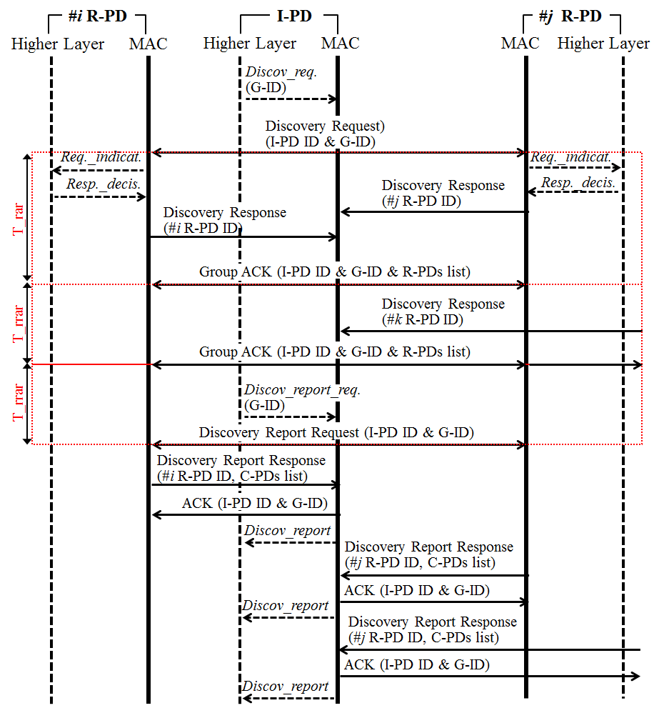

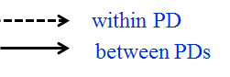
Figure aa—Discovery procedure sequence chart for forming many-to-many group.

