**IEEE P802.15**

**Wireless Personal Area Networks**

|  |  |  |
| --- | --- | --- |
| Project | IEEE P802.15 Working Group for Wireless Personal Area Networks (WPANs) | |
| Title | Draft text of one to many peering, re-peering, de-peering, procedure | |
| Date Submitted | November 2015 | |
| Source | Huan-Bang Li (NICT)  Marco Hernandez (NICT)  Igor Dotlić (NICT)  Ryu Miura (NICT) |  |
| Re: | TG8 draft text for peering related command for 802.15.8 | |
| Abstract | This is the work in progress text of the MAC component for IEEE 802.15.8 group for PAC. | |
| Purpose | This document provides the details of draft text to IEEE 802.15.8 | |
| Notice | This document does not represent the agreed views of the IEEE 802.15 Working Group or IEEE 802.15.8 Task Group. It represents only the views of the participants listed in the “Source(s)” field above. It is offered as a basis for discussion and is not binding on the contributing individual(s) or organization(s). The material in this document is subject to change in form and content after further study. The contributor(s) reserve(s) the right to add, amend or withdraw material contained herein. | |
| Release | The contributor acknowledges and accepts that this contribution becomes the property of IEEE and may be made publicly available by P802.15. | |
| Patent Policy | The contributor is familiar with the IEEE-SA Patent Policy and Procedures:  <http://standards.ieee.org/guides/bylaws/sect6-7.html#6> and  <http://standards.ieee.org/guides/opman/sect6.html#6.3>.  Further information is located at <http://standards.ieee.org/board/pat/pat-material.html> and  <http://standards.ieee.org/board/pat>. | |

# [This is draft text for subclause of Peering related command for TG8]

Black = existing text

Blue = proposed text

# MAC Layer

1. 1. Peering

MAC shall support the following procedures:

* Peering
* Re-peering
* De-peering

Peering is the procedure to establish a link between a pair of PDs or links among multiple PDs discovered during the discovery procedure.

Re-peering is the procedure to re-establish a link between a pair of PDs or links among multiple PDs which peered previously. In the re-peering procedure, peering may be simplified.

De-peering is the procedure to disconnect the link established by peering.

* + 1. Peering procedure

Peering procedure may include the following:

* Optional: Authentication & Authorization (full validation)
* Communication link parameters **are TBD**, such as link ID, device capability (i.e. number of antennas, MIMO), QoS, channel band, transmission power, round trip delay, etc.
* Establish the link.

The peering procedure is initiated by sending a peering request message including requested peering information. Responder may send a peering response message to requestor for indicating if the peering request is accepted or not. The response message may include peering information if the request is accepted.

As illustrated in Figure 26, a one-to-one Peering procedure may contain the following steps.

1. A PD’s Higher Layer (i.e. PD1’s Higher Layer) triggers Peering procedure with a Peering Request to its MAC (i.e. PD1’s MAC).
2. The MAC receiving the Higher Layer’s Peering Request (i.e. PD1’s MAC) sends the Peering Request message to the targeted PD’s MAC (i.e. PD2’s MAC).
3. The targeted PD’s MAC (i.e. PD2’s MAC) receives the Peering Request message and sends ACK/NACK message to the PD requesting peering (i.e. PD1’s MAC*).*
4. The targeted PD’s MAC (i.e. PD2’s MAC), sends the detected Peering Request message to its Higher Layer (i.e. PD2’s Higher Layer).
5. The Higher Layer receiving the Peering Request (i.e. PD2’s Higher Layer) conducts Authentication and Authorization if required.
6. The Higher Layer receiving the Peering Request (i.e. PD2’s Higher Layer) decides either to accept the Peering Request or not and indicates it to the MAC (i.e. PD2’s MAC) accordingly.
7. The targeted PD’s MAC (i.e. PD2’s MAC) sends Peering Response message to the PD requesting peering (i.e. PD1’s MAC) as directed by the Higher Layer.
8. The PD’MAC receiving the Peering Response message (i.e. PD1’s MAC) sends ACK/NACK message to the target PD (i.e. PD2’s MAC).
9. The PD’MAC receiving the Peering Response message (i.e. PD1’s MAC) sends the Peering Response message to its Higher Layer (i.e. PD1’s Higher Layer).
10. A link between PD1 and Pd2 is established is the peering request is accepted.



Figure 26—One-to-one peering procedure message sequence chart

As illustrated in Figure 26_x, a one-to-many Peering procedure may contain the following steps.

1. An initiating PD’s higher layer (i.e. PD_1’s higher layer) triggers Peering procedure with a Peering Request to its MAC layer (i.e. PD_1’s MAC layer).
2. The MAC receiving the Higher Layer’s Peering Request (i.e. PD_1’s MAC) sends the Peering Request message to a number of targeted PDs’ MAC layers (i.e. the MAC layers of PD_2, PD_3, and PD_k).
3. Each of the targeted PDs’ MAC layers (i.e. the MAC layers of PD_2, PD_3, and PD_k), respectively, receives the Peering Request message, then takes random backoff and sends ACK/NACK message to the PD requesting peering (i.e. PD_1’s MAC layer*).*
4. Each of the targeted PDs’ MAC layers (i.e. the MAC layers of PD_2, PD_3, and PD_k), respectively, sends the detected Peering Request message to its Higher Layer (i.e. the MAC layers of PD_2, PD_3, and PD_k).
5. Each of the higher layers receiving the Peering Request (i.e. the higher layers of PD_2, PD_3, and PD_k), respectively, conducts Authentication and Authorization if required.
6. Each of the higher layers receiving the Peering Request (i.e. the higher layers of PD_2, PD_3, and PD_k), respectively, decides either to accept the Peering Request or not and indicates it to its MAC layer (i.e. the MAC layers of PD_2, PD_3, and PD_k) accordingly.
7. Each of the targeted PDs’ MAC layers (i.e. the MAC layers of PD_2, PD_3, and PD_k), respectively, takes random backoff and sends Peering Response message to the PD requesting peering (i.e. PD_1’s MAC layer) as directed by its higher layer.
8. The initiating PD’s MAC layer (i.e. PD_1’s MAC layer) receives the Re-peering Response message and sends ACK/NACK message to the target PDs (i.e. the MAC layers of PD_2, PD_3, and PD_k).
9. The initiating PD’s MAC layer (i.e. PD_1’s MAC layer) sends the Peering Response message to its higher layer (i.e. PD_1’s higher layer).
10. Links between PD_1 and each of the targeted PDs (i.e., PD_2, PD_3, and PD_k) are respectively established.
11. If anyone of the targeted PDs’ MAC layer, after sending Peering Response message, does not receive ACK/NACK message from the initiating PD, it repeats step g).

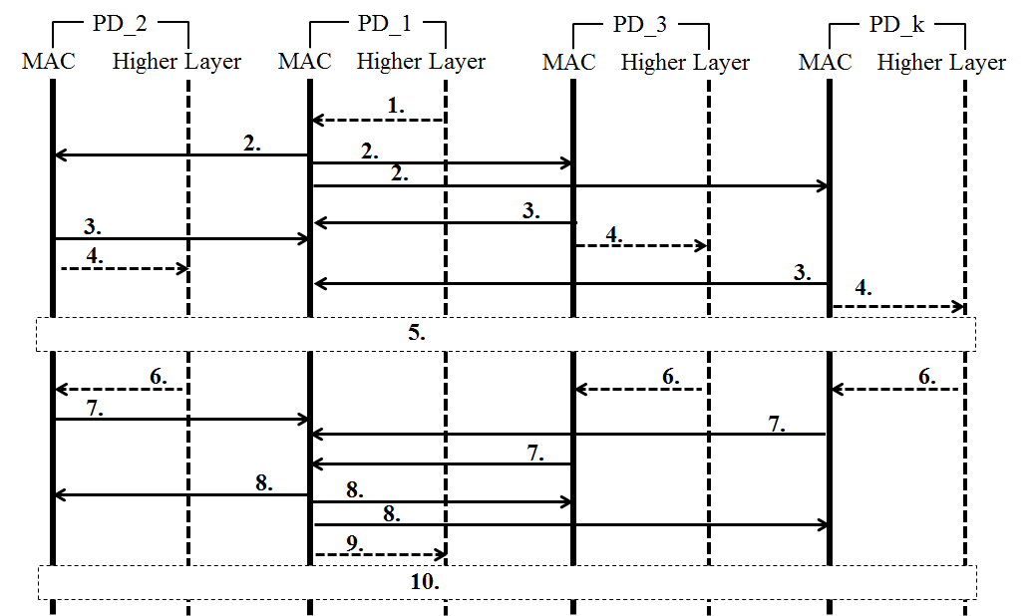



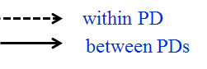

**Figure 26_x—One-to-many peering procedure message sequence chart**

* + 1. Re-peering procedure

Re-peering procedure may include the following:

* Optional: Authentication & Authorization update (light validation)
* Update communication link parameters - TBD.
* Re-establish the link

Re-peering procedure is similar to peering procedure. The main differences are: 1) some of the previous peering information may not be included in request and response messages; 2) the PD receiving the request validates peering information before making a decision to accept the re-peering request.

As illustrated in Figure 27, a one-to-one Re-peering procedure may contain the following steps.

1. A PD’s Higher Layer (i.e. PD1’s Higher Layer) triggers Re-peering procedure with a Re-peering Request to its MAC (i.e. PD1’s MAC).
2. The MAC receiving the Higher Layer’s Re-peering Request (i.e. PD1’s MAC) sends the Re-peering Request message to the targeted PD’s MAC (i.e. PD2’s MAC).
3. The targeted PD’s MAC (i.e. PD2’s MAC) receives the Re-peering Request message and sends ACK/NACK message to the PD requesting re-peering (i.e. PD1’s MAC).
4. The targeted PD’s MAC (i.e. PD2’s MAC), sends the received Re-peering Request message to its Higher Layer (i.e. PD2’s Higher Layer).
5. The Higher Layer receiving the Re-peering Request (i.e. PD2’s Higher Layer) conducts Authentication and Authorization update if required.
6. The Higher Layer receiving the Re-peering Request (i.e. PD2’s Higher Layer) decides either to accept the Re-peering Request or not and indicates it to the MAC (i.e. PD2’s MAC) accordingly.
7. The targeted PD’s MAC (i.e. PD2’s MAC) sends Re-peering Response message to the PD requesting re-peering (i.e. PD1’s MAC) as directed by the Higher Layer.
8. The PD’MAC receiving the Re-peering Response message (i.e. PD1’s MAC) sends ACK/NACK message to the target PD (i.e. PD2’s MAC).
9. The PD’MAC receiving the Re-peering Response message (i.e. PD1’s MAC) sends the Re-peering Response message to its Higher Layer (i.e. PD1’s Higher Layer).
10. A link between PD1 and Pd2 is re-established if the re-peering request is accepted.



Figure 27—One-to-one re-peering procedure message sequence chart

As illustrated in Figure 27_x, a one-to-many Re-peering procedure may contain the following steps.

1. A PD’s higher layer (i.e. PD_1’s higher layer) triggers Re-peering procedure with a Re-peering Request to its MAC layer (i.e. PD_1’s MAC layer).
2. The MAC layer receiving the higher layer’s Re-peering Request (i.e. PD_1’s MAC layer) sends the Re-peering Request message to the targeted PDs’ MAC layers (i.e. the MAC layers of PD_2, PD_3, and PD_k).
3. Each of the targeted PDs’ MAC layers (i.e. the MAC layers of PD_2, PD_3, and PD_k), respectively, receives the Re-peering Request message, then takes random backoff and sends ACK/NACK message to the PD requesting re-peering (i.e. PD_1’s MAC layer).
4. Each of the targeted PDs’ MAC layers (i.e. the MAC layers of PD_2, PD_3, and PD_k), respectively, sends the received Re-peering Request message to its higher layer (i.e. the higher layers of PD_2, PD_3, and PD_k).
5. Each of the higher layers receiving the Re-peering Request (i.e. the higher layers of PD_2, PD_3, and PD_k) respectively conducts Authentication and Authorization update if required.
6. Each of the higher layers receiving the Re-peering Request (i.e. the higher layers of PD_2, PD_3, and PD_k) respectively decides either to accept the Re-peering Request or not and indicates it to its MAC (i.e. the MAC layers of PD_2, PD_3, and PD_k) accordingly.
7. Each of the targeted PDs’ MAC layers (i.e. the MAC layers of PD_2, PD_3, and PD_k), respectively, take random backoff and sends Re-peering Response message to the PD requesting re-peering (i.e. PD_1’s MAC) as directed by its higher layer.
8. The initiating PD’s MAC layer (i.e. PD_1’s MAC) receives the Re-peering Response message and sends ACK/NACK message to the target PDs (i.e. the MAC layers of PD_2, PD_3, and PD_k).
9. The initiating PD’s MAC layer (i.e. PD_1’s MAC) sends the Re-peering Response message to its higher layer (i.e. PD_1’s higher layer).
10. Links between PD_1 and each of the targeted PDs (i.e., PD_2, PD_3, and PD_k) are respectively re-established.
11. If anyone of the targeted PDs’ MAC layer, after sending Re-peering Response message, does not receive ACK/NACK message from the initiating PD, it repeats step g).





Figure 27_x—One-to-many re-peering procedure message sequence chart

* + 1. De-peering procedure

De-peering procedure may include the following:

* Disconnect the link
* Release the link resources if needed.

De-peering procedure starts with a de-peering request, which is replied by a de-peering response message. De-peering response may be optional

As illustrated in Figure 28, a one-to-one De-peering procedure may contain the following steps.

1. A PD’s Higher Layer (i.e. PD1’s Higher Layer) triggers De-peering procedure with a De-peering Request to its MAC (i.e. PD1’s MAC).
2. The MAC receiving the Higher Layer’s De-peering Request (i.e. PD1’s MAC) sends the De-peering Request message to the targeted PD’s MAC (i.e. PD2’s MAC).
3. The targeted PD’s MAC (i.e. PD2’s MAC) receives the De-peering Request message and sends ACK/NACK message to the PD requesting de-peering (i.e. PD1’s MAC*).*
4. The targeted PD’s MAC (i.e. PD2’s MAC), sends the received De-peering Request message to its Higher Layer (i.e. PD2’s Higher Layer).
5. *Optional*: the Higher Layer receiving the De-peering Request (i.e. PD2’s Higher Layer) decides either to accept the De-peering Request or not and indicates it to the MAC (i.e. PD2’s MAC) accordingly.
6. *Optional*: the targeted PD’s MAC (i.e. PD2’s MAC) sends De-peering Response message to the PD requesting de-peering (i.e. PD1’s MAC) as directed by the Higher Layer.
7. *Optional*: the PD’MAC receiving the De-peering Response message (i.e. PD1’s MAC) sends ACK/NACK message to the target PD (i.e. PD2’s MAC).
8. *Optional*: the PD’MAC receiving the De-peering Response message (i.e. PD1’s MAC) sends the De-peering Response message to its Higher Layer (i.e. PD1’s Higher Layer).
9. *Optional:* the link between PD1 and Pd2 is disconnected.



Figure 28—One-to-one de-peering procedure message sequence chart

As illustrated in Figure 28_x, a one-to-many De-peering procedure may contain the following steps.

1. A PD’s higher layer (i.e. PD_1’s higher layer) triggers De-peering procedure with a De-peering Request to its MAC layer (i.e. PD_1’s MAC layer).
2. The MAC layer receiving the higher layer’s De-peering Request (i.e. PD_1’s MAC layer) sends the De-peering Request message to the targeted PDs’ MAC layers (i.e. the MAC layers of PD_2, PD_3, and PD_k).
3. Each of the targeted PDs’ MAC layers (i.e. the MAC layers of PD_2, PD_3, and PD_k), respectively, receives the De-peering Request message, then takes random backoff and sends ACK/NACK message to the PD requesting de-peering (i.e. PD_1’s MAC layer*).*
4. Each of the targeted PDs’ MAC layers (i.e. the MAC layers of PD_2, PD_3, and PD_k), respectively, sends the received De-peering Request message to its higher layer (i.e. the higher layers of PD_2, PD_3, and PD_k).
5. *Optional*: each of the higher layers receiving the De-peering Request (i.e. the higher layers of PD_2, PD_3, and PD_k) decides either to accept the De-peering Request or not and indicates it to the MAC (i.e. the MAC layers of PD_2, PD_3, and PD_k) accordingly.
6. *Optional*: each of the targeted PDs’ MAC layers (i.e. the higher layers of PD_2, PD_3, and PD_k) sends De-peering Response message to the PD requesting de-peering (i.e. PD_1’s MAC layer) as directed by the higher layer.
7. *Optional*: the initiating PD’s MAC layer (i.e. PD_1’s MAC) receives the De-peering Response message and sends ACK/NACK message to the target PDs (i.e. the MAC layers of PD_2, PD_3, and PD_k).
8. *Optional*: the initiating PD’s MAC layer (i.e. PD_1’s MAC) receives the De-peering Response message and sends the De-peering Response message to its higher layer (i.e. PD_1’s higher layer).
9. *Optional:* the links between PD_1 and other PDs (i.e., PD_2, PD_3, and PD_k) are disconnected.

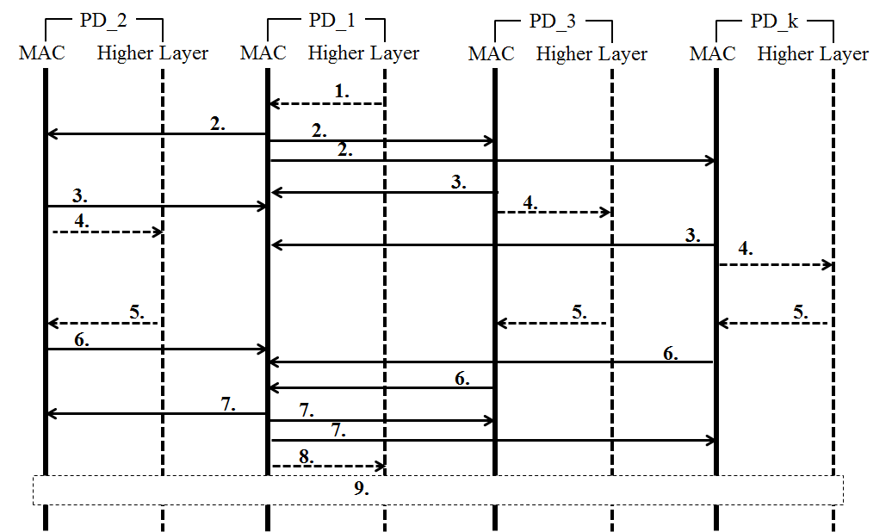







Figure 28_x—One-to-many de-peering procedure message sequence chart

* + 1. Access scheme in Peering Period

A PD shall transmit management messages for peering, re-peering, and de-peering in Peering Period using *p*-EIED protocol described in 5.6.1. A PD shall maintain and update independent *TM* and *p*basic for Peering Period separate from *TM* and *p*basic for CAP. See 5.6.1 for the detailed description of *p*-EIED.