IEEE P802.15
Wireless Personal Area Networks

Project | Dependability Interest Group
Title | Meeting Minutes for September 2015
Date Submitted | September 15, 2015
Source | [Jussi Haapola]  [Centre for Wireless Communications / University of Oulu] | Voice: +358 40 8363 018  E-mail: jhaapola@ee.oulu.fi
Re: | Meeting Minutes
Abstract
Purpose | Minutes of Dependability Interest Group sessions
Notice | This document has been prepared to assist the IEEE P802.15. It is offered as a basis for discussion and is not binding on the contributing individual(s) or organization(s). The material in this document is subject to change in form and content after further study. The contributor(s) reserve(s) the right to add, amend or withdraw material contained herein.
Release | The contributor acknowledges and accepts that this contribution becomes the property of IEEE and may be made publicly available by P802.15.

Tuesday, September 15, 2015, AM2, 10:30

  - Meeting called to order 10:30
By Chair Ryuji Kohno (YNU / CWC-Nippon)
Secretary Jussi Haapola (Centre for Wireless Communication / University of Oulu)

  - Roll Call
Notepad for Attendance circulated.

Ryuji Kohno presented Opening report Doc #679

Chair showed IEEE Patent policy.

Chair issued Call for Potentially Essential Patents
No essential intellectual property in the scope of IG DEP was declared.

  - Recap of CFI
Ryuji Kohno showed doc #15-14-0449-06.

  - Approval of previous meeting minutes
Upon no comments on the previous meeting minutes, doc #0379 meeting minutes were approved.

  - CFI second round reporting

Docs #701 and #711 showed by Ryuji Kohno.

  - Recess at 12:23.

  - Attendees

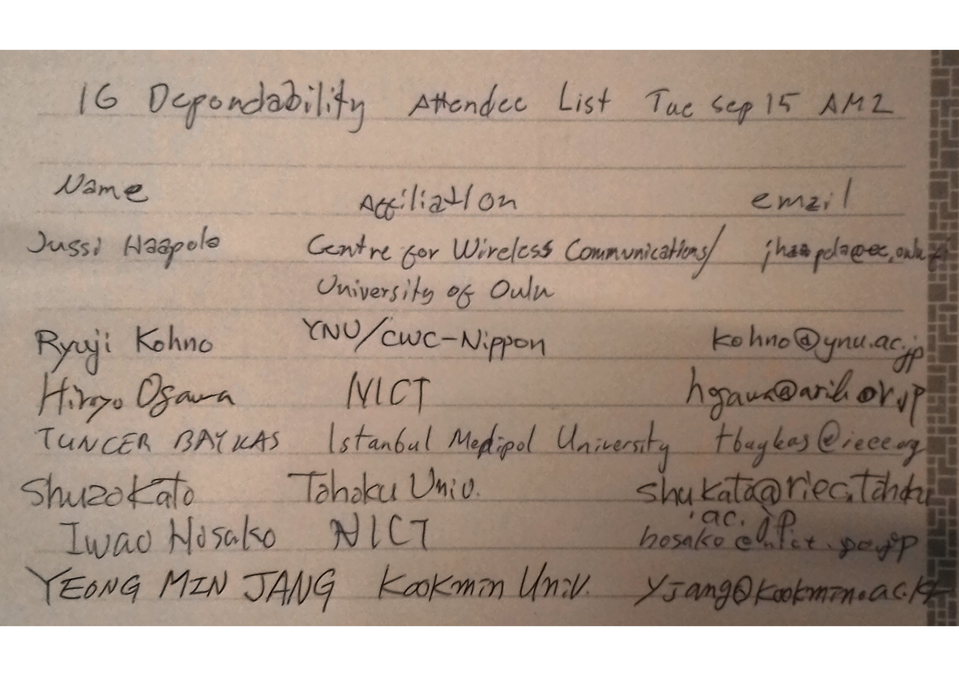

Wednesday, September 16, 2015, PM2, 16:00

  - Meeting called to order 16:05
By Chair Ryuji Kohno (YNU / CWC-Nippon)
Secretary Jussi Haapola (Centre for Wireless Communication / University of Oulu)

  - Roll Call
Notepad for Attendance circulated.

  - Revising CFI response r4
Doc 15-24-0217-05 has been uploaded to mentor.

  - AoB
None.

  - Adjourned at 17:05.

  - Attendees
