IEEE P802.15
Wireless Personal Area Networks

Project | IEEE P802.15 Working Group for Wireless Personal Area Networks (WPANs)
Title | TG 8 MAC Draft Text for Power Control
Date Submitted | July 16, 2015
Source | Qing Li (InterDigital Inc.) | Email: Qing.Li@InterDigital.com
Re: | Draft text of MAC data request command for 802.15.8
Abstract | This is the work in progress text of the MAC component for IEEE 802.15.8 group for PAC.
Purpose | This document provides the details of draft text to IEEE 802.15.8
Notice | This document does not represent the agreed views of the IEEE 802.15 Working Group or IEEE 802.15.8 Task Group. It represents only the views of the participants listed in the “Source(s)” field above. It is offered as a basis for discussion and is not binding on the contributing individual(s) or organization(s). The material in this document is subject to change in form and content after further study. The contributor(s) reserve(s) the right to add, amend or withdraw material contained herein.
Release | The contributor acknowledges and accepts that this contribution becomes the property of IEEE and may be made publicly available by P802.15.
Patent Policy | The contributor is familiar with the IEEE-SA Patent Policy and Procedures:  <http://standards.ieee.org/guides/bylaws/sect6-7.html#6> and  <http://standards.ieee.org/guides/opman/sect6.html#6.3>.  Further information is located at <http://standards.ieee.org/board/pat/pat-material.html> and  <http://standards.ieee.org/board/pat>.

- Transmit power control
To minimize the interference among the PDs in proximity and to save battery life for PAC devices, power control procedures are described in this sub-clause for the following scenarios:
- Single one-to-one communication between two PDs, i.e. a PD unicasts only to another PD in a PAC group;
- Multiple one-to-one communications from a PD to one of other PDs, i.e. a PD unicasts to other PDs in different PAC groups;
- One-to-many communications from a PD to other PDs, i.e. a PD multicasts to other PDs in one or multiple PAC groups.
For each antenna used for transmission of the PPDU, the block of complex-valued symbols shall be multiplied with the amplitude scaling factor P_{i} for PD_{i} (where i = 1, 2, 3, …, the index of PDs in proximity) in order to conform to the transmit power specified in clause 11.2 and 11.3.

11.1 Power control information detection
In a fully distributed PAC system, there is no central controller to set the power control algorithm parameters and the initial transmitting power level for each PD, which is needed for the transmitting power control. Therefore a PD needs to detect the power control information from the PDs in the radio range which is used for setting the power control algorithm parameters and initiating the transmitting power level.

Power control information may include the following:
- Application based context information: power category, communication range power control interval, modulation, coding rate, bandwidth, data rate, speed, transmitter location, etc.
- Application based power control information: transmit power, maximum and minimum transmit power, power adjustment, path loss, received signal quality (such as RSSI, SINR, or CQI), receiver’s location or device ID (i.e. the endpoint of one-to-many communications power control), etc.
The power control information is managed by upper layer and maybe exchanged among the PDs in proximity.
As illustrated in Figure 76, the power control information is either transmitted by MAC power control management frame with the power control information inserted in the IE field or payload, or transmitted with other management or data frames (i.e. piggybacked) in the IE field or payload.

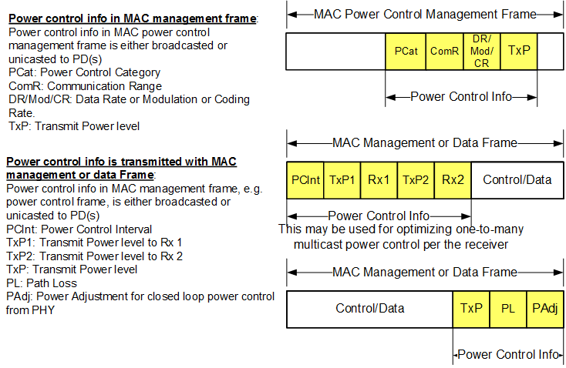
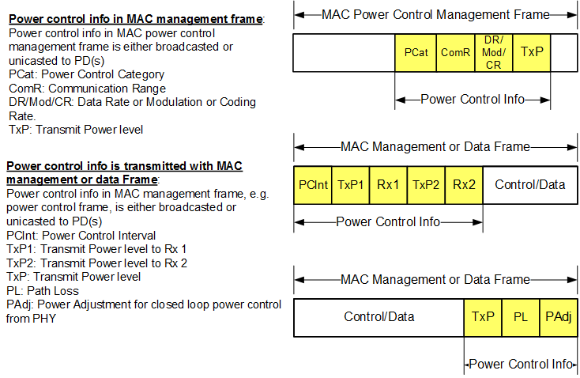

Figure 76 Power Control Information

Figure 77 illustrated the power control information detection in proximity.
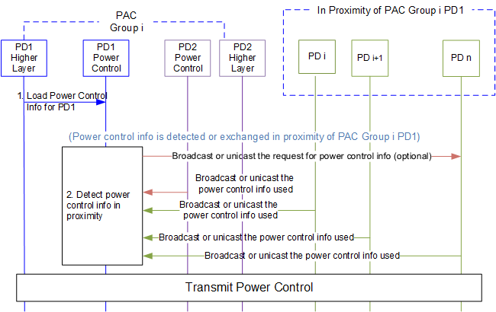
Figure 77 Power Control Information Detection

11.2 Power control during CFP
Based on the power control information detected by a PD, the power control algorithm parameters, such as modulation, coding rate, etc., are set accordingly.
11.3 Power control during CAP
To minimize the interference among the PDs during the CAP time interval, a closed loop power control is applied. Figure 78 illustrates the closed loop power control procedure.

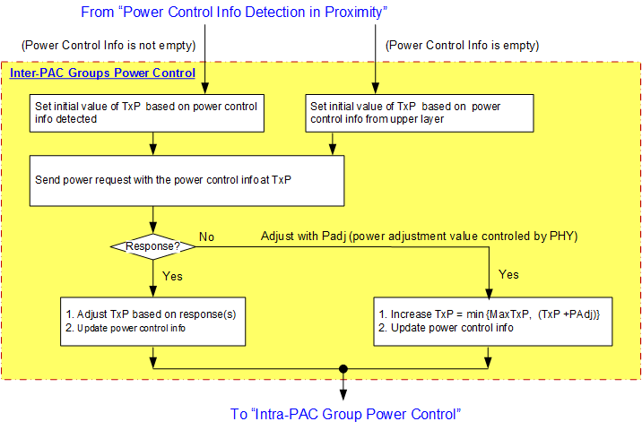
Figure TBD Closed Loop Power Control

Figure 80 shows multi-PAC group power control procedure for a PD participating in more than one PAC groups simultaneously.

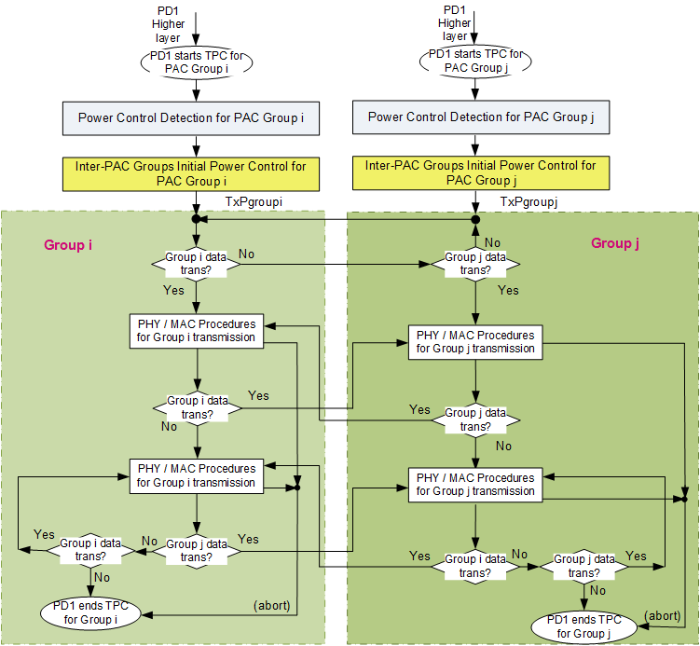
Figure 80 Multi-PAC Group Power Control

