IEEE P802.15
Wireless Personal Area Networks

Project | SC Maintenance
Title | Resolutions to SB comments on categories RIT
Date Submitted | July 15, 2015
Source | [Amarjeet Kumar]  [Procubed Technology Solutions Pvt. Ltd.] | Voice: +91 96117 33007  E-mail: kumar@procubedinc.com
Re: | Sponsor Ballot Comment resolution
Abstract
Purpose | Comment resolution
Notice | This document has been prepared to assist the IEEE P802.15. It is offered as a basis for discussion and is not binding on the contributing individual(s) or organization(s). The material in this document is subject to change in form and content after further study. The contributor(s) reserve(s) the right to add, amend or withdraw material contained herein.
Release | The contributor acknowledges and accepts that this contribution becomes the property of IEEE and may be made publicly available by P802.15.

i-37
Kumar, Amarjeet
Page 41 Clause 6.3.1 Line 45
Comment:

Sentence: As we know Passive or Active Scan is necessary to resolve PAN ID confliction. Coordinators operated in RIT mode don't send (enhanced) beacon frame because RIT mode is one of the non-beacon-enabled PAN. Coordinators operated in RIT mode can't receive (enhanced) beacon request frame because those coordinators wake up intermittently and the reception time is very short ( 1 or 2 ms per 5 seconds).

Proposed change:

Introduction of a new type Scan Type
RIT Passive Scan
Once the Upper Layer sends a MLME-Scan.request with ScanType as "RIT Passive Scan", the MAC Layer should turn ON its receiver in each channel request for scan and wait for the duration configured. It should receive the RIT-Data.request and send it to the upper layer as MLME-Scan.confirm once the Scan is completed.
The device initiating the RIT Passive scan should set the PAN ID as broadcast PAN ID and receive all RIT data request sent by neighboring nodes. Device supporting RIT Passive scan should send the RIT Data request as a broadcast packet, so that it can be received by all devices in neighborhood.

For additional detail, please refer the mentor document "15-15-0335-00-0mag-ieee802-15-4-mac-rit-change-proposal.ppt".

Type T
Must be Satisfied Yes
Resolution: Revise

Proposed Resolution:

Add below as section 6.3.1.4

6.3.1.4 RIT Passive Channel scan

The RIT passive scan is essentially the passive scan as described 6.3.1.2 but rather than discarding all frames that are not Beacon frames, the RIT passive scan discards all frames that are not RIT Data Request command frames.
A RIT passive scan over a specified set of channels is requested using the MLME-SCAN.request primitive with the Valid Range of the ScanType parameter set to indicate RIT_PASSIVE. For each channel, the device shall set phyCurrentChannel and phyCurrentPage as per the MLME-SCAN.request primitive. After switching to the channel for a RIT passive scan, the device shall enable its receiver for at most [macRITPeriod x n], where n is the value of ScanDuration parameter. During this time, the device shall reject all frames that are not RIT Data Request command frames and record the information contained in all unique RIT Data Request command frames in a PAN descriptor structure, as described in Table 68 including the channel information. A RIT Data Request command frame shall be assumed to be unique if it contains both a PAN ID and a source address that has not been seen before during the scan of the current channel.

If an RIT Data Request command frame is received when macAutoRequest is set to TRUE, the list of PAN descriptor structures shall be stored by the MAC sublayer until the scan is complete; at this time, the list shall be sent to the next higher layer in the PANDescriptorList parameter of the MLME-SCAN.confirm primitive.

If a RIT Data Request command frame is received when macAutoRequest is set to FALSE, each recorded PAN descriptor is sent to the next higher layer in a separate MLME-BEACON-NOTIFY.indication primitive as described in 8.2.5.1. A received RIT Data Request Command frame containing a non-zero length payload shall also cause the PAN descriptor to be sent to the next higher layer via the MLME-BEACON-NOTIFY.indication primitive. Once the scan with macAutoRequest set to FALSE is complete, the MLME-SCAN.confirm shall be issued to the next higher layer with a null PANDescriptorList.
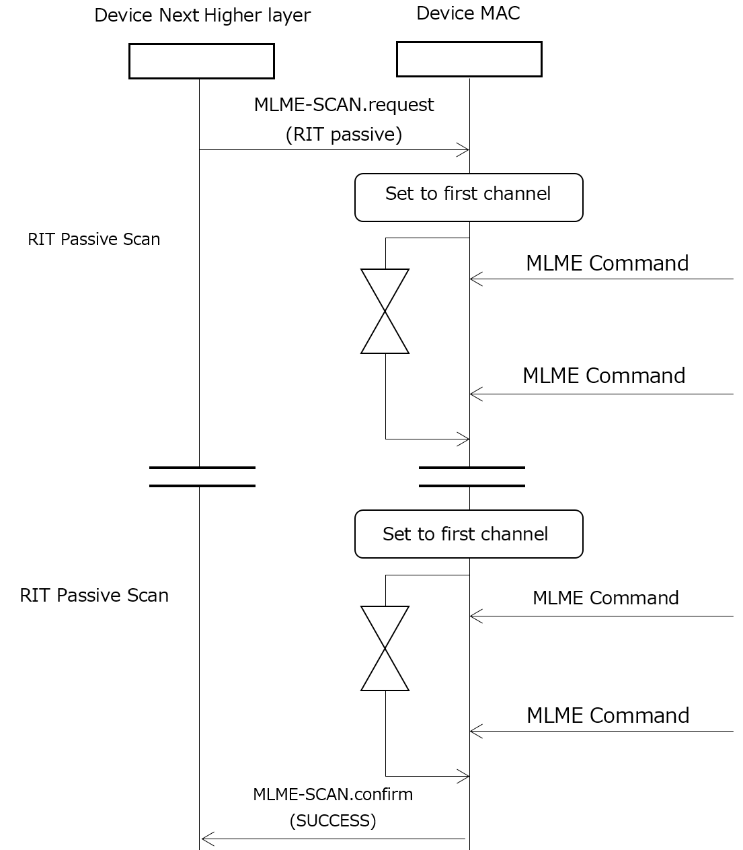
update Figure 31 as indicated

Update Table 82 by adding RIT_PASSIVE to the Valid Range for ScanType

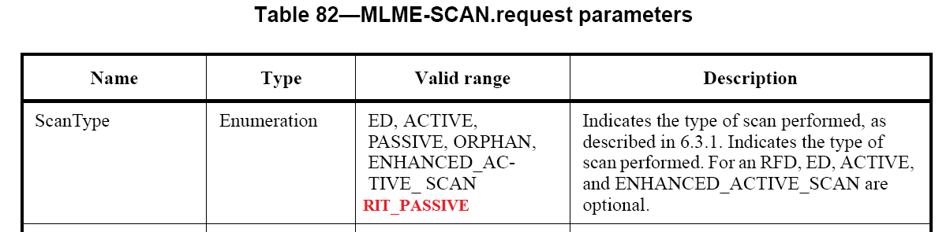

Update Table 83 by adding RIT_PASSIVE to the Valid Range for ScanType

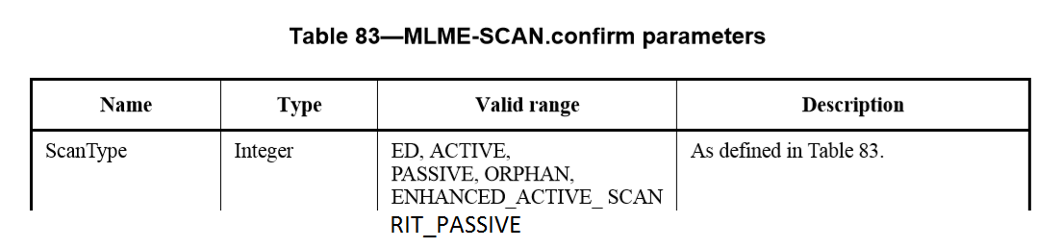

i-40
Kumar, Amarjeet
Page 102 Clause 6.12.3 Line 19
Comment:
Sentence: When two nodes have data to send to each other at same time, both will stop sending RIT Data request at same time and wait for other to send the RIT Data request. In this case both node will be in waiting mode and eventually not be able to send any data to each other.

Proposed change:
Enable the transmission of RIT data request intermittently when it is waiting for an RIT Data Request at arbitrary timing, this will allow each device to send RIT Data request during it is waiting for one. This will make sure that both nodes can fetch data from each other."

For additional detail, please refer the mentor document "15-15-0335-00-0mag-ieee802-15-4-mac-rit-change-proposal.ppt".

Type T
Must be Satisfied Yes
Resolution: Revise

Proposed Resolution:

Change the below text:

6.12.3.3 RIT Transmission

In order to transmit a frame in RIT mode, the device shall may at first stop its periodic transmission of RIT Data Request commands, enable its receiver, and wait at most macRitTxWaitDuration for reception of an RIT Data Request command from another device.

i-392
KINNEY, PATRICK
Page 102 Clause 6.12.3 Line 19
Comment:
Sentence: When two nodes have data to send to each other at same time, both will stop sending RIT Data request at same time and wait for other to send the RIT Data request. In this case both node will be in waiting mode and eventually not be able to send any data to each other.

Proposed change:
Enable the transmission of RIT data request intermittently when it is waiting for an RIT Data Request at arbitrary timing, this will allow each device to send RIT Data request during it is waiting for one. This will make sure that both nodes can fetch data from each other."

For additional detail, please refer the mentor document "15-15-0335-00-0mag-ieee802-15-4-mac-rit-change-proposal.ppt".

Type T
Must be Satisfied Yes
Resolution: Revise

Proposed Resolution:

Same as per comment i-40.
Change the below text:

6.12.3.3 RIT Transmission

In order to transmit a frame in RIT mode, the device shall may at first stop its periodic transmission of RIT Data Request commands, enable its receiver, and wait at most macRitTxWaitDuration for reception of an RIT Data Request command from another device.

i-42
Kumar, Amarjeet
Page 218 Clause 8.2.5.2 Line 38
Comment:
Currently there is no way to indicate the FCS error to the upper layer.

Proposed change:
Addition of new status "FCS_ERROR" in MLME-COMM-STATUS.indication.

For additional detail, please refer the mentor document "15-15-0335-00-0mag-ieee802-15-4-mac-rit-change-proposal.ppt".

Type T
Must be Satisfied Yes
Resolution: Reject
Proposed Resolution:

Behavior is already described in MAC Metrics IE.

i-394
KINNEY, PATRICK
Page 218 Clause 8.2.5.2 Line 38
Comment:
Currently there is no way to indicate the FCS error to the upper layer.

Proposed change:
Addition of new status "FCS_ERROR" in MLME-COMM-STATUS.indication.

For additional detail, please refer the mentor document "15-15-0335-00-0mag-ieee802-15-4-mac-rit-change-proposal.ppt".

Type T
Must be Satisfied Yes
Resolution: Revise
Proposed Resolution:

Same as resolution to comment i-42.
Behavior is already described in MAC Metrics IE.
i-38
Kumar, Amarjeet
Page 103 Clause 6.12.3.3 Line 42
Comment:
Current specification requires CSMA-CA to be performed during sending of data in response to RIT Data Request. However, in low power devices using RIT feature, device sending data in response to RIT data req. can be avoid CSMA-CA.

Proposed change:

"Current Text in Specification:
Upon reception of RIT Data Request command, the MAC sublayer sends the pending data using unslotted CSMA-CA.

Change it to:
Upon reception of RIT Data Request command, the MAC sublayer sends the pending data without using unslotted CSMA-CA."

For additional detail, please refer the mentor document "15-15-0335-00-0mag-ieee802-15-4-mac-rit-change-proposal.ppt".

Type T
Must be Satisfied Yes
Resolution: Reject
Proposed Resolution:

No change required, use CSMA with CCA mode =4

i-390
KINNEY, PATRICK
Page 103 Clause 6.12.3.3 Line 42
Comment:
Current specification requires CSMA-CA to be performed during sending of data in response to RIT Data Request. However, in low power devices using RIT feature, device sending data in response to RIT data req. can be avoid CSMA-CA.

Proposed change:

"Current Text in Specification:
Upon reception of RIT Data Request command, the MAC sublayer sends the pending data using unslotted CSMA-CA.

Change it to:
Upon reception of RIT Data Request command, the MAC sublayer sends the pending data without using unslotted CSMA-CA."

For additional detail, please refer the mentor document "15-15-0335-00-0mag-ieee802-15-4-mac-rit-change-proposal.ppt".

Type T
Must be Satisfied Yes
Resolution: Reject
Proposed Resolution:

No change required, use CSMA with CCA mode = 4

i-41
Kumar, Amarjeet
Page 102 Clause 6.12.3.2 Line 19
Comment:
Current specification does not give flexibility to the Node requesting for data to request any specific data. Node cannot request for any specific data from the sending node.

Proposed change:

Addition of Enhanced RIT Data Request

Here the node sending RIT data request to add an upper layer defined payload to it. The received node upper layer can receive the payload and send back the response required.

For additional detail, please refer the mentor document "15-15-0335-00-0mag-ieee802-15-4-mac-rit-change-proposal.ppt".

Type T
Must be Satisfied Yes
Resolution: Reject
Proposed Resolution:

After the changes done as part of comment i-68, this is not required.

i-393
KINNEY, PATRICK
Page 102 Clause 6.12.3.3 Line 42
Comment:
Current specification does not give flexibility to the Node requesting for data to request any specific data. Node cannot request for any specific data from the sending node.

Proposed change:

Proposed change:
Addition of Enhanced RIT Data Request
Here the node sending RIT data request to add an upper layer defined payload to it. The received node upper layer can receive the payload and send back the response required.

Type T
Must be Satisfied Yes
Resolution: Reject
Proposed Resolution:

After the changes done as part of comment i-68, this is not required.

i-68
Kumar, Amarjeet
Page 102 Clause 6.12.3.2 Line 19
Comment:
Current specification does not give flexibility to the Node requesting for data to request any specific data. Node cannot request for any specific data from the sending node.

Proposed change:

Addition of arbitrary payload to RIT Data Request. Here the node sending RIT data request to add an upper layer defined payload to it. The received node upper layer can receive the payload and send back the response required.

Type T
Must be Satisfied Yes
Resolution: Revise
Proposed Resolution:

Update the “Figure 210—RIT Data Request command Content field format” as shown below

Octets: 0/4 Variable
Listen information/Vendor Specific Payload

Update the 3rd paragraph of “7.5.22 RIT Data Request Command” as shown below

The Listen Information field may be omitted. If the List Information field is present, it shall be formatted as illustrated in Figure211.
If the Listen information is present, it should be formatted as illustrated in Figure 211.

Update the “Figure 211—Format of the Listen Information field” as indicated below

Octet: 1 | 1 | 2
Time To First Listen  (≠ 0xFF) | Number of Repeat Listen | Repeat Listen Interval

Add below as the last paragraph of “7.5.22 RIT Data Request Command” as shown below

Optionally the RIT data Request command can also contain user defined payload as macRITPayload and it should be formatted as illustrated in Figure xx.

Octet: 1 | Variable
0xFF | Payload
Figure xx – Format of User defined payload

Update the “Table 133 – MAC PIB Attribute” as shown below

Attribute | Type | Range | Description | Default
macRITPayload | Set of octets | _ | A sequence of zero or more octets to be transmitted in the RIT Data Req Payload field. | NULL
macRITPayloadLength | Integer | 0x00 - 0x7FF | Length of the macRITPayload. The max length of macRITPayloadLength will depends on the aMaxPhyPacketSize value set. | 0

Update the 4th sentence of 2nd paragraph in section “6.12.3.2 Periodic RIT data request transmission and reception” as shown below

When the RIT Data Request command carries a the timing information as payload, the device goes back to sleep after the transmission of the RIT Data Request command until the end of the Time to First Listen (T0) period of time.

Insert the below text as last paragraph in section “6.12.3.2 Periodic RIT data request transmission and reception”

Upon reception of RIT Data Request command with Vendor specific payload, the device shall notifies it to the next higher layer by initiating corresponding indication primitive.

i-36
Kumar, Amarjeet
Page 112 Clause 7.2 Line 16
Comment:
A new device creating a Network does a scan of the environment and get to know about the existing PAN in the network. Based on the scan results the new device selects a Unique PAN ID to create a new Personal Area Network. In case of an existing network which is using RIT, will not be able to communicate any information about its PAN as the receiver will be OFF most of the time. In such case there is a possibility that the new device may create the new Personal Area Network using a pre-existing PAN ID.

Proposed change:

Introduction of a new type of PAN ID
Extended PAN ID (64 bit)
If the extended PAN ID is selected, the PAN ID field will be of 64 bit length and it will contain the Extended address of the PAN coordinator. This will make sure that no two PAN in the network have same PAN ID even if we have a PAN with sleeping devices.
0xFFFFFFFFFFFFFFFF: Broadcast extended PAN Identifier in case the extended PAN ID Mode is selected.

Will need to change:
- 7.2 General MAC frame format
- 7.2.1 Frame Control field
- Enhanced Ack Frame Format
- All API which has PAN ID as parameter will need to have an additional parameter of PAN ID Mode

Will need to add the definition of "7.2.1.6 PAN ID Mode"

additional details can be found in mentor document "15-15-0336-00-0mag-ieee802-15-4-mac-panid-change-proposal.ppt"

Type T
Must be Satisfied Yes
Resolution: Rejected
Proposed Resolution:

MAC Layer already have mechanism in place to handle the PAN ID conflict, so it is not required to add Extended PAN ID.

i-389
KINNEY, PATRICK
Page 112 Clause 7.2 Line 16
Comment:
A new device creating a Network does a scan of the environment and get to know about the existing PAN in the network. Based on the scan results the new device selects a Unique PAN ID to create a new Personal Area Network. In case of an existing network which is using RIT, will not be able to communicate any information about its PAN as the receiver will be OFF most of the time. In such case there is a possibility that the new device may create the new Personal Area Network using a pre-existing PAN ID.

Proposed change:

Introduction of a new type of PAN ID
Extended PAN ID (64 bit)
If the extended PAN ID is selected, the PAN ID field will be of 64 bit length and it will contain the Extended address of the PAN coordinator. This will make sure that no two PAN in the network have same PAN ID even if we have a PAN with sleeping devices.
0xFFFFFFFFFFFFFFFF: Broadcast extended PAN Identifier in case the extended PAN ID Mode is selected.

Will need to change:
- 7.2 General MAC frame format
- 7.2.1 Frame Control field
- Enhanced Ack Frame Format
- All API which has PAN ID as parameter will need to have an additional parameter of PAN ID Mode

Will need to add the definition of "7.2.1.6 PAN ID Mode"

additional details can be found in mentor document "15-15-0336-00-0mag-ieee802-15-4-mac-panid-change-proposal.ppt"

Type T
Must be Satisfied Yes
Resolution: Rejected
Proposed Resolution:

MAC Layer already have mechanism in place to handle the PAN ID conflict, so it is not required to add Extended PAN ID.

i-39
Kumar, Amarjeet
Page 102 Clause 6.12.3.2 Line 19
Comment:
Current specification for LE-RIT Data exchange does not give any flexibility to the sending device to decide on what data to be sent. It has to be pre decided by the upper layer and queued to the MAC layer. This reduces the flexibility to upper layer.

Proposed change:

"Proposed Change:
Introduction of
- MLME-RIT-REQ.ind
- MLME-RIT-RES.req
- MLME-RIT-RES.conf
- MLME-RIT-RES.ind

Addition of new MAC Command:
RIT Data Response command (0x23)"

For additional detail, please refer the mentor document "15-15-0335-00-0mag-ieee802-15-4-mac-rit-change-proposal.ppt".

Type T
Must be Satisfied Yes
Resolution: Revise
Proposed Resolution:

Add the section “7.5.xx RIT Data Response Command”

7.5.xx RIT Data Response Command
The RIT Data Response command shall only be sent by a device supporting RIT mode. The RIT Data Response command Content field shall be formatted as illustrated in Figure xxx.

Octets: Variable
Vendor Specific Payload
Figure xxx—RIT Data Response command Content field format

The RIT Data Response content encapsulates a higher layer payload that is carried in the Payload field. Content is sent as received, i.e., no octet ordering changes shall be made.

The Frame Pending field of the Frame Control field shall be set to zero and ignored upon reception. All other fields shall be set appropriately according to the intended use of the command.

Add the below command ID in the “Table 50 MAC Commands”

Command identifier | Command name | RFD |  | Subclause
 |  | TX | RX
Allocated by IEEE | RIT Data Response Command | X | X | 7.5.xx
Table 50 - MAC Commands

Add below as Section “8.2.26 Primitives for RIT”

8.2.26 Primitives for RIT

8.2.26.1 MLME-RIT-Data-Req.indication

This primitive reports the reception of a RIT Data request command with Vendor specific payload.

The semantics of this primitive are:

MLME-RIT-Data-Req.indication (
SrcAddrMode,
SrcPANId,
SrcAddr,
DstAddrMode,
DstPANId,
DstAddr,
PayloadLength,
Payload,
LinkQuality,
DSN,
Timestamp,
SecurityLevel,
KeyIdMode,
KeySource,
KeyIndex
)
The primitive parameters are defined in Table xxx

Name | Type | Valid Range | Description
SrcAddrMode | Enumeration | NONE, SHORT,  EXTENDED,  SYMPLE | The source addressing mode for this primitive corresponding to the received MPDU.
SrcPanId | Integer | 0x0000 - 0xffff | The PAN ID of the entity from which the MSDU was received. Valid only when a source PAN ID is included in the received frame.
SrcAddr | _ | As specified by the SrcAddrMode parameter | The address of the entity from which the MSDU was received.
DstAddrMode | Enumeration | NONE, SHORT,  EXTENDED,  SYMPLE | The destination addressing mode for this primitive corresponding to the received MPDU
DstPanId | Integer | 0x0000 - 0xffff | The PAN ID of the entity to which the MSDU is being transferred. Set to the receiver’s PAN ID if the PAN ID is not carried in the received frame.
DstAddr | _ | As specified by the DstAddrMode parameter | The address of the entity to which the MSDU is being transferred.
PayloadLength | 0x00 - 0x7ff | 0x0000 - 0x07ff | Length of the payload received as part of RIT Data Req.
Payload | Set of octets | _ | The set of octets received as the Payload to the RIT Data Req.
LinkQuality | Integer | 0x00 - 0xff | LQI Value measured during reception of the MPDU. Lower values represent lower LQI, as described in 10.2.6.
DSN | Integer | 0x00 - 0xff | The DSN of the received Data frame if one was present.
Timestamp | Integer | 0x000000–0xffffff | Optional. The time, in symbols, at which the data were received, as described in 6.5.1. The symbol boundary is described by macSyncSymbolOffset, as described in Table133. The precision of this value shall be a minimum of 20bits, with the lowest 4 bits being the least significant.
SecurityLevel | Integer | 0x00 - 0x07 | The security level purportedly used by the received Data frame, as defined in Table152.
KeyIdMode | Integer | 0x00 - 0x03 | The mode used to identify the key purportedly used by the originator of the received frame, as defined in Table153. This parameter is invalid if the SecurityLevel parameter is set to 0x00.
KeySource | Set of octets | As specified by the KeyIdMode parameter | The originator of the key purportedly used by the originator of the received frame, as described in 9.4.3.1. This parameter is invalid if the KeyIdMode parameter is invalid or set to 0x00.
KeyIndex | Integer | 0x01 - 0xff | The index of the key purportedly used by the originator of the received frame, as described in 9.4.3.2. This parameter is invalid if the KeyIdMode parameter is invalid or set to 0x00.

Table xxx – RIT-Data-Req.indication parameters

This primitive is generated by the MLME of a device and issued to its next higher layer upon the reception of a RIT Data Request with Vendor specific payload.

On receipt of the MLME-RIT-Data-Req.indication primitive, the higher layer is notified of the reception of a RIT Data request.

8.2.26.2 MLME-RIT-Data.response

This primitive allows the next higher layer of a device to respond to the MLME-RIT-Data-Req.indication primitive.

The semantics of this primitive are:
MLME-RIT-Data.response (
SrcAddrMode,
DstAddrMode,
DstPANId,
DstAddr,
PayloadLength,
Payload,
AckTX,
SecurityLevel,
KeyIdMode,
KeySource,
KeyIndex,
headerIEList,
payloadIEList
)

The primitive parameters are defined in Table xxx

Name | Type | Valid Range | Description
SrcAddrMode | Enumeration | NONE, SHORT,  EXTENDED,  SYMPLE | The source addressing mode for this MPDU.
DstAddrMode | Enumeration | NONE, SHORT,  EXTENDED,  SYMPLE | The destination addressing mode for this MPDU.
DstPanId | Integer | 0x0000 - 0xffff | The PAN ID of the entity to which the MSDU is being transferred.
DstAddr | _ | As specified by the DstAddrMode parameter | The address of the entity to which the MSDU is being transferred.
PayloadLength | 0x00 - 0x7ff | 0x0000 - 0x07ff | Length of the payload to be sent.
Payload | Set of octets | _ | The set of octets received as the Payload to be transmitted as payload to the RIT Data Response command.
AckTx | Boolean | TRUE, FALSE | TRUE if acknowledgement transmission is used, FALSE otherwise
SecurityLevel | Integer | 0x00 - 0x07 | The security level purportedly used by the received Data frame, as defined in Table152.
KeyIdMode | Integer | 0x00 - 0x03 | The mode used to identify the key purportedly used by the originator of the received frame, as defined in Table153. This parameter is invalid if the SecurityLevel parameter is set to 0x00.
KeySource | Set of octets | As specified by the KeyIdMode parameter | The originator of the key purportedly used by the originator of the received frame, as described in 9.4.3.1. This parameter is invalid if the KeyIdMode parameter is invalid or set to 0x00.
KeyIndex | Integer | 0x01 - 0xff | The index of the key purportedly used by the originator of the received frame, as described in 9.4.3.2. This parameter is invalid if the KeyIdMode parameter is invalid or set to 0x00.
headerIEList | Set of IEs as described in Table10 | As defined in Table10 | The header IEs, excluding Termintation IEs, that are to be included with the frame in addition to any header IEs added by the MAC. If empty, no additional header IEs are to be included.
payloadIEList | Set of IEs as described in Table18 | As defined in Table18 | The payload IEs, excluding Termination IEs, that are to be included with the frame in addition to any payload IEs added by the MAC. If empty, no additional payload IEs are to be included.
Table xxx – RIT-Data-Req.response parameters

The MLME-RIT-Data.response primitive can be generated by the next higher layer and issued it to MLME.

Upon reception of MLME-RIT-Data.response primitive, the MLME of the device shall generate a RIT Data Response command, as described in 7.5.xx. The Payload parameter of MLME-RIT-Data.response shall be contained in the corresponding payload of the command.

8.2.26.3 MLME-RIT-Data-Response.confirm

This primitive reports the results of the RIT Data Response command.

The semantics of this primitive are:
MLME-RIT-Data-Response.confirm (
status
)
The primitive parameters are defined in Table xxx

Name | Type | Valid Range | Description
status | Enumeration | SUCCESS, INVALID_PARAMETER, NO_ACK | The status of RIT-Data-Response command
Table xxx – RIT-Data-Response.confirm parameters

Upon issuance of RIT Data Response command the status of it should be sent to the next higher layer using MLME-RIT-Data-Response.confirm.

8.2.26.4 MLME-RIT-Data-Response.indication

This primitive reports the reception of a RIT Data response.

The semantics of this primitive are:

MLME-RIT-Data-Response.indication (
SrcAddrMode,
SrcPANId,
SrcAddr,
DstAddrMode,
DstPANId,
DstAddr,
PayloadLength,
Payload,
LinkQuality,
DSN,
Timestamp,
SecurityLevel,
KeyIdMode,
KeySource,
KeyIndex
)
The primitive parameters are defined in Table xxx

Name | Type | Valid Range | Description
SrcAddrMode | Enumeration | NONE, SHORT,  EXTENDED,  SYMPLE | The source addressing mode for this primitive corresponding to the received MPDU.
SrcPanId | Integer | 0x0000 - 0xffff | The PAN ID of the entity from which the MSDU was received. Valid only when a source PAN ID is included in the received frame.
SrcAddr | _ | As specified by the SrcAddrMode parameter | The address of the entity from which the MSDU was received.
DstAddrMode | Enumeration | NONE, SHORT,  EXTENDED,  SYMPLE | The destination addressing mode for this primitive corresponding to the received MPDU
DstPanId | Integer | 0x0000 - 0xffff | The PAN ID of the entity to which the MSDU is being transferred. Set to the receiver’s PAN ID if the PAN ID is not carried in the received frame.
DstAddr | _ | As specified by the DstAddrMode parameter | The address of the entity to which the MSDU is being transferred.
PayloadLength | 0x00 - 0x7ff | 0x0000 - 0x07ff | Length of the payload received as part of RIT Data Response.
Payload | Set of octets | _ | The set of octets received as the Payload to the RIT Data Response.
LinkQuality | Integer | 0x00 - 0xff | LQI Value measured during reception of the MPDU. Lower values represent lower LQI, as described in 10.2.6.
DSN | Integer | 0x00 - 0xff | The DSN of the received Data frame if one was present.
Timestamp | Integer | 0x000000–0xffffff | Optional. The time, in symbols, at which the data were received, as described in 6.5.1. The symbol boundary is described by macSyncSymbolOffset, as described in Table133. The precision of this value shall be a minimum of 20bits, with the lowest 4 bits being the least significant.
SecurityLevel | Integer | 0x00 - 0x07 | The security level purportedly used by the received Data frame, as defined in Table152.
KeyIdMode | Integer | 0x00 - 0x03 | The mode used to identify the key purportedly used by the originator of the received frame, as defined in Table153. This parameter is invalid if the SecurityLevel parameter is set to 0x00.
KeySource | Set of octets | As specified by the KeyIdMode parameter | The originator of the key purportedly used by the originator of the received frame, as described in 9.4.3.1. This parameter is invalid if the KeyIdMode parameter is invalid or set to 0x00.
KeyIndex | Integer | 0x01 - 0xff | The index of the key purportedly used by the originator of the received frame, as described in 9.4.3.2. This parameter is invalid if the KeyIdMode parameter is invalid or set to 0x00.

Table xxx – RIT-Data-Response.indication parameters

This primitive is generated by the MLME of a device and issued to its next higher layer upon the reception of a RIT Data Response.

On receipt of the MLME-RIT-Data-Response.indication primitive, the higher layer is notified of the reception of a RIT Data response.

Add the below as last paragraph of Section “6.12.3.3 RIT Transmission”

When the RIT Data Request commands carry the vendor specific data present, it should be sent to the next higher layer using MLME-RIT-Data-Req.indication as defined in 8.2.26.1. The next higher layer can respond with the MLME-RIT-Data.response as defined in 8.2.26.2.

Optionally for the devices operating in Japanese 920 MHz band, a sender device may skip doing CSMA-CA for transmission of RIT Data response as long as it comply with the regulatory requirements.

Figure xx shows the message sequence chart for data transmission in RIT Mode with vendor specific data.

Figure xx - Message sequence chart for data transmission in RIT Mode with vendor specific data

i-391
KINNEY, PATRICK
Page 102 Clause 6.12.3.2 Line 19
Comment:
Current specification for LE-RIT Data exchange does not give any flexibility to the sending device to decide on what data to be sent. It has to be pre decided by the upper layer and queued to the MAC layer. This reduces the flexibility to upper layer.

Proposed change:

"Proposed Change:
Introduction of
- MLME-RIT-REQ.ind
- MLME-RIT-RES.req
- MLME-RIT-RES.conf
- MLME-RIT-RES.ind

Addition of new MAC Command:
RIT Data Response command (0x23)"

For additional detail, please refer the mentor document "15-15-0335-00-0mag-ieee802-15-4-mac-rit-change-proposal.ppt".

Type T
Must be Satisfied Yes
Resolution: Revise
Proposed Resolution:

This is a duplicate of comment i-39, hence the resolution to comment i-39 is applicable for this comment (i-391) also applicable.

