IEEE P802.15
Wireless Personal Area Networks

Project | SC Maintenance
Title | Resolutions to SB comments on categories RIT
Date Submitted | July 15, 2015
Source | [Amarjeet Kumar]  [Procubed Technology Solutions Pvt. Ltd.] | Voice: +91 96117 33007  E-mail: kumar@procubedinc.com
Re: | Sponsor Ballot Comment resolution
Abstract
Purpose | Comment resolution
Notice | This document has been prepared to assist the IEEE P802.15. It is offered as a basis for discussion and is not binding on the contributing individual(s) or organization(s). The material in this document is subject to change in form and content after further study. The contributor(s) reserve(s) the right to add, amend or withdraw material contained herein.
Release | The contributor acknowledges and accepts that this contribution becomes the property of IEEE and may be made publicly available by P802.15.

i-37
Kumar, Amarjeet
Page 41 Clause 6.3.1 Line 45
Comment:

Sentence: As we know Passive or Active Scan is necessary to resolve PAN ID confliction. Coordinators operated in RIT mode don't send (enhanced) beacon frame because RIT mode is one of the non-beacon-enabled PAN. Coordinators operated in RIT mode can't receive (enhanced) beacon request frame because those coordinators wake up intermittently and the reception time is very short ( 1 or 2 ms per 5 seconds).

Proposed change:

Introduction of a new type Scan Type
RIT Passive Scan
Once the Upper Layer sends a MLME-Scan.request with ScanType as "RIT Passive Scan", the MAC Layer should turn ON its receiver in each channel request for scan and wait for the duration configured. It should receive the RIT-Data.request and send it to the upper layer as MLME-Scan.confirm once the Scan is completed.
The device initiating the RIT Passive scan should set the PAN ID as broadcast PAN ID and receive all RIT data request sent by neighboring nodes. Device supporting RIT Passive scan should send the RIT Data request as a broadcast packet, so that it can be received by all devices in neighborhood.

For additional detail, please refer the mentor document "15-15-0335-00-0mag-ieee802-15-4-mac-rit-change-proposal.ppt".

Type T
Must be Satisfied Yes
Resolution: Revise

Proposed Resolution:

Add below as section 6.3.1.4

6.3.1.4 RIT Passive Channel scan

RIT passive channel scan allows a device to locate any node transmitting any command frames within its radio communications range. A message sequence chart for RIT passive scan is illustrated in Figure 31.

During a RIT passive scan, the MAC sublayer shall discard all frames received over the PHY data service that are not command frames.

Before commencing a RIT passive scan, the MAC sublayer shall store the value of macPanId and then set it to 0xffff for the duration of the scan. This enables the receive filter to accept all command frame rather than just the command from its current PAN, as described in 6.7.2. On completion of the scan, the MAC sublayer shall restore the value of macPanId to the value stored before the scan began.

A RIT passive scan over a specified set of channels is requested using the MLME-SCAN.request primitive with the ScanType parameter set to indicate RIT passive scan. For each channel, the device shall first switch to the channel, by setting phyCurrentChannel and phyCurrentPage accordingly. After switching to the channel for a RIT passive scan, the device shall enable its receiver for at most [aBaseSuperframeDuration x (2n + 1)], where n is the value of the ScanDuration parameter. During this time, the device shall reject all frames that are not command frames and record the information contained in all unique beacons in a PAN descriptor structure, as described in Table68 including the channel information and, if required, the preamble code.

If a command frame is received when macAutoRequest is set to TRUE, the list of PAN descriptor structures shall be stored by the MAC sublayer until the scan is complete; at this time, the list shall be sent to the next higher layer in the PANDescriptorList parameter of the MLME-SCAN.confirm primitive.

If a Command frame is received when macAutoRequest is set to FALSE, each recorded PAN descriptor is sent to the next higher layer in a separate MLME-BEACON-NOTIFY.indication primitive as described in 8.2.5.1. A received Command frame containing a non-zero length payload shall also cause the PAN descriptor to be sent to the next higher layer via the MLME-BEACON-NOTIFY.indication primitive. Once the scan with macAutoRequest set to FALSE is complete, the MLME-SCAN.confirm shall be issued to the next higher layer with a null PANDescriptorList.

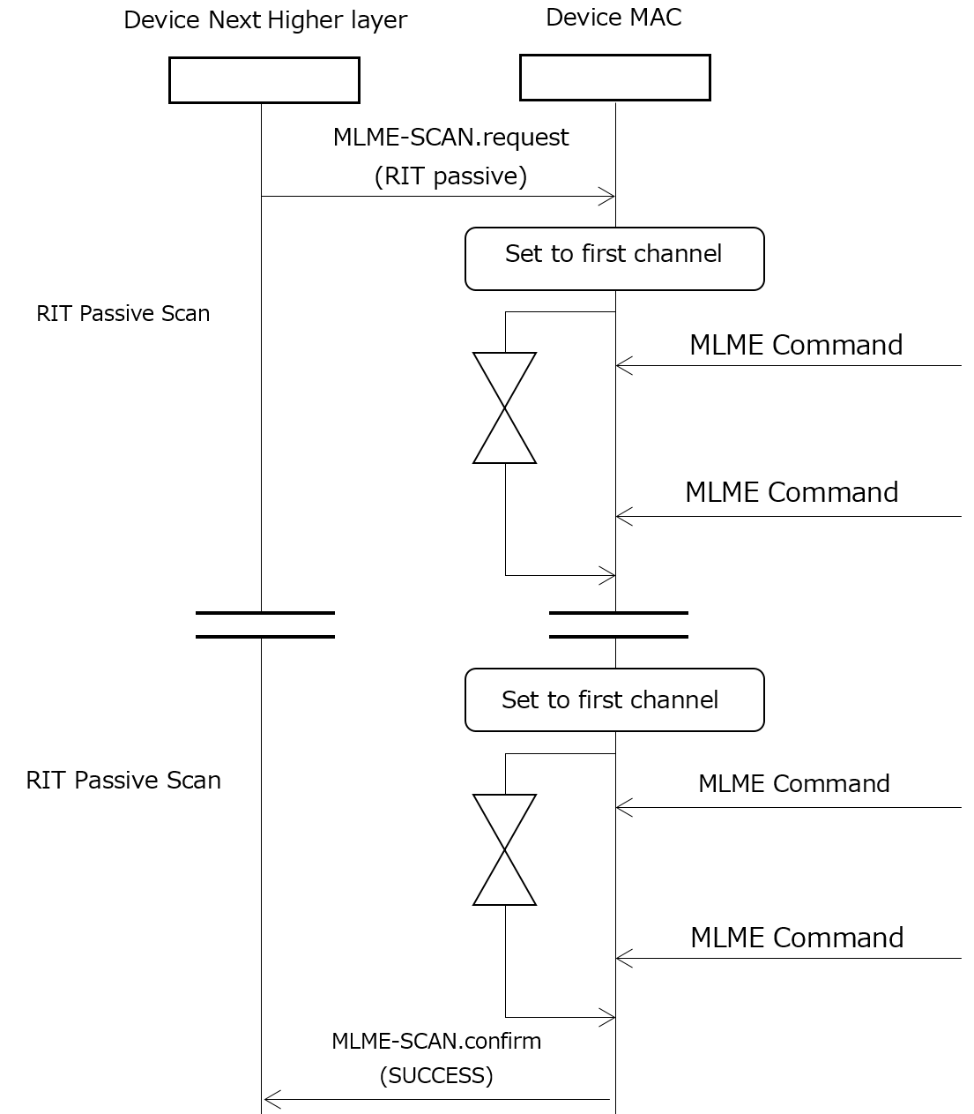

Update Table 82 for supporting additional Scan Type

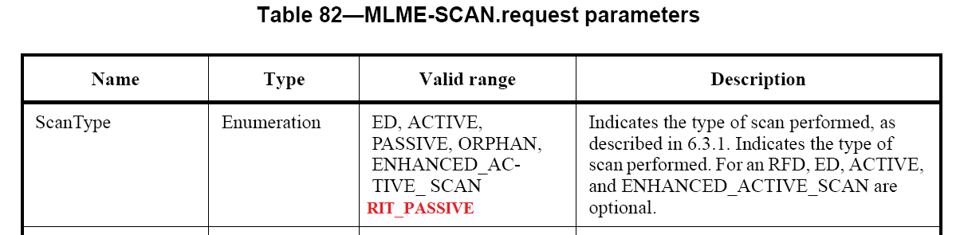

Update Table 83 for supporting additional Scan Type

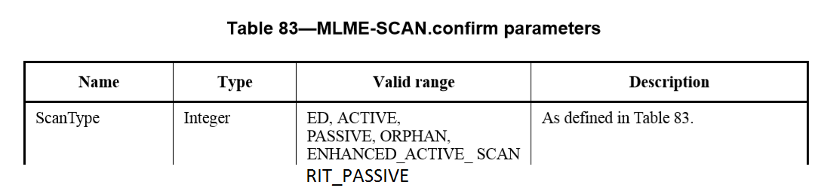

i-40
Kumar, Amarjeet
Page 102 Clause 6.12.3 Line 19
Comment:
Sentence: When two nodes have data to send to each other at same time, both will stop sending RIT Data request at same time and wait for other to send the RIT Data request. In this case both node will be in waiting mode and eventually not be able to send any data to each other.

Proposed change:
Enable the transmission of RIT data request intermittently when it is waiting for an RIT Data Request at arbitrary timing, this will allow each device to send RIT Data request during it is waiting for one. This will make sure that both nodes can fetch data from each other."

For additional detail, please refer the mentor document "15-15-0335-00-0mag-ieee802-15-4-mac-rit-change-proposal.ppt".

Type T
Must be Satisfied Yes
Resolution: Revise

Proposed Resolution:

Change the below text:

6.12.3.3 RIT Transmission

In order to transmit frame in RIT mode, the device shall at first stop its periodic transmission of RIT Data Request commands, enable its receiver, and wait at most macRitTxWaitDuration for reception of a RIT Data Request command from another device.

i-392
KINNEY, PATRICK
Page 102 Clause 6.12.3 Line 19
Comment:
Sentence: When two nodes have data to send to each other at same time, both will stop sending RIT Data request at same time and wait for other to send the RIT Data request. In this case both node will be in waiting mode and eventually not be able to send any data to each other.

Proposed change:
Enable the transmission of RIT data request intermittently when it is waiting for an RIT Data Request at arbitrary timing, this will allow each device to send RIT Data request during it is waiting for one. This will make sure that both nodes can fetch data from each other."

For additional detail, please refer the mentor document "15-15-0335-00-0mag-ieee802-15-4-mac-rit-change-proposal.ppt".

Type T
Must be Satisfied Yes
Resolution: Revise

Proposed Resolution:

Refer the resolution to the comment i-40.

i-42
Kumar, Amarjeet
Page 218 Clause 8.2.5.2 Line 38
Comment:
Currently there is no way to indicate the FCS error to the upper layer.

Proposed change:
Addition of new status "FCS_ERROR" in MLME-COMM-STATUS.indication.

For additional detail, please refer the mentor document "15-15-0335-00-0mag-ieee802-15-4-mac-rit-change-proposal.ppt".

Type T
Must be Satisfied Yes
Resolution: Revise
Proposed Resolution:

Solution is described in MAC Metrics IE.

i-394
KINNEY, PATRICK
Page 218 Clause 8.2.5.2 Line 38
Comment:
Currently there is no way to indicate the FCS error to the upper layer.

Proposed change:
Addition of new status "FCS_ERROR" in MLME-COMM-STATUS.indication.

For additional detail, please refer the mentor document "15-15-0335-00-0mag-ieee802-15-4-mac-rit-change-proposal.ppt".

Type T
Must be Satisfied Yes
Resolution: Revise
Proposed Resolution:

Refer the resolution to the comment i-42.

i-38
Kumar, Amarjeet
Page 103 Clause 6.12.3.3 Line 42
Comment:
Current specification requires CSMA-CA to be performed during sending of data in response to RIT Data Request. However, in low power devices using RIT feature, device sending data in response to RIT data req. can be avoid CSMA-CA.

Proposed change:

"Current Text in Specification:
Upon reception of RIT Data Request command, the MAC sublayer sends the pending data using unslotted CSMA-CA.

Change it to:
Upon reception of RIT Data Request command, the MAC sublayer sends the pending data without using unslotted CSMA-CA."

For additional detail, please refer the mentor document "15-15-0335-00-0mag-ieee802-15-4-mac-rit-change-proposal.ppt".

Type T
Must be Satisfied Yes
Resolution: Revise
Proposed Resolution:

No change required, use CSMA with CCA mode =4

i-390
KINNEY, PATRICK
Page 103 Clause 6.12.3.3 Line 42
Comment:
Current specification requires CSMA-CA to be performed during sending of data in response to RIT Data Request. However, in low power devices using RIT feature, device sending data in response to RIT data req. can be avoid CSMA-CA.

Proposed change:

"Current Text in Specification:
Upon reception of RIT Data Request command, the MAC sublayer sends the pending data using unslotted CSMA-CA.

Change it to:
Upon reception of RIT Data Request command, the MAC sublayer sends the pending data without using unslotted CSMA-CA."

For additional detail, please refer the mentor document "15-15-0335-00-0mag-ieee802-15-4-mac-rit-change-proposal.ppt".

Type T
Must be Satisfied Yes
Resolution: Revise
Proposed Resolution:

Refer the resolution to the comment i-38.

