IEEE P802.15
Wireless Personal Area Networks

Project | IEEE P802.15 Working Group for Wireless Personal Area Networks (WPANs)
Title | Comments on Low Rate PD of Technical Considerations Document
Date Submitted | [July 13, 2015]
Source | Jaesang Cha (SNUST);  Yeong Min Jang (Kookmin University);  Trang Nguyen Van (Kookmin University);  Soo-Young Chang (SYCA);  Jung Hoon Lee (Dong seoul University)
Re:
Abstract
Purpose
Notice | This document has been prepared to assist the IEEE P802.15. It is offered as a basis for discussion and is not binding on the contributing individual(s) or organization(s). The material in this document is subject to change in form and content after further study. The contributor(s) reserve(s) the right to add, amend or withdraw material contained herein.
Release | The contributor acknowledges and accepts that this contribution becomes the property of IEEE and may be made publicly available by P802.15.

List of contributors
Jaesang Cha | SNUST
Yeong Min Jang | Kookmin University
Trang Nguyen Van | Kookmin University
Jung Hoon Lee | Dong seoul University
Soo-Young Chang | SYCA

- Definition
- General Guidelines
- Introduction
- Optical Wireless Communication

Image Sensor Receiver

High-speed Photodiode Receiver

Low Speed Photodiode Receiver

Applications/Use cases

The following Low Speed Photodiode Receiver applications/use cases were presented in response to TG7r1 Call for Applications.

C1 Underwater/Seaside Communication [8]
C2 secure point-to-(multi)point communication [5, 8, 9]
C3 Digital signage [5, 8, 17]
C4 D2D/IoT [5, 9]
C5 LOS Authentication [5, 17]
C6 Identification based service [20, 21]
The standard will consist of multiple PHY/MAC modes to meet the following variety of Low Speed Photodiode Receiver requirements where the receiver consists of photodiode.
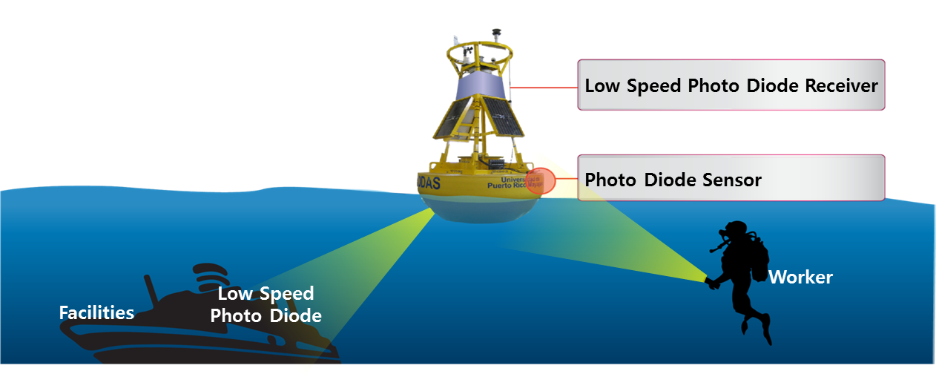

C1 : Underwater/Seaside Communication

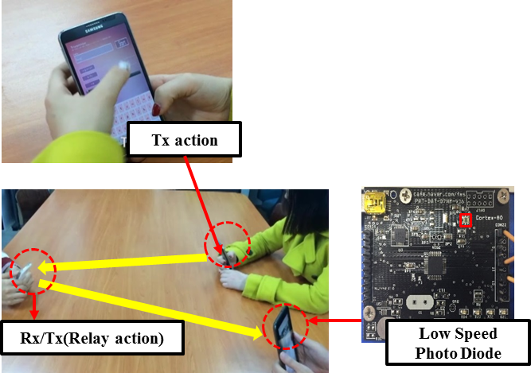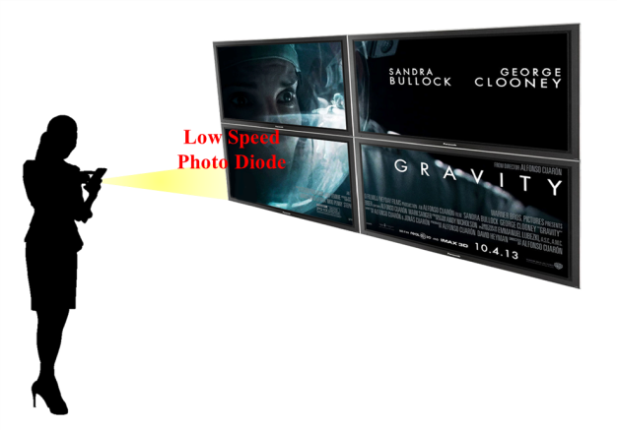
C2 : Secure point-to-(multi)point communication C3 : Digital signage

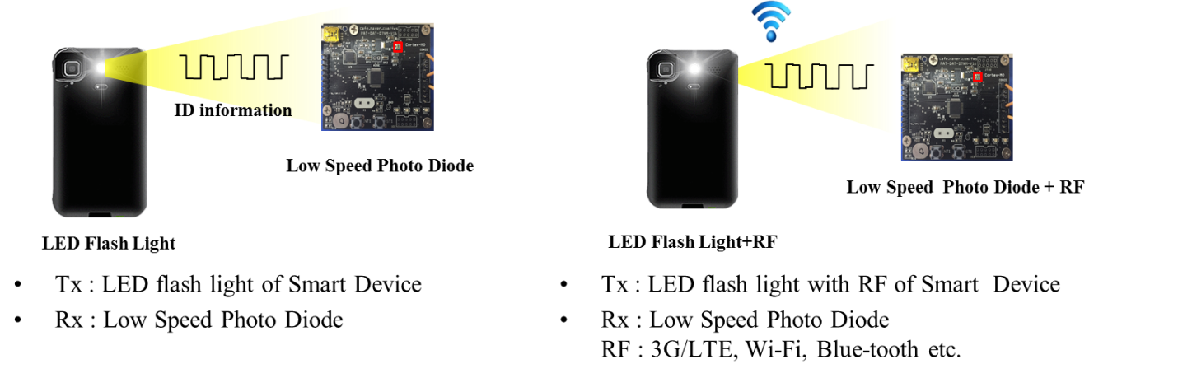

C4 : D2D/IoT
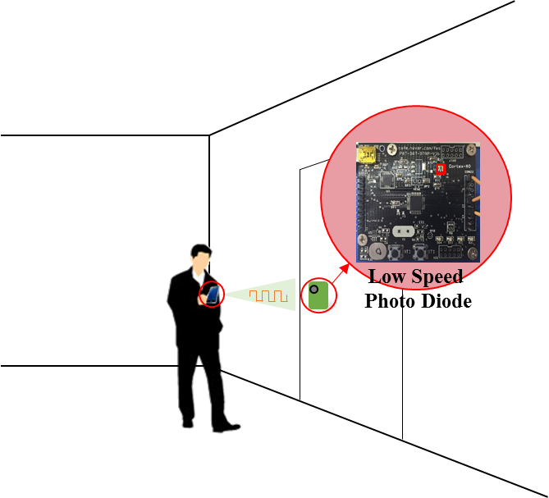

C5 : LOS Authentication
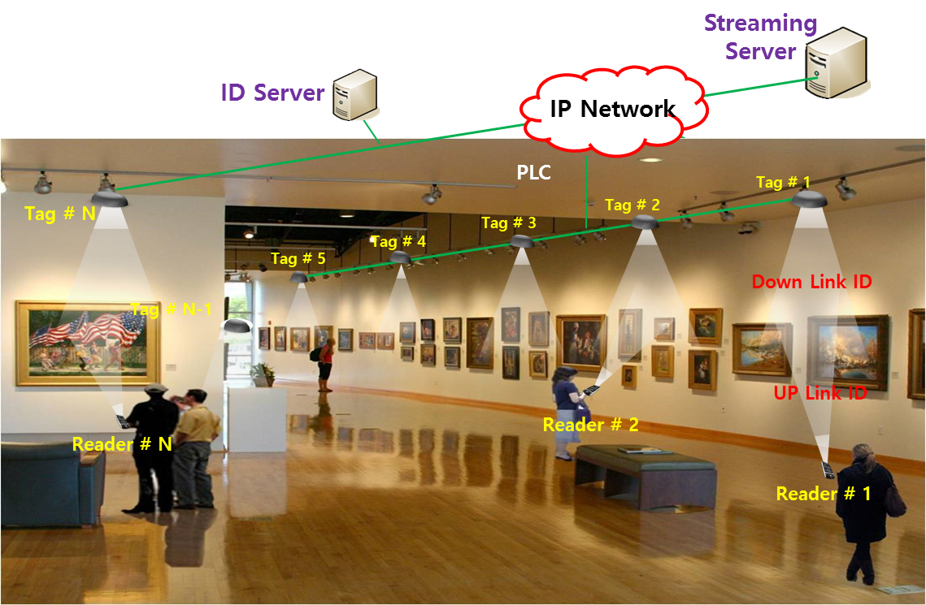

C6: Identification based service

Transmitter

The standard should support the LED Tags, Smart Phone Flash lights, Lighting source, etc. for various applications.

Device | Applications/Use cases
Smart Device Flash light | C2, C4,
Lighting source | C1, C3,C5,C6

Receiver

The standard will support Low Speed Photodiode Receiver. It measures intensity of visible light, IR and/or near UV, as receiver.

Carrier Wavelength

Carrier wavelength will be limited in visible light, IR and near UV frequency band.

Transfer mode

The standard may provide multiple PHY/MAC modes that allow the optimal use of the available optical bandwidth on a given luminaire for C1 – C6.
D2D/IoT data transmission and Relay mode with ID information with PHY/ MAC frame for applications C2, C3, C4, C5 and C6.
Uni/Bi-directional data transfer mode for applications C1 – C6..

Eye safety and Flicker

The modulated light will be safe for human eye in the aspects of frequency and intensity of light. And the modulated light will not stimulate sickness such as photosensitive epilepsy.
The standard will support at least one flicker free PHY mode, in which the modulation is imperceptible for human eye, for application C1 – C6. The standard may allow flicker PHY mode for application C1 – C6.

Dimming Control

The standard will support dimming control for all of applications

Communication Range

The communication range depends on multiple external factors (signal magnification, signal collimation, source power, etc.). These are implementation aspects and these numbers are provided as guidelines only.

Handover, link recovery and Interference Coordination

The standard may provide mechanisms to support handover between LED light sources, allowing the users to maintain a continuous network connection.

The standard may provide mechanisms that can be used to develop and deliver interference coordination techniques by higher layers.
The standard may support link recovery mechanism to maintain connection in unreliable channel for reducing the connection delay.

Localization

The standard may provide mechanisms to support indoor positioning algorithms from Identification of LEDs system.

Coexistence with Ambient Light

The standard will co-exist with ambient light that may be reflected on a surface of a transmitter and with existing 15.7 PHY modes.

Coexistence with Other Lighting Systems

The standard will co-exist with other lighting systems.

Identification of Transmitter

The standard will support a scheme to identify transmitters’ ID information. A receiver can trace a transmitter identification (ID) using Low Speed Photodiode Receiver system.

Referes.nces

- The IEEE P802.15.7r1 Short-Range Optical Wireless Communications Task Group Project Authorization Request (PAR): https://mentor.ieee.org/802.15/dcn/15/15-15-0064-00-0007-p802-15-7-revision-par-approved-2014-12-10.pdf
- Intel Response to 15.7r1 CFA: IEEE802.15-15-0146-00-007a
- CASIO Response to 15.7r1 CFA: IEEE802.15-15-0173-01-007a
- China Telecom CFA Response for Optical Camera Communications: IEEE802.15-15-0180-00-007a
- Introduction of LED-ID and Smart Device Camera based Applications: IEEE802.15-15-0196-00-007a
- Panasonic Response to 15.7r1 CFA: IEEE802.15-15-0197-00-007a
- NTU Response to 15.7r1 CFA: IEEE802.15-15-0203-00-007a
- LED Tag Applications for OWC: IEEE802.15-15-0211-00-007a
- D2D/P2P applications using Flash light and Camera of Smart Device: IEEE802.15-15-0212-00-007a
- Kookmin University Response to 15.7r1 CFA: Application of OWC: IEEE802.15-15-0242-00-007a
- Kookmin University Response to 15.7r1 CFA: Applications of OCC: IEEE802.15-15-0243-00-007a
- Fraunhofer HHI Response to 15.7r1 CFA: IEEE802.15-15-0248-01-007a
- pureLiFi_CFA_response: IEEE802.15-15-0192-00-007a
- LED Tag Applications for OWC: IEEE802.15-15-0211-00-007a
- D2D/P2P applications using Flash light and Camera of Smart Device: IEEE802.15-15-0212-00-007a
- Introduction of LED-ID and Smart Device Camera based Applications : for Short-Range Optical Wireless Communications Tutorial : IEEE 802.15-15-0196-00-007a
- OWC Use Cases : LED Patch based Use Cases for Facility Signage : IEEE 802.15-15-0082-00-0007
- Some Issues for OWC : IEEE 802.15.-15-0073-00-0007
- 15-15-0404-00-007a-kookmin-university-response-to-15-7r1-cfa-occ-application-in-light-house-to-ship-communication
- Overview of LED-ID: IEEE 802.15.-11-0501-00-0-0wng
- Overview and Applications of LED-ID System and Visible RFID System: IEEE 802.15-11-0666-00-wng0

