IEEE P802.15
Wireless Personal Area Networks

Project | IEEE P802.15 Working Group for Wireless Personal Area Networks (WPANs)
Title | Image Sensor Receiver Part of TG7r1 Technical Considerations Document
Date Submitted | [July, 2015]
Source | Hideki Aoyama (Panasonic);  Yeong Min Jang (Kookmin University);  Jaesang Cha (SNUST);  Soo-Young Chang (SYCA);  Nikola Serafimovski (pureLiFi);  Volker Jungnickel (Fraunhofer Heinrich Hertz Institute);  Trang Nguyen Van (Kookmin University);  Richard Roberts (Intel);  Md. Shareef Ifthekhar (Kookmin University);  Nam Tuan Le (Kookmin University);
Re:
Abstract
Purpose
Notice | This document has been prepared to assist the IEEE P802.15. It is offered as a basis for discussion and is not binding on the contributing individual(s) or organization(s). The material in this document is subject to change in form and content after further study. The contributor(s) reserve(s) the right to add, amend or withdraw material contained herein.
Release | The contributor acknowledges and accepts that this contribution becomes the property of IEEE and may be made publicly available by P802.15.

List of contributors
Hideki Aoyama | Panasonic
Mitsuaki Oshima | Panasonic
Rojan Chitrakar | Panasonic
Nikola Serafimovski | pureLiFi
Murat Uysal | Ozyegin University
Yu Zeng | China Telecom
Richard Roberts | Intel
Yeong Min Jang | Kookmin University
Jaesang Cha | SNUST
Soo-Young Chang | SYCA
Volker Jungnickel | Fraunhofer Heinrich Hertz Institute
Trang Nguyen Van | Kookmin University
Md. Shareef Ifthekhar | Kookmin University
Nam Tuan Le | Kookmin University

Table of Contents
Table of Contents 3
1. Definitions 5
2. General Guidelines 5
3. Introduction 8
4. Optical Wireless Communication 9
4.1 Image Sensor Receiver 9
4.1.1 Applications/Use cases 9
4.1.2 Transmitter 12
4.1.3 Receiver 13
4.1.4 Carrier Wavelength 13
4.1.5 Transfer mode 14
4.1.6 Eye safety and Flicker 14
4.1.7 Dimming Control 15
4.1.8 Communication Range 15
4.1.9 Power Consumption Control 15
4.1.10 Coexistence with Ambient Light 15
4.1.11 Coexistence with Other Lighting Systems 15
4.1.12 Simultaneous Communication with Multiple Transmitters 15
4.1.13 Simultaneous Communication with Multiple Receivers 16
4.1.14 Identification of Transmitter 16
4.1.15 Performance Data 18
4.1.16 Nearly point image data source 18
4.1.17 Simultaneous low frame rate and high frame rate transmission 18
4.1.18 Low overhead repetitive transmission 19
4.1.19 Image Sensor Compatibility 19
4.2 High Speed Photodiode Receiver 20
4.2.1 Applications/Use cases 20
4.2.2 Transmitter 21
4.2.3 Transfer mode 21
4.2.4 Eye safety and Flicker 22
4.2.5 Dimming Control 22
4.2.6 Communication Range 22
4.2.7 Multiple User Support 22
4.2.8 Asymmetric Communication 22
4.2.9 Handover and Interference Coordination 22
4.2.10 Localization 23
4.2.11 Coexistence with Ambient Light and Other Lighting Systems 23
4.2.12 Simultaneous Communication with Multiple Transmitters 23
4.2.13 Waveform 24
4.3 Low Speed Photodiode Receiver 24
4.3.1 Applications/Use cases 24
4.3.2 Transmitter 26
4.3.3 Receiver 26
4.3.4 Carrier Wavelength 26
4.3.5 Transfer mode 26
4.3.6 Eye safety and Flicker 26
4.3.7 Dimming Control 26
4.3.8 Communication Range 27
4.3.9 Handover and Interference Coordination 27
4.3.10 Localization 27
4.3.11 Coexistence with Ambient Light 27
4.3.12 Coexistence with Other Lighting Systems 27
4.3.13 Identification of Transmitter 27
5. References 28

Definitions

MIMO | Multiple Input/Multiple Output
LOS | Line Of Sight
LBS | Location Based Service
LED | Light Emitting Diode (unnecessary?)

General Guidelines

This technical considerations document (TCD) provides as a useful guideline to prepare proposals the technical aspects that TG7r1 standard may fulfill, such as performance-related issues, reliability issues and availability issues. These types of technical aspects are often called quality of service (QoS) requirements; other aspects are usually maintenance-level requirements or external constraints, sometimes called compliance.

Technical aspects have a name and a unique identifier. They are documented in the same manner as any specifications, including a description, an example, a source or references to related technical requirements and a revision history. TG7r1 needs to effectively define and manage these aspects to ensure they are meeting needs of the OWC (Optical Wireless Communications) users, while proving compliance.

This technical considerations document (TCD) is a guideline for proposal preparation which addresses the technical aspects of interest to the TG7r1 committee in regards to a draft standard that may fulfill performance-related issues, reliability issues and availability issues. These types of technical aspects are often called quality of service (QoS) requirements; other aspects are usually maintenance-level requirements or external constraints, sometimes called compliance.

Technical aspects have a name and a unique identifier. They are documented in the same manner as any specifications, including a description, an example, a source or references to related technical requirements and a revision history. TG7r1 needs to effectively define and manage these aspects to ensure they are meeting needs of the OWC (Optical Wireless Communications) users, while proving compliance.

Ideally, considerations should be:

• Correct technically and legally,
• Complete by expressing a whole idea or statement,
• Clear (i.e., unambiguous and not confusing),
• Consistent (not in conflict with other requirements),
• Verifiable, so that it can be determined that the system meets the requirements,
• Traceable (i.e., uniquely identified and track-able),
• Feasible, so that they can be accomplished within given cost and schedule limits,
• Modular, so that they can be changed without excessive impact to other requirements, and
• Design-independent, not to pose a specific solution on design.

Each consideration must first form a complete sentence, containing a subject and a predicate. These sentences must consistently use the verb “shall”, “will” or “must” to show the requirement's mandatory nature, and “should” or “may” to show that the requirement is optional. The whole requirement specifies a desired end goal or result and contains a success criterion or other measurable indication of the quality.

TCD needs to capture these levels of user requirements, maintaining intelligent traceability and change impact analysis between them.

TCD needs to capture these levels of user requirements, maintaining intelligent traceability and change impact analysis between them.

Typical constraint considerations can specify:

• Performance,
• Interfaces,
• Coexistence,
• Security,
• Safety,
• Reliability,
• Availability, and
• Maintainability.

An efficient way of writing better requirements is to ensure they are clearly mapped to test cases. When specifying considerations or requirements, test cases must be considered to provide directions to help to verify requirements or considerations in the document. This can be provided by specifying a packet error rate and packet size for comparing proposals, for example. Making sure each requirement is clearly verifiable from the start, which not only helps to prepare later phases of the project, but it also puts the developer in the correct state of mind. Requirements and their associated tests must also indicate what the system should not do, and what happens at the limits (i.e., degraded mode). This rule also applies for compliance requirements: indicating how they shall be tested is a good way to write better requirements.

TCD needs to implement a reliable and repeatable change control process that helps turn this challenge into an opportunity.

By providing examples and counter-examples of good requirements and documents, IEEE can enhance the quality, consistency, and completeness of the requirements. These can originally be templates, industry standards and rules inside a repository, such as the IEEE server.

Requirements for Typical Sentence Construction

Defects to be avoided are:

- Vagueness,
- Weakness,
- Over specification,
- Subjectivity,
- Multiplicity,
- Unclear meaning, and
- Implicit meaning.

Some words listed below should be used with caution:

“adequate”, “applicable”, “appropriate”, “approximate”, “bad”, “best practice”, “between”, “clearly”, “compatible”, “completely”, “consider”, “could”, “down to”, “easy/easily”, “effective”, “efficient”, “equivalent”, “excellent”, “good”, “his/her”, “however”, “ideal”, “etc”, “in order to”, “include but shall not be limited to”, “least”, “like”, “low”, “maximise”, “may”, “most”, “minimum/minimal”, “must”, “nearly”, “necessary”, “needed”, “normal”, “or”, “possible/possibly”, “practicable”, “provide”, “quality”, “readily”, “relevant”, “safe/safely“, “same”, “should”, “significant”, “similar”, “so as”, “subject to”, “substantial”, “sufficient”, “suitable”, “support”, “target”, “typical”, “up to”, “user friendly”, “whether”, “will”, “with”, and “worse”.

Difference between Considerations and Requirements (TCD vs. TRD)

The TG7r1 group decided to use the term “considerations” instead of “requirements” in order to adopt a less rigid and formal process with the intention to be able to develop the standard quickly. This document serves to provide guidance for development of technical proposals for the IEEE 802.15.7r1 standard. The contents of the document are expected to be similar to a technical requirements document, but each consideration aspect will be used for guidance to meet user requirements identified from the responses to TG7r1 Call for Applications (CfA) listed in the reference section.

Introduction

This document provides the technical contents of the project to develop PHY and MAC protocols for Optical Wireless Communications. This document will provide guidance on how to respond to a call for proposals.

This document serves two purposes:
- It summarizes the applications presented in response to TG7r1 Call for Applications and questions and answers.
- It describes and defines the fundamental requirements implied by the applications but not necessarily stated explicitly.

Optical Wireless Communication

Optical Wireless Communication (OWC) is a wireless communication method using optical wavelength radio wave as the carrier wave.
OWC can be classified into:
Image Sensor Receiver which enables optical wireless communications using an image sensor as a receiver.
High Speed Photodiode Receiver which is high-speed, bidirectional, networked and mobile wireless communications using light.
Low Speed Photodiode Receiver which is wireless light ID system using various LEDs.

OWC can be classified into:
Image Sensor Communications which enables optical wireless communications using an image sensor as a receiver.
High Speed Photodiode Communications which is high-speed, bidirectional, networked and mobile wireless communications using light with a high speed photodiode receiver.
Low Speed Photodiode Communications which is wireless light ID system using various LEDs with a low speed photodiode receiver.

Currently the 802.15.7-2011 standard defines three PHY data rates that use a photodiode receiver implementation: i) PHY 1 is 11.67 kbps to 266.6 kbps; ii) PHY 2 is 1.25 Mbsp to 96 Mbps and iii) PHY 3 is 12 Mbps to 96 Mbps. Based upon currently defined 15.7 PHYs, the definition of Low Speed Photodiode Communications is a PHY mode that contains at least one data rate lower than 11.67 kbps. Likewise, the definition of High Speed Photodiode Communications is a PHY mode that contains at least one data rate higher than 96 Mbps.

Image Sensor Receiver

Applications/Use cases

The following Image Sensor Receiver applications/use cases were presented in response to TG7r1 Call for Applications.

A1 Offline to Online Marketing/Public Information System [2, 3, 5, 6, 7]
A2 IoT (M2M/D2D/ Internet of Light (IoL)) [2, 3, 9, 10, 11]
A3 LBS Indoor Positioning [2, 5, 10, 17]
A4 Vehicular Communication [2, 7]
A5 Underwater Communication [8]
A6 Power Consumption Control [4]
A7 Vehicular Positioning [2]
A8 Seaside Communication [19]
A9 LED based Tag application [5, 8]
A10 Secure point-to-(multi)point communication [8, 9, 5]
A11 Digital signage [8, 5, 17]

The standard will consist of multiple PHY/MAC modes to meet the following variety of requirements.

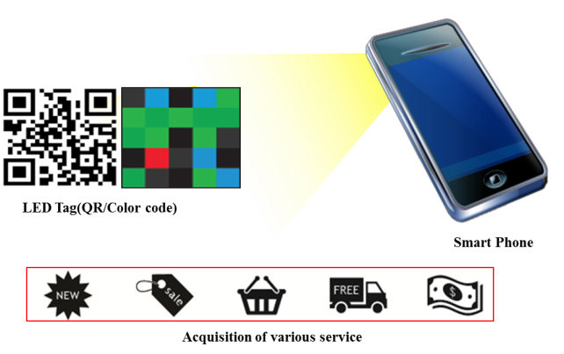 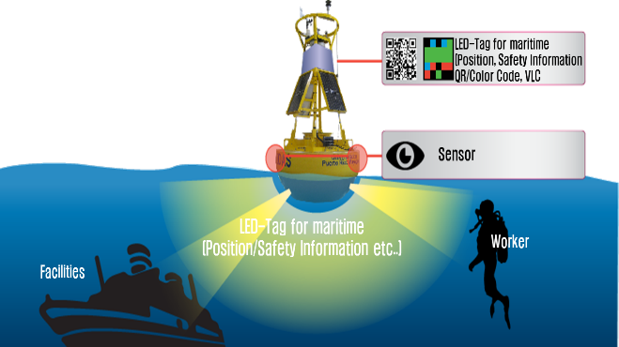 A9 : LED based Tag application A5 : Underwater/Seaside Communication

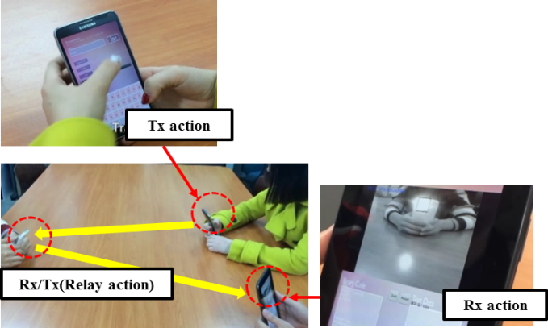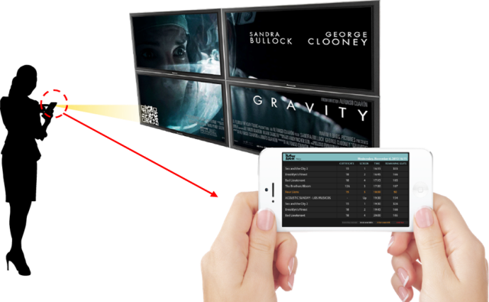
A10 : Secure point-to-(multi)point communication A1 : Digital signage
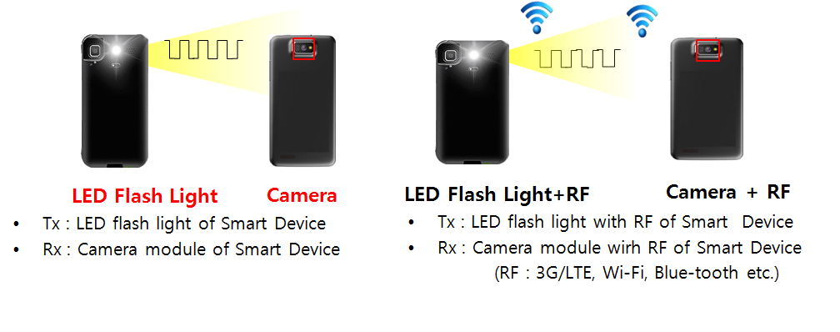
A2 : D2D/IoT

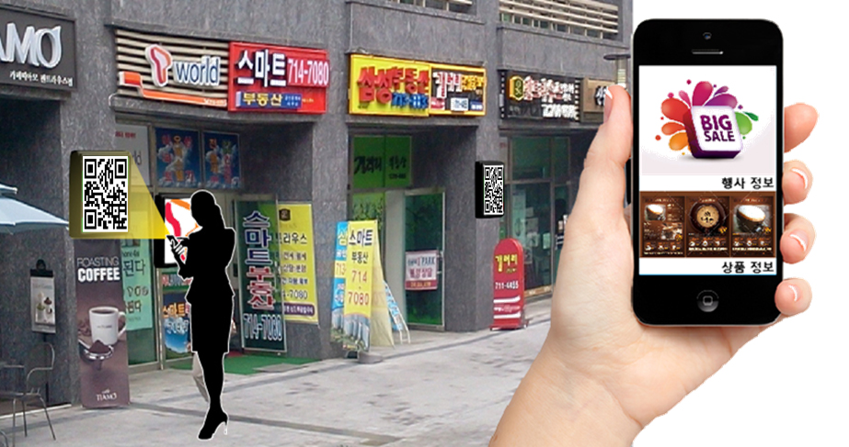
A1 : LOS Marketing

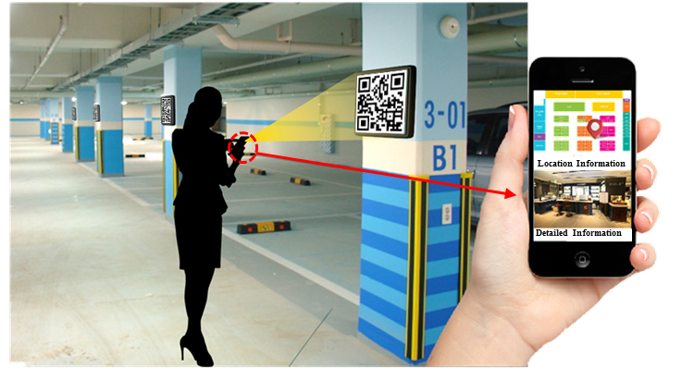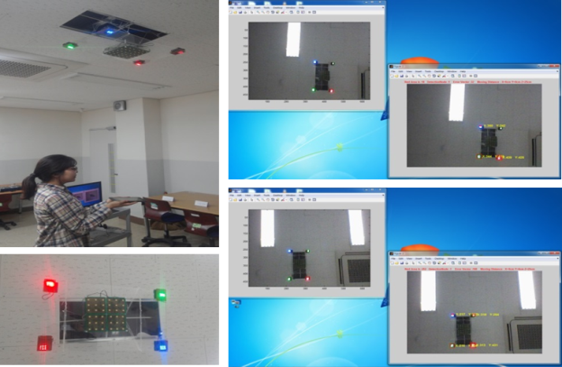

A3 : LBS Indoor Positioning

Transmitter

The standard should support the following devices as transmitters for each application.

Device | Applications/Use cases
Ceiling light / Lighting Source | A2, A3
Flash light | A5, A2
Car light | A4, A7
Indirect light | A1, A4
Illuminated signage with diffused light | A1, A2
Illuminated signage with discrete LEDs | A1, A2
Digital signage (such as LCD) | A1, A2
Traffic light and Intelligent Traffic System (ITS) | A1, A2, A4, A7
Lighthouse | A1, A8
LED Tag | A9, A5, A8, A1
Display / Image patterns | A9, A5, A8, A1

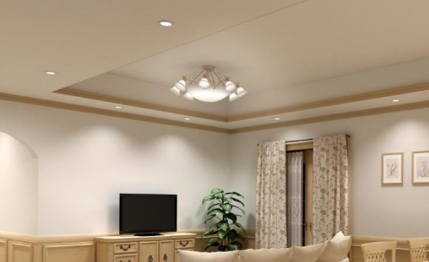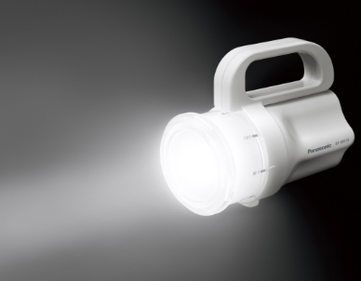
Ceiling light Flash light

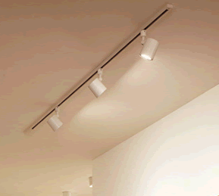
Car light Indirect light

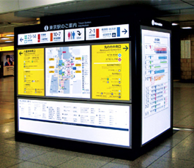
Illuminated signage Illuminated signage
with diffused light with discrete LEDs

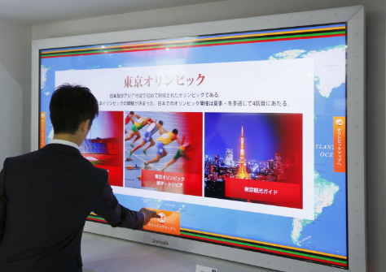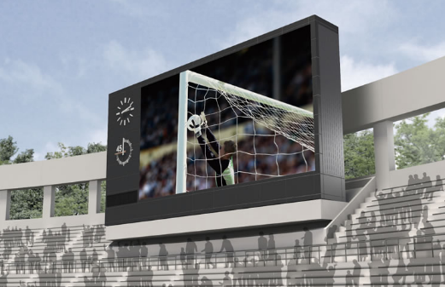
Digital signage

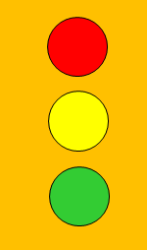
Traffic light Lighthouse

Receiver

The standard will support optical camera, which has image sensor that measure intensity of visible light, IR and/or UV, as receiver. The standard will support image sensors of global shuter/rolling shutter/ sequential shutterwith multiple PHY/MAC modes.

Carrier Wavelength

Carrier wavelength will be limited in visible light, IR and UV frequency band.

Transfer mode

      - TransmissionMode

A PHY/MAC mode of the standard will support at least one of the following transfer modes according to the duplex mode:

ID broadcast mode which repetitively broadcast ID with small overhead of MAC frame for application A1, A2, A3, A4 and A5.
Unidirectional data transfer mode which transmit longer data stream for application A2 and A4.
Bidirectional data transfer mode which enables efficient communication for application A2.

The standard may provide multiple PHY/MAC modes that allow the optimal use of the available optical bandwidth on a given luminaire for A1, A2, A3, A5, A8, A9, and A10.
D2D/IoT data transmission and Relay mode with ID information with PHY/ MAC frame for applications C2, C3 and C5.
Uni/Bi-directional data transfer mode for applications C1 – C7.

Device to device (D2D) data transmission is the direct wireless passing of data between smart devices without passing data through an infrastructure device such as an access point.

IoT data transmission is the inclusion of non-traditional devices into a communications network such as household appliances connecting and communicating with a user’s mobile device.
Relay mode is the ad-hoc forwarding of data by a device in the middle of two other devices that would normally be out of communication range.

4.1.5.2 Synchronization/Asynchronization mode
Asynchronous mode: The standard will support asynchronous communication between transmitters and receivers to allow mismatched frame rates between transmitters and receivers due to varying frame rate of camera.
Synchronized mode: The standard will support synchronized communication between transmitters and receivers in which the constant camera frame rate is considered.

Eye safety and Flicker

The modulated light that can be seen by the human eye shall be safe in regards to the frequency and intensity of light. And the modulated light will not stimulate sickness such as photosensitive epilepsy.
The standard will support at least one flicker free PHY mode, in which the modulation is imperceptible for human eye, for application A1, A3, A4, A7 and A8. The standard may allow flicker PHY mode for application A1, A2, A3, A5, A9 and A10, but it shall be safe for human eye as described above.

Dimming Control

The standard will support dimming control for application A1, A2, A3, A4 and A7.

Communication Range

The communication range depends on multiple external factors (signal magnification, signal collimation, source power, etc.). Communication range also depends on the size and the brightness of a transmitter in conjunction with some protocols. These are implementation aspects and these numbers are provided as guidelines only. The range performance criteria will be determined by the committee at the time the need arises, including the selection of an appropriate common channel model.

Power Consumption Control

The standard should support power consumption control for application A6.

Coexistence with Ambient Light

The standard will co-exist with ambient light that may be reflected on a surface of a transmitter. In addition, coexistence shall be shown with the existing IEEE802.15.7-2011 operating modes.

Coexistence with Other Lighting Systems

The standard will co-exist with other lighting systems. It will enable a receiver to receive a signal from a transmitter even if other lighting systems are captured in the same image frame, which are optically separable from the transmitter.

Simultaneous Communication with Multiple Transmitters

The standard will support simultaneous communication with multiple coordinated/uncoordinated transmitters, which are separated on a captured image.

Simultaneous Communication with Multiple Receivers

The standard will support simultaneous communication between multiple coordinated/uncoordinated transmitters and multiple image sensor receivers. The standard supports at least PHY/MAC layer for communication between transmitters and multiple cameras on the same device.

Identification of Transmitter

The standard will support a scheme to identify transmitters’ ID using Image Sensor. The standard will also support identifying the source of transmitted data by observation of the transmitting source in the image; that is, there must be association between an observed object that is transmitting data and the location of that object as formed on the image sensor.

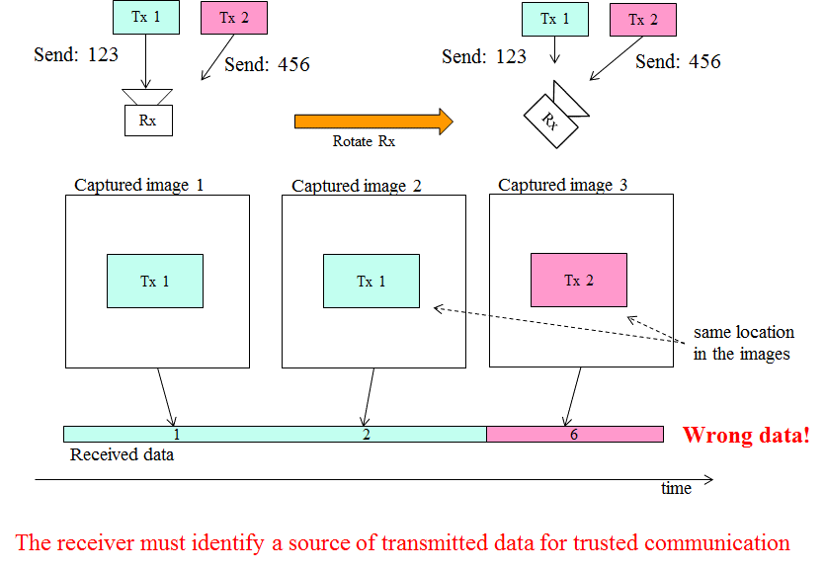

Performance Data

TBD - The committee shall determine performance data at a future time.

Nearly point image data source

The standard will support at least one Image Sensor Receiver PHY mode that works when the light source appears as nearly a point source; that is, the light source illuminates only a small number of image pixels.

Simultaneous low frame rate and high frame rate transmission

The standard will support at least one Image Sensor Receiver PHY mode that simultaneously allows Image Sensor Receiver modulated light sources to be identified at a low camera frame rate and then demodulated at a high camera frame rate using region-of-interest sub-sampling.

Low overhead repetitive transmission

The standard will support at least one Image Sensor Receiver MAC mode that supports repetitive informational broadcast at very low data rate; that is, the frame format has very little overhead and is optimized for short payloads sent in a repetitive manner.

Image Sensor Compatibility

The standard will support a PHY mode that is compatible to a variety of cameras with different image sensing sampling rates (read-out time), resolution, and frame rates (constant frame rate or varying frame rate).

High Speed Photodiode Receiver

Applications/Use cases

The following High Speed Photodiode Receiver applications/use cases were presented in response to TG7r1 Call for Applications.

- Indoor Office/Home Applications: (Conference Rooms, General Offices, Shopping Centres, Airports, Railways, Hospitals, Museums, Aircraft Cabins, Libraries etc.)
- Data Center / Industrial Establishments, Secure Wireless (Personalized Manufacturing Cells, Factories, Hangers, etc.)
- Vehicular Communications (Vehicle-to-vehicle, Vehicle-to-Infrastructure)
- Wireless Backhaul (Small Cell Backhaul, Surveillance Backhaul, Lan Bridging)

These have been summarized in document number 15-15-0302-01-007a.

B1: Indoor Office/Home Applications

B2: Data Center / Industrial Establishments / Secure Wireless

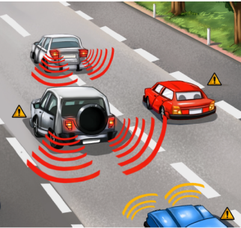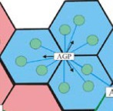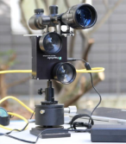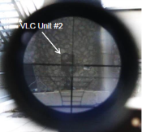

B3: Vehicular Communications B4: Wireless Backhaul

Transmitter

The standard should support the following devices as transmitters for each application.

Device | Applications/Use cases
Ceiling/Street light | B1, B2, B3
Indirect light | B1, B2
Car light | B3
Directed light | B2, B4

Transfer mode

The standard will support continuous data streaming for all applications with bidirectional functionality as well as short packet transmissions where low latency is required. The standard must provide a PHY mode that allows the optimal use of the available optical bandwidth on a given luminaire for B1 – B4.

The standard must define a range of data rates from minimum supported connectivity or at least 10 Mbps to peak data rates of 10 Gbps.

The standard must define a range of latencies from maximum supported of at most 20 ms to minimum latency of 1 ms.

Eye safety and Flicker

The modulated light will be safe for human eyes and will not stimulate photosensitive epilepsy. The standard should support flicker free PHY mode, in which the modulation is imperceptible for the human eye, for application B1 and B3. For the applications B2 and B4, infrared light may be used.

Dimming Control

The standard will support dimming control for application B1 – B3.

Communication Range

The communication range depends on multiple external factors (signal magnification, signal collimation, source power, etc.). These are implementation aspects and these numbers are provided as guidelines only. The committee will agree to use the same channel model to assess the performance capabilities of the proposed schemes by using link parameters that are typical for the specified application scenarios.

Multiple User Support

The standard must provide MAC/PHY mechanisms to support rate adaptation as well as the support of multiple users receiving different data streams from the same light source (multiple access).

Asymmetric Communication

The standard will support asymmetric communication between transmitters and receivers to allow higher data rates in one direction.

Moreover, the standard shall allow that bidirectional operation can be established in combination with other wireless techniques, for example, an optical and a radio-based link can be used in the upstream and downstream, respectively.

Handover and Interference Coordination

The standard must provide mechanisms to support horizontal handover between light sources, allowing the users to maintain a continuous network connection.

The standard must provide mechanisms that can be used to develop and deliver interference coordination techniques by higher layers.

The standard shall support vertical handover to other bidirectional wireless transmission techniques serving the same mobile devices in the same area, for example that data will be handed over to a radio-based wireless link when the mobile device leaves the coverage area of the optical wireless link.

Moreover, the standard shall support parallel transmissions together with other bidirectional wireless communication techniques, for example, the data can be transmitted in parallel over the optical and the radio-based wireless link.

Localization

The standard must provide mechanisms to support precise indoor positioning algorithms with less than 10 cm diameter precision.

Coexistence with Ambient Light and Other Lighting Systems

The standard will co-exist with ambient light whose reflected brightness is less than xx % of brightness of a transmitter.

The standard will co-exist with other lighting systems. This will enable a receiver communicate with a supported transmitter even in the presence of other modulated lights.

In addition, coexistence shall be shown with the existing IEEE802.15.7-2011 operating modes.

Simultaneous Communication with Multiple Transmitters

The standard will support interference coordination techniques to deal with simultaneous communication with multiple coordinated/uncoordinated transmitters, which is referred to as multiple-input multiple-output (MIMO).

It will support cooperative signal processing among multiple transmitters with negligible impact on latency.

The standard shall support efficient and reliable feedback and control channels for rate adaptation, multiple user support and cooperative signal processing and make the required information available to other fixed and mobile devices in the network.

Waveform

The standard will employ at least one PHY mode that uses variable current modulation.

Low Speed Photodiode Receiver

Applications/Use cases

The following Low Speed Photodiode Receiver applications/use cases were presented in response to TG7r1 Call for Applications.

C1 Underwater/Seaside Communication [8]
C2 secure point-to-(multi)point communication [5, 8, 9]
C3 Digital signage [5, 8, 17]
C4 D2D/IoT [5, 9]
C5 LOS marketing [5, 17]

The standard will consist of multiple PHY/MAC modes to meet the following variety of Low Speed Photodiode Receiver requirements where the receiver consists of a single photodiode.

C1 : Underwater/Seaside Communication

C2 : Secure point-to-(multi)point communication C3 : Digital signage
C4 : D2D/IoT

C5 : LOS Marketing

Transmitter

The standard should support the LED Tags, Smart Phone Flash lights, Lighting source, etc. for various applications.

Device | Applications/Use cases
Smart Device Flash light | C2, C4,
Lighting source | C1, C3,C5

Receiver

The standard will support Low Speed Photodiode Receiver. It measures intensity of visible light, IR and/or near UV, as receiver.

Carrier Wavelength

Carrier wavelength will be limited in visible light, IR and near UV frequency band.

Transfer mode

The standard may provide multiple PHY/MAC modes that allow the optimal use of the available optical bandwidth on a given luminaire for C1 – C5.
D2D/IoT data transmission and Relay mode with ID information with PHY/ MAC frame for applications C2, C3, C4 and C5.
Uni/Bi-directional data transfer mode for applications C1 – C5..

Eye safety and Flicker

The modulated light will be safe for human eye in the aspects of frequency and intensity of light. And the modulated light will not stimulate sickness such as photosensitive epilepsy.
The standard will support at least one flicker free PHY mode, in which the modulation is imperceptible for human eye, for application C1 – C5. The standard may allow flicker PHY mode for application C1 – C5.

Dimming Control

The standard will support dimming control for all of applications

Communication Range

The communication range depends on multiple external factors (signal magnification, signal collimation, source power, etc.). These are implementation aspects and these numbers are provided as guidelines only. The committee will agree to use the same channel model to assess the performance capabilities of the proposed schemes.

Coexistence with Ambient Light

The standard will co-exist with ambient light that may be reflected on a surface of a transmitter and with existing 15.7 PHY modes.

Coexistence with Other Lighting Systems

The standard will co-exist with other lighting systems.

Identification of Transmitter

The standard will support a scheme to identify transmitters when a receiver or a transmitter is moved. A receiver can trace a transmitter identification (ID) of Low Speed Photodiode Receiver system.

Referes.nces

- The IEEE P802.15.7r1 Short-Range Optical Wireless Communications Task Group Project Authorization Request (PAR): https://mentor.ieee.org/802.15/dcn/15/15-15-0064-00-0007-p802-15-7-revision-par-approved-2014-12-10.pdf
- Intel Response to 15.7r1 CFA: IEEE802.15-15-0146-00-007a
- CASIO Response to 15.7r1 CFA: IEEE802.15-15-0173-01-007a
- China Telecom CFA Response for Optical Camera Communications: IEEE802.15-15-0180-00-007a
- Introduction of LED-ID and Smart Device Camera based Applications: IEEE802.15-15-0196-00-007a
- Panasonic Response to 15.7r1 CFA: IEEE802.15-15-0197-00-007a
- NTU Response to 15.7r1 CFA: IEEE802.15-15-0203-00-007a
- LED Tag Applications for OWC: IEEE802.15-15-0211-00-007a
- D2D/P2P applications using Flash light and Camera of Smart Device: IEEE802.15-15-0212-00-007a
- Kookmin University Response to 15.7r1 CFA: Application of OWC: IEEE802.15-15-0242-00-007a
- Kookmin University Response to 15.7r1 CFA: Applications of OCC: IEEE802.15-15-0243-00-007a
- Fraunhofer HHI Response to 15.7r1 CFA: IEEE802.15-15-0248-01-007a
- pureLiFi_CFA_response: IEEE802.15-15-0192-00-007a
- LED Tag Applications for OWC: IEEE802.15-15-0211-00-007a
- D2D/P2P applications using Flash light and Camera of Smart Device: IEEE802.15-15-0212-00-007a
- Introduction of LED-ID and Smart Device Camera based Applications : for Short-Range Optical Wireless Communications Tutorial : IEEE 802.15-15-0196-00-007a
- OWC Use Cases : LED Patch based Use Cases for Facility Signage : IEEE 802.15-15-0082-00-0007
- Some Issues for OWC : IEEE 802.15.-15-0073-00-0007
- 15-15-0404-00-007a-kookmin-university-response-to-15-7r1-cfa-occ-application-in-light-house-to-ship-communication
- Overview of LED-ID: IEEE 802.15.-11-0501-00-0-0wng
- Overview and Applications of LED-ID System and Visible RFID System: IEEE 802.15-11-0666-00-wng0

Defined in document https://mentor.ieee.org/802.15/dcn/15/15-15-0445-00-007a-offline-to-online-marketing.pdf

