IEEE P802.15
Wireless Personal Area Networks

Project | IEEE P802.15 Working Group for Wireless Personal Area Networks (WPANs)
Title | Technical Considerations Document
Date Submitted | [July, 2015]
Source | TG7r1
Re:
Abstract
Purpose
Notice | This document has been prepared to assist the IEEE P802.15. It is offered as a basis for discussion and is not binding on the contributing individual(s) or organization(s). The material in this document is subject to change in form and content after further study. The contributor(s) reserve(s) the right to add, amend or withdraw material contained herein.
Release | The contributor acknowledges and accepts that this contribution becomes the property of IEEE and may be made publicly available by P802.15.

List of contributors
Yeong Min Jang | Kookmin University
Hideki Aoyama | Panasonic
Richard Roberts | Intel
Yu Zeng | China Telecom
Mitsuaki Oshima | Panasonic
Rojan Chitrakar | Panasonic
Nikola Serafimovski | pureLiFi
Murat Uysal | Ozyegin University
Jaesang Cha | SNUST
Soo-Young Chang | SYCA
Volker Jungnickel | Fraunhofer Heinrich Hertz Institute
Trang Nguyen Van | Kookmin University
Md. Shareef Ifthekhar | Kookmin University
Nam Tuan Le | Kookmin University

Table of Contents
Table of Contents 3
1. Definitions 5
2. General Guidelines 5
3. Introduction 7
4. Optical Wireless Communication 8
4.1 Eye Safety and Flicker 8
4.2 Communication Range 8
4.3 Image Sensor Communications 8
4.3.1 Applications/Use cases 8
4.3.2 Transmitter 12
4.3.3 Receiver 13
4.3.4 Carrier Wavelength 13
4.3.5 Transfer mode 14
4.3.6 Dimming Control 14
4.3.7 Power Consumption Control 14
4.3.8 Coexistence with Ambient Light 14
4.3.9 Coexistence with Other Lighting Systems 14
4.3.10 Simultaneous Communication with Multiple Transmitters 14
4.3.11 Simultaneous Communication with Multiple Receivers 15
4.3.12 Data Frame Consistency 15
4.3.13 Nearly point image data source 16
4.3.14 Identification of modulated light sources 16
4.3.15 Low overhead repetitive transmission 17
4.3.16 Image Sensor Compatibility 17
4.3.17 Localization 17
4.4 High Rate PD Communications 18
4.4.1 Applications/Use cases 18
4.4.2 Transmitter 19
4.4.3 Transfer mode 19
4.4.4 Dimming Control 20
4.4.5 Adaptive Transmission and Multiple User Support 20
4.4.6 Asymmetric Communication 20
4.4.7 Handover and Interference Coordination 20
4.4.8 Localization 20
4.4.9 Coexistence with Ambient Light and Other Lighting Systems 20
4.4.10 Simultaneous Communication with Multiple Transmitters 21
4.4.11 Waveform 21
4.4.12 Metric Reporting 21
4.5 Low Rate PD Communications 21
4.5.1 Applications/Use cases 21
4.5.2 Transmitter 24
4.5.3 Receiver 24
4.5.4 Carrier Wavelength 25
4.5.5 Transfer mode 25
4.5.6 Dimming Control 25
4.5.7 Handover, Link Recovery and Interference Coordination 25
4.5.8 Localization 25
4.5.9 Coexistence with Ambient Light 26
4.5.10 Coexistence with Other Lighting Systems 26
4.5.11 Identification of Transmitter 26
5. References 26

Definitions

MIMO | Multiple Input/Multiple Output
LOS | Line Of Sight
LBS | Location Based Service
LED | Light Emitting Diode
SAP | Service Access Point
PD | Photodiode

General Guidelines

This technical considerations document (TCD) is a guideline for proposal preparation which addresses the technical aspects of interest to the TG7r1 committee in regards to a draft standard that may fulfill performance-related issues, reliability issues and availability issues. These types of technical aspects are often called quality of service (QoS) considerations; other aspects are usually maintenance-level requirements or external constraints, sometimes called compliance.

Technical aspects have a name and a unique identifier. They are documented in the same manner as any specifications, including a description, an example, a source or references to related technical considerations and a revision history. TG7r1 needs to effectively define and manage these aspects to ensure they are meeting needs of the OWC (Optical Wireless Communications) users, while proving compliance.

Ideally, considerations should be:

• Correct technically and legally,
• Complete by expressing a whole idea or statement,
• Clear (i.e., unambiguous and not confusing),
• Consistent (not in conflict with other requirements),
• Verifiable, so that it can be determined that the system meets the requirements,
• Traceable (i.e., uniquely identified and track-able),
• Feasible, so that they can be accomplished within given cost and schedule limits,
• Modular, so that they can be changed without excessive impact to other requirements, and
• Design-independent, not to pose a specific solution on design.

Each consideration must first form a complete sentence, containing a subject and a predicate. These sentences must consistently use the verb “shall”, “will” or “must” to show the requirement's mandatory nature, and “should” or “may” to show that the requirement is optional. The whole requirement specifies a desired end goal or result and contains a success criterion or other measurable indication of the quality.

Typical constraint considerations can specify:

• Performance,
• Interfaces,
• Coexistence,
• Security,
• Safety,
• Reliability,
• Availability, and
• Maintainability.

An efficient way of writing better requirements is to ensure they are clearly mapped to test cases. When specifying considerations or requirements, test cases must be considered to provide directions to help to verify requirements or considerations in the document. This can be provided by specifying a packet error rate and packet size for comparing proposals, for example. Making sure each requirement is clearly verifiable from the start, which not only helps to prepare later phases of the project, but it also puts the developer in the correct state of mind. Requirements and their associated tests must also indicate what the system should not do, and what happens at the limits (i.e., degraded mode). This rule also applies for compliance requirements: indicating how they shall be tested is a good way to write better requirements.

TCD needs to implement a reliable and repeatable change control process that helps turn this challenge into an opportunity.

By providing examples and counter-examples of good requirements and documents, IEEE can enhance the quality, consistency, and completeness of the requirements. These can originally be templates, industry standards and rules inside a repository, such as the IEEE server.

Requirements for Typical Sentence Construction

Defects to be avoided are:

- Vagueness,
- Weakness,
- Over specification,
- Subjectivity,
- Multiplicity,
- Unclear meaning, and
- Implicit meaning.

Some words listed below should be used with caution:

“adequate”, “applicable”, “appropriate”, “approximate”, “bad”, “best practice”, “between”, “clearly”, “compatible”, “completely”, “consider”, “could”, “down to”, “easy/easily”, “effective”, “efficient”, “equivalent”, “excellent”, “good”, “his/her”, “however”, “ideal”, “etc”, “in order to”, “include but shall not be limited to”, “least”, “like”, “low”, “maximise”, “may”, “most”, “minimum/minimal”, “must”, “nearly”, “necessary”, “needed”, “normal”, “or”, “possible/possibly”, “practicable”, “provide”, “quality”, “readily”, “relevant”, “safe/safely“, “same”, “should”, “significant”, “similar”, “so as”, “subject to”, “substantial”, “sufficient”, “suitable”, “support”, “target”, “typical”, “up to”, “user friendly”, “whether”, “will”, “with”, and “worse”.

Difference between Considerations and Requirements (TCD vs. TRD)

The TG7r1 group decided to use the term “considerations” instead of “requirements” in order to adopt a less rigid and formal process with the intention to be able to develop the standard quickly. This document serves to provide guidance for development of technical proposals for the IEEE 802.15.7r1 standard. The contents of the document are expected to be similar to a technical requirements document, but each consideration aspect will be used for guidance to meet user requirements identified from the responses to TG7r1 Call for Applications (CfA) listed in the reference section.

Introduction

This document provides the technical contents of the project to develop PHY and MAC protocols for Optical Wireless Communications. This document will provide guidance on how to respond to a call for proposals.

This document serves two purposes:
- It summarizes the applications presented in response to TG7r1 Call for Applications and questions and answers.
- It describes and defines the fundamental requirements implied by the applications but not necessarily stated explicitly.

Optical Wireless Communication

Optical Wireless Communication (OWC) is a wireless communication method using optical wavelengths.

OWC can be classified into:
Image Sensor Communications which enables optical wireless communications using an image sensor as a receiver.
High Rate PD Communications which is high-speed, bidirectional, networked and mobile wireless communications using light with a high speed photodiode receiver.
Low Rate PD Communications which is wireless light ID system using various LEDs with a low speed photodiode receiver.

In regards to the definition of low speed and high speed, the throughput threshold data rate is 1 Mbps as measured at the PHY SAP. Throughput less than 1 Mbps rate at the PHY SAP is considered low rate and higher than 1 Mbps at the PHY SAP is considered high rate.

Eye Safety and Flicker

The modulated light that can be seen by the human eye shall be safe in regards to the frequency and intensity of light (e.g. IEC 60825-1:2014). And the modulated light will not stimulate sickness such as photosensitive epilepsy (e.g. Annex A Bibliography of IEEE802.15.7-2011).

Communication Range

The range performance criteria will be determined by the committee at the time the need arises, including the selection of an appropriate common channel model.

Image Sensor Communications

Applications/Use cases

The following Image Sensor Receiver applications/use cases were presented in response to TG7r1 Call for Applications.

A1 Offline to Online Marketing/Public Information System [2, 3, 5, 6, 7]
A2 IoT (M2M/D2D/ Internet of Light (IoL)) [2, 3, 9, 10, 11]
A3 LBS / Indoor Positioning [2, 5, 10, 17]
A4 Vehicular Communication [2, 7]
A5 Underwater Communication [8]
A6 Power Consumption Control [4]
A7 Vehicular Positioning [2]
A8 Seaside Communication [19]
A9 LED based Tag application [5, 8]
A10 Point-to-(multi)point / relay communication [8, 9, 5]
A11 Digital signage [8, 5, 17]

The standard will consist of multiple PHY/MAC modes to meet the following variety of requirements.

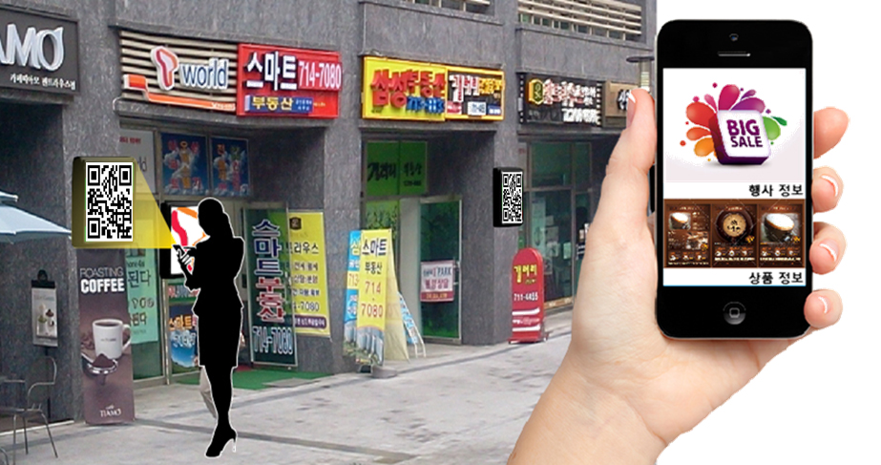
A1 : Offline to Online Marketing/Public Information System

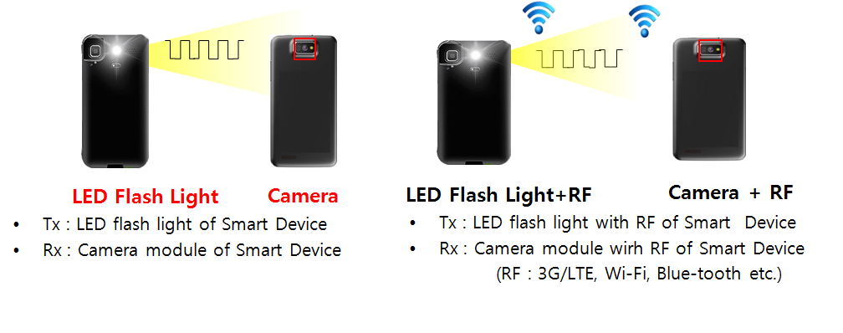
A2 : IoT (M2M/D2D/ Internet of Light (IoL))

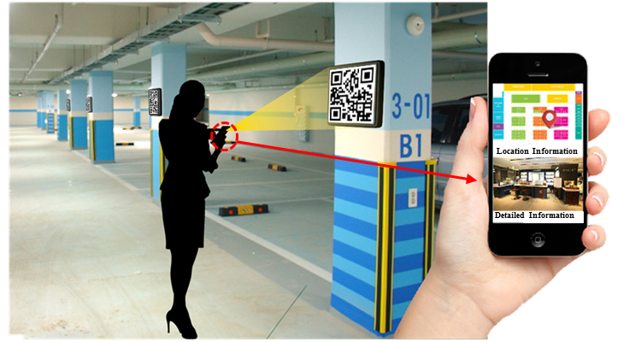
A3 : LBS / Indoor Positioning

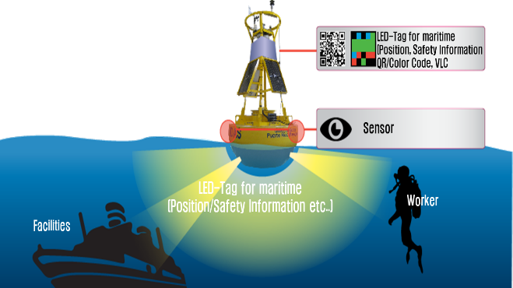
A5 : Underwater/Seaside Communication

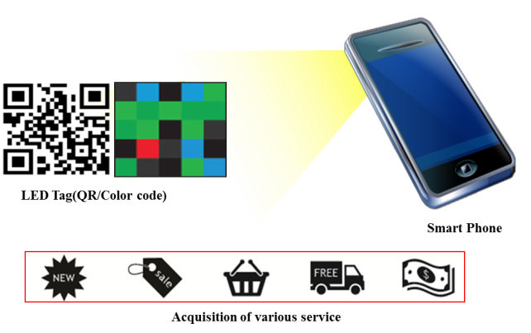
A9 : LED based Tag application

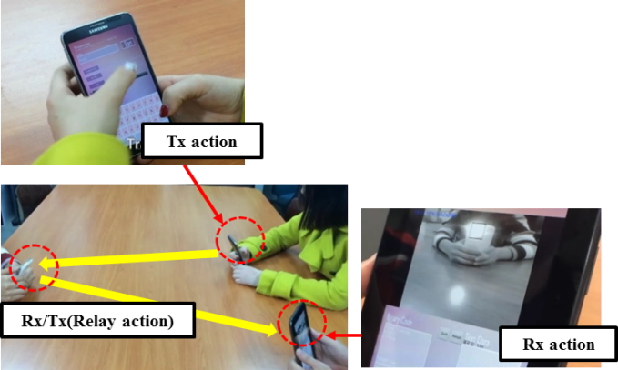
A10 : Point-to-(multi)point / relay communication

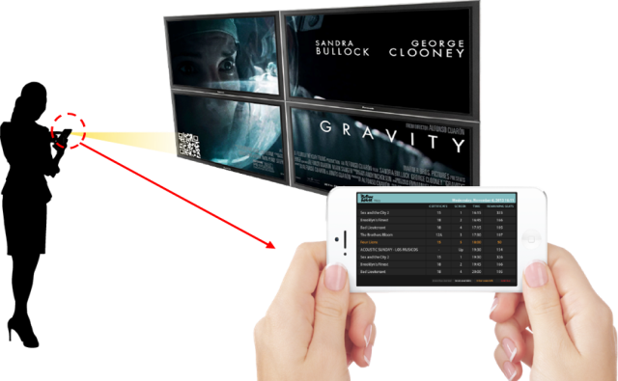
A11 : Digital signage

The standard will support at least one flicker free PHY mode, in which the modulation is imperceptible for human eye, for application A1, A3, A4, A6, A7, A8 and A11. The standard may allow flicker PHY mode for application A1, A2, A3, A5, A9 and A10, but it shall be safe for human eye as described in clause 4.1.

Transmitter

The standard should support the following devices as transmitters for each application.

Device | Applications/Use cases
Ceiling light / Lighting Source | A2, A3
Flash light | A5, A2
Car light | A4, A7
Indirect light | A1, A4
Illuminated signage with diffused light | A1, A2
Illuminated signage with discrete LEDs | A1, A2
Digital signage (such as LCD) | A1, A2
Traffic light and Intelligent Traffic System (ITS) | A1, A2, A4, A7
Lighthouse | A1, A8
LED Tag | A9, A5, A8, A1
Display / Image patterns | A9, A5, A8, A1

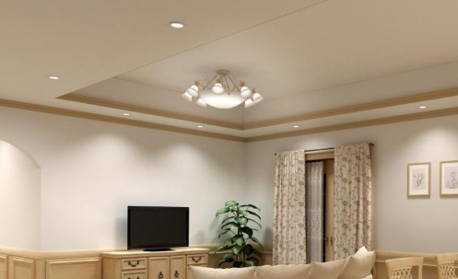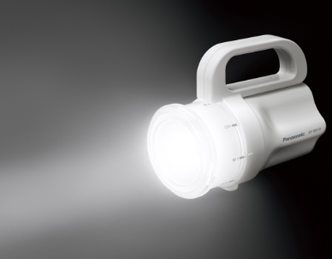
Ceiling light Flash light

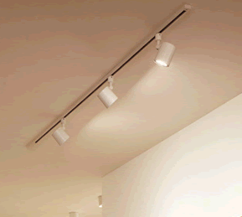
Car light Indirect light

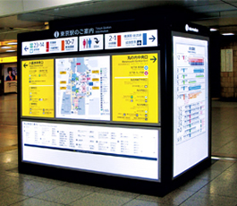
Illuminated signage Illuminated signage
with diffused light with discrete LEDs

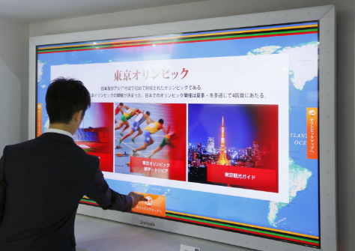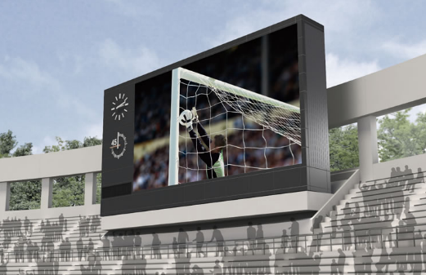
Digital signage

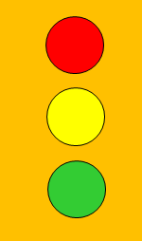
Traffic light Lighthouse

Receiver

The standard will support an optical camera receiver, which has an image sensor that measures the intensity of visible light, IR and/or UV. The standard will support image sensors of global shutter or sequential shutter (such as rolling shutter) with multiple PHY/MAC modes.

Carrier Wavelength

Carrier wavelength will be limited to visible light, IR and UV.

Transfer mode

A PHY/MAC mode of the standard will support at least one of the following transfer modes according to the duplex mode:

ID broadcast mode which repetitively broadcast ID with small overhead of MAC frame for application A1, A2, A3, A4, A5, A7, A9 and A11.
Unidirectional data transfer mode which transmit longer data stream for application A2, A4, A6, A8 and A11.
Bidirectional data transfer mode which enables efficient communication for application A2 and A10.

The standard may provide multiple PHY/MAC modes that allow the efficient use of the available optical bandwidth on a given luminaire.

Dimming Control

The standard will support dimming control for application A1, A2, A3, A4 and A7.

Power Consumption Control

The standard should support power consumption control for application A6.

Coexistence with Ambient Light

The standard will co-exist with ambient light that may be reflected on a surface of a transmitter. In addition, coexistence shall be investigated with the existing IEEE802.15.7-2011 operating modes.

Coexistence with Other Lighting Systems

The standard will co-exist with other lighting systems. It will enable a receiver to receive a signal from a transmitter even if other lighting systems are captured in the same image frame, which are optically separable from the transmitter.

Simultaneous Communication with Multiple Transmitters

The standard may support simultaneous communication with multiple coordinated/uncoordinated transmitters, which are separated on a captured image. Simultaneous communication with coordinated transmitters is called Multiple Input/Multiple Output (MIMO) and a MIMO MAC protocol may be incorporated into the standard so the camera enabled receiving device knows how to process the received data.

Simultaneous Communication with Multiple Receivers

The standard may support at least one PHY/MAC layer for simultaneous image sensor communication between multiple coordinated/uncoordinated transmitters and multiple coordinated/uncoordinated receivers.

Data Frame Consistency

The standard will support a scheme to confirm data frame consistency to avoid incorrect data frame in situations such as described in the following figure.

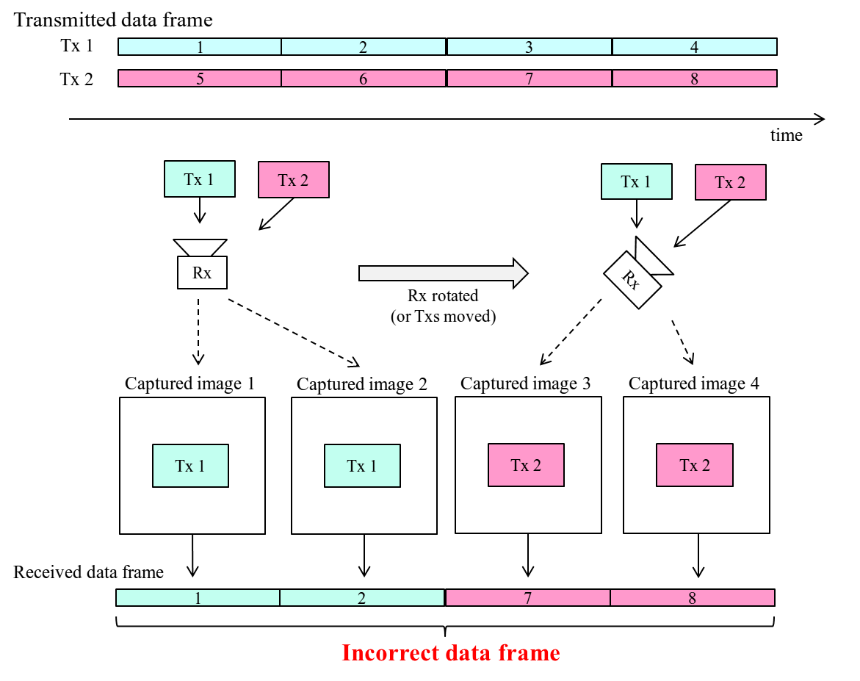

Nearly point image data source

The standard will support at least one PHY mode that works when the light source appears as nearly a point source; that is, the light source illuminates only a small number of image pixels.

Identification of modulated light sources

The standard may support at least one PHY mode that allows identification of modulated light sources at one camera frame rate and then demodulation at a different camera frame rate.

Low overhead repetitive transmission

The standard will support at least one MAC mode that supports repetitive informational broadcast at very low data rate; that is, the frame format has very little overhead and is optimized for short payloads sent in a repetitive manner.

Image Sensor Compatibility

The standard will support a PHY mode that is compatible with a variety of cameras with different image sensing sampling rates (read-out time), resolutions and frame rates. Specifically, either constant frame rate or varying frame rate will be supported. And also specifically, either constant resolution or varying resolution will be supported.

Localization

The standard may provide mechanisms to support positioning algorithms.

High Rate PD Communications

Applications/Use cases

The following High Speed Photodiode Receiver applications/use cases were presented in response to TG7r1 Call for Applications.

- Indoor Office/Home Applications: (Conference Rooms, General Offices, Shopping Centres, Airports, Railways, Hospitals, Museums, Aircraft Cabins, Libraries etc.)
- Data Center / Industrial Establishments, Secure Wireless (Personalized Manufacturing Cells, Factories, Hangers, etc.)
- Vehicular Communications (Vehicle-to-vehicle, Vehicle-to-Infrastructure)
- Wireless Backhaul (Small Cell Backhaul, Surveillance Backhaul, LAN Bridging)

These have been summarized in document number 15-15-0302-01-007a.

B1: Indoor Office/Home Applications

B2: Data Center / Industrial Establishments / Secure Wireless

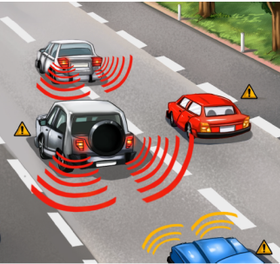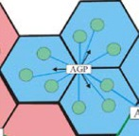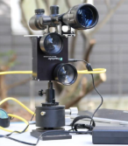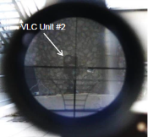

B3: Vehicular Communications B4: Wireless Backhaul

The standard should support flicker free PHY mode, in which the modulation is imperceptible for the human eye, for application B1 and B3. For the applications B2 and B4, infrared light may be used.

Transmitter

The standard shall support the following devices as transmitters for each application.

Device | Applications/Use cases
Ceiling/Street light | B1, B2, B3
Indirect light | B1, B2
Car light | B3
Directed light | B2, B4

Transfer mode

The standard will support continuous data streaming for all applications with bidirectional functionality as well as short packet transmissions where low latency is required. The standard must provide a PHY mode that allows an efficient use of the available optical bandwidth of a given luminaire for B1 – B4.

The standard must define a range of data rates with minimum supported connectivity of at least 1 Mbps at the PHY SAP. The standard must support at least one PHY mode that supports peak data rates of 10 Gbps at the PHY SAP.

The standard may allow a range of latencies from maximum supported of at most 30 ms to minimum latency of 1 ms.

Dimming Control

The standard will support dimming control for application B1 – B3.

Adaptive Transmission and Multiple User Support

The standard must provide MAC/PHY mechanisms to support adaptive transmission as well as the support of multiple users communicating different data streams from the same light source (multiple access).

Asymmetric Communication

The standard will support asymmetric communication between transmitters and receivers to allow higher data rates in one direction.

Handover and Interference Coordination

The standard will provide mechanisms to support horizontal handover between light sources, allowing the users to maintain a continuous network connection for applications B1 – B3.

The standard may provide efficient mechanisms that can be used to deliver interference coordination techniques by higher layers.

Handover mechanisms may not be required for point-to-point communications.

Localization

The standard may provide mechanisms to support positioning algorithms.

Coexistence with Ambient Light and Other Lighting Systems

The standard will co-exist with ambient lights. This may enable a receiver to communicate with a supported transmitter even in the presence of other modulated lights.

In addition, coexistence shall be investigated with the existing IEEE802.15.7-2011 operating modes.

Simultaneous Communication with Multiple Transmitters

The standard may support multiple coordinated/uncoordinated transmitters, which is referred to as multiple-input multiple-output (MIMO) communications. It may support cooperative signal processing among multiple transmitters with negligible impact on latency.

The standard will support efficient and reliable feedback and control channels. These may be used for adaptive transmission, multiple user support, MIMO support, cooperative signal processing or other features.

Waveform

The standard will employ at least one PHY mode that uses variable current modulation.

Metric Reporting

The standard may provide internal metrics via an open interface. This information may be used to support cooperative signal processing, vertical handover and link aggregation with other wireless transmission techniques.

For this purpose, the High Rate PD Communications may report the following metrics with minimized overhead and low latency:
- Information about instantaneous metrics such as SINR and detailed channel state information.
- Information about recent history of the metrics such as temporal characteristics, signal blocking, frequency of signal losses.

Low Rate PD Communications

Applications/Use cases

The following Low Speed Photodiode Receiver applications/use cases were presented in response to TG7r1 Call for Applications.

C1 Underwater/Seaside Communication [8]
C2 Point-to-(multi)point / communication [5, 8, 9]
C3 Digital signage [5, 8, 17]
C4 D2D/IoT [5, 9]
C5 LOS Authentication [5, 17]
C6 Identification based service [20, 21]

The standard will consist of multiple PHY/MAC modes to meet the following variety of Low Speed Photodiode Receiver requirements where the receiver consists of photodiode.
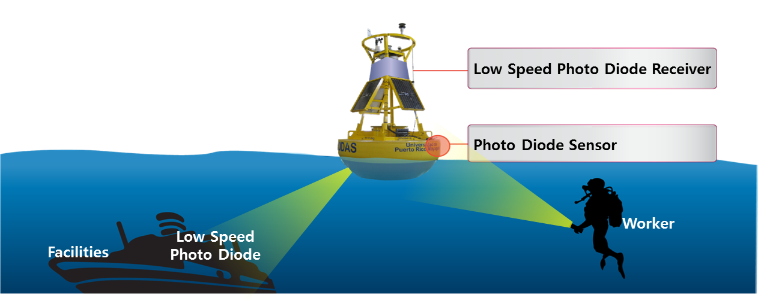

C1 : Underwater/Seaside Communication

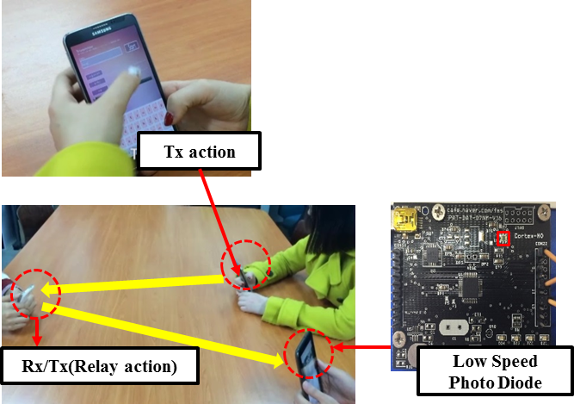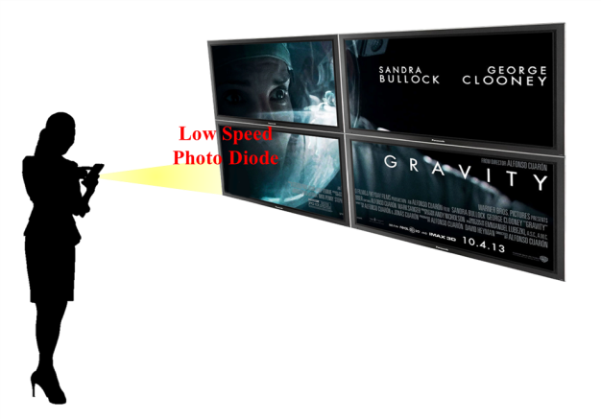
C2 : Point-to-(multi)point / relay communication C3 : Digital signage

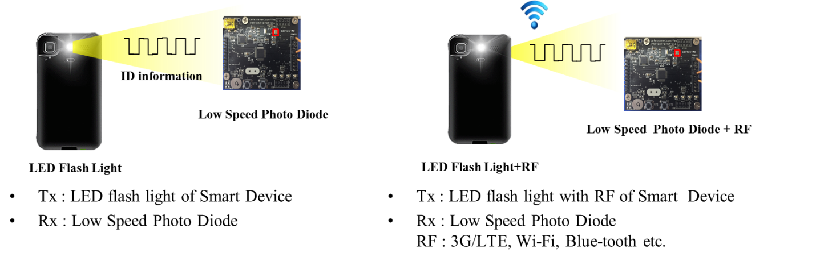

C4 : D2D/IoT
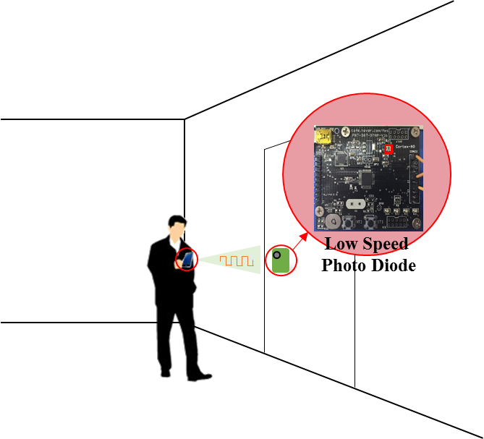

C5 : LOS Authentication

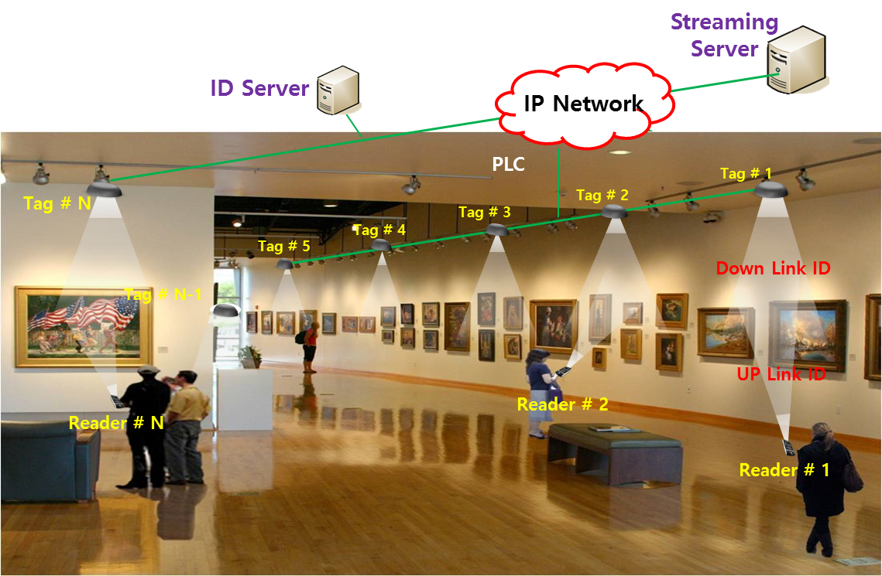

C6: Identification based service

The standard will support at least one flicker free PHY mode, in which the modulation is imperceptible for human eye, for application C1 – C6. The standard may allow flicker PHY mode for application C1 – C6.

Transmitter

The standard should support the LED Tags, Smart Phone Flash lights, Lighting source, etc. for various applications.

Device | Applications/Use cases
Smart Device Flash light | C2, C4,
Lighting source | C1, C3,C5,C6

In addition, it should support the transmitters indicated in clause 4.3.2.

Receiver

The standard will support Low Speed Photodiode Receiver. It measures intensity of visible light, IR and/or near UV, as receiver.

Carrier Wavelength

Carrier wavelength will be limited to visible light, IR and near UV frequency band.

Transfer mode

The standard may provide multiple PHY/MAC modes that allow the optimal use of the available optical bandwidth on a given luminaire for C1 – C6.

D2D/IoT data transmission and Relay mode with ID information with PHY/ MAC frame for applications C2, C3, C4, C5 and C6.
Uni/Bi-directional data transfer mode for applications C1 – C6..

In regards to the definition of low speed and high speed, the throughput threshold data rate is 1 Mbps as measured at the PHY SAP. Throughput less than 1 Mbps rate at the PHY SAP is considered low rate and higher than 1 Mbps at the PHY SAP is considered high rate.

Dimming Control

The standard will support dimming control for all of applications

Handover, Link Recovery and Interference Coordination

The standard may provide mechanisms to support handover between LED light sources, allowing the users to maintain a continuous network connection.

The standard may provide mechanisms that can be used to develop and deliver interference coordination techniques by higher layers.

The standard may support link recovery mechanism to maintain connection in unreliable channel for reducing the connection delay.

Localization

The standard may provide mechanisms to support indoor positioning algorithms from Identification of LEDs system.

Coexistence with Ambient Light

The standard will co-exist with ambient light that may be reflected on a surface of a transmitter. In addition, coexistence shall be investigated with the existing IEEE802.15.7-2011 operating modes.

Coexistence with Other Lighting Systems

The standard will co-exist with other lighting systems.

Identification of Transmitter

The standard will support a scheme to identify transmitters’ ID information. A receiver can trace a transmitter identification (ID) using Low Speed Photodiode Receiver system.

References

- The IEEE P802.15.7r1 Short-Range Optical Wireless Communications Task Group Project Authorization Request (PAR): https://mentor.ieee.org/802.15/dcn/15/15-15-0064-00-0007-p802-15-7-revision-par-approved-2014-12-10.pdf
- Intel Response to 15.7r1 CFA: IEEE802.15-15-0146-00-007a
- CASIO Response to 15.7r1 CFA: IEEE802.15-15-0173-01-007a
- China Telecom CFA Response for Optical Camera Communications: IEEE802.15-15-0180-00-007a
- Introduction of LED-ID and Smart Device Camera based Applications: IEEE802.15-15-0196-00-007a
- Panasonic Response to 15.7r1 CFA: IEEE802.15-15-0197-00-007a
- NTU Response to 15.7r1 CFA: IEEE802.15-15-0203-00-007a
- LED Tag Applications for OWC: IEEE802.15-15-0211-00-007a
- D2D/P2P applications using Flash light and Camera of Smart Device: IEEE802.15-15-0212-00-007a
- Kookmin University Response to 15.7r1 CFA: Application of OWC: IEEE802.15-15-0242-00-007a
- Kookmin University Response to 15.7r1 CFA: Applications of OCC: IEEE802.15-15-0243-00-007a
- Fraunhofer HHI Response to 15.7r1 CFA: IEEE802.15-15-0248-01-007a
- pureLiFi_CFA_response: IEEE802.15-15-0192-00-007a
- LED Tag Applications for OWC: IEEE802.15-15-0211-00-007a
- D2D/P2P applications using Flash light and Camera of Smart Device: IEEE802.15-15-0212-00-007a
- Introduction of LED-ID and Smart Device Camera based Applications : for Short-Range Optical Wireless Communications Tutorial : IEEE 802.15-15-0196-00-007a
- OWC Use Cases : LED Patch based Use Cases for Facility Signage : IEEE 802.15-15-0082-00-0007
- Some Issues for OWC : IEEE 802.15.-15-0073-00-0007
- 15-15-0404-00-007a-kookmin-university-response-to-15-7r1-cfa-occ-application-in-light-house-to-ship-communication
- Overview of LED-ID: IEEE 802.15.-11-0501-00-0-0wng
- Overview and Applications of LED-ID System and Visible RFID System: IEEE 802.15-11-0666-00-wng0

Defined in document https://mentor.ieee.org/802.15/dcn/15/15-15-0445-00-007a-offline-to-online-marketing.pdf
IoT data transmission is the inclusion of non-traditional devices into a communications network such as household appliances connecting and communicating with a user’s device.
Device to device (D2D) data transmission is the direct wireless passing of data between devices without passing data through an infrastructure device such as an access point.
LBS means Location-Based Services and is defined at https://en.wikipedia.org/wiki/Location-based_service
Relay mode is the ad-hoc forwarding of data by a device in the middle of two other devices that would normally be out of communication range.

