IEEE P802.15
Wireless Personal Area Networks

Project | IEEE P802.15 Working Group for Wireless Personal Area Networks (WPANs)
Title | Draft of LED-ID Part of TG7r1 Technical Considerations Document
Date Submitted | [13 May, 2015]
Source | [Jaesang Cha*, Soo-Young Chang**]  [*Seoul National Univ. Of Science & Tech., **CSUS]  [chajs@seoultech.ac.kr, sychang06@gmail.com]
Re: | [TG7r1 TCD ]
Abstract | [Draft of LED-ID part of technical considerations for TG7r1.]
Purpose | [To assist to prepare TG7r1 TCD]
Notice | This document has been prepared to assist the IEEE P802.15. It is offered as a basis for discussion and is not binding on the contributing individual(s) or organization(s). The material in this document is subject to change in form and content after further study. The contributor(s) reserve(s) the right to add, amend or withdraw material contained herein.
Release | The contributor acknowledges and accepts that this contribution becomes the property of IEEE and may be made publicly available by P802.15.

List of contributors
Hideki Aoyama | Panasonic
Mitsuaki Oshima | Panasonic
Rojan Chitrakar | Panasonic
Nikola Serafimovski | pureLiFi
Murat Uysal | Ozyegin University
Yu Zeng | China Telecom
Richard Roberts | Intel
Yeong Min Jang | Kookmin University
Jaesang Cha | Seoul National Univ. of Science& Tech.(SNUST)
Soo-Young Chang | CSUS

Table of Contents
Table of Contents 3
4.3 LED-ID 10
4.3.1 Applications/Use cases 10
4.3.2 Transmitter 10
4.3.3 Receiver 10
4.3.4 Carrier Frequency 11
4.3.5 Transfer mode 11
4.3.6 Eye safety and Flicker 11
4.3.7 Dimming Control 11
4.3.8 Communication Range 11
4.3.9 Coexistence with Ambient Light 12
4.3.10 Coexistence with Other Lighting Systems 12
4.3.11 Identification of Transmitter 12
5. References 12
6. Appendix 12

4.3 LED-ID

Applications/Use cases

The following LED-ID applications/use cases were presented in response to TG7r1 Call for Applications.

C1 LED based Tag application [1, 3]
C2 Underwater/Seaside Communication [1]
C3 secure point-to-(multi)point communication [1, 2, 3]
C4 Digital signage [1, 3, 4]
C5 D2D/IoT [2, 3]
C6 LOS marketing [3, 4]
C7 LBS and Indoor Positioning [3, 4]

The standard will consist of multiple PHY/MAC modes to meet the following variety of requirements.

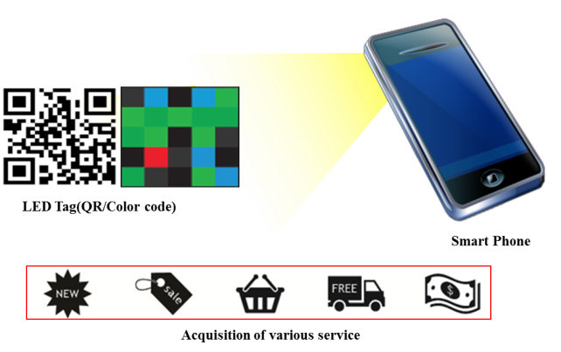 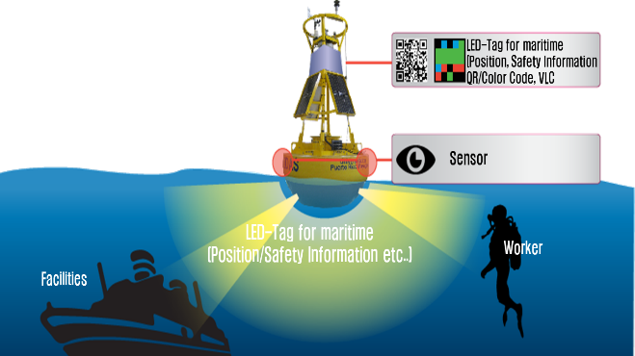 C1 : LED based Tag application C2 : Underwater/Seaside Communication

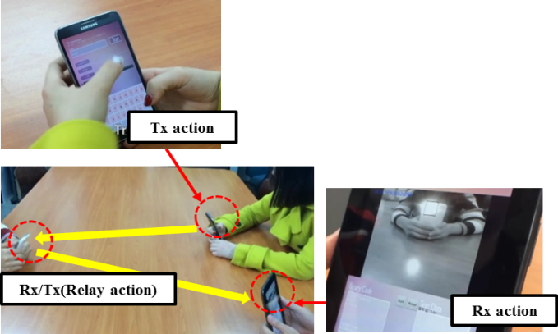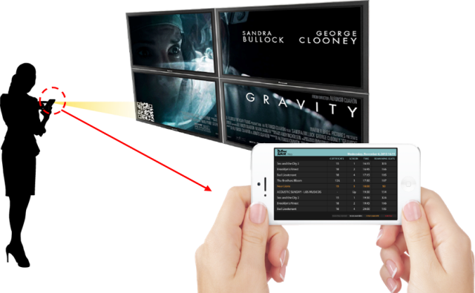
C3 : Secure point-to-(multi)point communication C4 : Digital signage
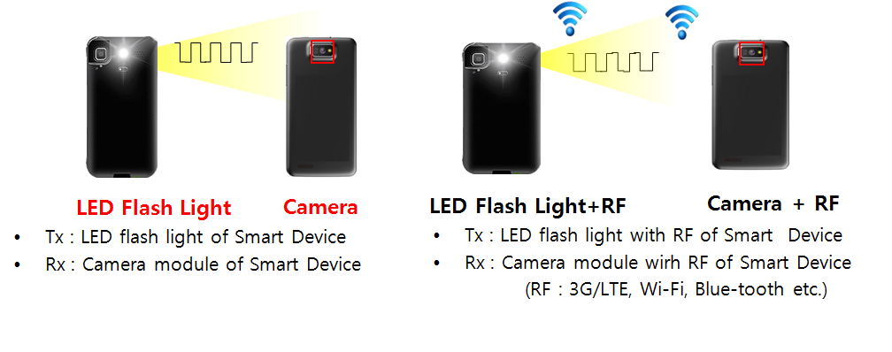
C5 : D2D/IoT

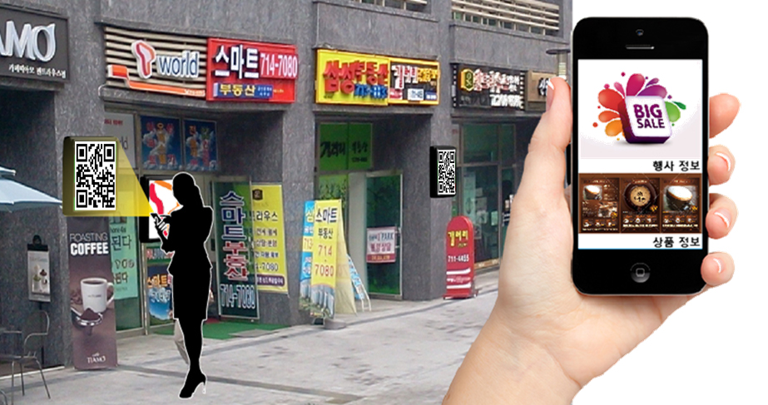
C6 : LOS Marketing

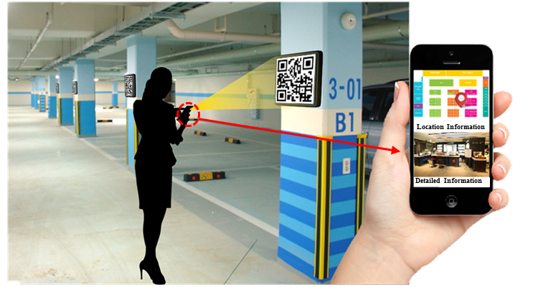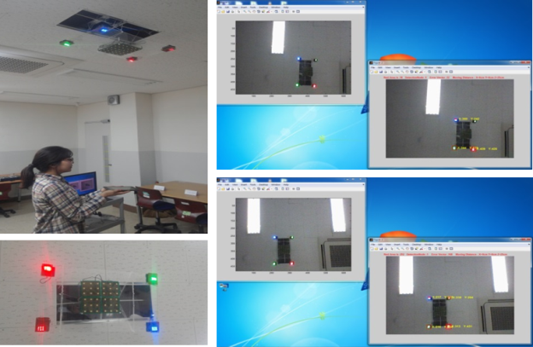
C7 : LBS and Indoor Positioning

Transmitter

The standard should support the LED Tags & display/image patterns (QR/Color code like Bar code) Smart Phone Flash lights, Lighting source, etc. for various applications.

Device | Applications/Use cases
LED Tag | C1, C2, C4
Display / Image patterns | C1, C2, C4, C6
Smart Device Flash light | C2, C3, C5
Lighting source | C1, C2,C6, C7
Signage multiple color source | C4, C6

Receiver

The standard will support PD/Camera (Image Sensor). It measure intensity of visible light, IR and/or near UV, as receiver.

Carrier Frequency

Carrier frequency will be limited in visible light, IR and near UV frequency band.

Transfer mode

The standard may provide multiple PHY/MAC modes that allow the optimal use of the available optical bandwidth on a given luminaire for C1 – C7.
D2D/IoT data transmission and Relay mode with ID information with PHY/ MAC frame for applications C2, C3 and C5.
Uni/Bi-directional data transfer mode for applications C1 – C7.
Hybrid data transmission mode is available C1, C3, C5 and C7.

Eye safety and Flicker

The modulated light will be safe for human eye in the aspects of frequency and intensity of light. And the modulated light will not stimulate sickness such as photosensitive epilepsy.
The standard will support at least one flicker free PHY mode, in which the modulation is imperceptible for human eye, for application C1 – C7. The standard may allow flicker PHY mode for application C1 – C7.

Dimming Control

The standard will support dimming control for all of applications

Communication Range

The communication range depends on multiple external factors (signal magnification, signal collimation, source power, etc.). These are implementation aspects and these numbers are provided as guidelines only. The committee will agree to use the same channel model to assess the performance capabilities of the proposed schemes.

Coexistence with Ambient Light

The standard will co-exist with ambient light that may be reflected on a surface of a transmitter and with existing 15.7 PHY modes.

Coexistence with Other Lighting Systems

The standard will co-exist with other lighting systems.

Identification of Transmitter

The standard will support a scheme to identify transmitters when a receiver or a transmitter is moved. A receiver can trace a transmitter identification(ID) of LED-ID systems

References

- LED Tag Applications for OWC: IEEE802.15-15-0211-00-007a
- D2D/P2P applications using Flash light and Camera of Smart Device: IEEE802.15-15-0212-00-007a
- Introduction of LED-ID and Smart Device Camera based Applications : for Short-Range Optical Wireless Communications Tutorial : IEEE 802.15-15-0196-00-007a
- OWC Use Cases : LED Patch based Use Cases for Facility Signage : IEEE 802.15-15-0082-00-0007
- Some Issues for OWC : IEEE 802.15.-15-0073-00-0007

