IEEE P802.15
Wireless Personal Area Networks

Project | Dependability Interest Group
Title | Meeting Minutes for May 2015
Date Submitted | May 12, 2015
Source | [Jussi Haapola]  [Centre for Wireless Communications / University of Oulu] | Voice: +358 40 8363 018  E-mail: jhaapola@ee.oulu.fi
Re: | Meeting Minutes
Abstract
Purpose | Minutes of Dependability Interest Group sessions
Notice | This document has been prepared to assist the IEEE P802.15. It is offered as a basis for discussion and is not binding on the contributing individual(s) or organization(s). The material in this document is subject to change in form and content after further study. The contributor(s) reserve(s) the right to add, amend or withdraw material contained herein.
Release | The contributor acknowledges and accepts that this contribution becomes the property of IEEE and may be made publicly available by P802.15.

Monday, May 11, 2015, PM2, 16:00

  - Meeting called to order 16:12
By Chair Ryuji Kohno (YNU / CWC-Nippon)
Secretary Jussi Haapola (Centre for Wireless Communication / University of Oulu)

  - Roll Call
Notepad for Attendance circulated.

Chair showed IEEE Patent policy.

Chair issued Call for Potentially Essential Patents
No essential intellectual property in the scope of IG DEP was declared.

Ryuji Kohno presented Opening report Doc xxx

  - Approval of previous meeting minutes
Doc #0220 Minutes were approved.

  - CFI second round reporting

Ryuji Kohno presented interests of several companies with respect to the CFI.

  - Recess at 17:45.

  - Attendees
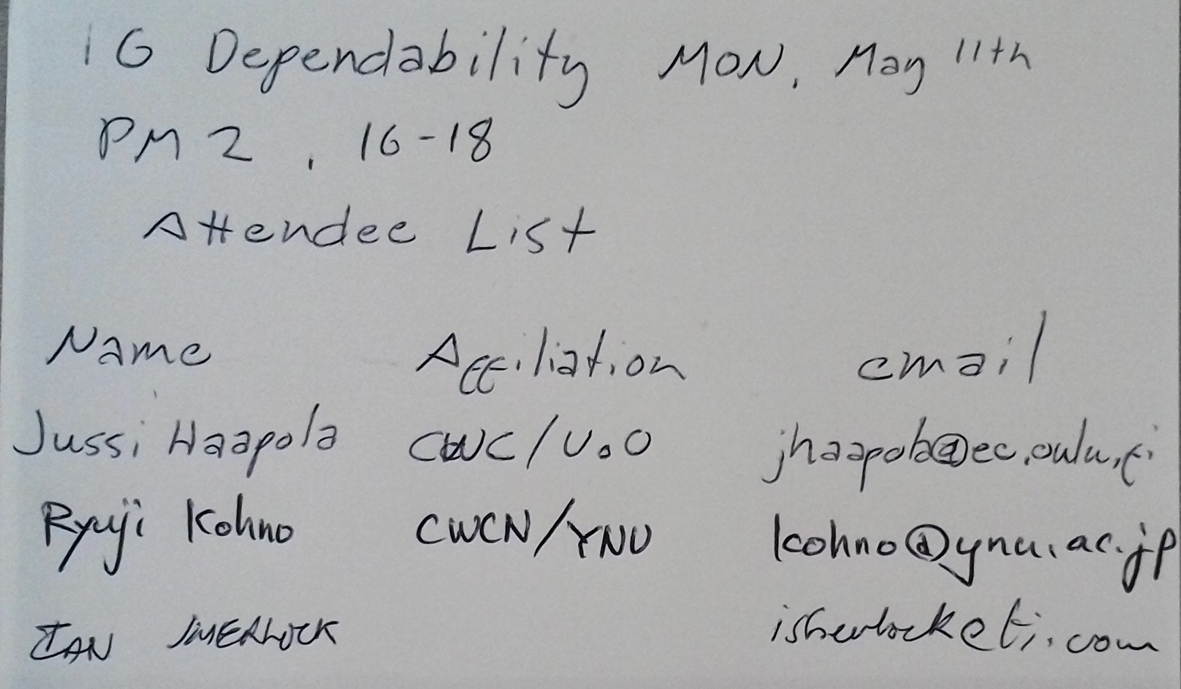

Tuesday, May 12, 2015, AM1, 08:00

  - Meeting called to order at 8:53
By Chair Ryuji Kohno (YNU / CWC-Nippon)
Secretary Jussi Haapola (Centre for Wireless Communication / University of Oulu)

  - Roll Call
Notepad for Attendance circulated

  - Review of Dependable communications criteria
Criteria listed at the end of doc #217r2.

  - AoB
Jussi to update tentative timeline.

  - Adjourn at 9:58

  - Attendees
